1、Write a program to not only find the weighted shortest distances, but also count the number of different minimum paths from any vertex to a given source vertex in a digraph. It is guaranteed that all the weights are positive.

**Format of functions:**

void ShortestDist( MGraph Graph, int dist[], int count[], Vertex S );

where MGraph is defined as the following:

typedef struct GNode *PtrToGNode;

struct GNode{

int Nv;

int Ne;

WeightType G[MaxVertexNum][MaxVertexNum];

};

typedef PtrToGNode MGraph;

The shortest distance from V to the source S is supposed to be stored indist[V]. If V cannot be reached from S, store -1 instead. The number of different minimum paths from V to the source S is supposed to be stored in count[V] and count[S]=1.

**Sample program of judge:**

#include <stdio.h>

#include <stdlib.h>

typedef enum {false, true} bool;

#define INFINITY 1000000

#define MaxVertexNum 10 /* maximum number of vertices */

typedef int Vertex; /* vertices are numbered from 0 to MaxVertexNum-1 */

typedef int WeightType;

typedef struct GNode *PtrToGNode;

struct GNode{

int Nv;

int Ne;

WeightType G[MaxVertexNum][MaxVertexNum];

};

typedef PtrToGNode MGraph;

MGraph ReadG(); /* details omitted */

void ShortestDist( MGraph Graph, int dist[], int count[], Vertex S );

int main()

{

int dist[MaxVertexNum], count[MaxVertexNum];

Vertex S, V;

MGraph G = ReadG();

scanf("%d", &S);

ShortestDist( G, dist, count, S );

for ( V=0; V<G->Nv; V++ )

printf("%d ", dist[V]);

printf("\n");

for ( V=0; V<G->Nv; V++ )

printf("%d ", count[V]);

printf("\n");

return 0;

}

/* Your function will be put here */

**Sample Input (for the graph shown in the figure):**

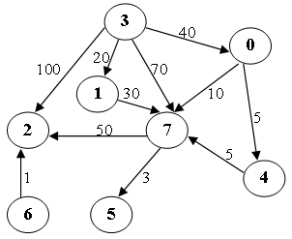

8 11

0 4 5

0 7 10

1 7 30

3 0 40

3 1 20

3 2 100

3 7 70

4 7 5

6 2 1

7 5 3

7 2 50

3

**Sample Output:**

40 20 100 0 45 53 -1 50

1 1 4 1 1 3 0 3

2、Write a program to find the weighted shortest distances from any vertex to a given source vertex in a digraph. If there is more than one minimum path from v to w, a path with the fewest number of edges is chosen. It is guaranteed that all the weights are positive and such a path is unique for any vertex.

**Format of functions:**

void ShortestDist( MGraph Graph, int dist[], int path[], Vertex S );

where MGraph is defined as the following:

typedef struct GNode *PtrToGNode;

struct GNode{

int Nv;

int Ne;

WeightType G[MaxVertexNum][MaxVertexNum];

};

typedef PtrToGNode MGraph;

The shortest distance from V to the source S is supposed to be stored indist[V]. If V cannot be reached from S, store -1 instead. If W is the vertex being visited right before V along the shortest path from S to V, then path[V]=W. If V cannot be reached from S, path[V]=-1, and we have path[S]=-1.

**Sample program of judge:**

#include <stdio.h>

#include <stdlib.h>

typedef enum {false, true} bool;

#define INFINITY 1000000

#define MaxVertexNum 10 /* maximum number of vertices */

typedef int Vertex; /* vertices are numbered from 0 to MaxVertexNum-1 */

typedef int WeightType;

typedef struct GNode *PtrToGNode;

struct GNode{

int Nv;

int Ne;

WeightType G[MaxVertexNum][MaxVertexNum];

};

typedef PtrToGNode MGraph;

MGraph ReadG(); /* details omitted */

void ShortestDist( MGraph Graph, int dist[], int path[], Vertex S );

int main()

{

int dist[MaxVertexNum], path[MaxVertexNum];

Vertex S, V;

MGraph G = ReadG();

scanf("%d", &S);

ShortestDist( G, dist, path, S );

for ( V=0; V<G->Nv; V++ )

printf("%d ", dist[V]);

printf("\n");

for ( V=0; V<G->Nv; V++ )

printf("%d ", path[V]);

printf("\n");

return 0;

}

/* Your function will be put here */

**Sample Input (for the graph shown in the figure):**

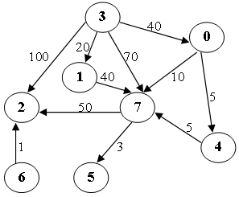

8 11

0 4 5

0 7 10

1 7 40

3 0 40

3 1 20

3 2 100

3 7 70

4 7 5

6 2 1

7 5 3

7 2 50

3

**Sample Output:**

40 20 100 0 45 53 -1 50

3 3 3 -1 0 7 -1 0