Molina, Joshua Ali S.

DSALGO1

IDB2

11/15/2024

#1:

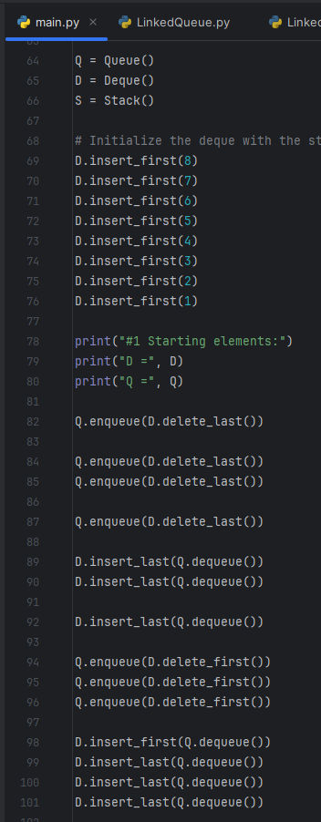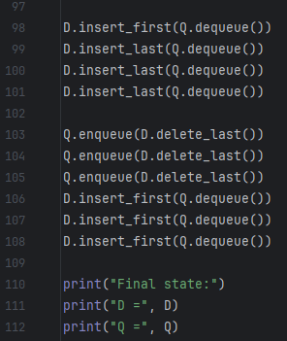

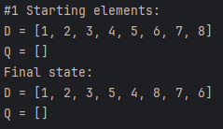

#2:

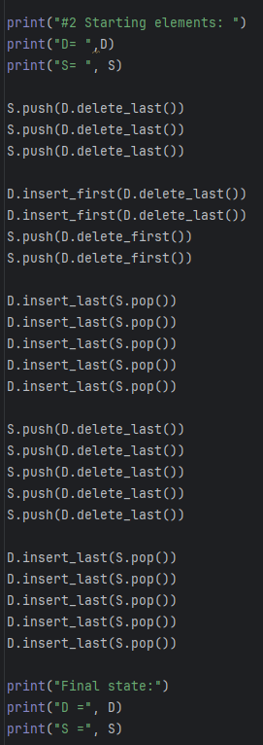

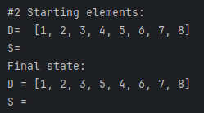

**LinkedQueue Class:**

class LinkedQueue:  
 *"""FIFO queue implementation using a singly linked list for storage."""* # ---------------- nested _Node class ----------------  
 class _Node:  
 *"""Lightweight non-public class for storing a singly linked node."""* __slots__ = '_element', '_next' # streamline memory usage  
  
 def __init__(self, element, next):  
 self._element = element  
 self._next = next  
  
 # --------------- queue methods ----------------  
 def __init__(self):  
 *"""Create an empty queue."""* self._head = None  
 self._tail = None  
 self._size = 0  
  
 def __len__(self):  
 *"""Return the number of elements in the queue."""* return self._size  
  
 def is_empty(self):  
 *"""Return True if the queue is empty."""* return self._size == 0  
  
 def first(self):  
 *"""Return (but do not remove) the element at the front of the queue."""* if self.is_empty():  
 raise Exception('Queue is empty')  
 return self._head._element # front aligned with the head of the list  
  
 def dequeue(self):  
 *"""Remove and return the first element of the queue (FIFO).  
  
 Raise Exception if the queue is empty.  
 """* if self.is_empty():  
 raise Exception('Queue is empty')  
 answer = self._head._element  
 self._head = self._head._next  
 self._size -= 1  
 if self.is_empty(): # special case as queue is empty  
 self._tail = None # removed head had been the tail  
 return answer  
  
 def enqueue(self, e):  
 *"""Add an element to the back of queue."""* newest = self._Node(e, None) # node will be new tail node  
 if self.is_empty():  
 self._head = newest # special case: previously empty  
 else:  
 self._tail._next = newest  
 self._tail = newest # update reference to tail node  
 self._size += 1  
  
 def __str__(self):  
 *"""Return a string representation of the queue's contents."""* elements = []  
 current = self._head  
 while current is not None:  
 elements.append(str(current._element))  
 current = current._next  
 return "[" + ", ".join(elements) + "]"

**LinkedDeque Class:**

from DoublyLinkedBase import _DoublyLinkedBase  
class LinkedDeque(_DoublyLinkedBase):#note the use of inheritance  
 *'''Double ended queue implementation based on a doubly linked list.'''* def first(self):  
 *'''Return but do not remove the element at the front of the deque'''* if self.is_empty():  
 raise Exception("Deque is empty!")  
 return self._header._next._element #real item just after header  
 def last(self):  
 *'''Return but do not remove the element at the back of the deque'''* if self.is_empty():  
 raise Exception("Deque is empty!")  
 return self._trailer._prev._element #real item just before trailer  
 def insert_first(self, e):  
 *'''Add an element to the fron of the deque.'''* self._insert_between(e, self._header, self._header._next)#after header  
 def insert_last(self, e):  
 *'''Add an element to the back of the deque'''* self._insert_between(e, self._trailer._prev, self._trailer)#before trailer  
 def delete_first(self):  
 *'''Remove and return the element from the front of the deque.'''* '''Raise Exception if the deque is empty.'''  
 if self.is_empty():  
 raise Exception("Deque is empty!")  
 return self._delete_node(self._header._next)#use inherited method  
 def delete_last(self):  
 *'''Remove and return the element from the back of the deque.'''* '''Raise Exception if the deque is empty.'''  
 if self.is_empty():  
 raise Exception("Deque is empty!")  
 return self._delete_node(self._trailer._prev)#use inherited method  
 def __str__(self):  
 *"""Return a string representation of the deque's contents."""* elements = []  
 current = self._header._next  
 while current is not self._trailer:  
 elements.append(str(current._element))  
 current = current._next  
 return "[" + ", ".join(elements) + "]"

**LinkedStack Class:**

class LinkedStack:  
 class Node:  
 def __init__(self, data=None, next_node=None):  
 self.data = data  
 self.next = next_node  
  
 def __init__(self):  
 self.top = None  
 self.size = 0  
  
 def push(self, item):  
 new_node = self.Node(item, self.top)  
 self.top = new_node  
 self.size += 1  
  
 def pop(self):  
 if self.is_empty():  
 raise IndexError("pop from empty stack")  
 data = self.top.data  
 self.top = self.top.next  
 self.size -= 1  
 return data  
  
 def peek(self):  
 if self.is_empty():  
 raise IndexError("peek from empty stack")  
 return self.top.data  
  
 def is_empty(self):  
 return self.size == 0  
  
 def __str__(self):  
 items = []  
 current = self.top  
 while current:  
 items.append(str(current.data))  
 current = current.next  
 return " -> ".join(items)