Testing the Stability and Correctness of Python's marshal Module
Repository: https://github.com/Molingspance/marshal-testing-project

1 Introduction
Python's marshal module serializes and deserializes selected internal Python object types. It is mainly used for pseudo-compiled bytecode such as .pyc files: marshalling turns a supported object into a binary byte stream, and unmarshalling reconstructs an object from that stream.
This project evaluates marshal from a user-visible API perspective. The main question is whether the same input produces the same serialized output, where same output means hash-identical bytes rather than only logical equivalence.
The test suite focuses on three observable properties:
• Stability: repeated marshal.dumps(x) should produce byte-for-byte identical streams.
• Correctness: marshal.loads(marshal.dumps(x)) should preserve the supported value.
• Robustness: unsupported objects and malformed byte streams should raise controlled exceptions, not crash the interpreter.
The main risk areas covered by the black-box tests are:
• Different operating systems and Python versions.
• Special floating-point values such as NaN, Inf, and -0.0.
• Recursive, cyclic, and shared-reference data structures.
• Empty objects, very large objects, and deeply nested collections.
• Unsupported object types and corrupted marshal byte streams.

1.1 Test Oracles
The test oracles are implemented mainly in src/oracles.py and are used consistently across the black-box tests:
• Hash stability oracle: calls marshal.dumps(x) repeatedly and compares SHA-256 hashes.
• Round-trip oracle: checks marshal.loads(marshal.dumps(x)) with custom structural equivalence.
• Exception oracle: accepts controlled exceptions such as TypeError, ValueError, EOFError, and RecursionError for invalid inputs.
• Special-behavior oracle: records expected lossy behavior, such as bytearray values loading back as bytes.

2 Black-Box Testing
Black-box testing treats marshal as an API. The tests are designed from input classes and observable outputs, not from the internal C implementation. The observable outputs are serialized bytes, SHA-256 hashes, loaded objects, and raised exceptions.
The black-box design uses three techniques:
• Equivalence partitioning for representative supported and unsupported object classes.
• Boundary value analysis for values likely to expose encoding or comparison problems.
• Fuzz testing for broader random and mutated input exploration.

2.1 Equivalence Partitioning
Representative inputs are defined in src/specimens.py. The partitions are:
• Atomic values: None, bool, int, float, complex, str, and bytes.
• Containers: list, tuple, dict, set, and frozenset.
• Special supported values: code objects, recursive containers, and shared-reference structures.
• Unsupported values: functions, lambdas, generators, instances, file handles, OrderedDict, Counter, defaultdict, datetime, Decimal, and UUID.
The corresponding tests are:
• tests/test_roundtrip.py: valid partitions, file API round-trip, and repeated-dumps hash stability.
• tests/test_cycles.py: recursive containers and shared-reference preservation.
• tests/test_special_behaviors.py: bytearray loading back as bytes.
• tests/test_invalid_inputs.py: unsupported objects and malformed byte streams.

2.2 Boundary Value Analysis
Boundary cases are listed by all_boundary_case_ids() in src/specimens.py and executed in tests/test_boundaries.py. They include:
• Integer boundaries around -1, 0, 1, 255/256, 2**31, 2**63, and very large integers.
• Floating-point boundaries such as 0.0, -0.0, NaN, Inf, and -Inf.
• Empty strings, bytes, lists, dictionaries, sets, and frozensets.
• Large strings, long bytes, large containers, and deeply nested structures.
The boundary tests check two outcomes:
• test_boundary_cases_roundtrip(): the loaded object remains structurally equivalent to the original.
• test_boundary_cases_stable_in_process(): five repeated dumps produce identical SHA-256 hashes.

2.3 Fuzz Testing
Fuzz testing complements the hand-picked partitions and boundaries. It is implemented in src/fuzz_generator.py and exercised by tests/test_fuzzing.py and tests/test_invalid_inputs.py.
The suite uses two fuzzing modes:
• Generation-based fuzzing: creates legal nested objects with a fixed seed and checks round-trip correctness plus repeated-dumps stability.
• Lexical fuzzing: mutates existing marshal byte streams through truncation, dropped bytes, type-tag replacement, bit flips, inserted bytes, and random suffixes.
For generated valid inputs, no failure is expected. For mutated byte streams, the expected result is either a valid decoded object or a controlled exception. This checks robustness, while still acknowledging that fuzzing is sample-based and cannot prove complete correctness.

3 White-Box Testing
White-Box Testing focuses on the internal structure and implementation paths of the program under test. In the strict form taught in structural testing, statement coverage, branch coverage, and condition coverage are measured from real executed source-code paths.
For Python's marshal module, exact C-level coverage would require rebuilding CPython with coverage instrumentation and then running the test suite with that specially built interpreter. This project does not rebuild or instrument CPython, so it does not report exact statement, branch, or condition coverage percentages for Python/marshal.c.
Instead, the project uses a source-guided representative-path approach. It reads the major type-dispatch and error-handling paths in marshal.c, maps them to concrete Python specimens, and validates the observed behavior through round-trip, stability, and exception checks. The only numeric coverage example in this project is for the helper function _register_pair() in src/oracles.py, which is part of the project's own comparison oracle.

3.1 Statement Coverage
Statement Coverage requires every executable statement to be executed at least once. For marshal, the objective is to cover the main serialization and error-handling statements.
Statement Coverage is achieved by selecting representative input categories that trigger the main serialization and error-handling statements in marshal, including singleton objects, numeric objects, text and binary objects, container objects, and special cases such as code objects, recursive structures, unsupported objects, and corrupted byte streams.
For an explicit numeric example, the project uses _register_pair() in oracles.py:
- test case 1: first visit of a new left/right object pair, 88.89%
- test case 2: revisit of an already registered left/right object pair, 66.67%
- combined statement coverage: 100.0%
Together, these two tests cover all 9 executable statements in _register_pair().
Example test methods:
- test_register_pair_first_visit(): covers the "first registration" path
- test_register_pair_revisit():
covers the "already registered revisit" path

3.2 Branch Coverage
Branch Coverage focuses on whether each important decision outcome is exercised, requiring the major branches of the program to be executed during testing.
For marshal, we analyzed the main branch points in serialization and deserialization, and designed test inputs to cover successful serialization versus serialization exceptions, successful loading versus corrupted-stream exceptions, normal containers versus recursive or shared-reference containers, normal floating-point values versus special NaN and -0.0 cases, and repeated dumps within the same process.
Example test methods: •
- test_recursive_list_roundtrip_preserves_cycle():
covers the recursive-list branch •
- test_recursive_dict_roundtrip_preserves_cycle():
covers the recursive-dictionary branch •
- test_unsupported_objects_raise_reasonable_exceptions():
covers the unsupported-object exception branch •
- test_targeted_corrupted_streams_raise_reasonable_exceptions():
covers the corrupted-byte-stream exception branch •
- test_repeated_dumps_are_hash_identical_in_one_process():
checks the stable-output branch before cross-process comparison

3.3 Condition Coverage
Condition Coverage focuses on all possible outcomes of each boolean condition expression, requiring each important condition to take both True and False values during testing.
For marshal, this provides a more fine-grained way to check whether special conditions can affect the final byte-level representation. We analyzed key conditions in marshal and designed representative inputs to cover whether a floating-point value is NaN, whether a zero-valued float has a negative sign, whether a container is empty, whether a container is recursive, whether an input byte stream is truncated, and whether the first type tag is invalid.
These conditions are triggered by representative specimens such as float_nan, float_negative_zero, list_empty / dict_empty, recursive_list / recursive_dict, invalid-tag, and truncated-list.
Example test methods:
- test_boundary_cases_roundtrip():
covers key conditions involving NaN, -0.0, and empty containers
- test_equivalent_handles_cycles_without_infinite_recursion():
covers recursive-structure comparison conditions
- test_targeted_corrupted_streams_raise_reasonable_exceptions():
covers truncated-stream and invalid-tag conditions

4 Compatibility Testing
The output of marshal may be affected by environmental factors. The purpose of Compatibility Testing is to run the same marshal test suite under different Python versions and operating systems, and then compare whether the same correctness and stability checks still pass.
We tested the following environmental factors:
Using the same marshal specimen set and test oracles, we run identical test cases under different Python versions. The bundled local baseline uses Python 3.9.15, and the prepared version range covers Python 3.10, 3.11, 3.12, and 3.13. The comparison focuses on whether round-trip correctness, exception handling, boundary-value tests, and same-process dump stability checks remain consistent. Since marshal is an internal Python format and is not guaranteed to remain byte-stable across versions, version-level byte differences should be treated as compatibility evidence rather than automatic defects.
Running the same test suite on different operating systems, including Windows, Linux, and macOS, we observe whether the tests can execute successfully and whether the generated local evidence remains consistent. The current test code uses only Python standard-library modules and portable path handling, so it is intended to run without platform-specific dependencies

5 Traceability Matrix
This section links the requirements and relations verified by the marshal test suite to the automated test cases that provide evidence for them. The matrix is recorded at the test-function level so that each reported result can be traced back to executable code.

5.1 Identifier Definitions
Identifier | Definition
R | Requirement or relation that the test suite is expected to verify.
TC | Test Case. In this report, one TC is one executable unittest test function; a TC may cover one or more R items.
✓ | The TC directly verifies or provides evidence for the corresponding R item.

5.2 Requirement / Relation Definitions
R ID | Requirement / Relation
R1 | Int(Linux) = Int(Windows)
R2 | Float(Linux) = Float(Windows)
R3 | String/Bytes(Linux) = String/Bytes(Windows)
R4 | Container(Linux) = Container(Windows)
R5 | RecursiveStructure(Linux) = RecursiveStructure(Windows)
R6 | CodeObject(Linux) = CodeObject(Windows)
R7 | Valid objects satisfy round-trip correctness: loads(dumps(x)) ≈ x
R8 | Same-process repeated dumps(x) is stable
R9 | Unsupported objects raise reasonable exceptions
R10 | Corrupted byte streams are handled safely
R11 | Generated valid fuzz inputs satisfy round-trip and stability
R12 | Lexical fuzzing does not crash the interpreter
R13 | Bytearray can be dumped but loads back as bytes
R14 | _register_pair() white-box statement coverage is exercised

5.3 TC-R Traceability Matrix
For R1-R6, the same test cases are intended to be executed on Windows and Linux so that object-category behavior can be compared across environments. R7-R14 are verified by the functional, fuzzing, negative, special-behavior, and white-box tests listed below.
TC | R1 | R2 | R3 | R4 | R5 | R6 | R7 | R8 | R9 | R10 | R11 | R12 | R13 | R14
test_all_valid_specimens_stable_in_process() | ✓ | ✓ | ✓ | ✓ | ✓ | ✓ |  | ✓
test_all_valid_specimens_  roundtrip() | ✓ | ✓ | ✓ | ✓ | ✓ | ✓ | ✓
test_file_api_roundtrip() | ✓ | ✓ | ✓ | ✓ |  | ✓ | ✓
test_boundary_cases_  roundtrip() | ✓ | ✓ | ✓ | ✓ |  |  | ✓
test_boundary_cases_  stable_in_process() | ✓ | ✓ | ✓ | ✓ |  |  |  | ✓
test_recursive_list_roundtrip_  preserves_cycle() |  |  |  |  | ✓ |  | ✓
test_recursive_dict_roundtrip_  preserves_cycle() |  |  |  |  | ✓ |  | ✓
test_indirect_recursive_list_  roundtrip_preserves_cycle() |  |  |  |  | ✓ |  | ✓
test_shared_reference_roundtrip_  preserves_aliasing() |  |  |  |  | ✓ |  | ✓
test_equivalent_handles_cycles_  without_infinite_recursion() |  |  |  |  | ✓
test_unsupported_objects_raise_  reasonable_exceptions() |  |  |  |  |  |  |  |  | ✓
test_targeted_corrupted_streams_  raise_reasonable_exceptions() |  |  |  |  |  |  |  |  |  | ✓
test_lexical_fuzzing_  does_not_crash_process() |  |  |  |  |  |  |  |  |  | ✓ |  | ✓
test_generated_values_roundtrip_  and_remain_stable() | ✓ | ✓ | ✓ | ✓ |  |  | ✓ | ✓ |  |  | ✓
test_bytearray_values_  load_as_bytes() |  |  | ✓ |  |  |  |  |  |  |  |  |  | ✓
test_register_pair_  first_visit() |  |  |  |  |  |  |  |  |  |  |  |  |  | ✓
test_register_pair_  revisit() |  |  |  |  |  |  |  |  |  |  |  |  |  | ✓

6 Key Findings
Through Black-Box Testing and White-Box Testing, the project identified the following key findings.

6.1 Round-Trip Correctness Holds for Representative Valid Inputs
Phenomenon: for the representative valid inputs covered by the project, including primitive types, nested containers, recursive structures, shared references, and code objects, marshal.loads(marshal.dumps(x)) reconstructed structures equivalent to the originals.
Reason: the core goal of marshal is closer to object reconstruction than to cross-environment byte-level consistency. Within the current testing scope, it performs well in preserving object meaning after deserialization.

6.2 Corrupted Byte Streams Do Not Always Fail
Phenomenon: in lexical fuzzing, 9 out of 30 mutated byte streams were still successfully decoded instead of raising exceptions.
Reason: some corruption methods merely transformed the original byte stream into another still-valid marshal encoding, or appended trailing data after a complete object in a way that did not prevent parsing. Therefore, corrupted input should not always be assumed to fail.

7 Limitations and Recommendations
Although this testing covered marshal's behavior across representative data types, boundary values, fuzzing inputs, and multiple execution environments, some limitations remain. The executed compatibility evidence covers Windows with Python 3.9, 3.10, 3.11, 3.12, and 3.13, Linux with Python 3.10.12, and macOS; however, older Python versions and special hardware architectures such as ARM were not covered.
The suite uses Equivalence Partitioning, Boundary Value Analysis, Fuzz Testing, Compatibility Testing, and source-guided White-Box Testing ideas, but it does not rebuild CPython or instrument Python/marshal.c. Therefore, it cannot claim exact C-level coverage, and it cannot prove that every supported input is hash-identical under all circumstances. Fuzzing also improves confidence but cannot prove the absence of defects.
Based on these limitations, future work should add the remaining platform and hardware evidence, compare saved marshal byte streams or specimen hashes across environments, and consider CPython instrumentation for deeper White-Box Testing. These improvements would make the stability evidence more complete without overstating what the current suite proves.

8 Conclusion
This project systematically evaluated the stability and correctness of Python's marshal module using Equivalence Partitioning, Boundary Value Analysis, Fuzz Testing, Compatibility Testing, and source-guided White-Box Testing. The test suite focuses on whether representative inputs can be serialized stably, whether deserialized objects remain equivalent, and whether invalid or corrupted inputs raise controlled exceptions.
The test results show:
marshal preserves round-trip correctness for the representative supported inputs covered by the suite, including primitive values, boundary values, nested containers, recursive structures, shared references, and code objects.
Within one process, repeated dumps remained stable for the covered specimens and boundary values, supporting the same-process hash-stability oracle used in this project.
The compatibility runs completed successfully on Windows with Python 3.9 through 3.13, Linux with Python 3.10.12, and macOS. This demonstrates that the correctness and robustness checks can run across several environments, but it does not prove universal byte-for-byte stability for all Python versions and platforms.
Several special behaviors require careful interpretation: bytearray can be dumped but loads back as bytes, and corrupted byte streams may sometimes decode into another valid marshal value instead of raising an exception.
In summary, marshal is suitable for Python internal data handling and object reconstruction within a controlled runtime ecosystem. However, for scenarios requiring strict hash consistency, cross-platform exchange, or cross-version data stability, a more stable and controllable serialization scheme such as JSON, MessagePack, or a custom protocol should be used instead.

9 AI Usage Disclosure
AI assistance was used during the organization and wording of this report, but the final content was manually reviewed, revised, and aligned with the actual test results.

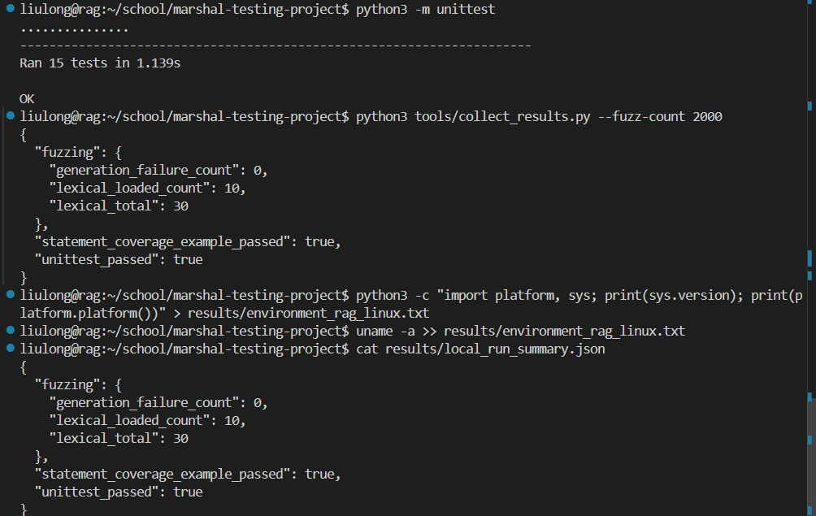
Linux截图
Python3.10
