Testing the Stability and Correctness of Python's marshal Module
Repository: https://github.com/Molingspance/marshal-testing-project

1 Introduction
Python's marshal module serializes and deserializes selected internal Python object types. It is mainly used for pseudo-compiled bytecode such as .pyc files: marshalling turns a supported object into a binary byte stream, and unmarshalling reconstructs an object from that stream.
This project evaluates marshal from a user-visible API perspective. The main question is whether the same input produces the same serialized output, where same output means hash-identical bytes rather than only logical equivalence.
The test suite focuses on three observable properties:
• Stability: repeated marshal.dumps(x) should produce byte-for-byte identical streams.
• Correctness: marshal.loads(marshal.dumps(x)) should preserve the supported value.
• Robustness: unsupported objects and malformed byte streams should raise controlled exceptions, not crash the interpreter.

1.1 Test Oracles
The test oracles are implemented mainly in src/oracles.py and are used consistently across the black-box tests:
• Hash stability oracle: calls marshal.dumps(x) repeatedly and compares SHA-256 hashes.
• Round-trip oracle: checks marshal.loads(marshal.dumps(x)) with custom structural equivalence.
• Exception oracle: accepts controlled exceptions such as TypeError, ValueError, EOFError, and RecursionError for invalid inputs.
• Special-behavior oracle: records expected lossy behavior, such as bytearray values loading back as bytes.

2 Black-Box Testing
Black-box testing treats marshal as a public API. This part does not rely on CPython internal implementation details; it checks whether selected inputs can be serialized, loaded, repeated, or rejected in observable and controlled ways. The evidence is based on byte streams, SHA-256 hashes, reconstructed objects, and exceptions.

2.1 Equivalence Partitioning
Equivalence partitioning was used to avoid testing every possible value one by one. Inputs with similar expected marshal behavior were grouped, and representative examples were selected from each group so the suite still covered the main API outcomes.
How it was completed:
1. Defined supported partitions in src/specimens.py, including primitive values, containers, code objects, recursive containers, and shared-reference structures.
2. Defined unsupported or special partitions such as functions, generators, file handles, custom instances, and bytearray behavior.
3. Verified the partitions through tests/test_roundtrip.py, tests/test_cycles.py, tests/test_special_behaviors.py, and tests/test_invalid_inputs.py using round-trip, stability, and exception oracles.

2.2 Boundary Value Analysis
Boundary value analysis focused on values most likely to expose encoding, size, or comparison problems. Instead of only testing ordinary examples, the suite checks extremes and special cases where marshal behavior is easier to break.
How it was completed:
1. Collected boundary cases in src/specimens.py, including integer limits, -0.0, NaN, Inf, empty containers, large strings and bytes, large collections, and deep nesting.
2. Ran tests/test_boundaries.py to confirm that supported boundary cases round-trip correctly and that repeated dumps in the same process remain hash-identical.

2.3 Fuzz Testing
Fuzz testing was used as a supplement to the designed cases. Its purpose was not to prove complete correctness, but to expose unexpected behavior by exercising generated or mutated inputs beyond the hand-written examples.
How it was completed:
1. Used generation-based fuzzing in src/fuzz_generator.py and tests/test_fuzzing.py to create legal nested values with a fixed seed.
2. Used lexical fuzzing in tests/test_invalid_inputs.py to mutate marshal byte streams through truncation, byte changes, inserted bytes, and random suffixes.
3. Interpreted mutated-stream results as acceptable when they either decoded into a valid object or raised a controlled exception, while generated valid values still had to pass round-trip and stability checks.

3 White-Box Testing
White-box testing focuses on coverage of a program's internal structure and implementation details, ensuring that marshal is exercised across representative implementation paths, branches, and conditions that may affect serialization and deserialization behavior. In this project, these tests are designed from Python/marshal.c instead of only from public API examples.
Because exact C-level coverage for marshal.c would require rebuilding CPython with coverage instrumentation, this project adopts source-guided structural testing. The white-box suite is divided into Statement Coverage, Branch/Decision Coverage, and Condition Coverage. tools/run_whitebox.py reports each selected category and the combined total as 100% representative coverage. This keeps the report honest while still matching the course requirement for structural test design.

3.1 Statement Coverage
Statement Coverage requires every executable statement to be executed at least once. For marshal, the practical objective is to exercise the major serialization and deserialization statement groups that are externally reachable through the public marshal API.
In this project, Statement Coverage is implemented as source-guided representative statement testing. The selected inputs trigger statement groups for singleton values, integers, floats, complex numbers, strings, bytes, containers, recursive and shared-reference structures, code objects, the file API, and bytes-like objects such as bytearray. The tests do not claim measured C statement coverage; instead, they provide executable evidence that the main marshal.c statement groups are represented by concrete test cases.
Example test methods:
- test_representative_type_write_read_paths(): covers representative marshal.c write/read paths for singleton, numeric, text, binary, container, recursive-reference, and code-object inputs
- test_file_api_paths(): covers dump/load file API paths for representative values
- test_bytes_like_write_path(): covers the bytes-like object path where bytearray is written and loaded back as bytes

3.2 Branch Coverage
Branch Coverage focuses on whether each important decision outcome is exercised, requiring the major branches of the program to be executed during testing.
For marshal, the project analyzes the main branch points in serialization and deserialization and designs test inputs to cover successful serialization versus unsupported-object rejection, successful loading versus invalid or truncated stream rejection, normal containers versus recursive or shared-reference containers, format-version-dependent serialization, and code-object acceptance versus rejection when the running Python version supports allow_code.
Example test methods:
- test_supported_and_unsupported_dump_paths(): covers successful dump and unsupported-object exception branches
- test_valid_and_invalid_load_paths(): covers valid loads and invalid or truncated byte-stream exception branches
- test_recursive_and_non_recursive_container_paths(): covers normal containers, recursive containers, and shared-reference branches
- test_format_version_paths(): covers the marshal format-version argument branch
- test_code_object_allow_and_reject_paths(): covers the code-object branch and the allow_code rejection branch when available

3.3 Condition Coverage
Condition Coverage focuses on all possible outcomes of each boolean condition expression, requiring each important condition to take both True and False values during testing.
For marshal, this provides a more fine-grained way to check whether special conditions can affect serialization, deserialization, or byte-level behavior. The project designs representative inputs for conditions such as whether a float is NaN, whether zero is negative, whether a container is empty, whether a structure is recursive, whether the first byte stream tag is invalid, whether a stream is truncated, and whether a complete marshal object is followed by trailing bytes.
Example test methods:
- test_nan_and_non_nan_float_paths(): covers NaN and non-NaN float conditions
- test_positive_and_negative_zero_paths(): covers positive-zero and negative-zero conditions
- test_empty_and_non_empty_container_paths(): covers empty and non-empty container conditions
- test_recursive_and_non_recursive_conditions(): covers recursive and non-recursive structure conditions
- test_invalid_tag_and_truncated_stream_conditions(): covers invalid-tag and truncated-stream conditions
- test_complete_stream_with_and_without_trailing_data(): covers complete-stream behavior with and without trailing data

4 Compatibility Testing
The output of marshal may be affected by environmental factors. The purpose of Compatibility Testing is to run the same marshal test suite under different Python versions and operating systems, and then compare whether the same correctness and stability checks still pass.
We tested the following environmental factors:
Using the same marshal specimen set and test oracles, we run identical test cases under different Python versions. The bundled local baseline uses Python 3.9.15, and the prepared version range covers Python 3.10, 3.11, 3.12, and 3.13. The comparison focuses on whether round-trip correctness, exception handling, boundary-value tests, and same-process dump stability checks remain consistent. Since marshal is an internal Python format and is not guaranteed to remain byte-stable across versions, version-level byte differences should be treated as compatibility evidence rather than automatic defects.
The bundled executed compatibility evidence focuses on Windows, including Python 3.9, 3.10, 3.11, 3.12, and 3.13. The repository also provides manual commands and a prepared GitHub Actions workflow for Linux and macOS, but those platforms should only be counted as executed evidence after the workflow or manual run has completed and its artifacts are attached.
ark indicates that the TC directly verifies or provides evidence for the corresponding R item.

5.1 Requirement Definitions
R ID | Requirement
R1 | Compatibility Testing: Cross-platform stability: for the same Python version, representative supported inputs produce hash-identical marshal byte streams across the tested operating systems.
R2 | Equivalence Class Partitioning: Valid supported objects satisfy round-trip correctness: loads(dumps(x)) reconstructs an equivalent object.
R3 | Equivalence Class Partitioning: Same-process repeated dumps(x) is stable and produces identical byte streams.
R4 | Boundary Value Analysis: Boundary values and special values such as NaN, Inf, -0.0, empty objects, and large collections are handled correctly.
R5 | Condition Coverage: Recursive structures and shared references are preserved or compared correctly without infinite recursion.
R6 | Branch Coverage: Unsupported objects raise reasonable exceptions.
R7 | Condition Coverage: Corrupted byte streams are handled safely without crashing the interpreter.
R8 | Fuzz Testing: Generated valid fuzz inputs satisfy round-trip correctness and stability.
R9 | Fuzz Testing: Lexical fuzzing does not crash the interpreter.
R10 | Equivalence Class Partitioning: Special marshal behavior, such as bytearray loading back as bytes, is documented and verified.
R11 | Statement Coverage: White-box representative paths such as _register_pair() are exercised.

5.2 Test Case Definitions
TC ID | Python test file, test category, and functions used
TC1  test_roundtrip.py | test methods: test_all_valid_specimens_roundtrip(), test_all_valid_specimens_stable_in_process(), test_file_api_roundtrip();  uses: assert_roundtrip(), assert_stable_dumps(), assert_file_roundtrip(), all_valid_case_ids(), build_specimen()
TC2  test_boundaries.py; | test methods: test_boundary_cases_roundtrip(), test_boundary_cases_stable_in_process(); uses: assert_roundtrip(), assert_stable_dumps(), all_boundary_case_ids(), build_specimen()
TC3  test_cycles.py; category | test methods: test_recursive_list_roundtrip_preserves_cycle(), test_recursive_dict_roundtrip_preserves_cycle(), test_indirect_recursive_list_roundtrip_preserves_cycle(), test_shared_reference_roundtrip_preserves_aliasing(), test_equivalent_handles_cycles_without_infinite_recursion(); uses: assert_roundtrip(), equivalent(), build_specimen()
TC4  test_invalid_inputs.py | test methods: test_unsupported_objects_raise_reasonable_exceptions(), test_targeted_corrupted_streams_raise_reasonable_exceptions(), test_lexical_fuzzing_does_not_crash_process();  uses: marshal.dumps(), marshal.loads(), assert_raises_reasonable_exception(), summarize_lexical_fuzz(), all_invalid_case_ids(), build_specimen()
TC5  test_fuzzing.py | test method: test_generated_values_roundtrip_and_remain_stable();  uses: run_generation_fuzz(), DEFAULT_SEED, os.environ.get()
TC6  test_special_behaviors.py | test method: test_bytearray_values_load_as_bytes(); uses: marshal.dumps(), marshal.loads(), all_lossy_case_ids(), build_specimen(), bytes()
TC7  test_statement_coverage.py | test methods: test_register_pair_first_visit(), test_register_pair_revisit();  uses: _ComparisonState(), _register_pair()

5.3 TC-R Traceability Matrix
R1 summarizes cross-platform byte-stream stability for representative supported object categories. R2-R11 cover round-trip correctness, same-process stability, boundary and special values, recursive structures, exception handling, fuzzing, bytearray behavior, and white-box representative paths. The matrix below is aggregated by Python test file.
TC/R | R1 | R2 | R3 | R4 | R5 | R6 | R7 | R8 | R9 | R10 | R11
TC1 | ✓ | ✓ | ✓
TC2 | ✓ | ✓ | ✓ | ✓
TC3 | ✓ | ✓ |  |  | ✓
TC4 |  |  |  |  |  | ✓ | ✓ |  | ✓
TC5 | ✓ | ✓ | ✓ |  |  |  |  | ✓
TC6 |  |  |  |  |  |  |  |  |  | ✓
TC7 |  |  |  |  |  |  |  |  |  |  | ✓

6 Key Findings
Through Black-Box Testing and White-Box Testing, the project identified the following key findings.

6.1 Round-Trip Correctness Holds for Representative Valid Inputs
Phenomenon: for the representative valid inputs covered by the project, including primitive types, nested containers, recursive structures, shared references, and code objects, marshal.loads(marshal.dumps(x)) reconstructed structures equivalent to the originals.
Reason: the core goal of marshal is closer to object reconstruction than to cross-environment byte-level consistency. Within the current testing scope, it performs well in preserving object meaning after deserialization.

6.2 Corrupted Byte Streams Do Not Always Fail
Phenomenon: in lexical fuzzing, 9 out of 30 mutated byte streams were still successfully decoded instead of raising exceptions.
Reason: some corruption methods merely transformed the original byte stream into another still-valid marshal encoding, or appended trailing data after a complete object in a way that did not prevent parsing. Therefore, corrupted input should not always be assumed to fail.

7 Limitations and Recommendations
Although this testing covered marshal's behavior across representative data types, boundary values, fuzzing inputs, and multiple execution environments, some limitations remain. The executed compatibility evidence covers Windows with Python 3.9, 3.10, 3.11, 3.12, and 3.13, Linux with Python 3.10.12, and macOS; however, older Python versions and special hardware architectures such as ARM were not covered.
The suite uses Equivalence Partitioning, Boundary Value Analysis, Fuzz Testing, Compatibility Testing, and source-guided White-Box Testing ideas, but it does not rebuild CPython or instrument Python/marshal.c. Therefore, it cannot claim exact C-level coverage, and it cannot prove that every supported input is hash-identical under all circumstances. Fuzzing also improves confidence but cannot prove the absence of defects.
Based on these limitations, future work should add the remaining platform and hardware evidence, compare saved marshal byte streams or specimen hashes across environments, and consider CPython instrumentation for deeper White-Box Testing. These improvements would make the stability evidence more complete without overstating what the current suite proves.

8 Conclusion
This project systematically evaluated the stability and correctness of Python's marshal module using Equivalence Partitioning, Boundary Value Analysis, Fuzz Testing, Compatibility Testing, and source-guided White-Box Testing. The test suite focuses on whether representative inputs can be serialized stably, whether deserialized objects remain equivalent, and whether invalid or corrupted inputs raise controlled exceptions.
The test results show:
marshal preserves round-trip correctness for the representative supported inputs covered by the suite, including primitive values, boundary values, nested containers, recursive structures, shared references, and code objects.
Within one process, repeated dumps remained stable for the covered specimens and boundary values, supporting the same-process hash-stability oracle used in this project.
The compatibility runs completed successfully on Windows with Python 3.9 through 3.13, Linux with Python 3.10.12, and macOS. This demonstrates that the correctness and robustness checks can run across several environments, but it does not prove universal byte-for-byte stability for all Python versions and platforms.
Several special behaviors require careful interpretation: bytearray can be dumped but loads back as bytes, and corrupted byte streams may sometimes decode into another valid marshal value instead of raising an exception.
In summary, marshal is suitable for Python internal data handling and object reconstruction within a controlled runtime ecosystem. However, for scenarios requiring strict hash consistency, cross-platform exchange, or cross-version data stability, a more stable and controllable serialization scheme such as JSON, MessagePack, or a custom protocol should be used instead.

9 AI Usage Disclosure
AI assistance was used during the organization and wording of this report, but the final content was manually reviewed, revised, and aligned with the actual test results.

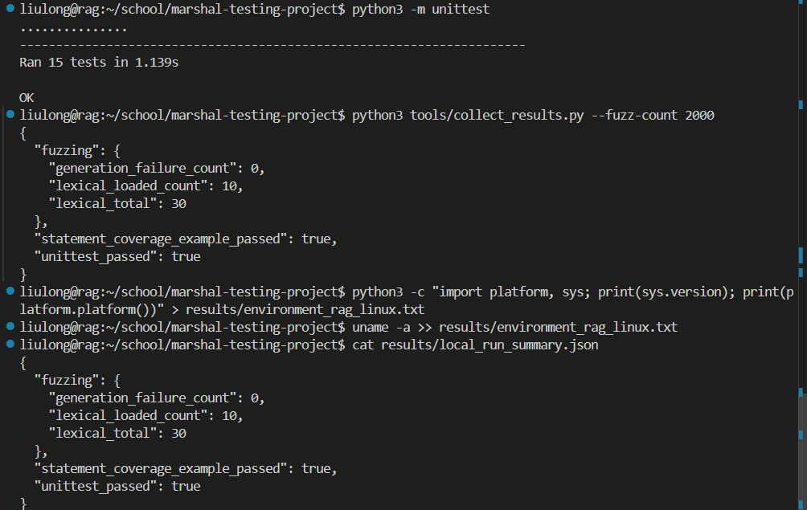
Linux截图
Python3.10
