**The National University of Lesotho**

**Department of Mathematics and Computer Science**

**Faculty of Science and technology**



**CS4430: DISTRIBUTED DATABASE SYSTEMS**

**Task: System Design of Ntsoekhe DDBMS**

**Due: 15/04/2024**

**Participants:**

|  |  |  |  |
| --- | --- | --- | --- |
|  | **Student Number** | **Surname, initials** | **Major** |
| 1. | 202000281 | K. MPHOU | B. Sc. CS |
| 2. | 201903845 | M. NTLHOKI | B. Sc. CS |
| 3. | 202004682 | M. TEISI | B. Sc. CS & PHYSCIS |
| 4. | 202000705 | M. LEROTHOLI | B. Sc. CS & MATHS |
| 5. | 201405391 | R. SEOTSANYANA | B. Sc. CS & STATS |

**NTSHOEKHE SYSTEM ARCHITECURE**

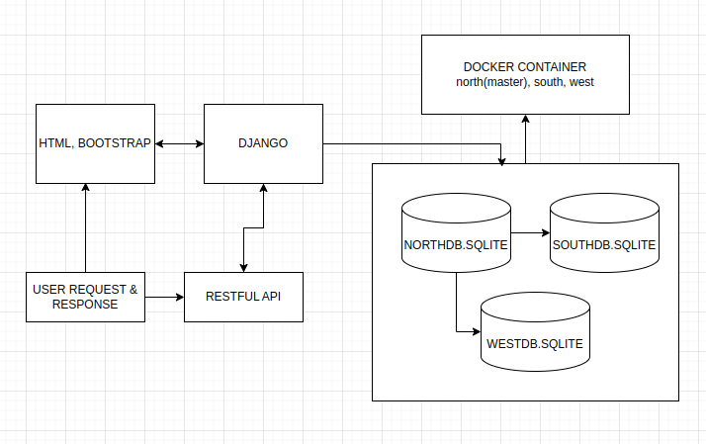

**1. Tiers:**

* **Client Tier:**
* This tier consists of user interface (web apps) used to interact with the database. They will send requests through a RESTful API.
* **Application Tier:** This tier utilizes Django as a web framework and runs on each distributed node within a Docker container. It's responsible for:
  + Handling user requests from the client tier via the API.
  + Performing business logic related to health data.
  + Interacting with the database tier on the same node.

**2. Database Tier:**

* **Database Storage:** Each node will have a local SQLite database instance to store health data. SQLite offers simplicity and ease of use for a prototype.

**3. Communication:**

* **RESTful API:** The application tier exposes a RESTful API for CRUD (Create, Read, Update, Delete) operations on health data models. Clients will interact with the system through these APIs.

**Entity-Relationship Diagram (ERD)**

A **Hospital** can have **m**any** Patients**, and a **Patient** can be treated at **one** **Hospitals** in our system(throughout their lifetime). This is represented by a one-to-many relationship between Hospital and Patient.

A **Hospital** can employ **many Doctors**, and a **Doctor** can work at **one Hospitals**. This is another one-to-many relationship.

