1) Start Delphi and select Component

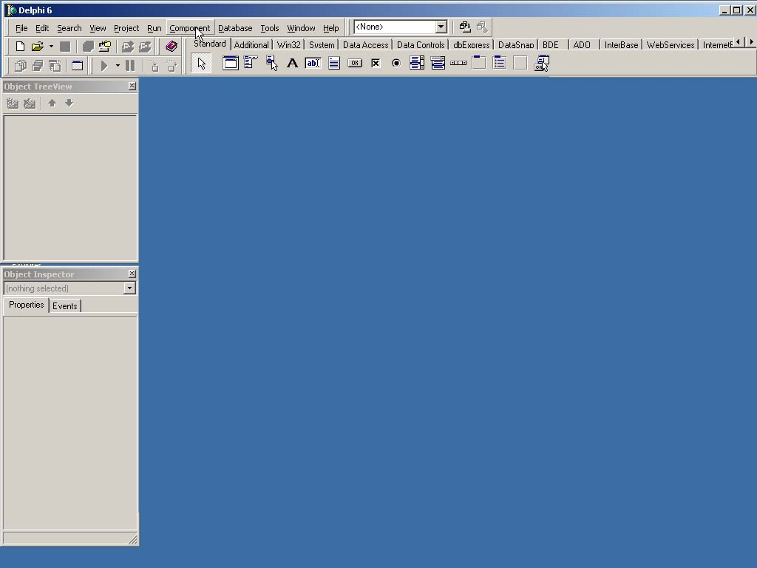

2) Select Import ActiveX Control...

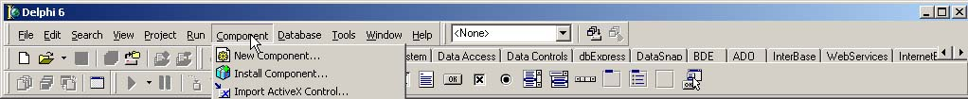

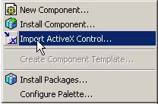

3) Look for the Cobalt A.I. ActiveX control (dialog displays the ActiveX controls registered on your system).

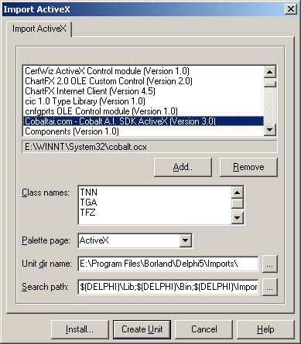

4) Select the Component palette location in which you want to place selected library. You can leave the ActiveX option selected.

5) Click on Install.
6) Select a package where the new component must be installed or
Create a new package for the new TNN, TGA and TFZ controls.

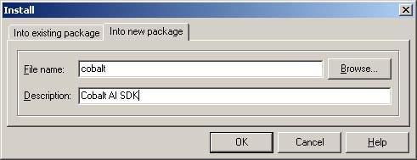

7) Click on OK.

8) Delphi will ask if you want to rebuild the modified/new package. Click Yes.

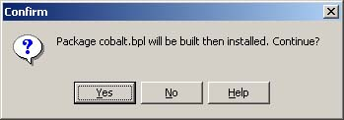

9) After the package is compiled, Delphi will show you a message saying that the new components was registered and already available as part of the VCL.

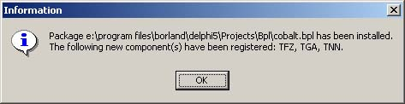

10) Close the package detail window, allowing Delphi to save the changes to it.
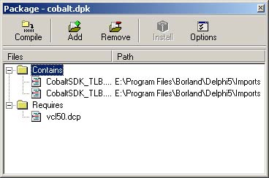

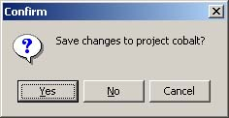

11) The component is now available in the ActiveX tab (if you didn't change this setting in step 4)

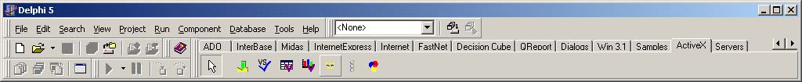

12) By default, when Delphi generates a TypeLib from the OCX (CobaltSDK_TLB.pas unit), it uses the v-table interface. It is necessary to change the generated code to use the disp interface instead of the v-table interface.
Make the following changes:

TGA Class

FIntf: _GADisp; {_GA;}
function GetControlInterface: _GADisp; {_GA;}
...
property ControlInterface: _GADisp {_GA} read GetControlInterface;
....

procedure TGA.CreateControl;

procedure DoCreate;
begin
FIntf := IUnknown(OleObject) as _GADisp; {_GA;}
end;

begin
if FIntf = nil then DoCreate;
end;

function TGA.GetControlInterface: _GADisp; {_GA;}
begin
CreateControl;
Result := FIntf;
end;

Class FZ

FIntf: _FZDisp; {_FZ;}
function GetControlInterface: _FZDisp; {_FZ;}
...
property ControlInterface: _FZDisp {_FZ} read GetControlInterface;
....

procedure TFZ.CreateControl;

procedure DoCreate;
begin
FIntf := IUnknown(OleObject) as _FZDisp; {_FZ;}
end;

begin
if FIntf = nil then DoCreate;
end;

function TFZ.GetControlInterface: _FZDisp; {_FZ;}
begin
CreateControl;
Result := FIntf;
end;
Class TNN

FIntf: _NNDisp; {_NN;}
function GetControlInterface: _NNDisp; {_NN;}
...
property ControlInterface: _NNDisp {_NN} read GetControlInterface;
....

procedure TNN.CreateControl;

procedure DoCreate;
begin
FIntf := IUnknown(OleObject) as _NNDisp; {_NN;}
end;

begin
if FIntf = nil then DoCreate;
end;

function TNN.GetControlInterface: _NNDisp; {_NN;}
begin
CreateControl;
Result := FIntf;
end;

13) Drop the component on a form, and you may begin using it.

