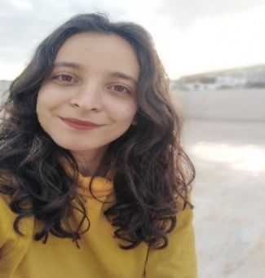

MOLKA KATROU

Computer Science Engineering Student

Dedicated and self-motivated second year CS student at ENSI looking for a summer internship

# CONTACT



[molka.katrou@ensi-uma.tn](mailto:oussama.aouini@ensi-uma.tn)

+216 93 532 115

Bizerte, Tunisia



[linkedin.com/in/](https://www.linkedin.com/in/oussama-aouini/)molka-katrou-57751020b/

# SKILLS

Python

C/C++

JAVA

Android Studio

HTML

CSS

PHP

Oracle

SQL

UML

**EDUCATION**

## Computer Science Engineering Degree

### ENSI - National School for Computer Science

*2019 - Present*

## Pre-Engineering

### IPEIB - Preparatory Institute for Engineering Studies of Bizerte

*2017 - 2019*

## High School Diploma

### Bizerte’s High School

*2013 - 2017*

# PROJECTS

**Development of a resume-matching website**

* Python, Machine learning, NLP

**Absence management mobile application for ENSI**

* Android Studio/JAVA/JSON

**ATM Machine application**

* JAVA/JEE

# LANGUAGES

Arabe ✯✯✯✯✯✯✯

English ✯✯✯✯✯✯✯

French ✯✯✯✯✯

# INTERESTS

**Community Life**

Open Source Software ENSI Club (2019 - Present) CSI Shields (2019 - Present)

ENSI competitive programming Club (2019 - Present)

# CERTIFICATES

Introduction to Machine learning (coursera)

Reading Novels

Writing