Batty Bakes Site Plan

Molli Batty

WDD 130

Overview

Purpose
I’m starting a cozy little bakery right from my apartment, and I want to share my fresh-baked treats online! The website will show off all my goodies — bread, brownies, cookies, cakes, pastries, and cinnamon rolls — with photos, prices, and a simple form so people can order easily. Each item will include allergy info for customers to check before ordering. What makes my site special is its warm, homemade vibe and small-batch bakes that change often. It’s all about bringing the smell of fresh bread and sweet treats straight from my kitchen to my neighbors!

Audience
My audience are my neighbors and the local community in Rexburg who want fresh, homemade baked goods, a simple way to order online, and a more personal alternative to the processed options found in larger grocery stores.

Branding

Website Logo
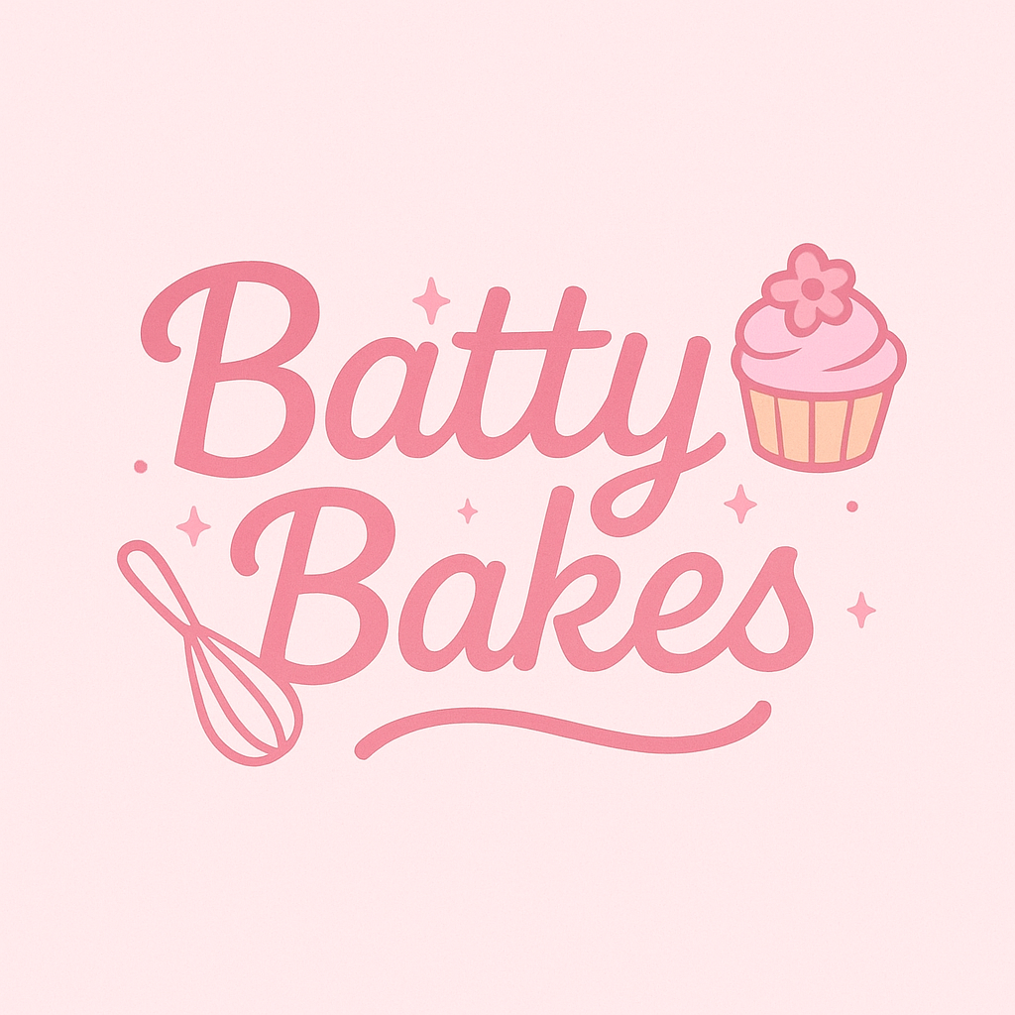

Style Guide

Color Palette
Primary | Secondary | Accent 1 | Accent 2
#FB6F92 | #B82B5F | #FEE8EC | #FDCBB0

Typography

Heading Font: Momo Signature

Paragraph Font: Open Sans

<style>

@import url('https://fonts.googleapis.com/css2?family=Momo+Signature&family=Open+Sans:ital,wght@0,300..800;1,300..800&display=swap');

</style>

Navigation
Home Page2 Page3

Content

[put all content for the pages here, including written text and images]
Products:
- Blueberry Streusel bread - $4.00 each
- Lemon Raspberry Bread- $4.00
- Banana bread- $4.00
- Zucchini bread- $4.00
- Chocolate Peppermint Bread- $4.00
- Pumpkin bread- $4.00
- Chocolate Chip Cookies, Dozen = $6.00
- Peanut Butter Cookies, Dozen = $6.00
- Sugar Cookies, Dozen = $6.00
- Snickerdoodles, Dozen = $6.00
- Lemon Cookies, Dozen = $6.00
- Vanilla Layer Cake - $25.00
- Chocolate Fudge Cake - $25.00
- Red Velvet Cake - $25.00
- Funfetti Cake - $25.00

Images in folder

Wireframes
Home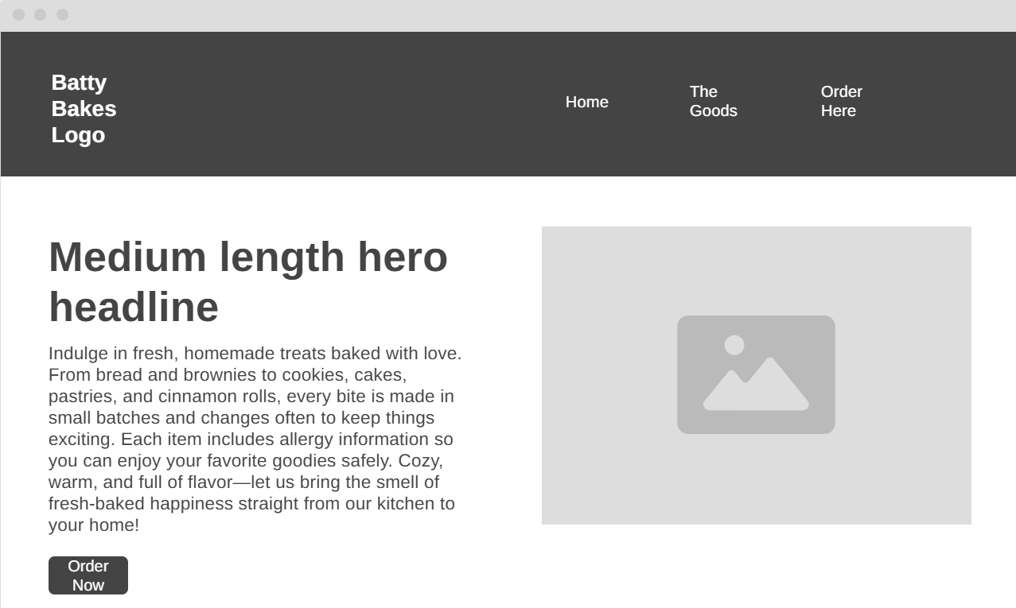

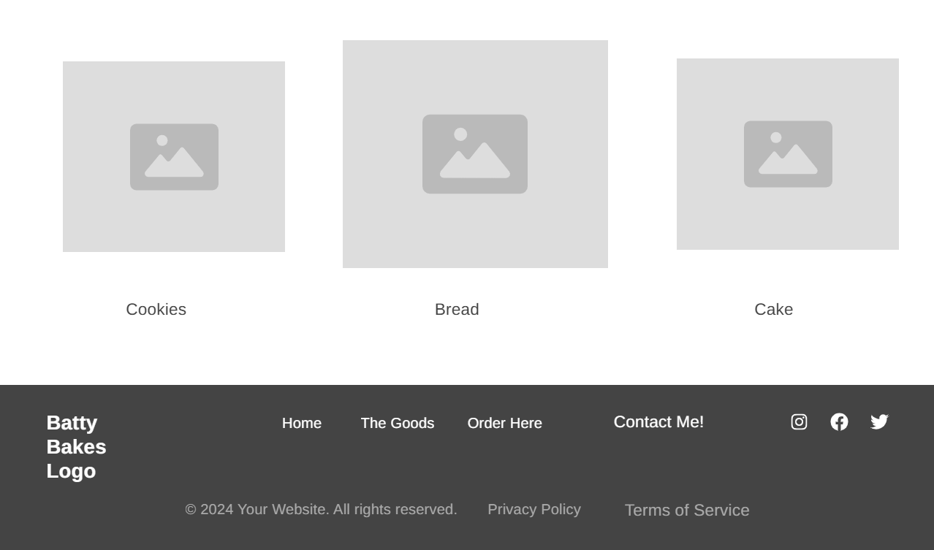

The Goods

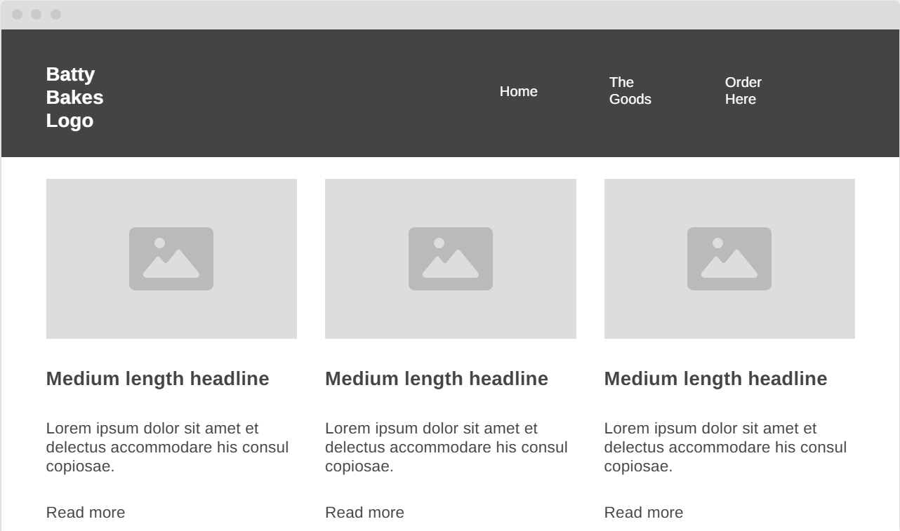

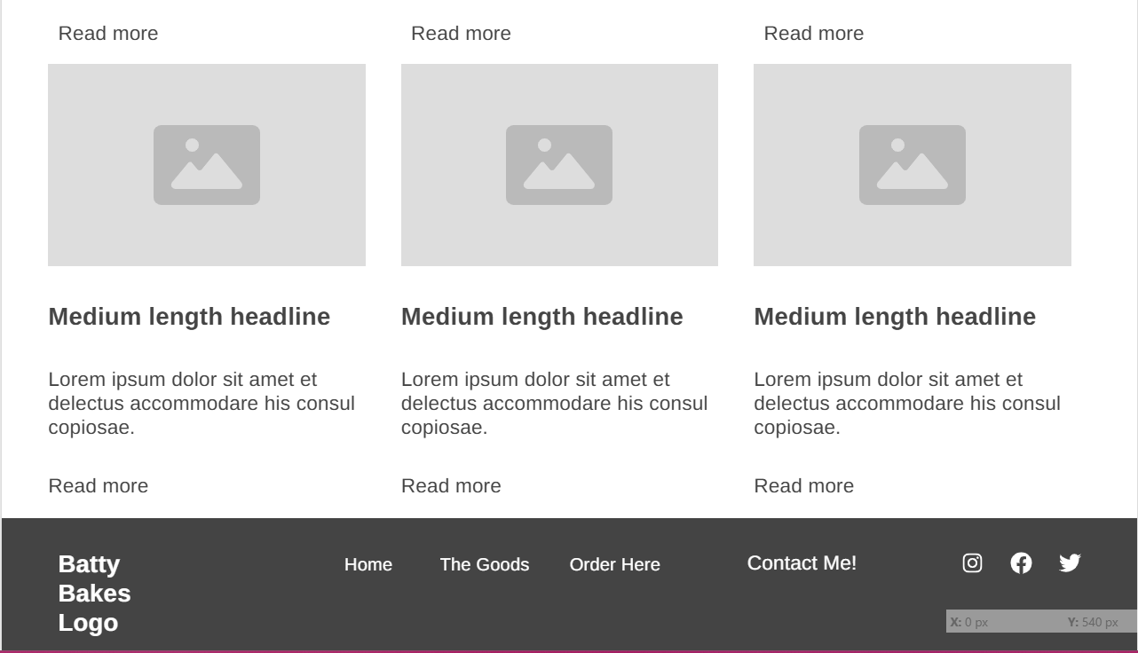

Cart

