**Fig. 1** (A) Shows a sketch of the small QRM-Thorax phantom with the cardiac calcification insert phantom located in the center. (B) Shows an axial and lateral sketch of the cardiac calcification insert phantom.

**Fig. 2** Shows a cross-section of a static artery (A) next to a cross-section of a motion-affected artery (B). Fig. 2B underwent linear motion at a rate of 30 mm/s, corresponding to a heart rate of >75 bpm. Window: 400, Level: 40.

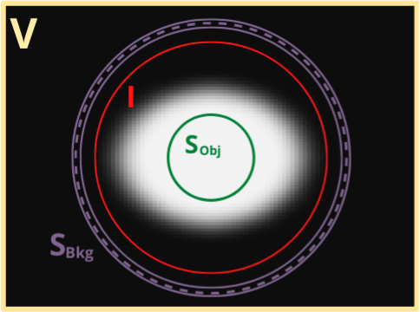

**Fig. 3** Shows the cross-section of a simulated vessel lumen. and are regions of pure background and pure calcium, respectively, which are unaffected by the partial volume effect. These are used to calculate , the integrated intensity of the plaque, which contains pure calcium and voxels affected by the partial volume effect.



**Fig. 4** Shows linear regression analysis of integrated calcium mass (A) and Agatston scoring (B). The known masses of the calcium inserts were used for the comparison. All inserts were unaffected by motion (stationary).



**Fig. 5** Shows linear regression analysis of integrated calcium mass (A) and Agatston scoring (B). The known masses of the calcium inserts were used for the comparison. Includes all inserts affected by motion.



**Fig. 6** Shows reproducibility measurements of the integrated calcium mass technique on the large phantoms. The calculated mass for scan 1 was compared against the calculated mass of scan 2. Scanner 1 (A), Scanner 2 (B), Scanner 3 (C), and Scanner 4 (D) were different vendors used to acquire each scan. R correlation, root mean squared error, and root mean squared deviation values are shown within each graph.



**Fig. 7** Shows reproducibility measurements of the Agatston scoring technique on the large phantoms. The calculated mass for scan 1 was compared against the calculated mass of scan 2. Scanner 1 (A), Scanner 2 (B), Scanner 3 (C), and Scanner 4 (D) were different vendors used to acquire each scan. R correlation, root mean squared error, and root mean squared deviation values are shown within each graph.



**Fig. 8** Shows the percentage of false-negative (CAC=0) scores (A) and false-positive (CAC>0) socres (B), computed by integrated calcium mass (left) and Agatston scoring (right). Integrated calcium mass produced 54 false-negative zero-CAC scores out of 360 total measurements. Agatston scoring produced 102 false-negative zero-CAC scores out of 360 total measurements. Integrated calcium mass produced 0 false-positive (CAC=0) scores out of 120 total measurements. Agatston scoring produced 8 false-negative zero-CAC scores out of 120 total measurements.

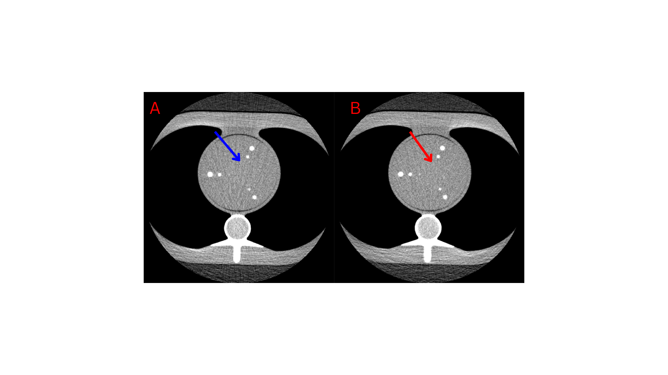

**Fig. 9** Shows two different images containing false-negative (CAC=0) scores. Fig. 9A (blue arrow) shows an insert that produced a false-negative (CAC=0) score for both Agatston scoring and integrated calcium mass. Fig. 9B (red arrow) shows a calcium insert that produced a false-negative (CAC=0) score for only Agatston scoring. Window: 400, Level: 40.



**Fig. 10** Shows accuracy measurements of different slice thicknesses for the integrated calcium mass technique (A and B) and the Agatston scoring technique (C and D). A slice thickness of 1 mm (A and C) and 2 mm (B and D) was used. R-correlation, root mean squared error, and root mean squared deviation values are shown within each graph.



**Fig. 11** Shows accuracy measurements of different tube voltages for the integrated calcium mass technique (A and B) and the Agatston scoring technique (C and D). A tube voltage of 100 kV (A and C) and 80 kV (B and D) was used. R-correlation, root mean squared error, and root mean squared deviation values are shown within each graph.