📕 **Table of Contents**

**Abstract**

1. **Introduction**
2. **Method**
   1. - Simulation
      1. - Motion Blurring
   2. - Physical Phantom
   3. - Agatston Scoring
   4. Integrated Calcium Mass
      1. - Calibration
   5. - Volume Fraction Mass
   6. - Statistical Analysis
3. **Results**
   1. - Stationary
      1. - Accuracy
      2. - Reproducibility
      3. - Sensitivity and Specificity
   2. - Motion
      1. - Accuracy
      2. - Reproducibility
      3. - Sensitivity and Specificity

3.2 - Physical Phantom

* + 1. - Accuracy
    2. - Reproducibility
    3. - Sensitivity and Specificity

1. **Discussion**
2. **Conclusion Acknowledgements References**

**Abstract**

1. **Introduction**
2. **Method**



* 1. **- Simulation**
     1. **- Motion Blurring**
  2. **- Physical Phantom**
  3. **- Agatston Scoring**
  4. **Integrated Calcium Mass**
     1. **- Calibration**
  5. **- Volume Fraction Mass**
  6. **- Statistical Analysis**

1. **Results**



* 1. **- Stationary**
     1. **- Accuracy**

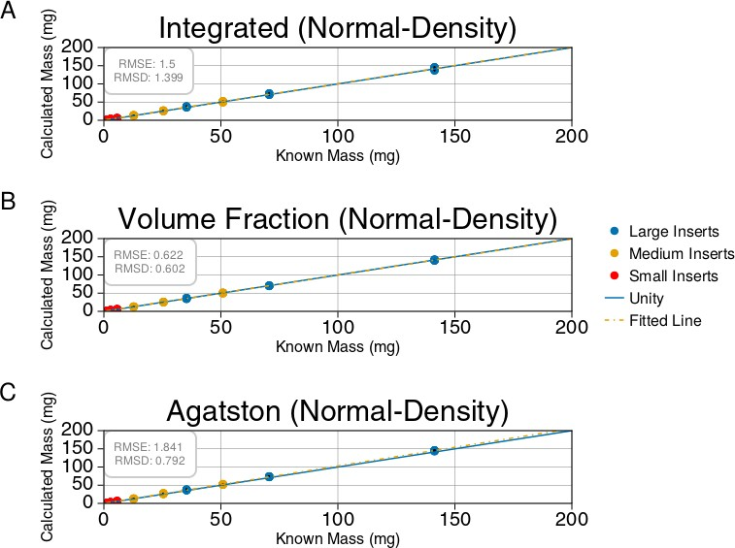

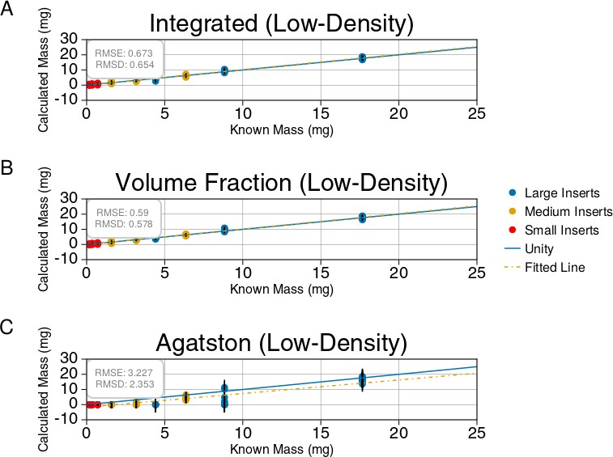

* + 1. **- Reproducibility**

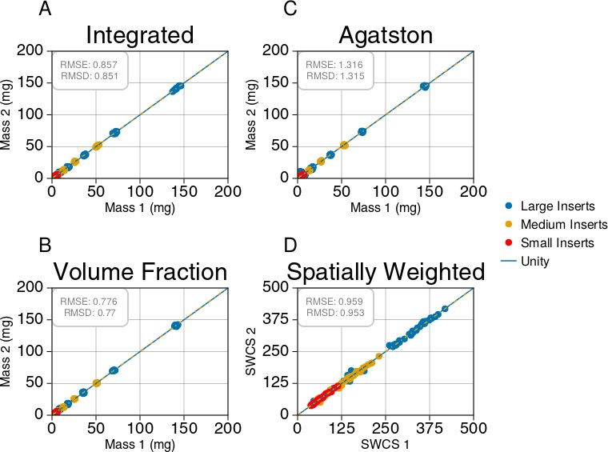

* + 1. **- Sensitivity and Specificity**

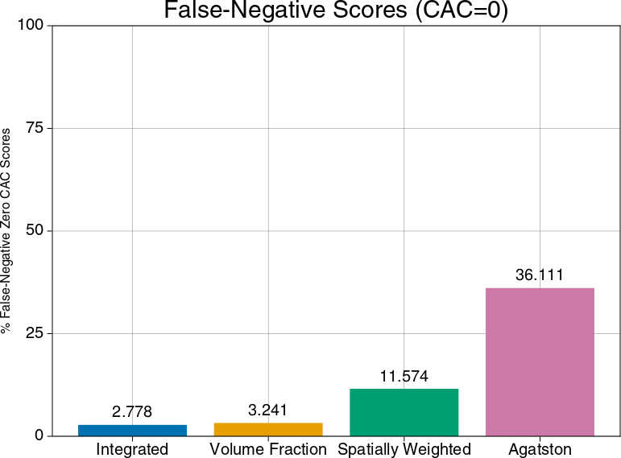

* 1. **- Motion**
     1. **- Accuracy**

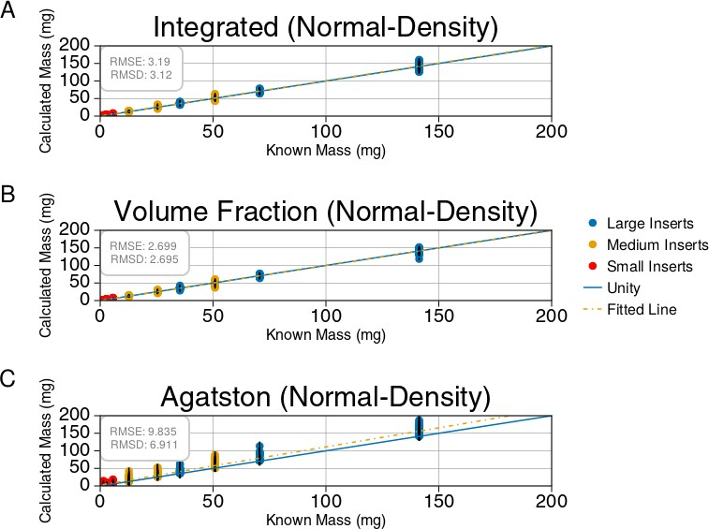

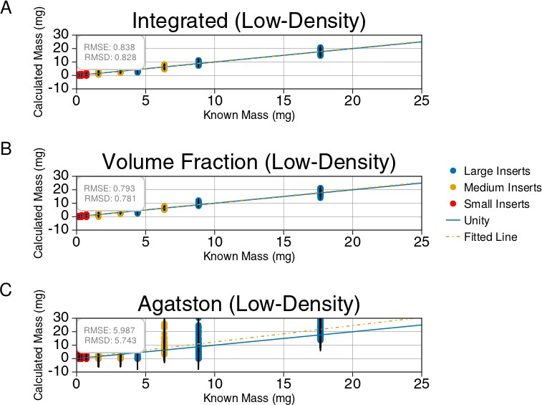

* + 1. **- Reproducibility**

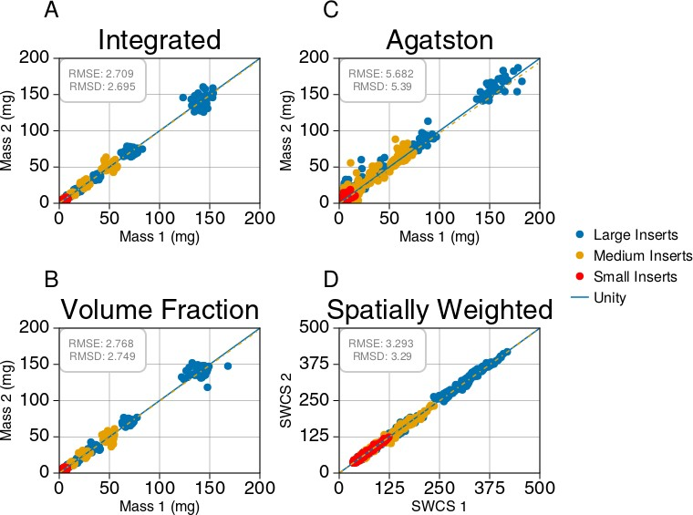

* + 1. **- Sensitivity and Specificity**

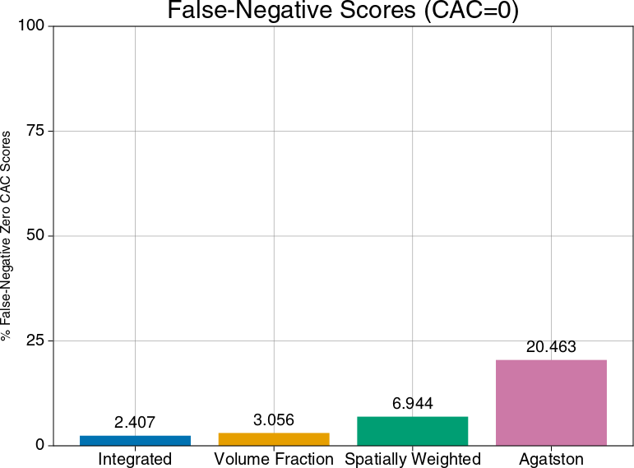

**3.2 - Physical Phantom**

* + 1. **- Accuracy**
    2. **- Reproducibility**
    3. **- Sensitivity and Specificity**

1. **Discussion**
2. **Conclusion**

**Acknowledgements**

**References**