**Output Screenshots**

1.Display All The Files In Ascending Order 🡪

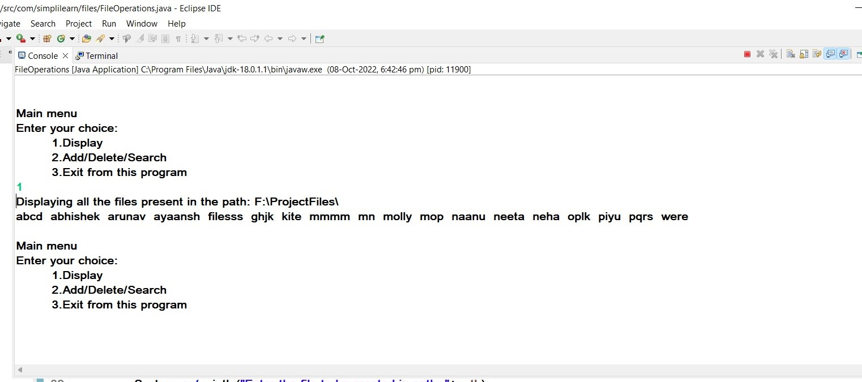

2.Enter Sub-Menu For Further File Operations 🡪

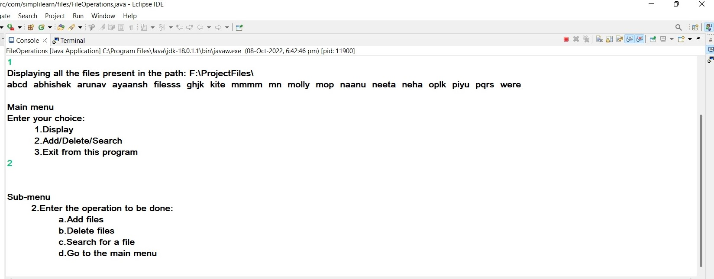

2.a. Add/Create Files 🡪

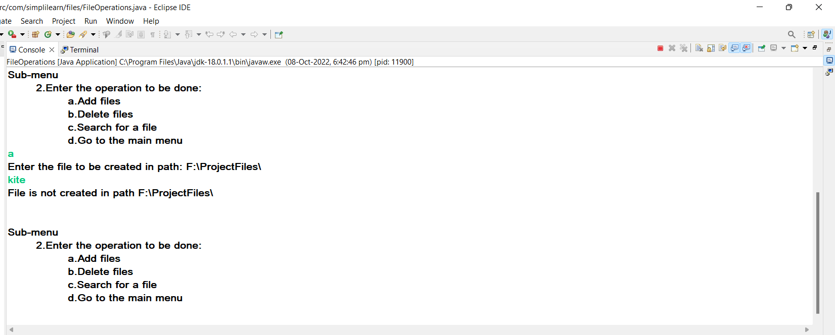

2.b. Delete File

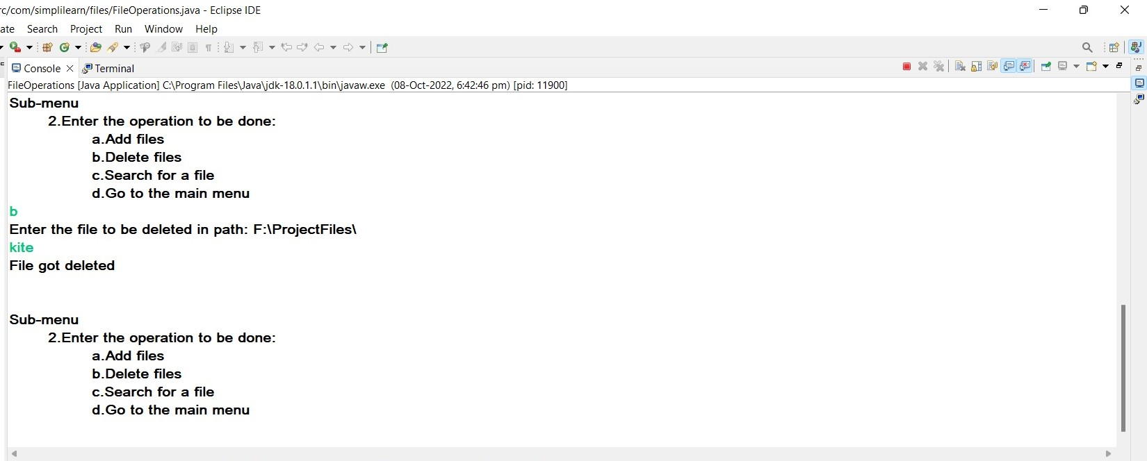

2.c. Search for a File 🡪

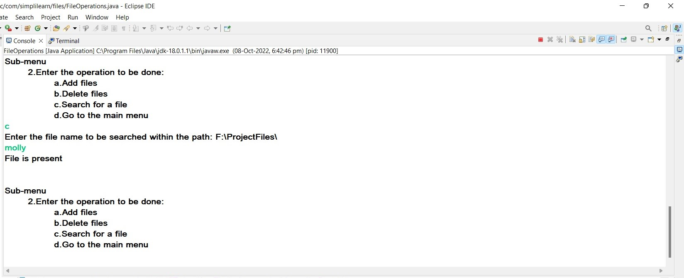

2.d. Navigate to the Main-Menu

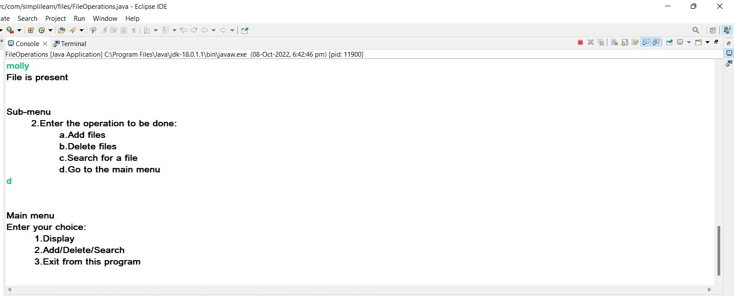

3.Exit from the program

