1.Welcome Page

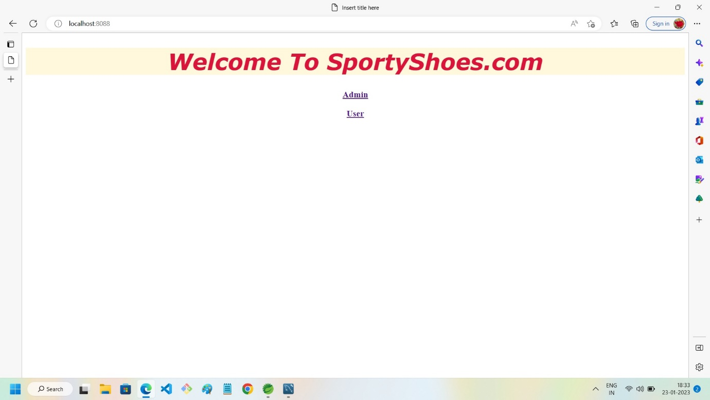

2.Wrong Credential Case Of Admin

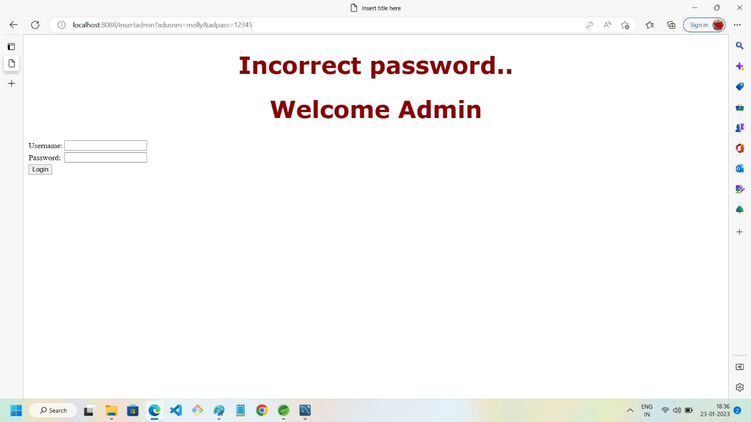

3.Admin LOGIN Successful

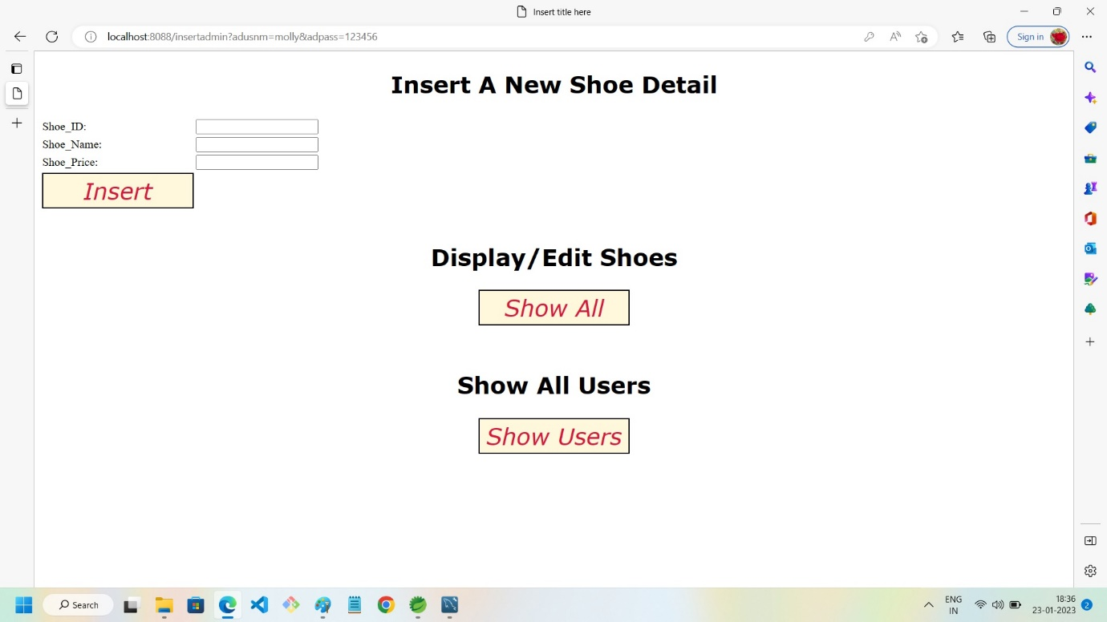

4. Shoe Display, Edit, Delete

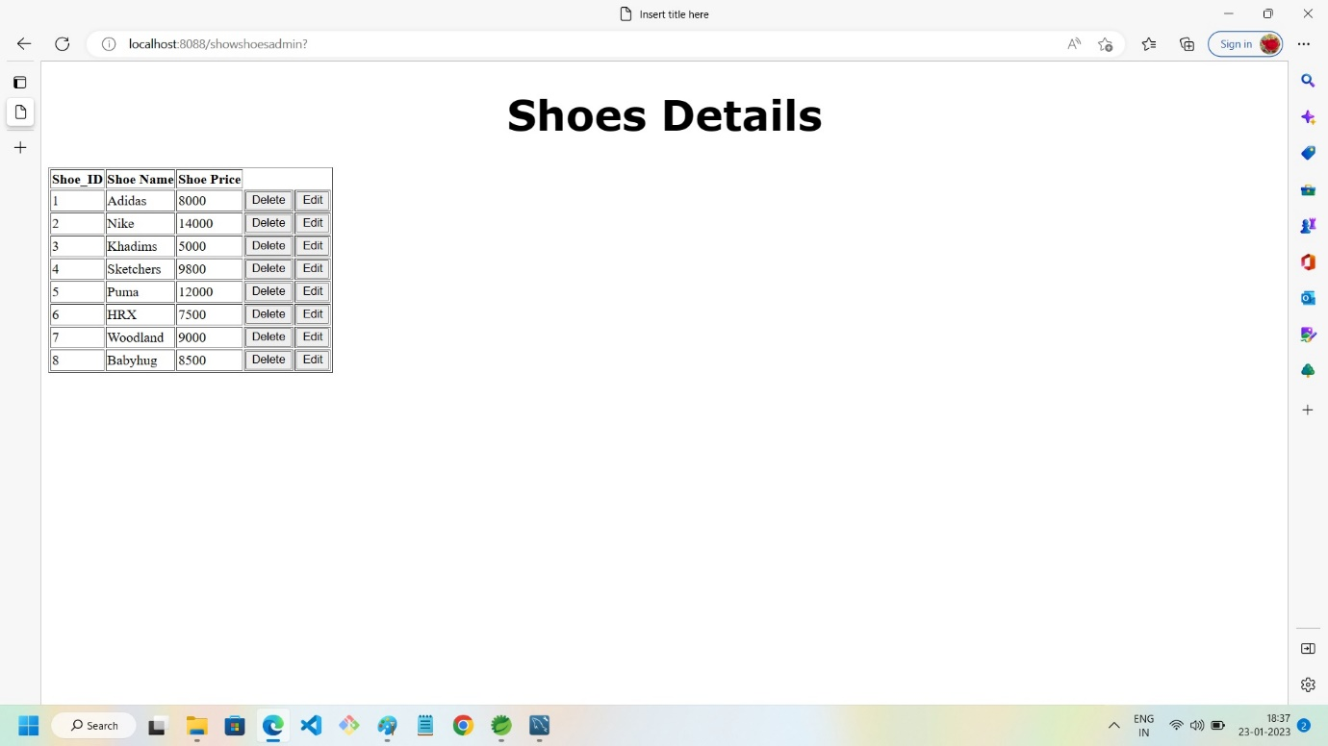

5.List Of User that Admin can access

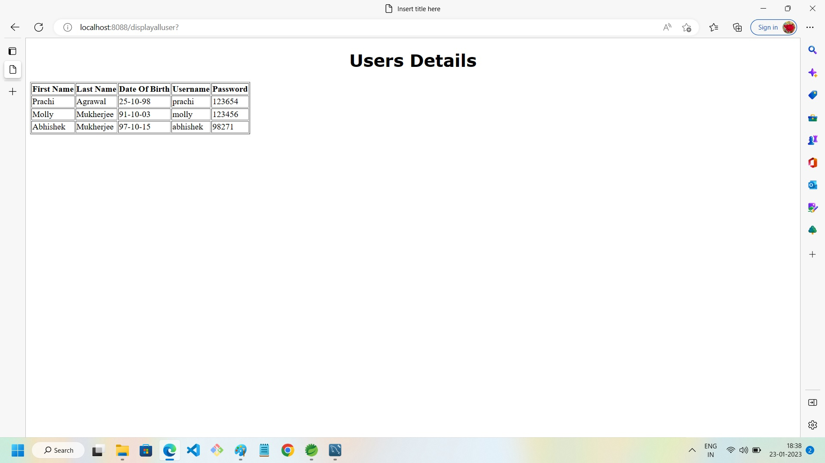

6.Admin Registration from Backend only(Using Postman) ***Restful services***

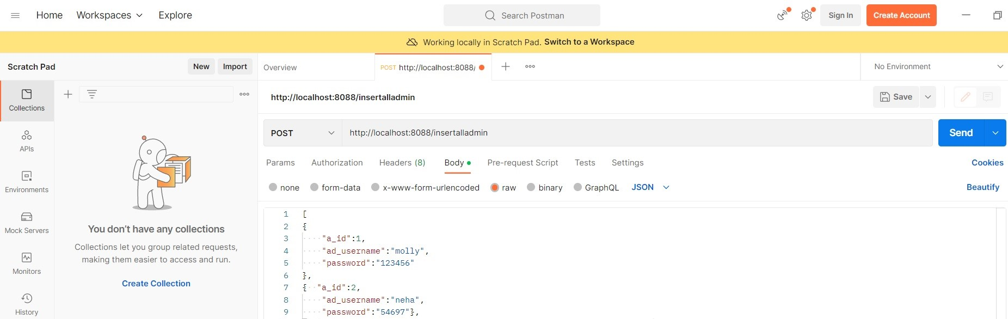

7.User Front Page

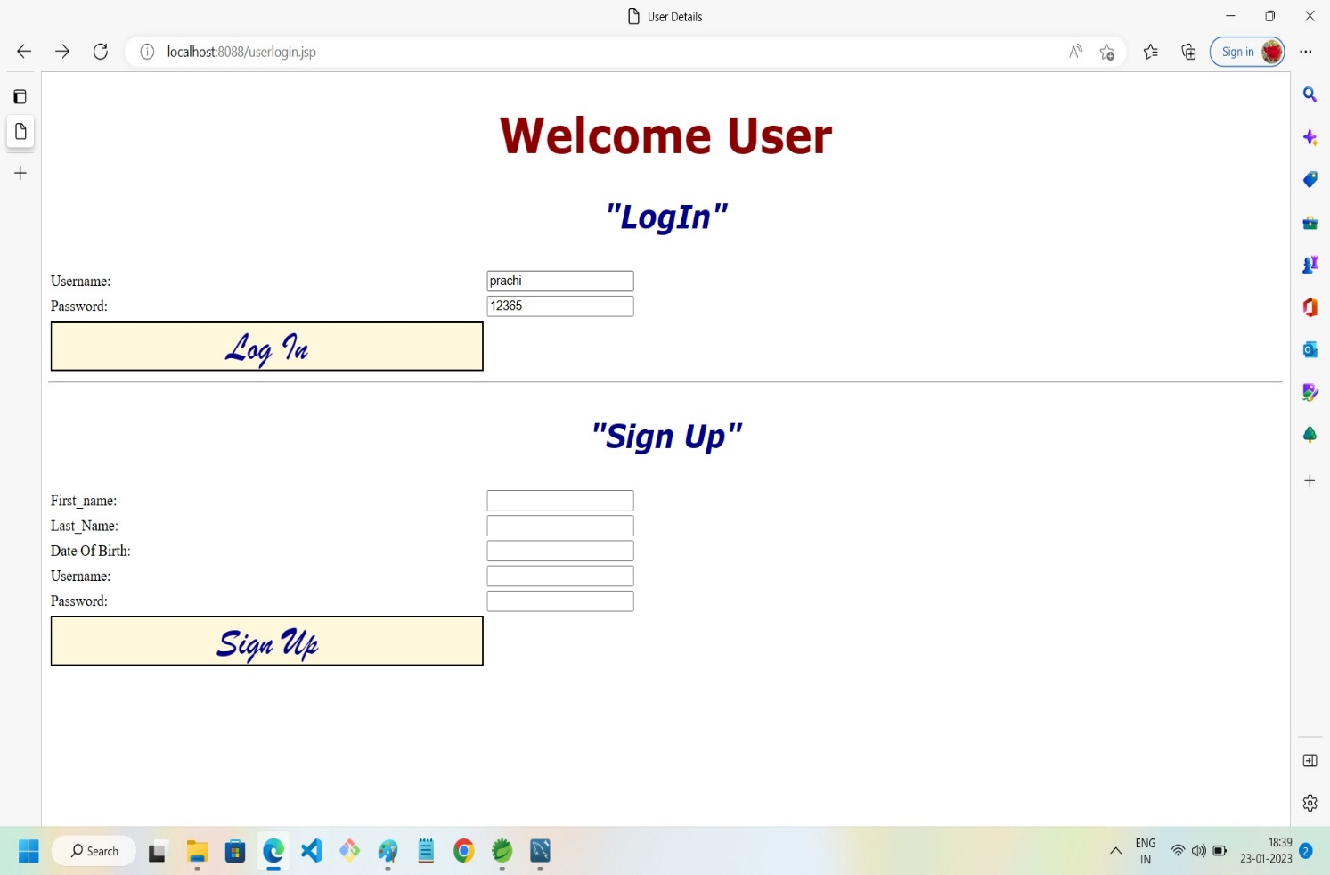

8.User Not-Registered Case

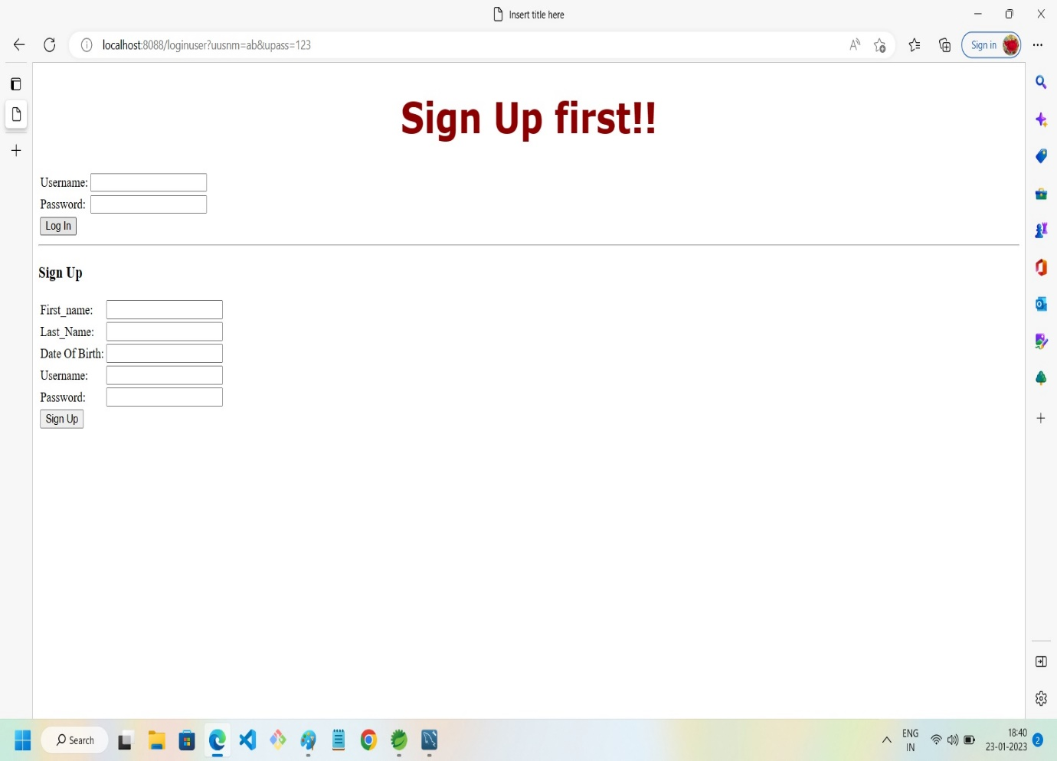

9.User Wrong Credential Case

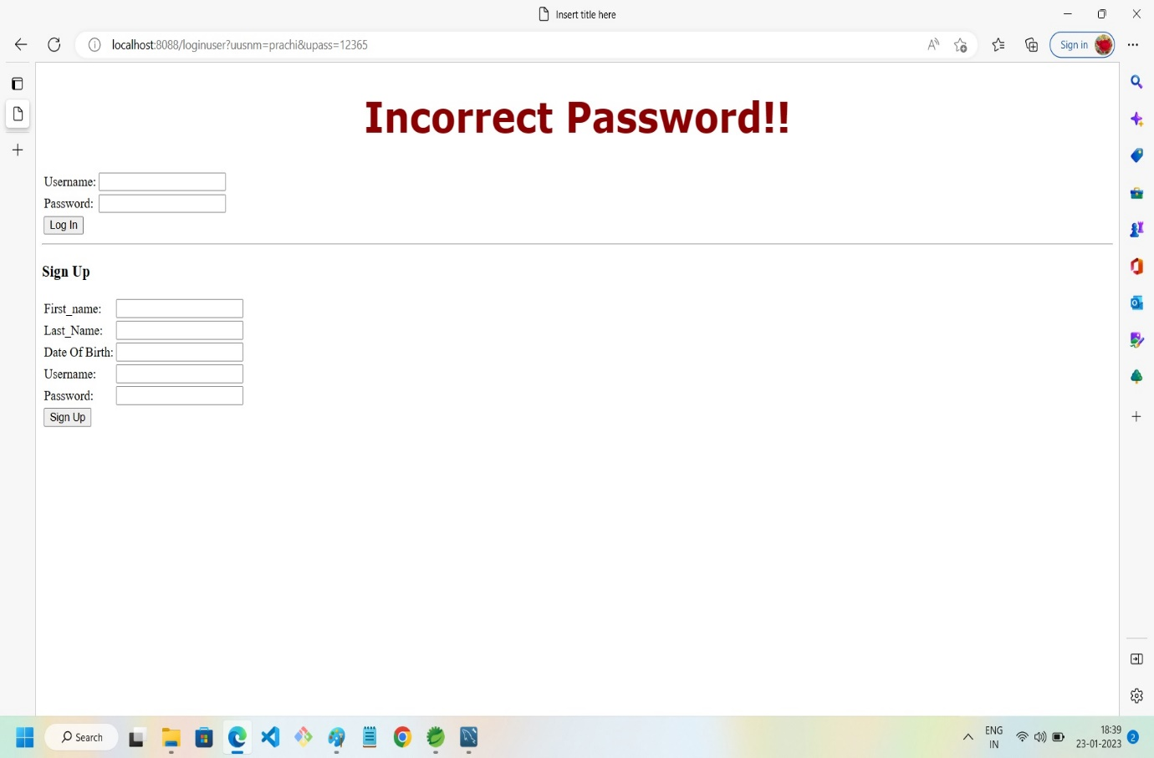

10.New User

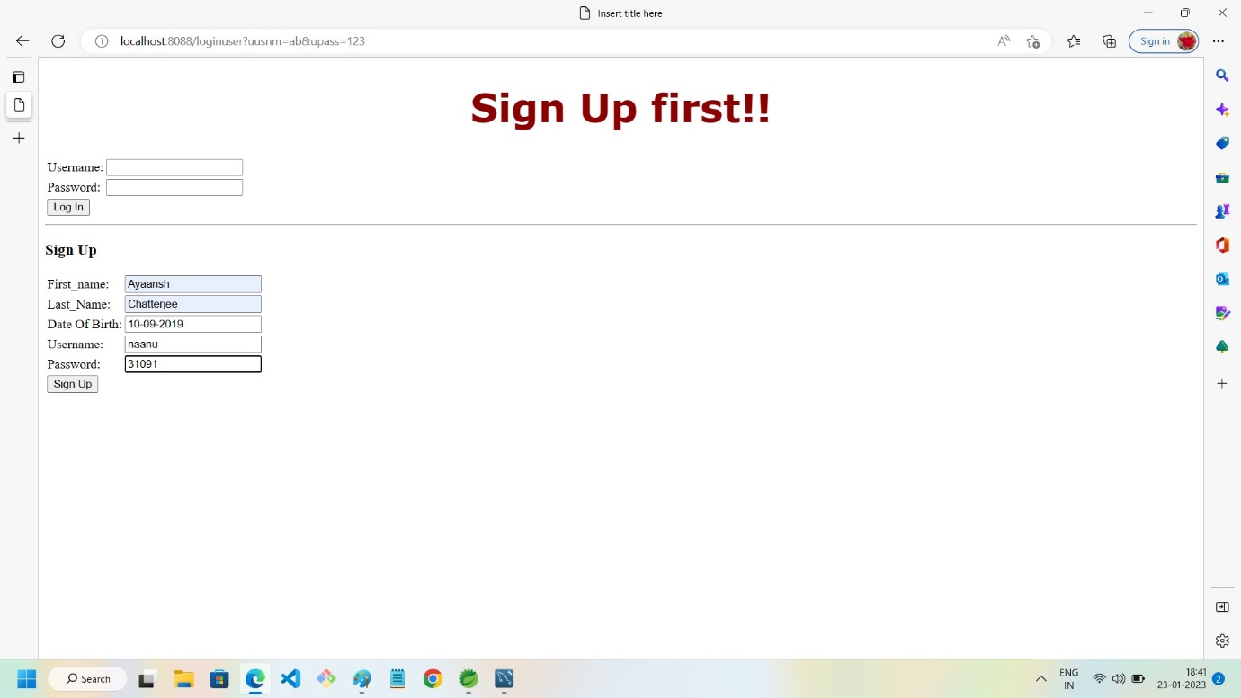

11. After user Login/Signup successful

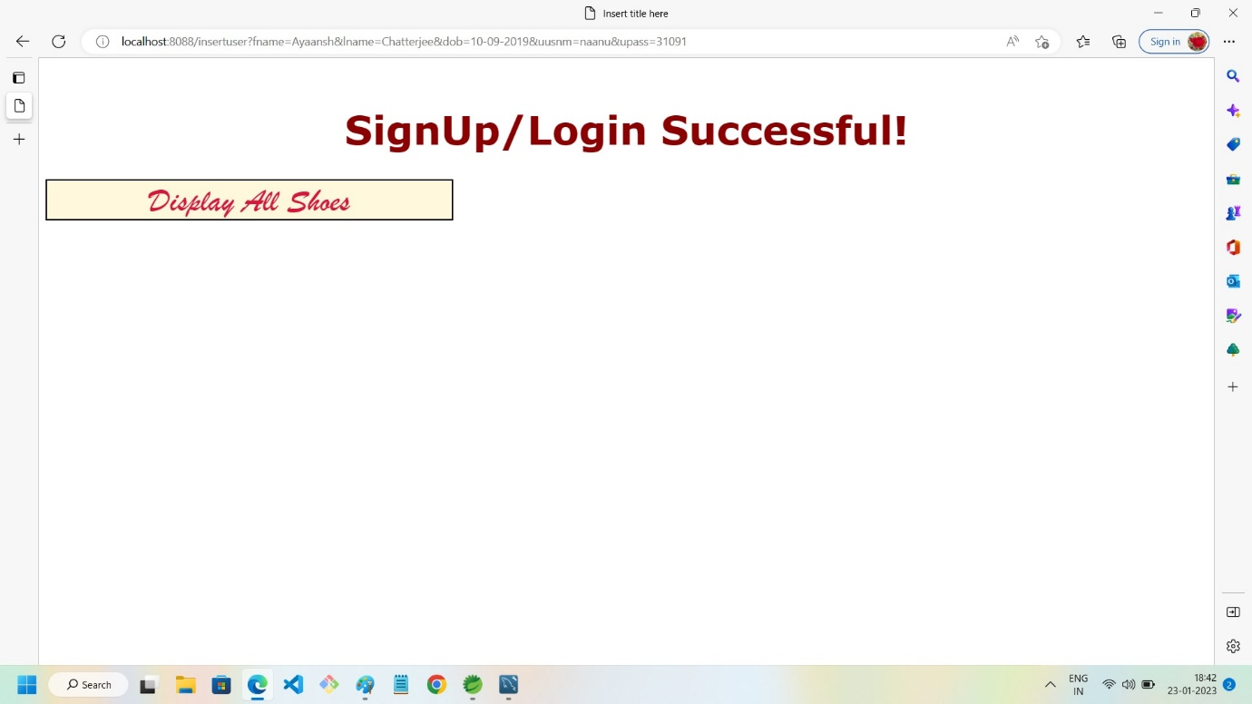

12. Shoe List with price for users

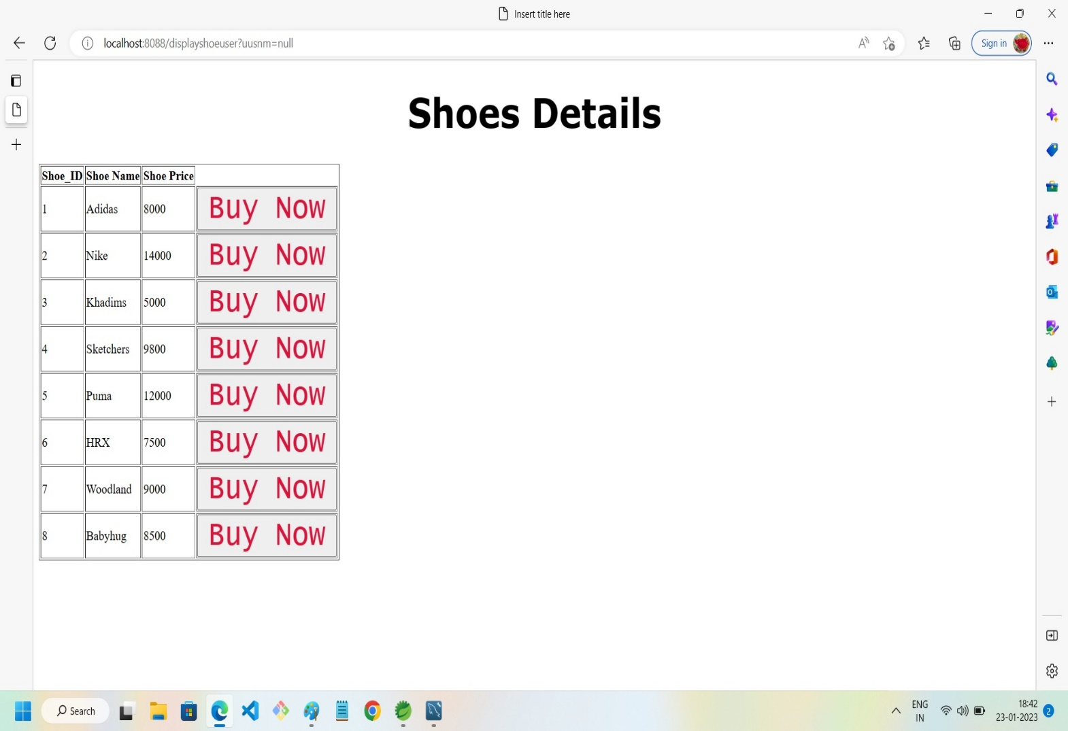

13. Asking for a Dummy Bank ID which is created in backend to have some balance for transaction purpose

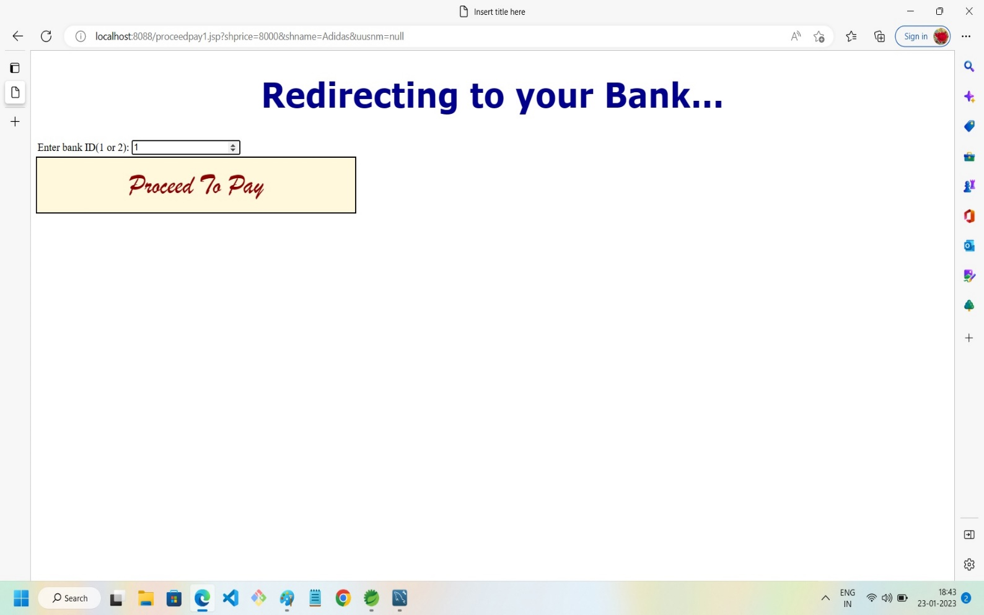

14. Payment Successful

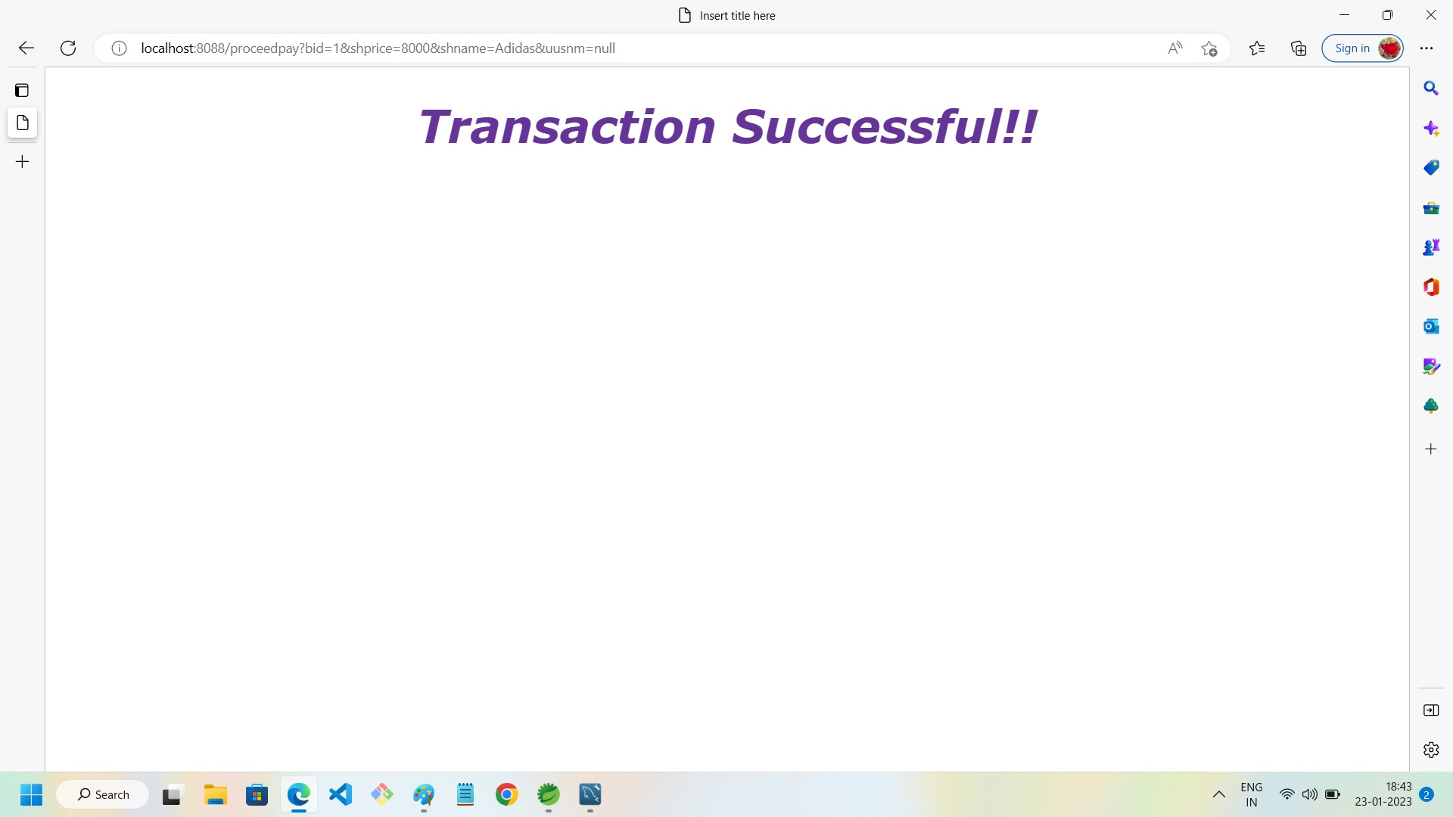

15. Declined transaction in case of low balance

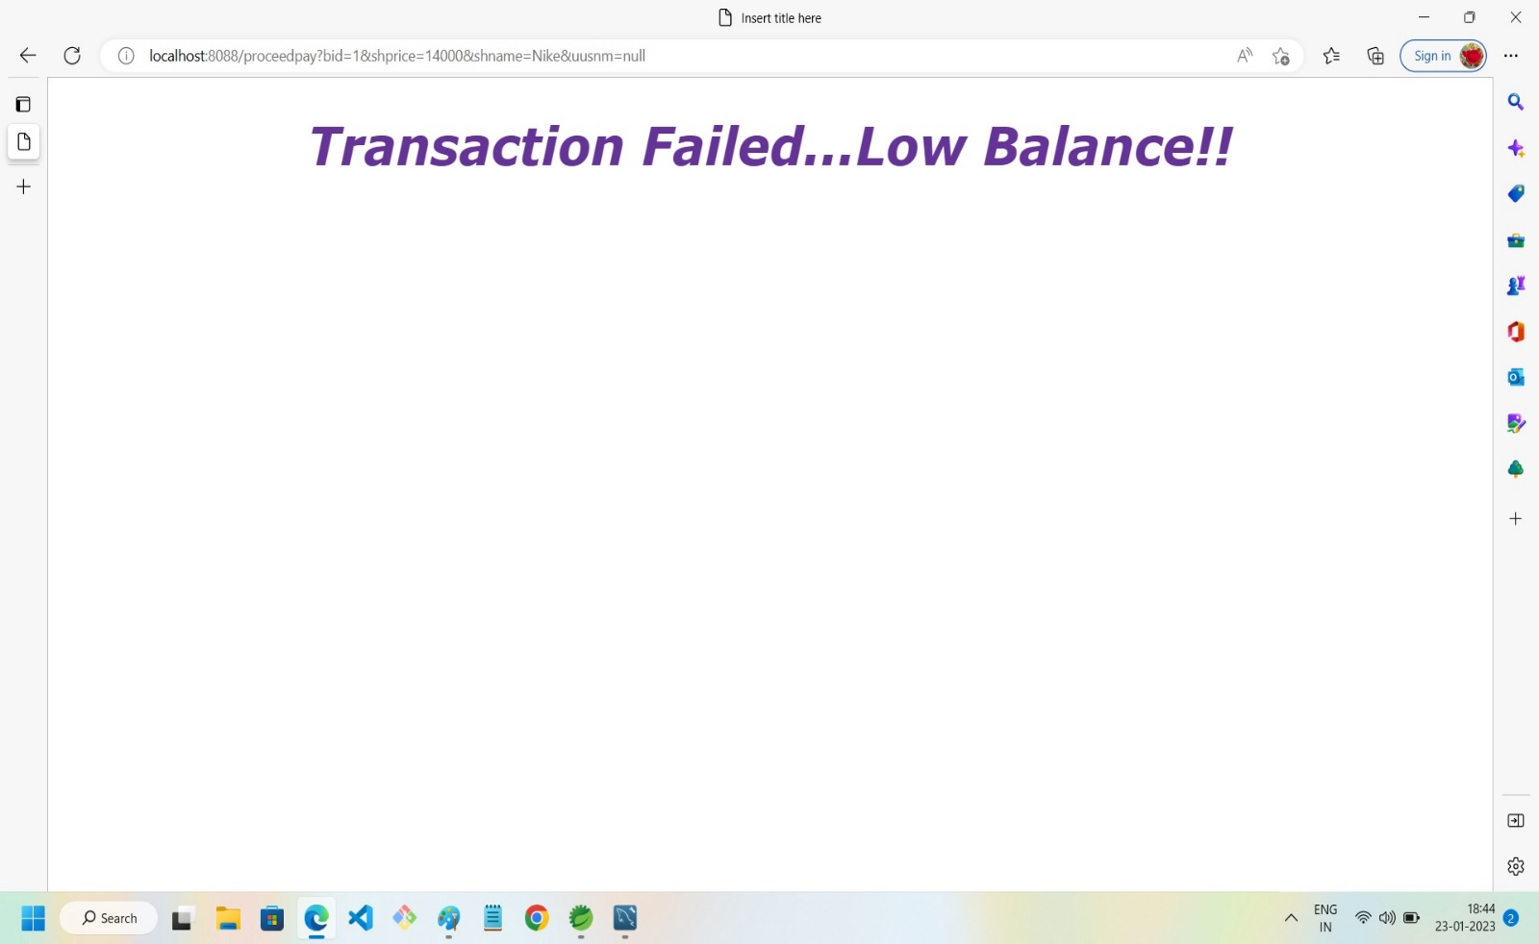

15. Bank Detail insertion Via Restful(POSTMAN)

