SpringBoot
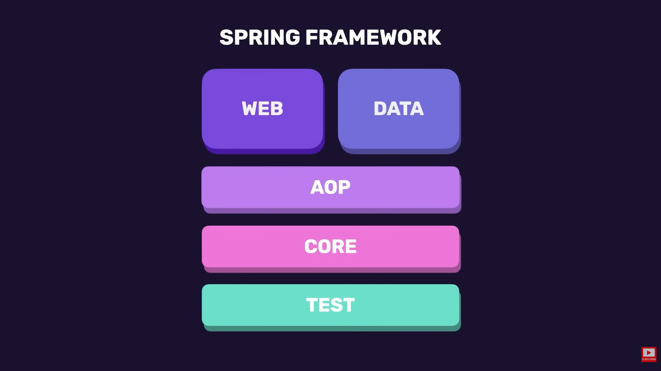

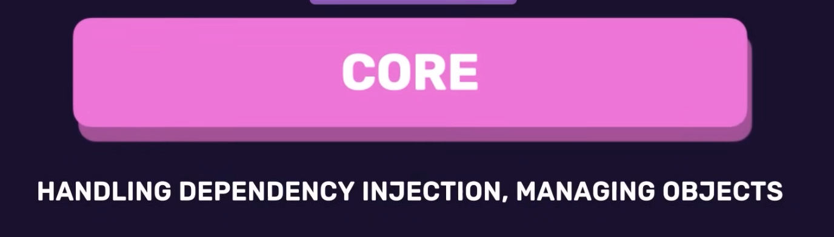
Instead of using Individual libraries, we use Starter Dependencies.
Dependencies:
- They are selected bunch of libraries bundled together into a thing called dependencies. So a dependency will have the required libraries of what you are trying to do

Annotations:
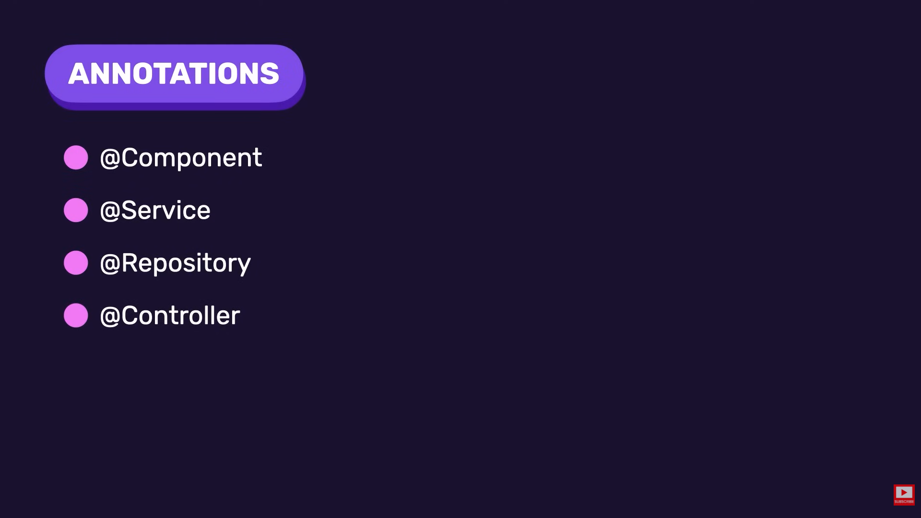
- @Component annotation is used to tell spring to automatically manage this object for us.
- @Service annotation is used for business logics.
- @Repository is used for databases.
- @Controller is used for telling Spring that this class is a controller, it will control the flow of the build execution.

