STACKEDHUB
First-Time User Manual
A simple guide to signing in, understanding the application, and getting started.

Version | 1.0
Date | 01 October 2026
System | StackedHub – food and customer management
Audience | First-time staff, admin and customers

Important: This guide reflects the functionality that could be verified from the currently published StackedHub prototype. The authenticated dashboard could not be inspected without a live signed-in session, so this manual does not invent dashboard controls or workflows.

Developed by:
Team Member | Role
Lefa Molokomme | Project Lead & Frontend Developer
Atlegang Gamede | Backend developer
Keamogetswe Hlahane | System architect & quality assurance
Siviwe Kalipa | Project lead assistant & frontend developer
Tshepang Mojahi | DevOps Engineer

Contents

Contents 2
1. Introduction 3
Welcome to stackedHub 3
2. System Requirements 3
3. Getting Started – How stackedHub works 4
Meet StackedHub – One Platform, three types of users. 4
How StackedHub Works: 6
System Architecture 17
Glossary 18
Trouble shooting, FAQ & Tips 19
Support & Revision History 20

Introduction

Welcome to stackedHub
Welcome to StackedHub, a web-based platform designed to bring the different parts of the Stacked Foods experience together in one place. StackedHub connects customers, staff and administrators through a central digital platform. Each user enters the system according to their role and is presented with functionality relevant to what they need to accomplish.
For customers, StackedHub provides an accessible way to interact with the service. Staff use the platform to carry out operational activities, while administrators oversee and manage the system.
This manual will guide you through the StackedHub experience from your first visit to completing common tasks within the system.

2. System Requirements

- Use a modern browser such as Microsoft Edge, Google Chrome, Firefox or Safari.
- Have an internet connection when accessing the hosted application.
- Have your StackedHub account details available.
- If the deployment uses a live backend, make sure the API is running and reachable.

3. Getting Started – How stackedHub works

1. Open https://stackedhubgo.lovable.app/.
2. Wait for the sign-in page to load.
3. Select Staff, Admin or Customer according to your account.
4. Enter your email and password.
5. Click Sign in.
6. Continue to the dashboard available to your role.

Meet StackedHub – One Platform, three types of users.

StackedHub is built around three personas:
Customer:
I want to use Stackedhub to interact with the business and manage my customer experience:
Create Account
↓
Login
↓
Customer Dashboard
↓
Browse / Interact
↓
Complete Action
↓
View Result

Staff:
I use Stackedhub to perform the day-to-day operational task assigned to me
Login
↓
Staff Dashboard
↓
View Work
↓
Process / Update
↓
Confirm
↓
Complete

Admin:
I oversee the system and manage information and users required to keep StackedHub running
Login
↓
Staff Dashboard
↓
View Work
↓
Process / Update
↓
Confirm
↓
Complete

How StackedHub Works:

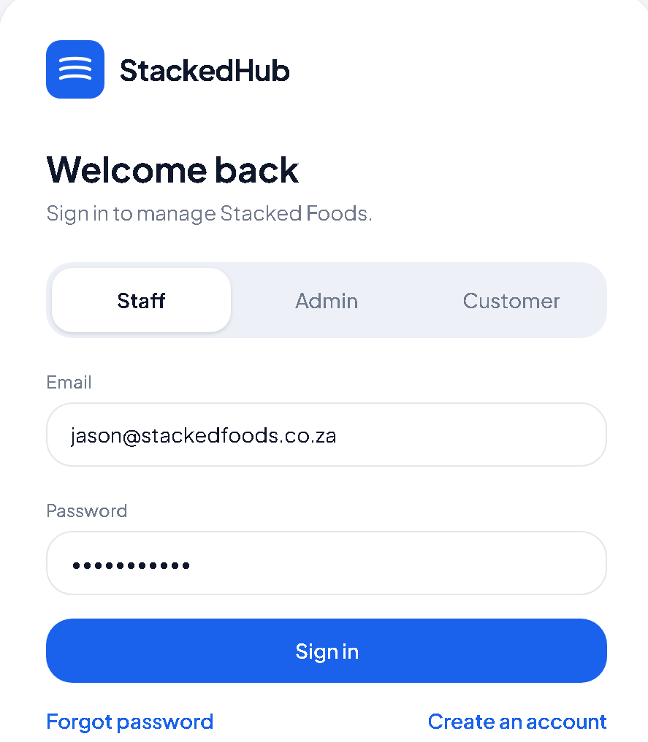
Figure 1 – Sign-in Screen

This is the first screen that users are greeted with, sign in using the role assigned to you.

Selecting your role:

Figure 2 – Sign-in screen(selecting your role)
Select the role assigned to you (staff, admin, customer)

Customer Dashboard:
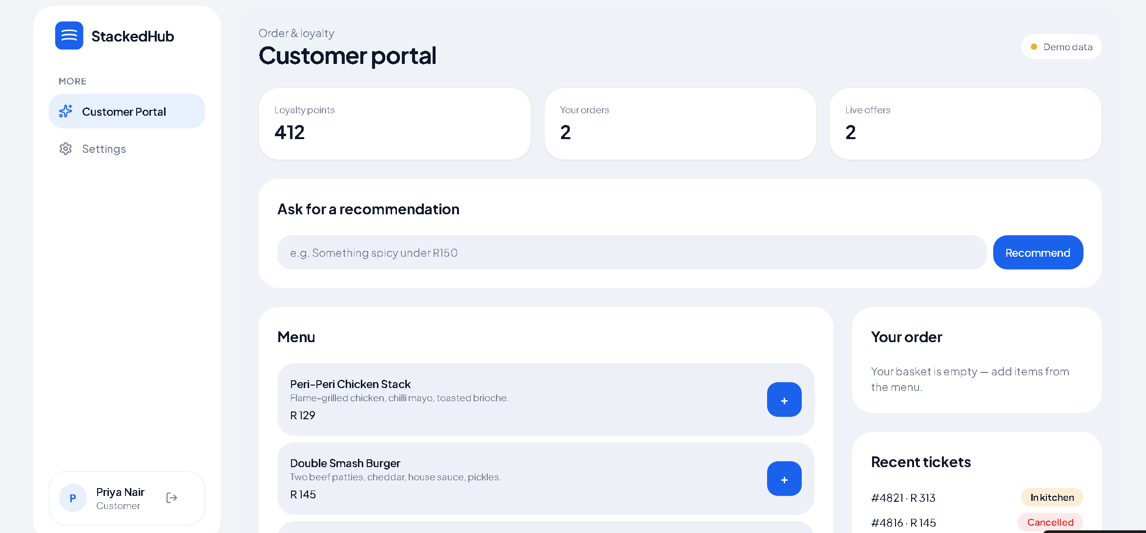
Figure 3 – customer dashboard
Navigation flow:
Loyalty points – total points accumulated from orders
Your orders – recent orders made
Live offers – promotional offers currently available
Menu – Items available
Your order – current order
Recent tickets – recent orders placed
Recommendation bar – AI assistant meal recommendation

Staff Dashboard:
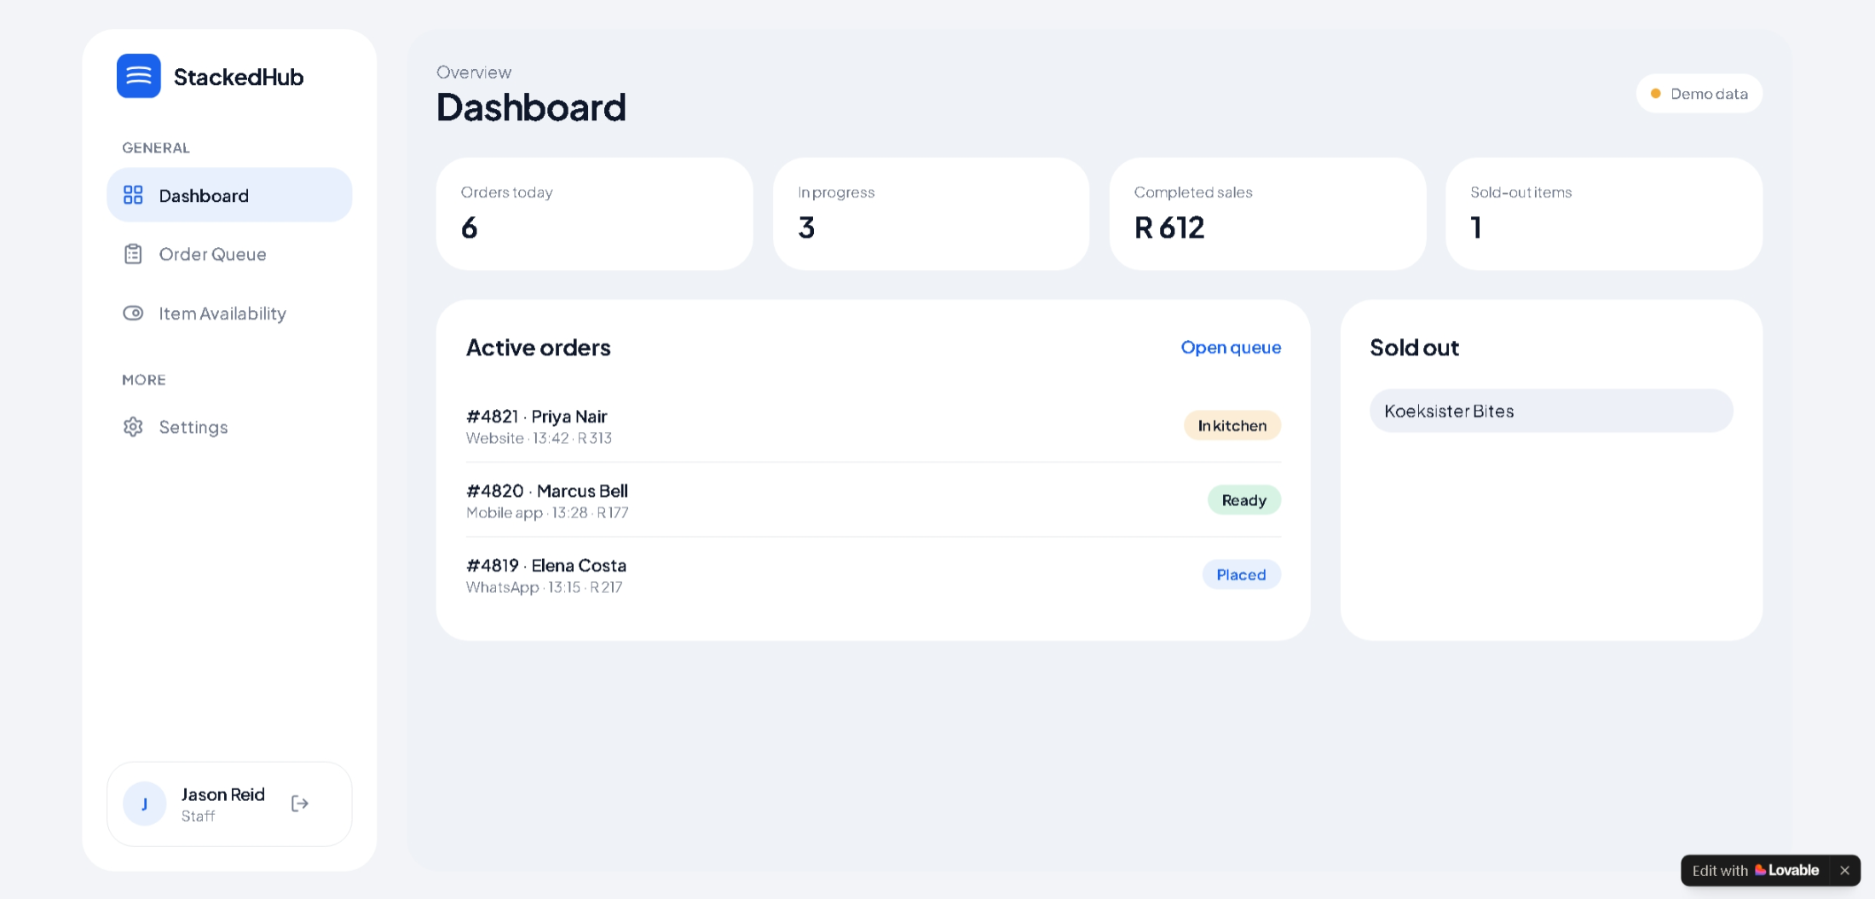
Figure 4 – Staff Dashboard (manage kitchen orders & menu)

Navigation Flow:
Orders today – total order for the day
In progress – orders currently being processed
Completed sales – total sales for the day
Sold-out items – items currently being sold out
Active orders – currently active orders (in kitchen – being prepared, ready, placed)
Sold out – sold out items
Tab menu:
Order Queue – manage your orders
Item availability – manage all items and their availability
Settings – view your profile information

Staff Dashboard: Order Queue
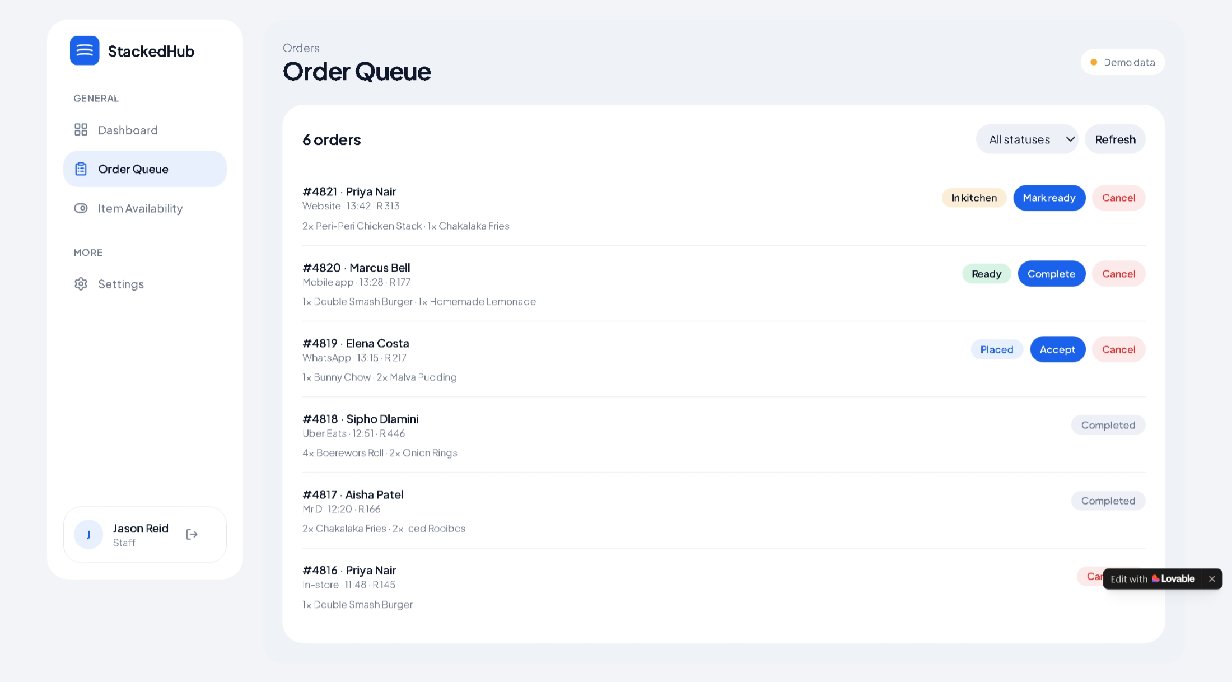
Figure 5 – order queue management page
The order queue page gives you an overview and simple way to manage all active orders. The staff can choose to accept the an order, cancel an order or mark the order as ready.
Simply click one the three buttons (mark ready, cancel, accept) to manage the order.

Item Availability:
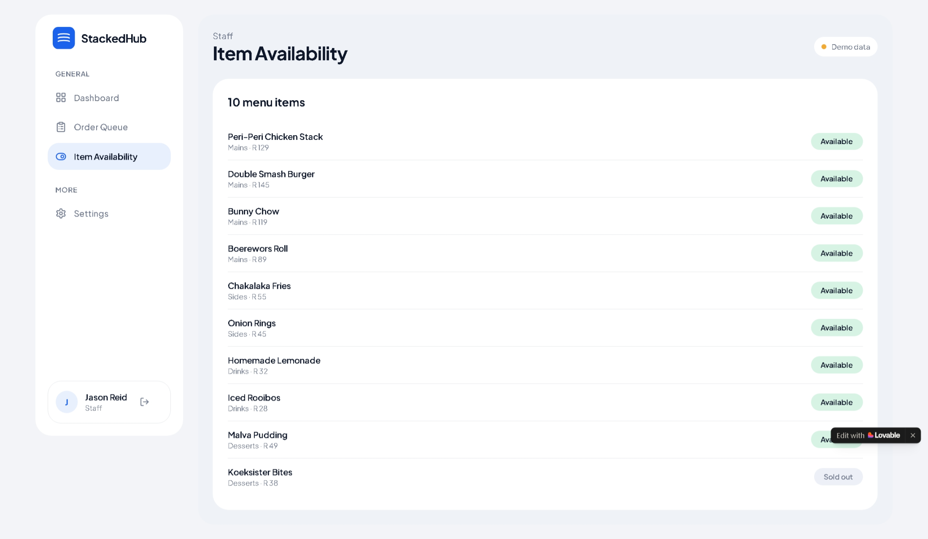
Navigation flow:
The item availability screen shows you all items that are available and gives you an overlook of all items in a simple and compact tabular form.
To mark an item as sold out, simply click the available button and the button will change to “sold out”indicating that the item has been sold out.

Admin Dashboard:
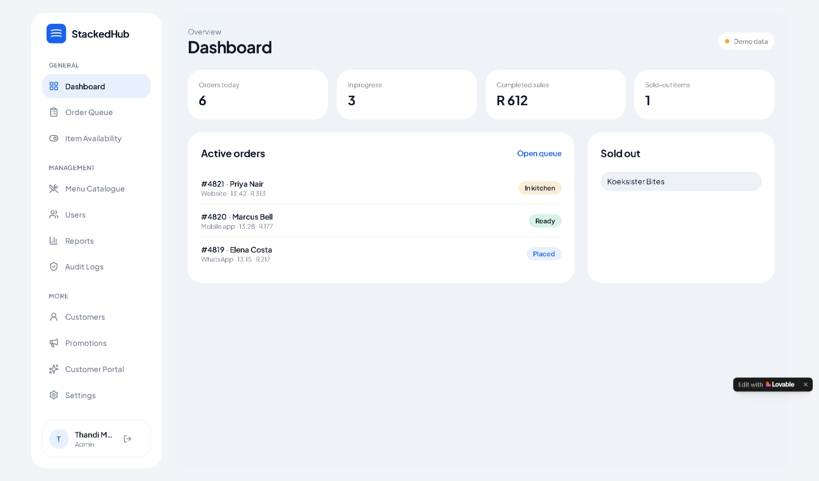
Figure 6 – Admin Dashboard
The admin dashboard is similar to the staff dashboard, giving you an overview of active orders, sold out items, completed sales etc. the admin dashboard has more tab menu than the staff dashboard since as the admin your managing the entire StackedHub system from users, to menu items etc.

Menu Catalogue:
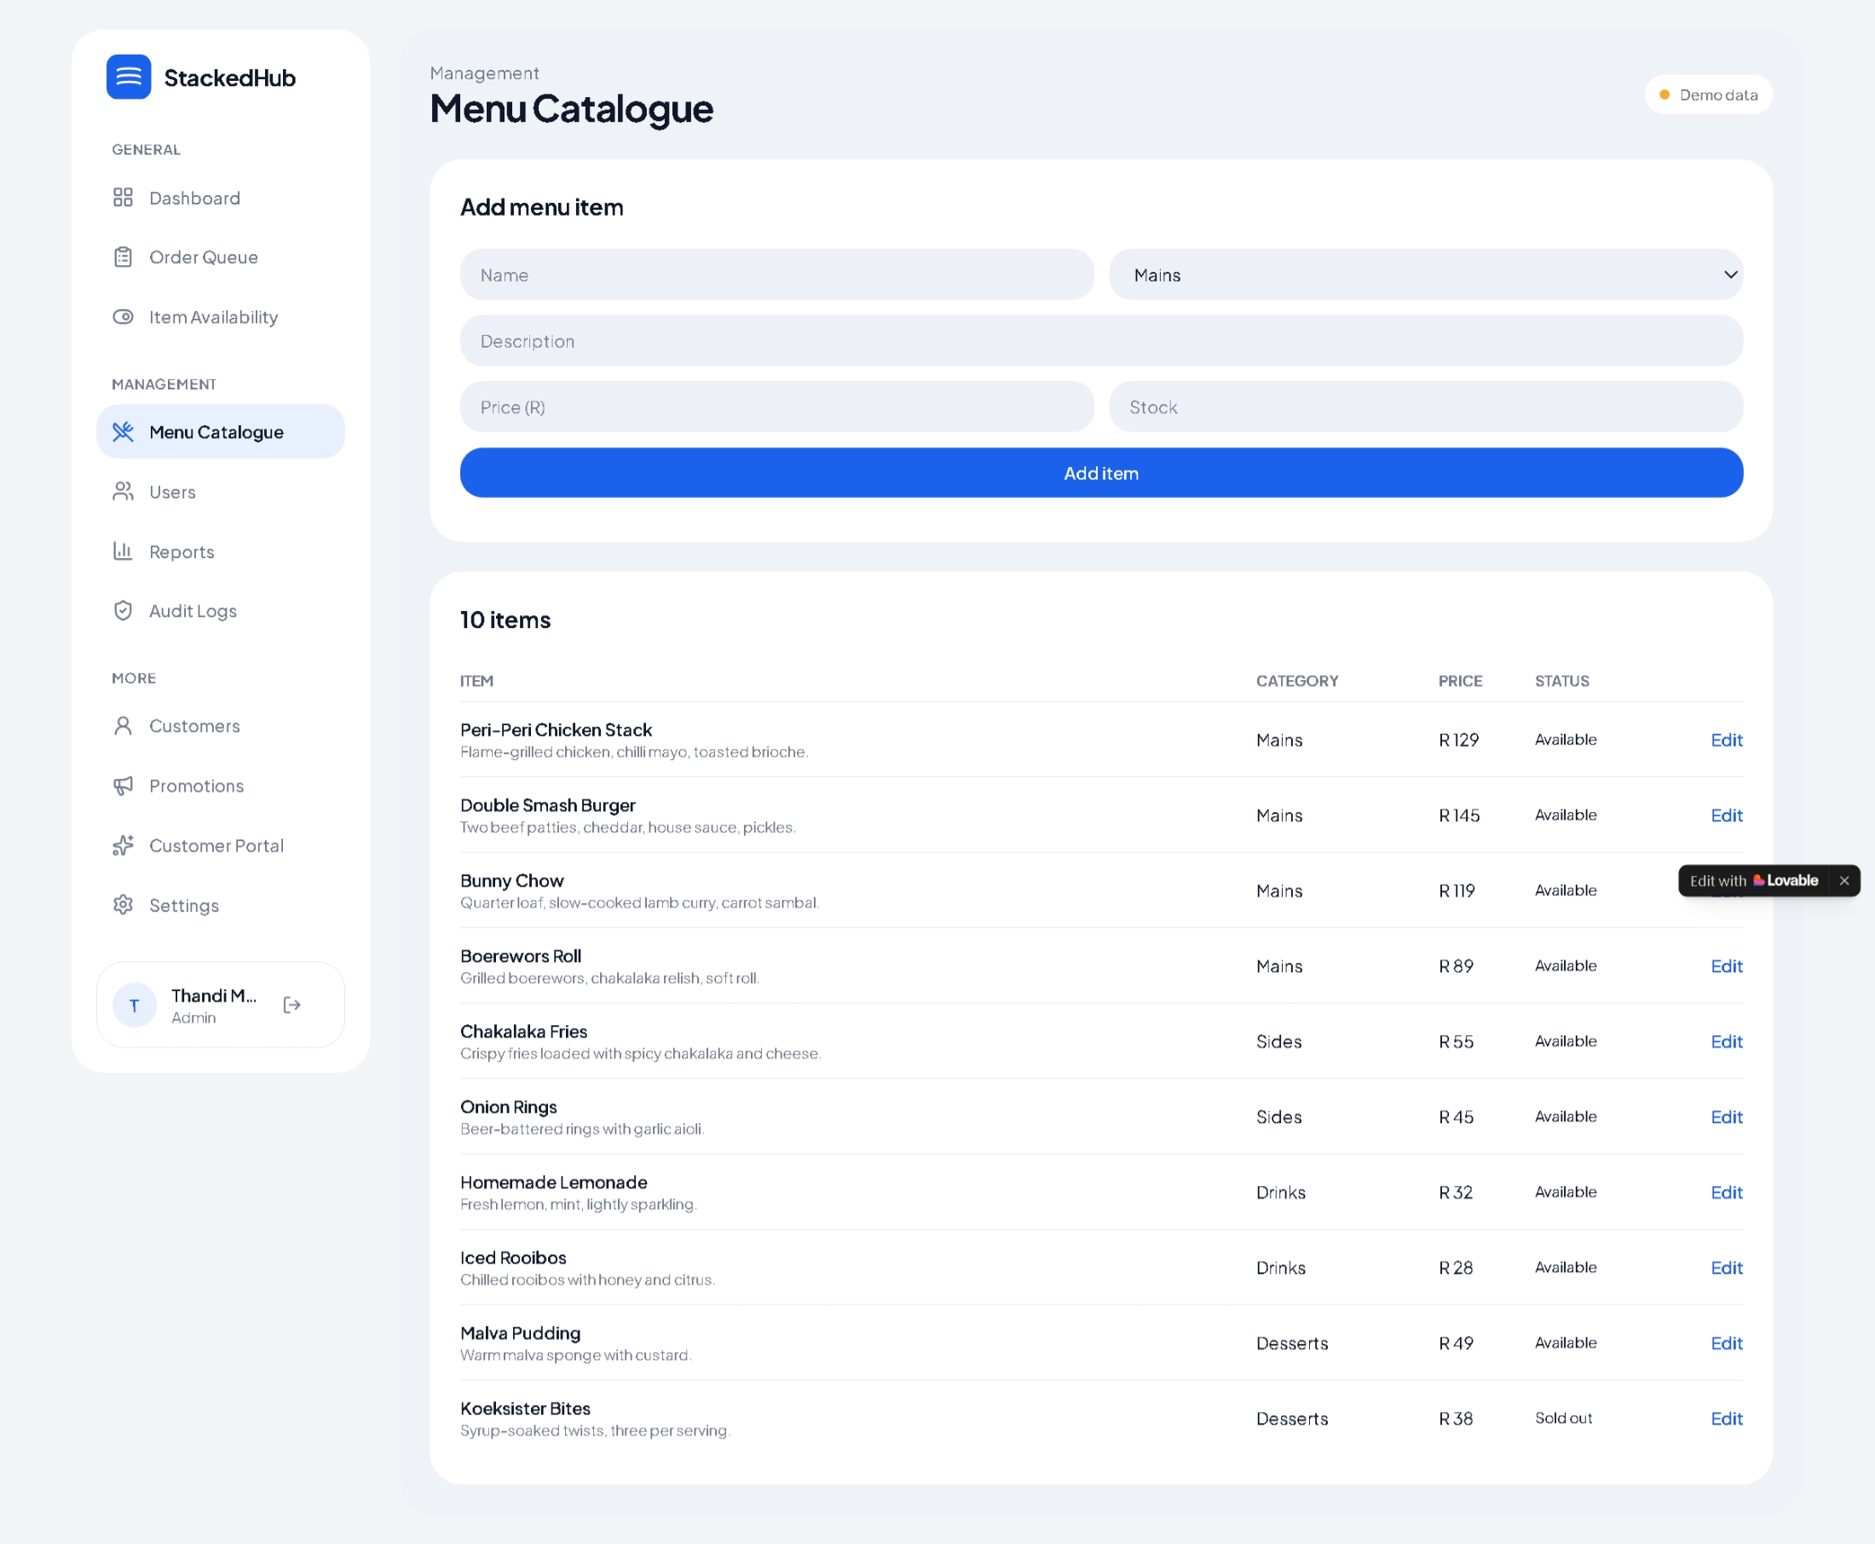
Figure 7 – menu catalogue screen
The menu catalogue screen lets the administrator manage the different menu items that Stackedhub offers, they can easily add a new menu item by filling in the menu item form, the item will then be displayed in the tabular form item list. The admin can also edit a menu item by clicking edit to either change the item, add a description, change the price or its availability status. E.g. (example below:
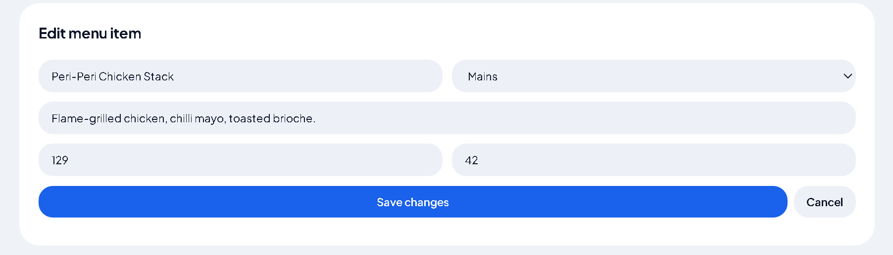
Users:
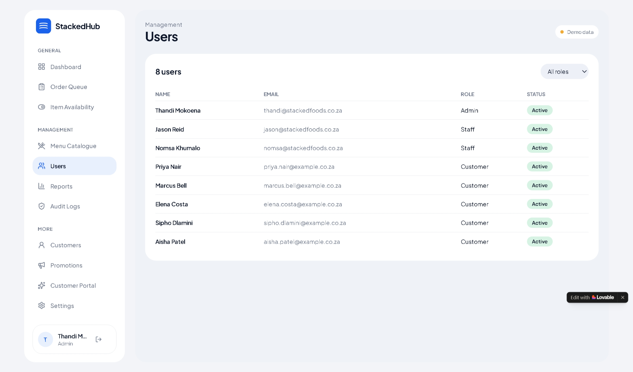
Figure 8 – Users page
The users page, gives the admin an overview of the different users that are currently enrolled into the system, from staff, customer and admin including their status.

Reports:
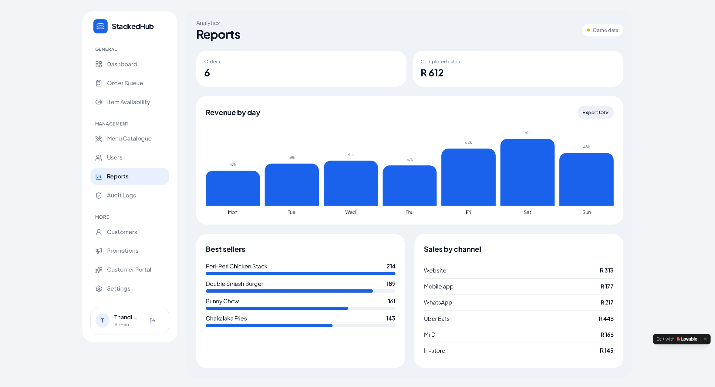
Figure 9 – reports page
The Report screen gives the admin an overview the StackedHub’s performance and how good are they doing in terms of sales. The admin is able to see total orders, completed sales, a chart displaying revenue by day with an export CSV button that allows you to export chart data into an excel spreadsheet so you never miss out on crucial data.
The page also provides an overview of item bestsellers in a visual progress bar so its easier to interpret what items are your best sellers as well as the sales by channel card, giving you an overview of what social platforms drive the most growth.

Audit log:
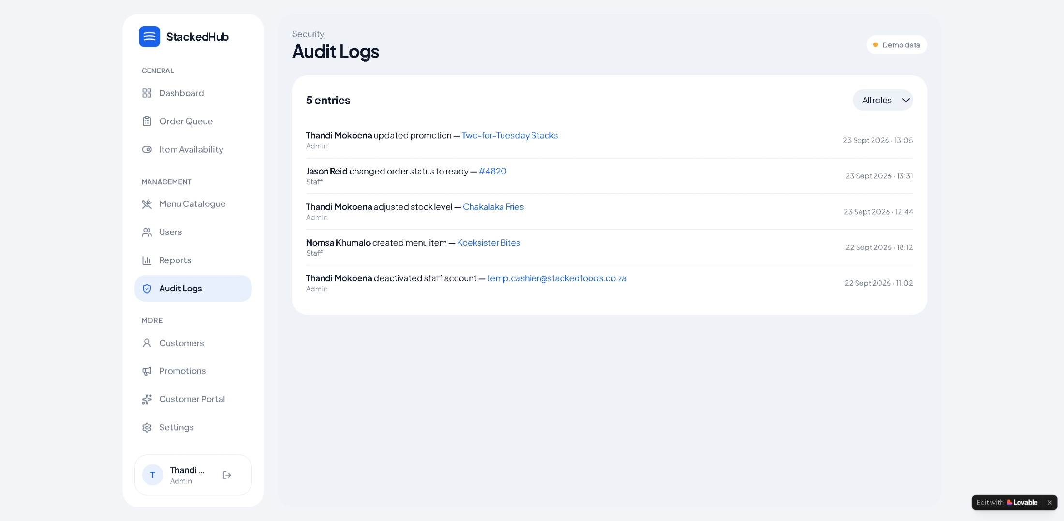
Figure 10 – audit log page
The audit log page provides a simple summary of user activity, administrators are able to see the activity of each user and how they interact with the system.

Customers:
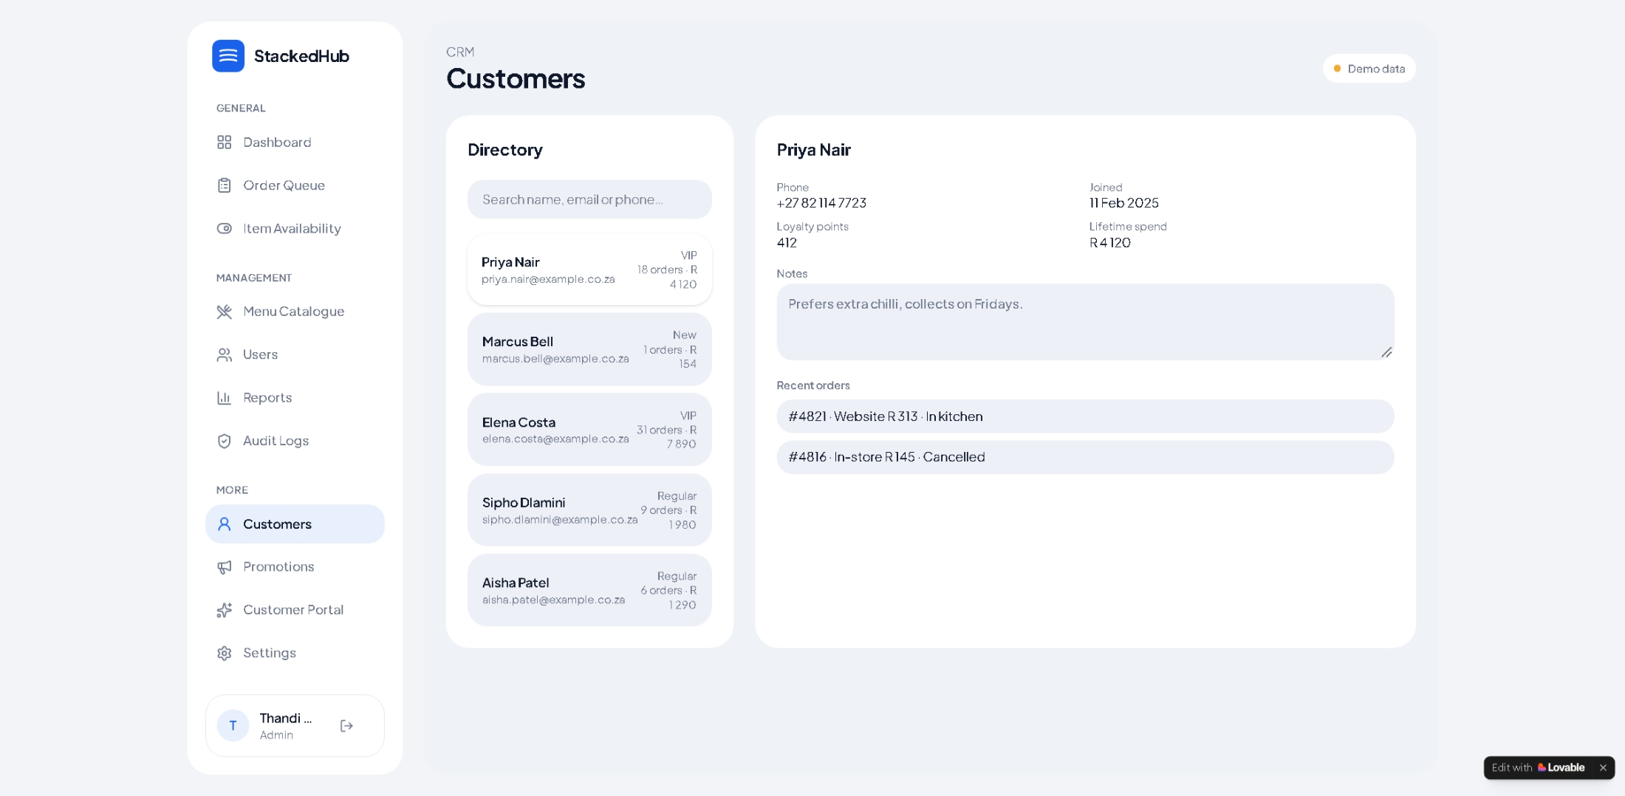
The customers page, allows the admin to manage customer information. For security reasons admins can only see a customers phone number and email, other information like order address is not displayed to protect the user’s privacy.
This information is useful because the admin can view the most loyal customer based on their loyalty points and offer discounts or promotions to maintain lifetime customer loyalty.

Promotions:
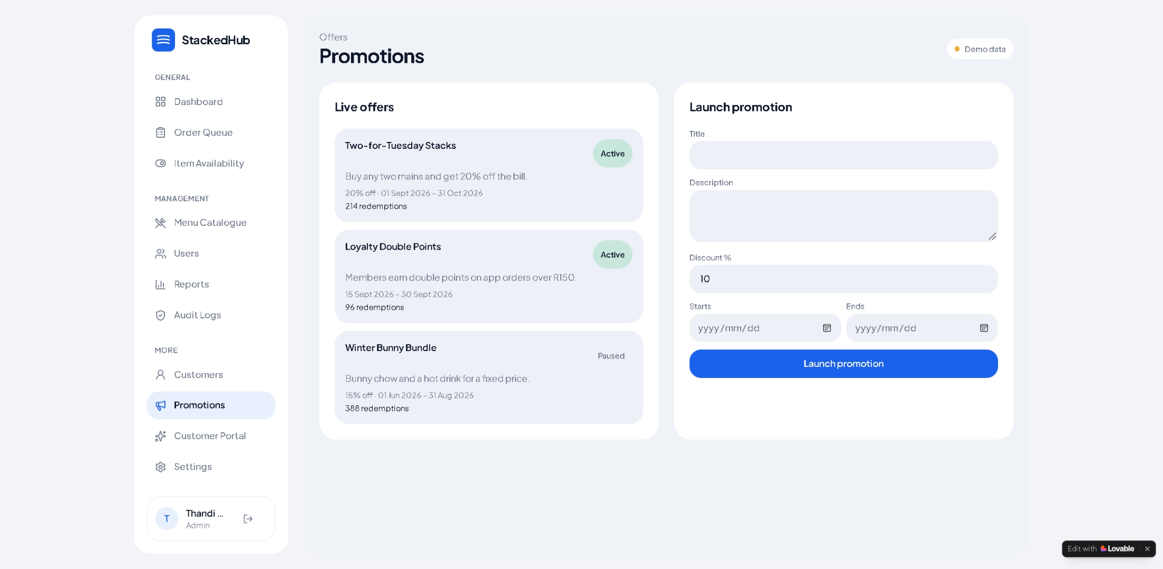
Figure 11 – promotions page
The promotions page allows the admin to easily set up promotions. It gives you an life offers view of all offers that are currently live and paused. Launch a new promotion by filling out the promotion form.

System Architecture

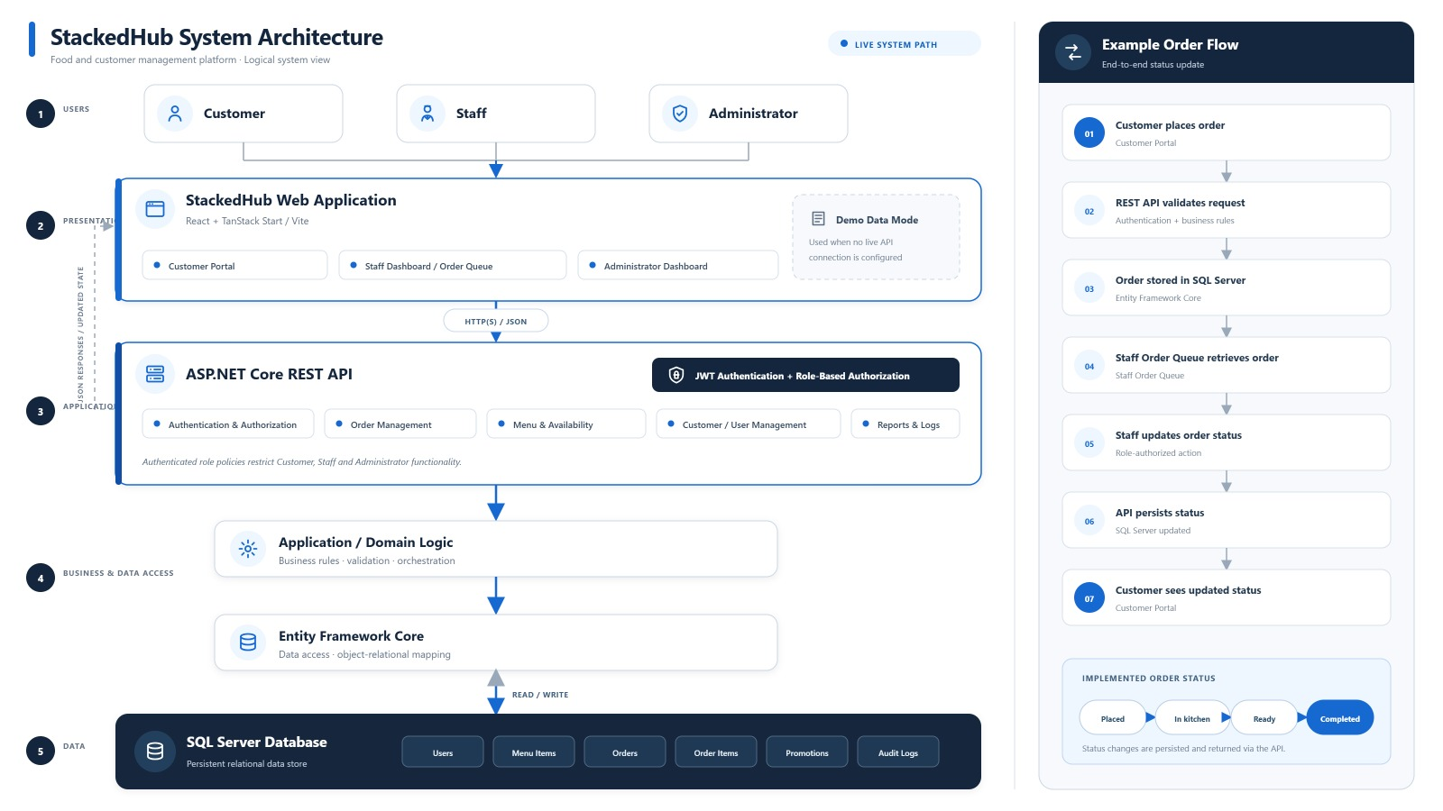
Figure 12 – System Architecture Diagram

Glossary

- Admin | - A user responsible for managing the system and administrative functions.

- API | - Application Programming Interface used to allow different software components to communicate.

- Authentication | - The process of verifying who a user is.

- Backend | - The server-side part of StackedHub responsible for processing requests and data.

- Dashboard | - The main area users see after signing in.

- Database | - The structured storage system used to store application information.

- Demo Mode | - A prototype mode that allows users to interact with the system using demonstration data.

- Frontend | - The visual part of StackedHub users interact with through the browser.

- Login | - The process of entering account credentials to access the system.

- Logout | - The action used to securely leave an authenticated session.

- Navigation | - The controls used to move between different areas of the application.

- Password | - A secret credential used to authenticate a user.

- Permission | - The level of access granted to a user or role.

- Role | - A user category such as Customer, Staff or Admin.

- Staff | - A user who performs operational tasks within StackedHub.

- Customer | - A user who interacts with StackedHub as a customer.

- Admin Dashboard | - The administrative area available to authorised administrators.

- API Connection | - The connection between the StackedHub frontend and backend service.

- API Base URL | - The address where the frontend looks for the backend API.

- Session | - The period during which a user remains authenticated.

- Web Application | Software accessed through a web browser.

- Prototype | An early or demonstration version of the application.

- Role-Based Access Control | A security approach where available functionality depends on the user's role.

Trouble shooting, FAQ & Tips

Cant log in? – if you’re having trouble logging in, follow this simple step:
Check your role
Check that you’re using the correct email you used when signing up
Check if the password matches the one you used when signing up
Contact support for further assistant
Dashboard isn’t loading:
Refresh your page
Check your internet connection
Check that the api is connected and displaying the connection indicator
The API connection fails.
What to do: Check that the backend is running and that the API base URL is correct. The prototype provides a
Test connection button.
I expected a password-reset email.
What to do: The current prototype does not send a real reset email. Contact the project administrator if you need
account assistance.
I am unsure which role to select.
What to do: Use the role assigned to your account: Staff, Admin or Customer. Ask your administrator if you are unsure.
The application behaves differently from this guide.
What to do: The hosted prototype may have been updated. Confirm the deployed version and contact the project

Helpful tips
- Keep your login details private.
- Use the correct role for your account.
- After making a change, verify that the expected result appears.
- If you are testing the prototype, remember that demo mode and production/API-connected mode may behave
differently.

Support & Revision History

Contact the system administrator, development team or deployment support contact for project-specific issues.
Version 1.0 — 01 October 2026 — Initial first-time-user guide.
Submission note: The supplied guide recommends clear, numbered screenshots and feature-by-feature procedures, and specifically warns against adding features that are not part of the actual project. The final version should therefore add authenticated dashboard screenshots and exact feature steps from the final build.
To view a live demonstration of the system click the link below:
Live demo - https://youtu.be/6pr168hcEcE

