**浴园数据库设计**

学号：2110508 姓名：杨冰雪 班级：0996

1. **概念模型ER图及关系模式**

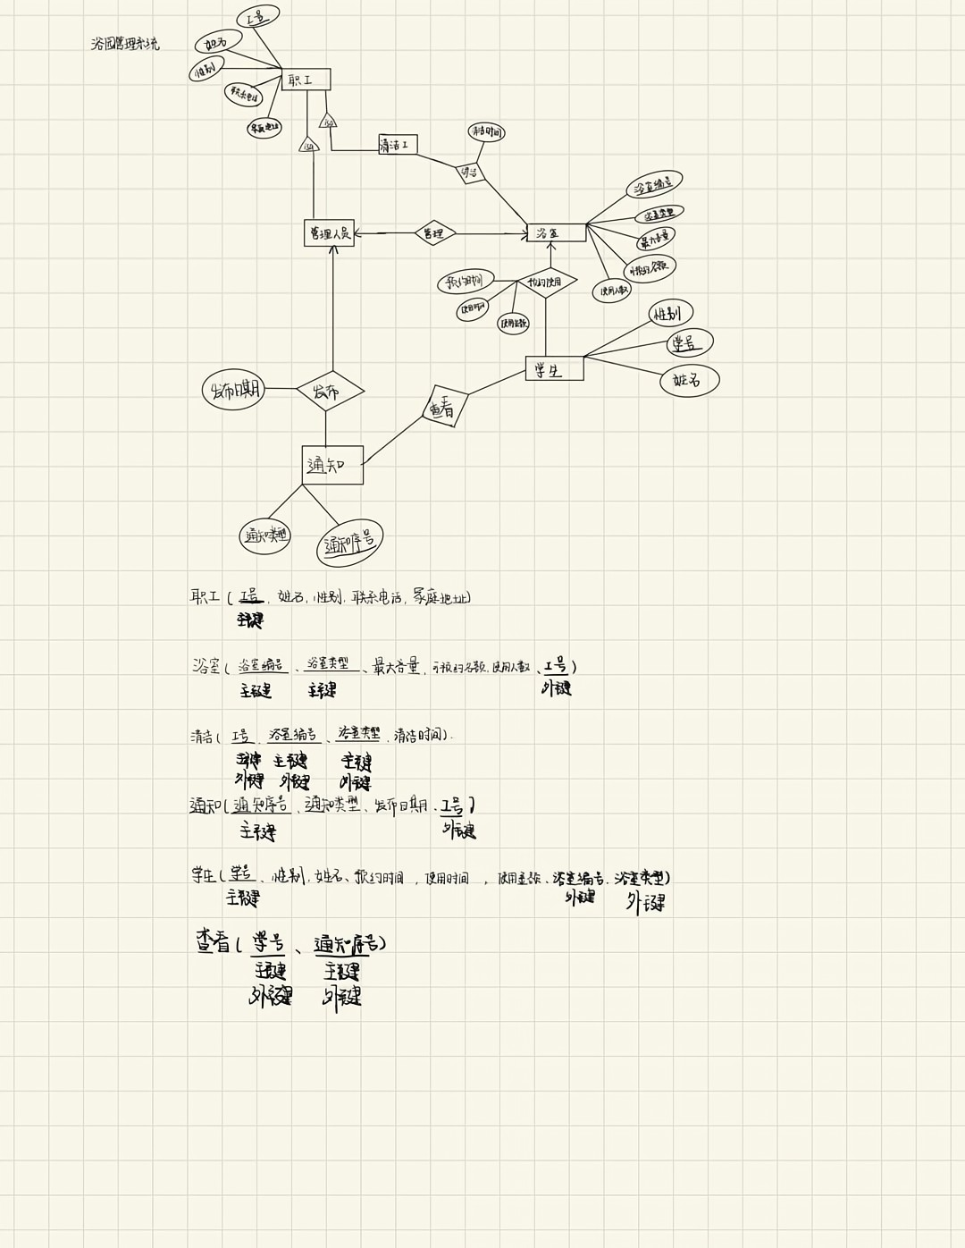

1. **SQL语句创建关系模式**

drop table if exists Worker;

drop table if exists Washroom;

drop table if exists Clean;

drop table if exists Notice;

drop table if exists Student;

drop table if exists see;

create table Worker

(

Wno char(10) not null,

Wname char(10) not null,

Wsex char(2) not null,

Wcallno char(15) not null,

Wadd char(20),

primary key (Wno)

);

create table Washroom

(

Washno char(10) not null,

Washtype char(10) not null,

Wash_max_contain int not null,

Wash_book_no int not null,

Wash_using_no int,

Wno char(10),

primary key (Washno, Washtype)

);

create table Clean

(

Washno char(10) not null,

Washtype char(10) not null,

Wno char(10) not null,

Clean_time datetime not null,

primary key (Washno, Washtype, Wno)

);

create table Notice

(

Noticeno char(10) not null,

Noticetype char(15),

public_date datetime not null,

Wno char(10);

primary key (Noticeno)

);

create table Student

(

Sno char(10) not null,

Ssex char(2) not null,

Sname char(10) not null,

book_time datetime,

use_time datetime,

use_price int,

Washno char(10).

Washtype char(10),

primary key (Sno)

);

create table see

(

Sno char(10) not null,

Noticeno char(10) not null,

primary key (Sno, Noticeno)

);

alter table Washroom add constraint FK_manage2 foreign key (Wno)

references Worker (Wno);

alter table clean add constraint FK_clean foreign key (Washno, Washtype)

references Washroom (Washno, Washtype);

alter table clean add constraint FK_clean2 foreign key (Wno)

references Washworker (Wno);

alter table Notice add constraint FK_public foreign key (Wno)

references Worker (Wno);

alter table Student add constraint FK_book_use foreign key (Washno, Washtype)

references Washroom (Washno, Washtype);

alter table see add constraint FK_see foreign key (Sno)

references Student (Sno);

alter table see add constraint FK_see2 foreign key (Noticeno)

references Notice (Noticeno);

1. **5个查询语句样例**
2. 单表查询：

查找性别为女生的学生的信息：select * from Student where Ssex=’girl’;

1. 多表连接查询：

查找姓名为张三的清洁工打扫的浴室编号为：select Washno from Worker natural join Clean where Wname=’张三’;

1. 多表嵌套查询

查找所以看过通知序号大于5的同学的姓名：select Sname from Student where Sno

In（select Sno from see where Noticeno>5);

1. Exists查询

查找发布1号通知的管理人员姓名：select Wname from Worker if exists（select * from Notice where Wno=Notcie.Wno AND Noticeno=’1’);

1. 聚合操作查询

查找学生总人数：select count(*) from Student;

1. **用PowerDesigner工具实现设计**

**ER图：**

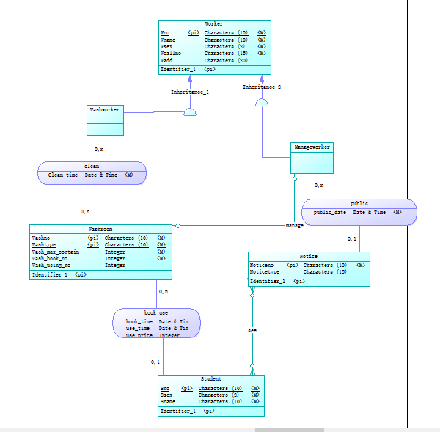

**关系模式图：**

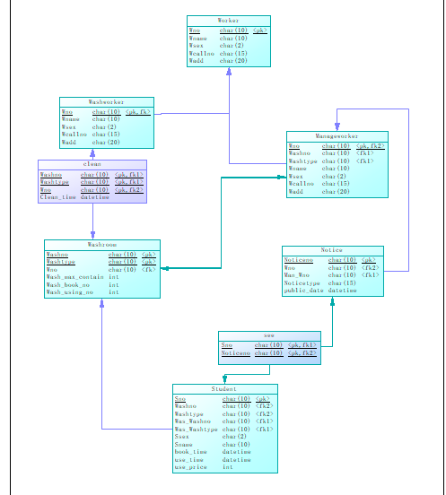

**SQL语句：**

/*==============================================================*/

/* DBMS name: MySQL 5.0 */

/* Created on: 2023/4/13 9:52:42 */

/*==============================================================*/

drop table if exists Manageworker;

drop table if exists Notice;

drop table if exists Student;

drop table if exists Washroom;

drop table if exists Washworker;

drop table if exists Worker;

drop table if exists clean;

drop table if exists see;

/*==============================================================*/

/* Table: Manageworker */

/*==============================================================*/

create table Manageworker

(

Wno char(10) not null,

Washno char(10),

Washtype char(10),

Wname char(10) not null,

Wsex char(2) not null,

Wcallno char(15) not null,

Wadd char(20),

primary key (Wno)

);

/*==============================================================*/

/* Table: Notice */

/*==============================================================*/

create table Notice

(

Noticeno char(10) not null,

Wno char(10),

Man_Wno char(10) not null,

Noticetype char(15),

public_date datetime not null,

primary key (Noticeno)

);

/*==============================================================*/

/* Table: Student */

/*==============================================================*/

create table Student

(

Sno char(10) not null,

Washno char(10),

Washtype char(10),

Was_Washno char(10) not null,

Was_Washtype char(10) not null,

Ssex char(2) not null,

Sname char(10) not null,

book_time datetime,

use_time datetime,

use_price int,

primary key (Sno)

);

/*==============================================================*/

/* Table: Washroom */

/*==============================================================*/

create table Washroom

(

Washno char(10) not null,

Washtype char(10) not null,

Wno char(10),

Wash_max_contain int not null,

Wash_book_no int not null,

Wash_using_no int,

primary key (Washno, Washtype)

);

/*==============================================================*/

/* Table: Washworker */

/*==============================================================*/

create table Washworker

(

Wno char(10) not null,

Wname char(10) not null,

Wsex char(2) not null,

Wcallno char(15) not null,

Wadd char(20),

primary key (Wno)

);

/*==============================================================*/

/* Table: Worker */

/*==============================================================*/

create table Worker

(

Wno char(10) not null,

Wname char(10) not null,

Wsex char(2) not null,

Wcallno char(15) not null,

Wadd char(20),

primary key (Wno)

);

/*==============================================================*/

/* Table: clean */

/*==============================================================*/

create table clean

(

Washno char(10) not null,

Washtype char(10) not null,

Wno char(10) not null,

Clean_time datetime not null,

primary key (Washno, Washtype, Wno)

);

/*==============================================================*/

/* Table: see */

/*==============================================================*/

create table see

(

Sno char(10) not null,

Noticeno char(10) not null,

primary key (Sno, Noticeno)

);

alter table Manageworker add constraint FK_Inheritance_2 foreign key (Wno)

references Worker (Wno);

alter table Manageworker add constraint FK_manage foreign key (Washno, Washtype)

references Washroom (Washno, Washtype);

alter table Notice add constraint FK_public foreign key (Wno)

references Manageworker (Wno);

alter table Notice add constraint FK_public2 foreign key (Man_Wno)

references Manageworker (Wno);

alter table Student add constraint FK_book_use foreign key (Washno, Washtype)

references Washroom (Washno, Washtype);

alter table Student add constraint FK_book_use2 foreign key (Was_Washno, Was_Washtype)

references Washroom (Washno, Washtype);

alter table Washroom add constraint FK_manage2 foreign key (Wno)

references Manageworker (Wno);

alter table Washworker add constraint FK_Inheritance_1 foreign key (Wno)

references Worker (Wno);

alter table clean add constraint FK_clean foreign key (Washno, Washtype)

references Washroom (Washno, Washtype);

alter table clean add constraint FK_clean2 foreign key (Wno)

references Washworker (Wno);

alter table see add constraint FK_see foreign key (Sno)

references Student (Sno);

alter table see add constraint FK_see2 foreign key (Noticeno)

references Notice (Noticeno);

1. **对比**
2. 有差异，对于isa关系的ER图转化为关系模式时，我选择的是the Null Value Approach，而power design选择的是the OO Approach，两种方式各有优劣，the Null Value Approach 创建表更少，查询时表间转换所花费时间更少，而且因为两个子类的属性相同，所以出现Null值可能性低，但对于如果查询单个Washworker和Manageworker的信息时，可能也会查询更多元组。
3. 使用PowerDesigner生成SQL语句结构清楚明了并且添加了大量的注释方便阅读，并且还出现了一些附加语句，来更规范的创建数据库。PowerDesigner会在生成SQL语句时生成删除所要创建的表，这是为了防止数据库中已经存在了我们要创建的表。PowerDesigner会在生成SQL语句时创建主键索引，用来提高查询的效率。PowerDesigner还添加了外键约束，以确保约束的完整性。