AI IMAGE FORENSICS
800 Real + 800 AI-Generated Images
Exploratory Analysis Report — analysis_800_v1(3)

Objective
To compare real and AI-generated images using several low-level image representations and identify which ones contain useful class-level differences before CNN development.
Dataset check | Result
Real / AI-generated | 800 / 800
Total | 1,600
Resolution | 256 × 256
Format | PNG
Scalar forensic features | 269
Missing / constant features | 0 / 0
Pairing | Unpaired
Analyses used
FFT/spectral • DCT • DWT • QWT • residuals • edges/gradients • LBP • GLCM • color/intensity • ELA
Scope note: the manifest places all 1,600 images in the train split, so this is exploratory analysis, not a final held-out test result.

Dataset Extraction and Pre-processing
A subset of the Tiny-GenImage dataset (TheKernel01/Tiny-GenImage) was downloaded from Hugging Face. The dataset contains real and AI-generated images, from which 800 images per class were randomly selected using a fixed seed (42), giving a balanced dataset of 1,600 images.
For consistency, all selected images were:
- Converted to RGB
- Resized/cropped to 256 × 256 pixels
- Saved in PNG format
- Processed using the same preprocessing pipeline for both classes
The extraction script also generated a manifest.csv containing the output path, class label, original dataset row, and split information. This resulted in the final structure:
dataset/
├── real/ (800 images)
├── fake/ (800 images)
└── manifest.csv
The images were selected independently from the two classes, so real and fake images were not paired. This makes the dataset suitable for class-level statistical and visual comparison of forensic features.

1. Strongest Result: FFT / Spectral Feature
The strongest feature was synth_b_p8_x_mean. The histogram and boxplot both show a clear shift between the two classes.
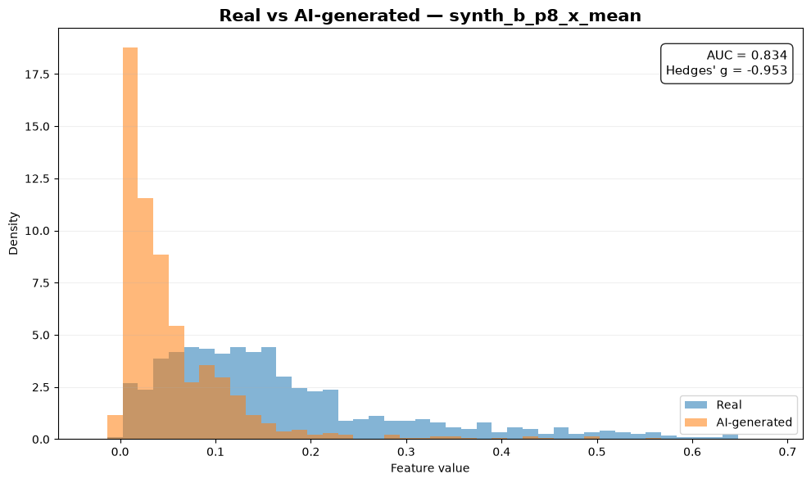
Figure 1. Distribution of the strongest FFT/spectral feature.
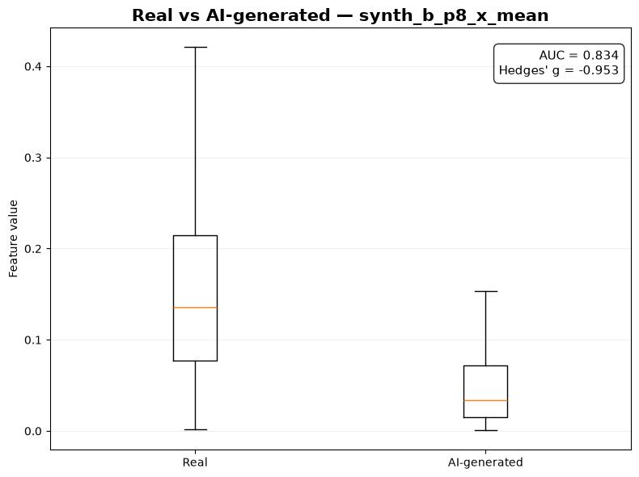
Figure 2. Boxplot of the same feature.
Measure | Value
Real mean | 0.177648
AI-generated mean | 0.056547
Hedges' g | −0.953
AUC separation | 0.834
Mann–Whitney p | 1.20 × 10⁻¹¹⁸
Meaning: this single spectral feature provides strong class separation in this dataset. AUC 0.834 means the feature is substantially better than random (0.5) at ranking real vs AI-generated samples.

2. Consistency Across Strong Spectral Features
The same type of separation appears across several period-4 and period-8 spectral features, so the strongest result is not an isolated feature.
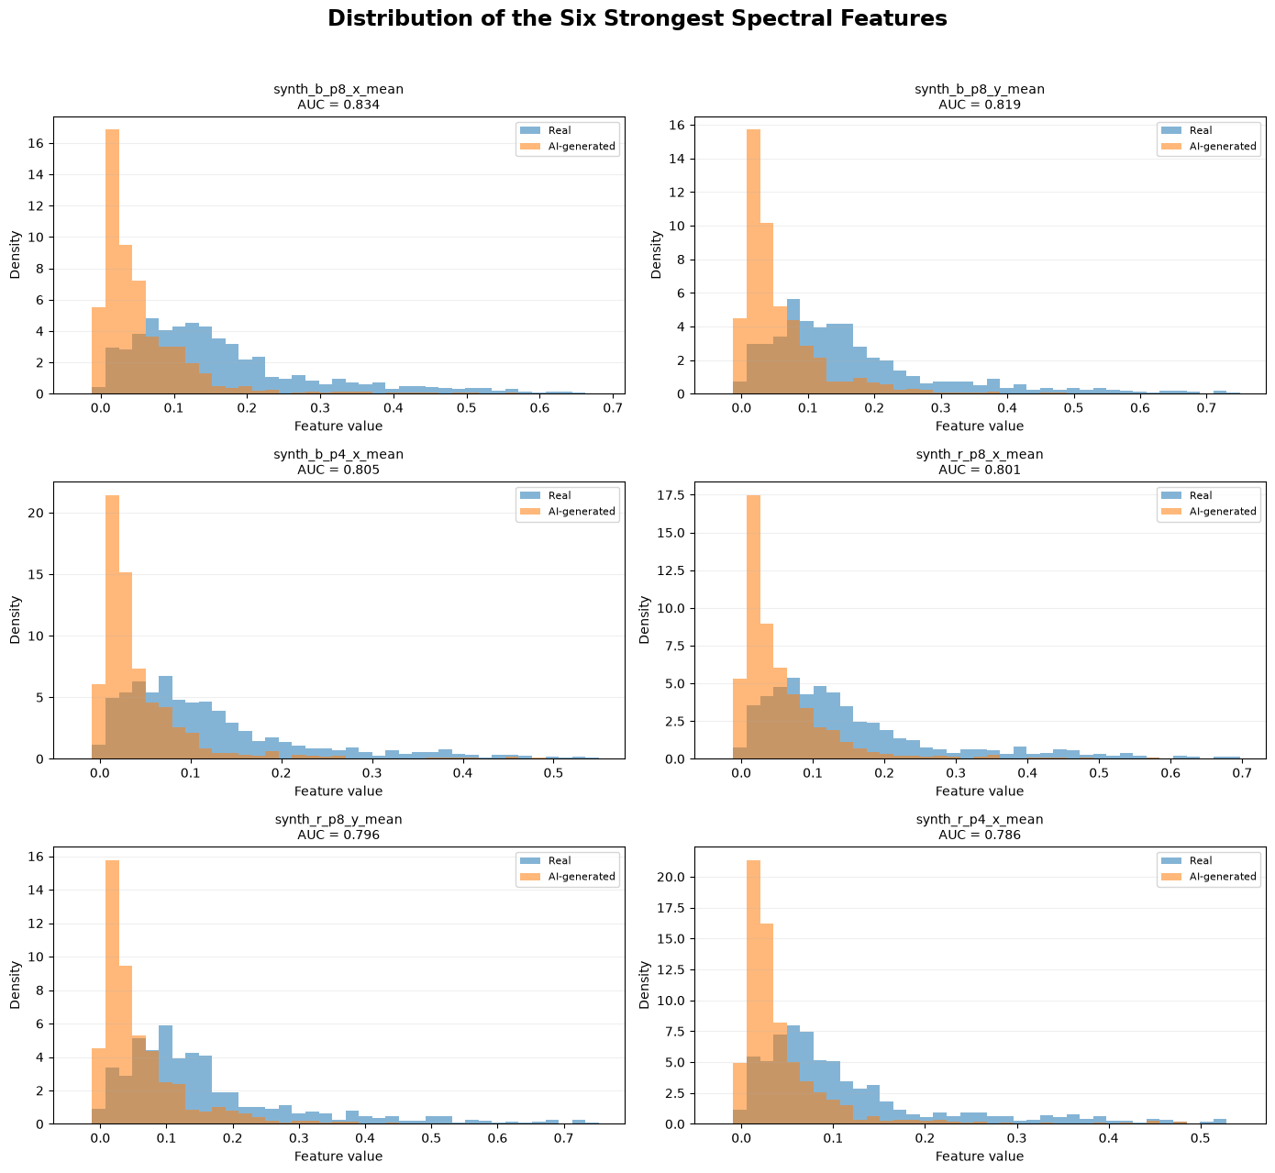
Figure 3. Six strongest spectral-feature distributions.
Feature | AUC separation
synth_b_p8_x_mean | 0.834
synth_b_p8_y_mean | 0.819
synth_b_p4_x_mean | 0.805
synth_r_p8_x_mean | 0.801
synth_r_p8_y_mean | 0.796
synth_r_p4_x_mean | 0.786
Main takeaway: specific periodic components in the frequency representation are the clearest signal found by this analysis.

3. Comparison of the Forensic Analyses
Instead of comparing every one of the 269 features, the plot below shows the best-performing feature from each family.
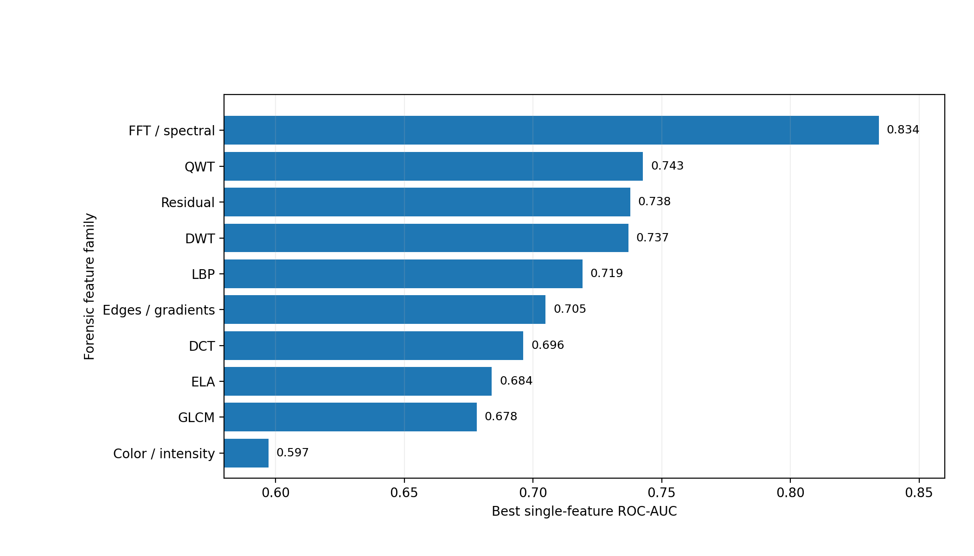
Figure 4. Best single-feature AUC separation by forensic family.
FFT/spectral is clearly strongest. QWT, residual, DWT and LBP are the next most promising groups. DCT, ELA and GLCM show moderate separation, while simple color/intensity statistics are comparatively weak.
Family | Best AUC
FFT / spectral | 0.834
QWT | 0.743
Residual | 0.738
DWT | 0.737
LBP | 0.719
Edges / gradients | 0.705
DCT | 0.696
ELA | 0.684
GLCM | 0.678
Color / intensity | 0.597
The result does not mean weaker families are useless. It means their best single scalar features were less discriminative than the strongest FFT features on this dataset.

4. Effect Size and PCA
AUC tells us about class separation. Hedges' g tells us how large the difference is relative to the variation.
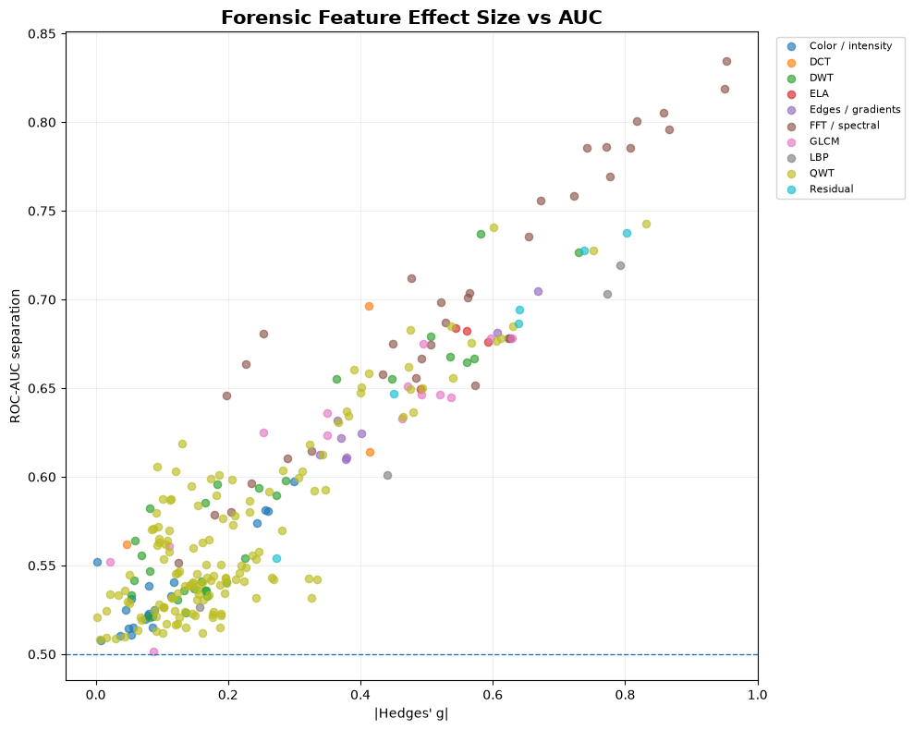
Figure 5. Effect size versus AUC. Strong FFT features are toward the upper-right.
This supports the spectral result: the strongest FFT features have both relatively large effect sizes and high AUC, rather than only very small p-values.
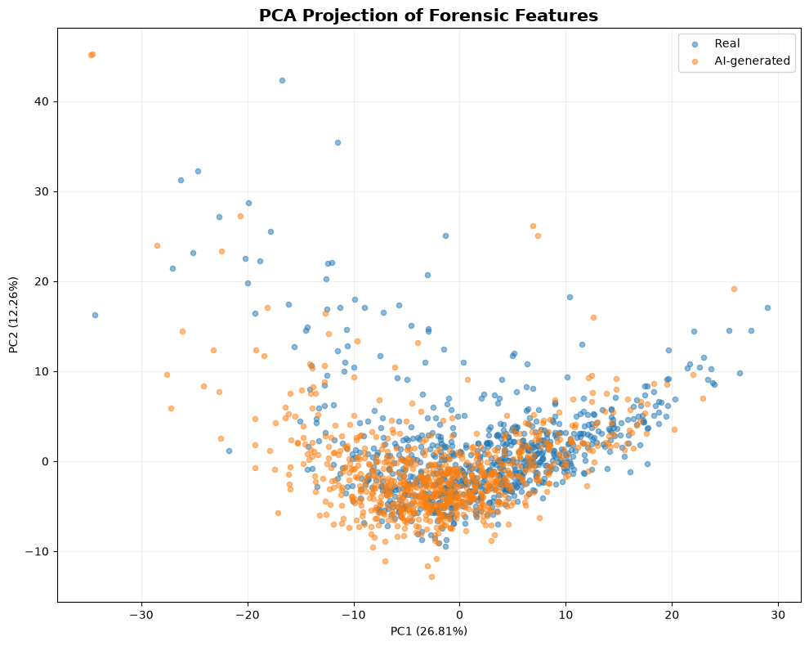
Figure 6. PCA projection of the 1,600 images.
PCA shows substantial overlap between the classes. PC1 explains 26.81% and PC2 12.26% of the variance (39.06% together). This is not a contradiction: PCA explains overall variance and is not trained to separate real and fake.

5. Final Findings
Question | Result
Strongest family | FFT / spectral
Best feature | synth_b_p8_x_mean
Best AUC separation | 0.834
Other strong candidates | QWT, residual, DWT, LBP
DCT | Moderate; weaker than FFT
Color / intensity | Weakest family (best AUC 0.597)
Feature quality | 269 features; 0 missing; 0 constant
Next step: start the CNN stage with an RGB baseline, then test FFT/spectral, residual and DWT representations one at a time and compare them using controlled ablations. These results show dataset-level differences; they do not yet prove cross-generator generalization.
Source: analysis_800_v1(3).ipynb and its executed outputs.

