These are the links in this lecture:

* + <http://www-formal.stanford.edu/jmc/history/lisp/lisp.html>
  + [Google: MapReduce: Simplified Data Processing on Large Clusters](http://research.google.com/archive/mapreduce.html)
  + [Apache Hadoop](http://research.yahoo.com/files/cutting.pdf)
  + [Yahoo! web scale search indexing](http://developer.yahoo.com/hadoop/)
  + [Amazon Web Services Elastic MapReduce](http://aws.amazon.com/elasticmapreduce/)
  + [Spark: Cluster Computing with Working Sets](http://people.csail.mit.edu/matei/papers/2010/hotcloud_spark.pdf)
  + [*Resilient Distributed Datasets: A Fault-Tolerant Abstraction for In-Memory Cluster Computing*](http://usenix.org/system/files/conference/nsdi12/nsdi12-final138.pdf)

# History Review

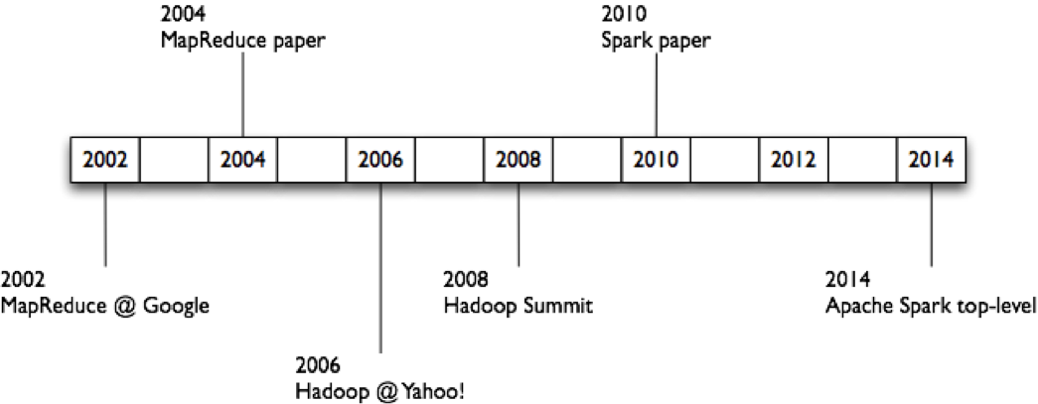

* 1956-1979: Stanford, MIT, CMU, and other universities develop set/list operations in LISP, Prolog, and other languages for parallel processing (see <http://www-formal.stanford.edu/jmc/history/lisp/lisp.html>).
* Circa 2004: [Google: MapReduce: Simplified Data Processing on Large Clusters](http://research.google.com/archive/mapreduce.html)  
   by Jeffrey Dean and Sanjay Ghemawat
* Circa 2006: [Apache Hadoop](http://research.yahoo.com/files/cutting.pdf), originating from the Yahoo!’s Nutch Project  
   Doug Cutting
* Circa 2008: [Yahoo! web scale search indexing](http://developer.yahoo.com/hadoop/)  
   - Hadoop Summit, Hadoop User Group
* Circa 2009: Cloud computing with [Amazon Web Services Elastic MapReduce](http://aws.amazon.com/elasticmapreduce/) (AWS EMR)  
  , a Hadoop version modified for Amazon Elastic Cloud Computing (EC2) and Amazon Simple Storage System (S3), including support for Apache Hive and Pig.

# Apache Spark Research Papers

* [Spark: Cluster Computing with Working Sets](http://people.csail.mit.edu/matei/papers/2010/hotcloud_spark.pdf),   
  Matei Zaharia, Mosharaf Chowdhury, Michael J. Franklin, Scott Shenker, Ion Stoica.   
  USENIX HotCloud (2010)  
  .
* [Resilient Distributed Datasets: A Fault-Tolerant Abstraction for In-Memory Cluster Computing](http://usenix.org/system/files/conference/nsdi12/nsdi12-final138.pdf),   
  Matei Zaharia, Mosharaf Chowdhury, Tathagata Das,   
  Ankur Dave, Justin Ma, Murphy McCauley, Michael J. Franklin,   
  Scott Shenker, Ion Stoica  
  . NSDI (2012)