̨﷽

An-Najah National University

Faculty of Engineering and Information Technology

Computer Engineering Department



**Hardware Graduation Project**

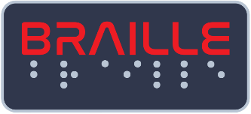

**Braille Printer**

Prepared by :

**-Momen Odeh -Noor Aldeen Abu Shehadeh**

Supervised by :

**Dr. Samer Arandi**

Submitted on :  
**28th, August 2023**

Presented in partial fulfillment of the requirements for Bachelor degree in Computer Engineering.

# Dedication

Dedication to loving memory of our grandmother, our loving parents, family, friends and for everyone who believed and loved us.

# Acknowledgment

We extend our deepest gratitude and appreciation to the individuals who have played a significant role in our graduation project. Their guidance, support, and unwavering belief in our abilities have been invaluable throughout this journey.

We would like to **thank our supervisor** **Dr. Samer Arandi** a lot for his helpful, kind, patience and taking care of us, and for making everything simple. He was always inspiring and encouraging us to move.

We would also like to **thank all the teachers and teacher’s assistant in the Department of Computer Engineering**, and we feel proud to be students in it, as this helps us to improve our educational level as well as improve our skills.

# Disclaimer

This report was written by students at the Computer Engineering Department, Faculty of Engineering, An-Najah National University. It has not been altered or corrected, other than editorial corrections, as a result of assessment and it may contain language as well as content errors. The views expressed in it together with any outcomes and recommendations are solely those of the students. An-Najah National University accepts no responsibility or liability for the consequences of this report being used for a purpose other than the purpose for which it was commissioned.

# Table of content

Dedication 2

Acknowledgment 3

Disclaimer 5

Table of content 5

Abstract 6

Chapter 1: Introduction 7

▪ Statement of the problem 7

▪ Objective 7

▪ Scope of the work 8

▪ Importance of the work 9

▪ Organization of the report 10

Chapter 2:Constraints, Standards and earlier course work 12

▪ Constraints and design limitations 12

▪ Standards 13

▪ Earlier course work 13

Chapter 4: Methodology 14

▪ How It Works? 14

▪ The Mechanism 15

▪ What We Need? 16

▪ Design 20

Chapter 5: Result and Analysis 28

Chapter 7: Conclusions and Recommendation 29

# Abstract

People with visual disabilities suffer from the problem of unavailability of books  
and references in Braille, which restricts their access to them. Therefore, there is a need  
for printing Braille. However, they face several challenges, including the high cost of  
printers and their scarcity in the market.

A Braille printer provides a valuable means for visual disabilities people to access printed  
knowledge and materials by converting plain texts into Braille patterns. This significantly  
enhances the learning and personal development of individuals with visual impairments.

We implemented a Braille Printer that connected with web server to get the text. It also contains a paper feeder which will scroll paper from the paper container to the printing area. the paper feeder consists of a DC motor to scroll the paper. printing mechanism contains a solenoid to knock on the paper that is pinned at the XY coordinate, controlled using 2 stepper motors. After finish printing the feeding mechanism scrolling the paper from printing area to out of printer.

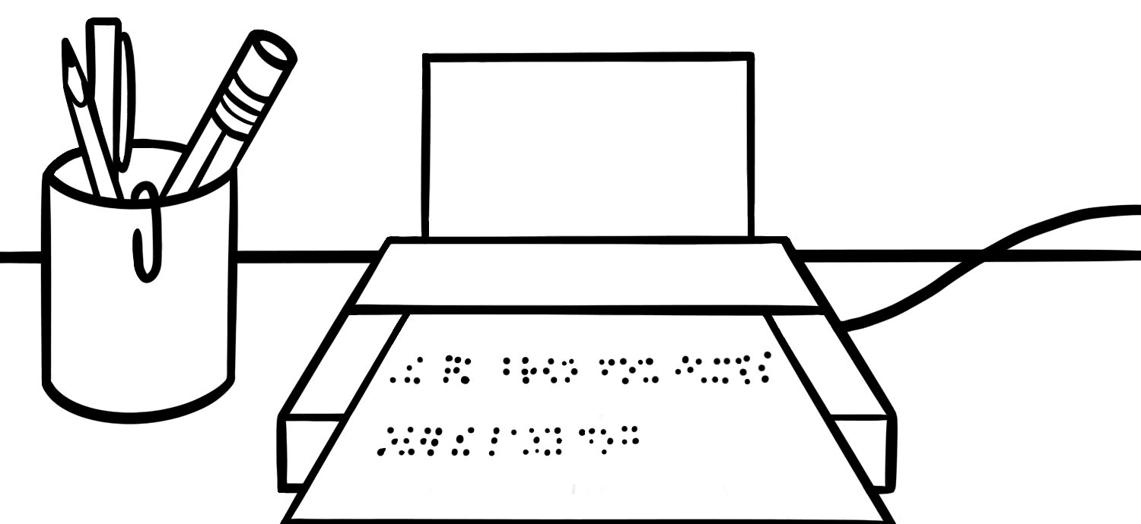

# Chapter 1: Introduction

## Statement of the problem

People with visual disabilities they face several challenges when need to print text in Braille. One of the most significant challenges they face is the high cost of buying Braille printers, placing them beyond the reach of many who would benefit from their use.

Moreover, the scarcity of Braille printers in the market exacerbates this issue. While paper printers are widely available and accessible, Braille printers are relatively limited in supply. This scarcity is a result of several factors, including the specialized nature of Braille embossing technology, the smaller target market for such devices, and the technical complexities involved in their production.

As a consequence of these challenges, visually impaired individuals often encounter barriers in obtaining crucial printed materials in a format they can comprehend. Educational materials, books, work-related documents, and even everyday communication can all be inaccessible due to the high cost and scarcity of Braille printers. This not only hinders their educational and professional progress but also restricts their ability to fully engage in social and personal activities that involve written information.

In light of these obstacles, there is a pressing need for innovative solutions that address the cost-effectiveness and availability of Braille printers. By making these devices more affordable and accessible, individuals with visual disabilities can gain greater independence, educational opportunities, and inclusion in various aspects of society. Thus, a comprehensive exploration of these challenges and potential solutions is crucial in ensuring equitable access to information and promoting the overall well-being of visually impaired individuals.

## Objective

The purpose of our work is to address the limitations and challenges visually impaired people face in the printing text in braille, and to provide them with a comprehensive solution through the Braille Printer system. The objectives of our work are as follow:

* **Develop a user-friendly system**: Our main goal is to create a user-friendly Braille Printer, complete with an LCD display and a buzzer to provide transparent feedback during the printing process. Additionally, we are designing a web application that is intuitive and user-friendly. This application will empower users to effortlessly input the text they desire to be printed in Braille.
* **Automating the Printing Process:** Our goal is to create a printer that is completely automated. This required placing the papers in the paper container, entering the text using a web application, and once the printing is complete, take the printed paper.
* **Enhancing Affordability and Accessibility of Braille Printing**: Currently, Braille printers available in the market not only take a significant amount of time to acquire but also come at a high cost ranging from $4000 to $7000. In contrast, our printer can be assembled rapidly, making it available on demand, and it is offered at a much lower cost, ranging from $300 to $400.
* **Precision and Quality**: The printer produces good-quality results that adhere to Braille language rules.

## Scope of the work

* **Web Application using React JS:** Develop a Web application using React JS that allows users to connect to the Braille Printer via the ESP8266 D1 mini (WiFi module). The application should provide a user-friendly interface for enter text and sending it to the Printer.
* **WiFi Connectivity:** Implement the **WiFi** communication between the Web application and the Printer using the ESP8266 D1 mini. Establish a reliable connection to facilitate data transmission between the Web application and the Printer.
* **Designing a Text-to-Braille Conversion Algorithm:** Develop an algorithm that received the text from WiFi module then proceed to convert the text into a suitable representation that corresponds to Braille language rules.
* **Developing an Efficient Paper Feeder Mechanism:** Our focus is on creating a robust paper feeding system that operates seamlessly from the paper container to the printing area.
* **Developing a Printing mechanism:** build an XY coordinate to controlling the printing process and put solenoid on coordinate to knock the paper (for printing).

* **System Integration and Testing:** Integrate all the components and functionalities of the system, including the Web application, WiFi connectivity, paper feeders, XY coordinate, LCD and buzzer. Conduct thorough testing to ensure the system operates reliably and accurately.

## Importance of the work

The Braille Printer holds significant importance for visually impaired people. Here are the key reasons why this work is essential:

* **Precision and Quality:** This printer yields good results, meticulously adhering to Braille language rules concerning the spacing between knocked points and characters.
* **Time and Effort Savings comparing with manual way:** Traditional manual way methods can be time-consuming and labor-intensive. The Braille Printer significantly reduces the time and effort required for printing paper and reduce the error while printing the papers.
* **Low coast:** Braille printers available in the market have a high cost ranging from $4000 to $7000. In contrast, our printer it is offered at a much lower cost, ranging from $300 to $400.
* **Availability:** Braille printers available in the market take a significant amount of time to acquire. In contrast, our printer can be assembled rapidly, making it available on demand.
* **Enhancing Customer Satisfaction:** This initiative seeks to elevate customer satisfaction by introducing cost-effective Braille printers into the market. By offering affordable alternatives, individuals with visual disabilities can access high-quality Braille printing solutions that not only meet their needs but also align with their budget constraints. This approach ensures that the value of accessible and accurate Braille printing is attainable to a broader audience, ultimately leading to increased customer contentment and inclusivity.

**▪ Organization of the report**

The report is structured in a logical and systematic manner to effectively present the information related to the project. The organization of the report is as follows:

* **Introduction:** This section provides an overview of the project, highlighting the problem statement, objectives, and the importance of the work. It sets the context for the rest of the report.
* **Constraints, Standards/Codes, and Earlier Course Work:** In Chapter 2, a detailed discussion is provided on the constraints, standards, and codes that were considered during the project. Additionally, any relevant earlier coursework that informed the project's methodology or approach is discussed.
* **Literature Review:** Chapter 3 focuses on the literature review. It presents a comprehensive review of existing research, studies, and relevant literature related to Braille Printers, automation techniques, and similar projects. This section helps establish the project's context and highlights any gaps in the existing knowledge.
* **Methodology:** Chapter 4 explains the materials and methods used throughout the project. It provides a detailed description of the experimental setup, the Web application development process, and the design and implementation of the Braille Printer. The chapter outlines the steps taken to achieve the project objectives.
* **Results and Analysis:** Chapter 5 presents the results obtained from the project. It includes the outcomes of the Printing process using the Braille Printer, as well as any relevant data or measurements. The results are analyzed and interpreted to draw meaningful conclusions.
* **Discussion:** Chapter 6 focuses on the discussion of the results. It provides a comprehensive analysis of the findings, highlighting the features, benefits, and limitations of the Braille Printer. The chapter also addresses any challenges faced during the project and offers recommendations for future improvements.
* **Conclusion:** The report concludes by summarizing the key findings, reiterating the significance of the work, and highlighting its potential impact. It may also include a reflection on the overall project experience and suggestions for further research.
* **References:** A list of all the references cited throughout the report is provided in the References section, following the conclusion.

# Chapter 2: Theoretical Background and Previous Work

Braille printing technology has undergone significant advancements over the years, with the primary objective of facilitating access to written content for individuals who are blind or visually impaired. The development of Braille printers has played a pivotal role in achieving this goal.

Initially, Braille was printed manually by using a Braille stylus to emboss dots onto paper. However, this method was inefficient and time-consuming.

The transition from manual embossing to mechanical embossing devices marked a crucial advancement in Braille printing technology. Mechanical embossers utilized punch and die mechanisms to emboss Braille characters onto paper. While these devices offered improved efficiency, they were still relatively large, expensive, and limited in terms of print speed.

The integration of digital technology into Braille printing revolutionized the field. Electronic Braille printers emerged, leveraging computer-generated content to emboss Braille characters onto paper. These printers enabled the conversion of digital text into Braille format, making it possible to produce a wide range of materials, from books to educational materials.

On the other hand, this improvement required to complex design for the printer and high cost. in our design we aim to build printer with low cost and simple design.

# Chapter 3: Methodology

## How It Works?

At first you need to turn on the printer by press on power button then the WiFi module start connecting to the WiFi then connect to the server and print status on LCD then reset XY coordinate to the start position.

Now we can enter text that you want to print it to the Web application then press on print button if there is a previous req that send to the server will appear message and we can re press on print button after loader disappear after that the text is sent to the server then the WiFi module listen to the server if they have a new text to print it or not if there, then WiFi module send text to the Arduino serially then Arduino send received to then WiFi module serially then the WiFi module update status on server to be in progress then Arduino will start to printing process.

To start of the printing process should there is a papers on paper container if the paper container not contain papers then the buzzer beeping and print “No papers” on LCD. If there is a paper in paper container then the paper feeder scrolls one paper to the first roller then the roller scrolls the paper to the printing area then take char by char from string that contain text then convert it to the representation in Braille then start knocking on the paper by the solenoid and move to the next until paper is full or finish printing then the roller 2 scroll the paper to the out of printing area, if paper is full, then after move paper to out of printing area return to take new paper and repeat process and continue until finish text. After finish printing the buzzer beeping and print “finish printing” on the LCD and update status on Server to Finished then show pop up on the Web application that indicate to finish printing.

## The Mechanism of conversion text to braille: when text received in the Arduino store it on string then when start printing take char by char and get the corresponding representation on braille language by using this mechanism:

bool SymbolMatrices[numSymbol][numRows][numCols]=/*store the representation of all char */

{

  // Matrix for 'a'

  {

    {true, false},

    {false, false},

    {false, false}

  },

  // Matrix for 'b'

  {

    {true, false},

    {true, false},

    {false, false}

  },/*and so on to all char*/}

int getSymbolIndex(char c)// take char and return corresponding index

{

  if(c >= 'a' && c<='z')

  {

    return c-'a';

  }

  else if(c >= 'A' && c <= 'Z')

  {

    return c-'A';

  }

  else if(c == '.')return 26;

  else if(c==',')return 27;

  else if(c=='?')return 28;

  else if(c=='!')return 29;

  else if(c=="'")return 30;

  else if(c=='-')return 31;

  else if(c=='#')return 31;

  else if(c==' ')return 33;//capital 🡪 index 34 | number 🡪 index 35

  else if(c>='0' && c<='9')

  {

    return 36 + (c-'0');

  }

  else return 33;//any other char return ' '

}

## What We Need?

* **Hardware component**

| **Hardware Component** | **Image** | **Number of times Used** | **Purpose** |
| --- | --- | --- | --- |
| Arduino Mega |  | **1** | Main controller board for overall system functionality. |
| ESP8266 D1 mimi |  | **1** | Used for WiFi communication between the Braille Printer and the Web application application. |
| Optical sensor TCRT 5000 |  | **3** | Used to detect if there is a paper or not. |
| Stepper Motors Nema 17 |  | **2** | Control to the XY coordinates. |
| A4988 Stepper Motor Driver Carrier |  | **2** | Drives the stepper motor responsible for precise movement in the system |
| DC motor |  | **3** | Controlling of paper feeder and rollers |
| H-bridge |  | **2** | Drives the DC motor responsible for precise movement in the system |
| Servo Motor MG966R |  | **1** | To prevent the paper scrolling when put it in paper container. |
| 5V 2-Channels Relay Module Active High/Low |  | **1** | To controlling to the solenoid and buzzer. |
| Inverter IC |  | **1** | To Invert the logic of EN in driver of stepper motors. |
| DC 12V 2.1Kg 10mm Stroke Push Pull Type Solenoid |  | **1** | To knocking on the paper. |
| Braille pen |  | **1** | To put it on the head of solenoid |
| 12V 16mm Metal Push Button Switch |  | **1** | Serves as an on/off switch for the entire system, allowing easy control of the system's power. |
| 12V 12A Power Supply |  | **1** | Supplies the required power to the system, ensuring proper functioning of the components. |
| LM2596 Adjustable Step Down Buck Converter |  | **2** | Provides a regulated 5V output to power several components in the system.   Generates a stable 6.7V supply voltage to power the Arduino board and ensure its operation. |
| LCD 20*4 |  | **1** | To show the status of printing process |
| 12v Buzzer |  | **1** | To indicate to the status of the printing process. |
| Limit switch |  | **2** | To reset XY coordinate to the start point. |
| MGN12 12mm Linear Guide Rail 40cm |  | **1** | Y coordinate |
| MGN12 12mm Linear Guide Rail 30cm |  | **1** | X coordinate |
| MGN12C Steel Slide Block Carriage Unit |  | **2** | To move on X and Y coordinate |
| GT2 Timing Pulley 20 Teeth Bore 6.35mm |  | **2** | To put it in the head of the stepper motor to move system |
| GT2 16 Teeth Idler Pulley Bore 3mm |  | **2** | To put it in the corresponding side of each of stepper motors. |
| 1meter Rubber GT2-6mm Open Timing Belt ,6mm Width |  | **2** | To move MGN (XY movement) |
| Paper feeder |  | **1** | Scroll the paper from paper container to the roller 1 |
| Paper roller 1 |  | **1** | Scroll the paper to the printing area |
| Paper roller 2 |  | **1** | Scroll the paper to the out of printing area |
| PVC Foam Sheet |  | **1** | Put it as a surface of printing area to knock the paper on it |

## Design

* **Body of machine**

1. We first took apart an old printer to see how the paper feeding mechanism inside the printer worked and from this printer we get a DC motors, paper feeder and rollers.

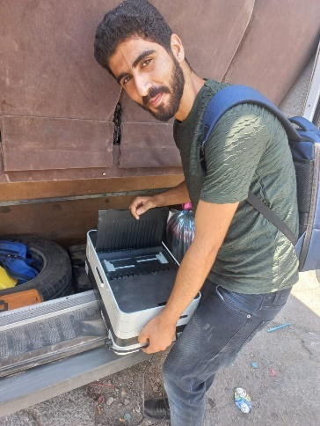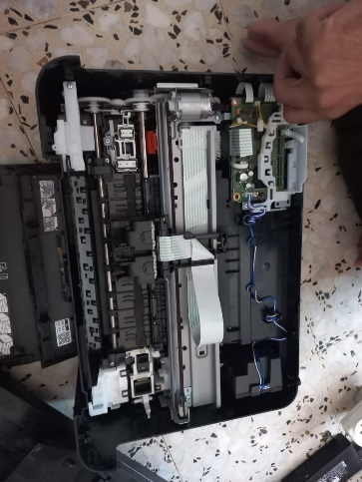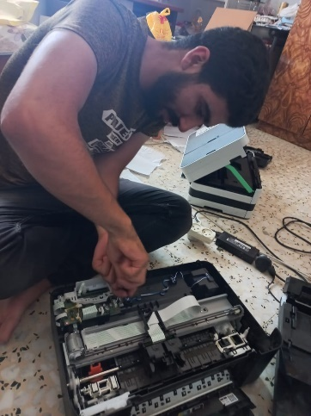

Figure1: dismantled an old printer

1. We began by envisioning the printer's structure based on the old printer, and then proceeded to construct the framework using wood. The structure design indicated the need to select the correct angle for the flat surface responsible for paper feeding.

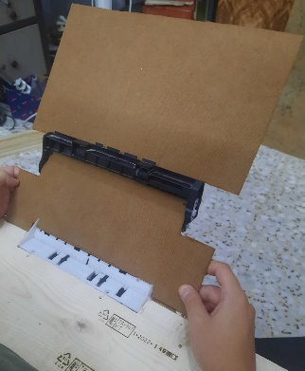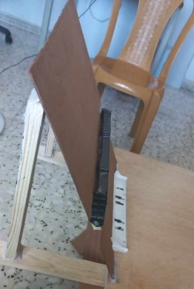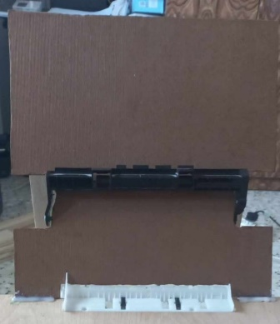

Figure 2: paper feeder in paper container

1. building the XY coordinate.

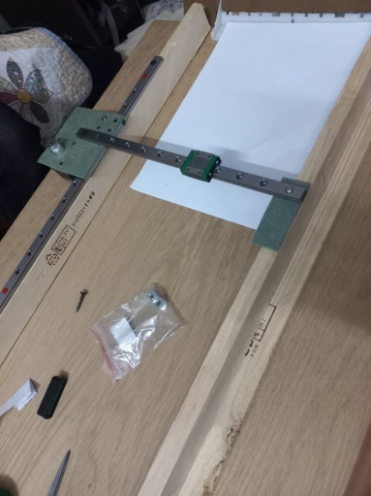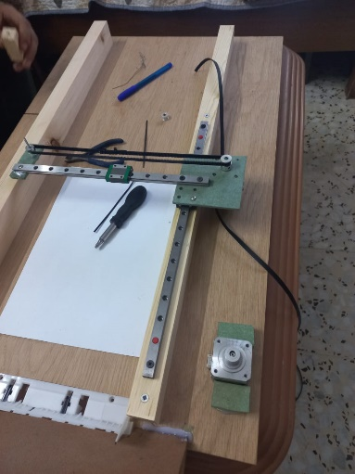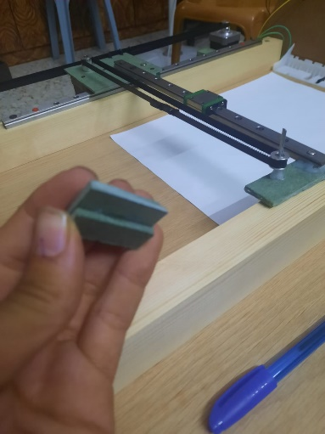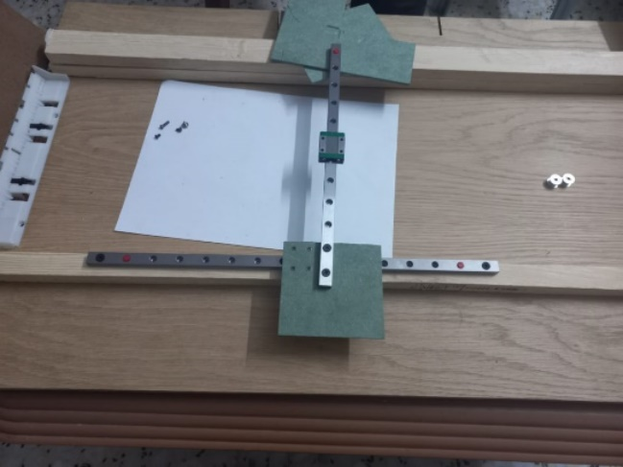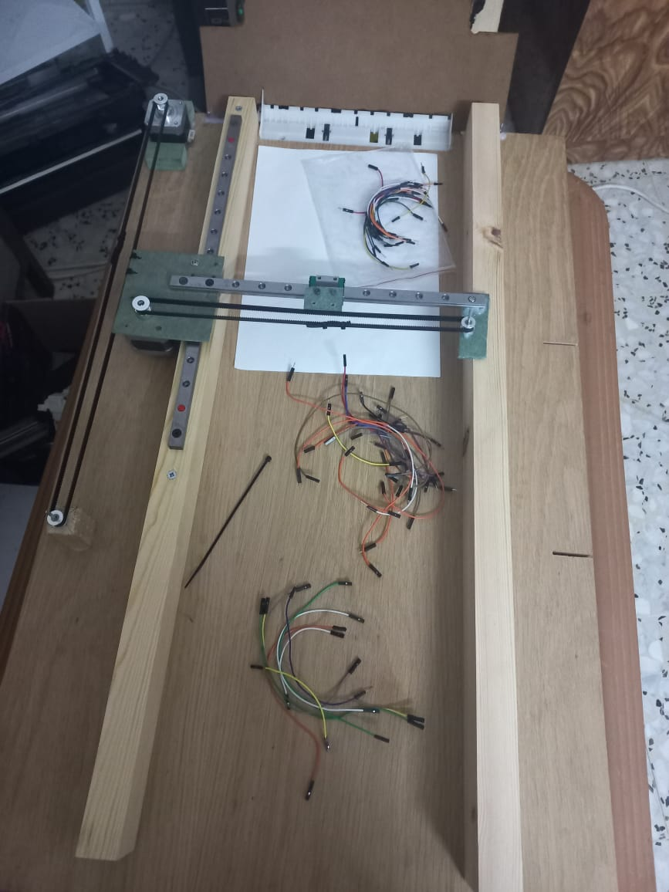

Figure 3: build XY coordinate

1. We attached the paper rollers at the start and at the end of printing area.

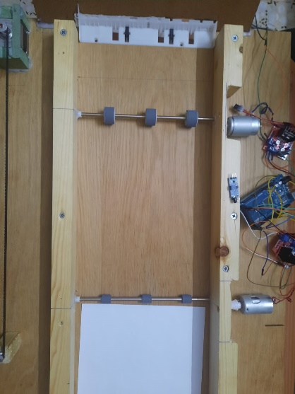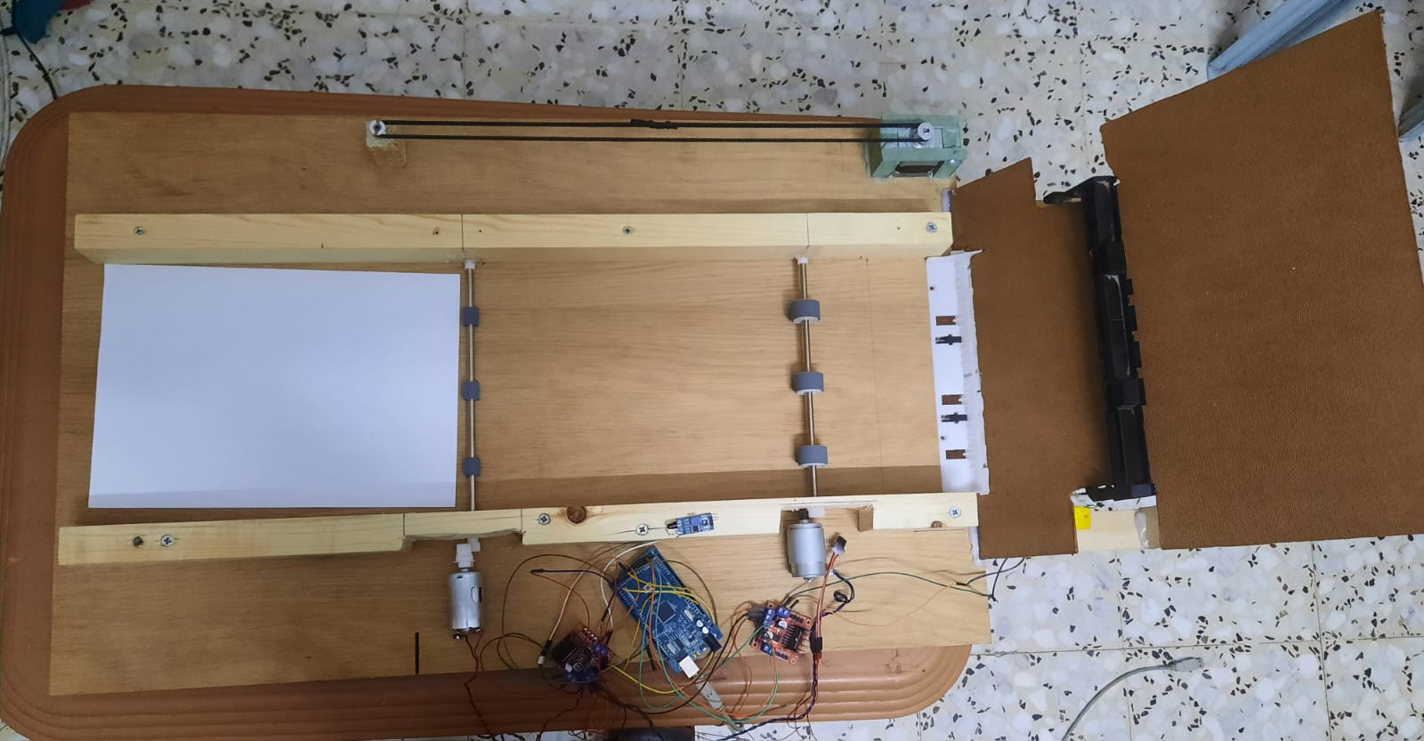

Figure 4: attached the paper rollers

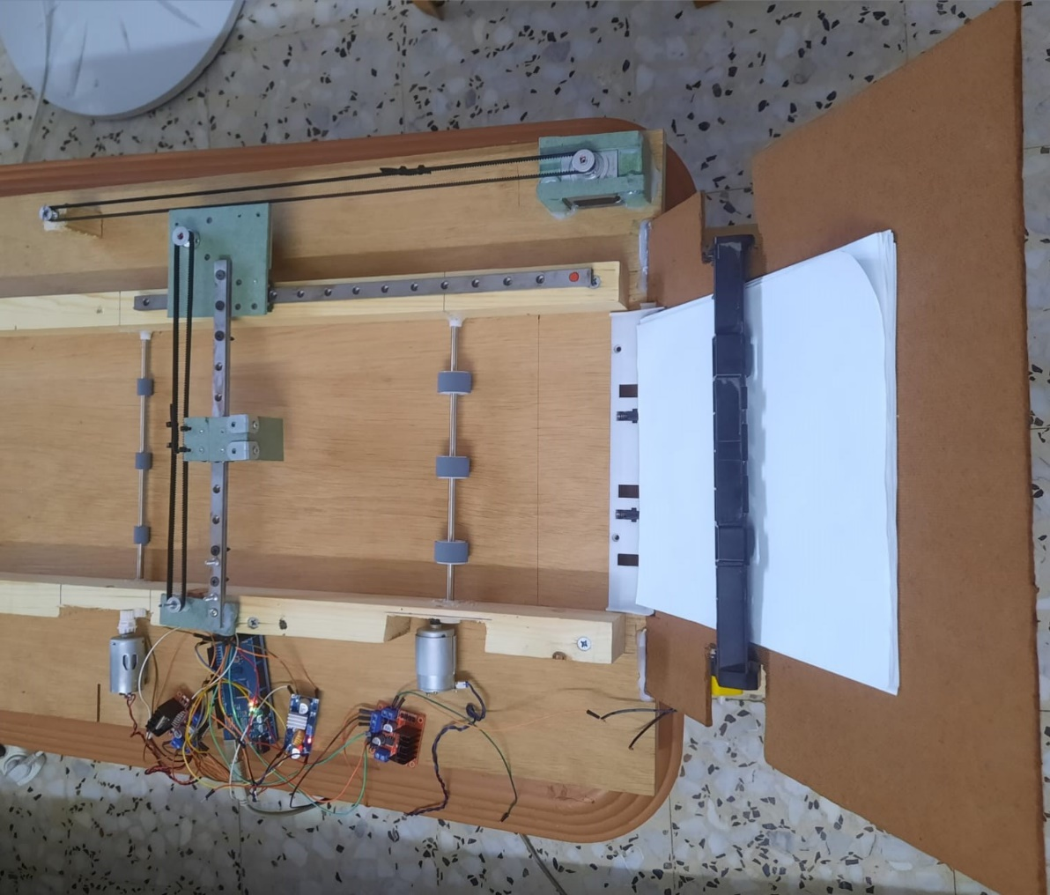  
Figure 5: attached feeder, paper rollers and XY coordinate

1. **Move to the production stage:**

The previous design was a prototype due to its lack of stability and imprecise dimensions. As a result, we reconstructed the original design with the help of a carpenter to achieve a stable and precise outcome.

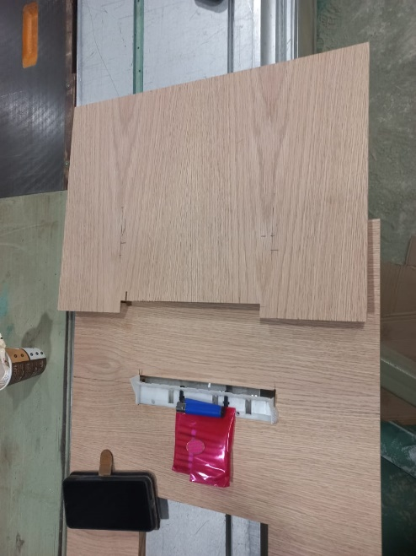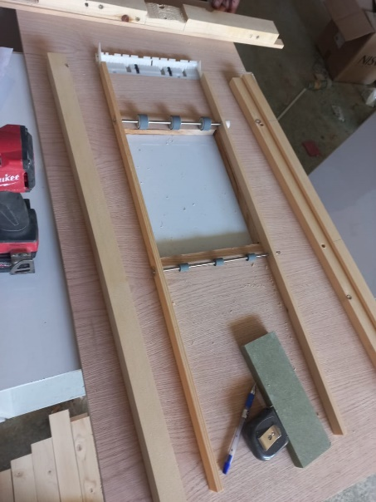

Figure 6 : start working to the final design

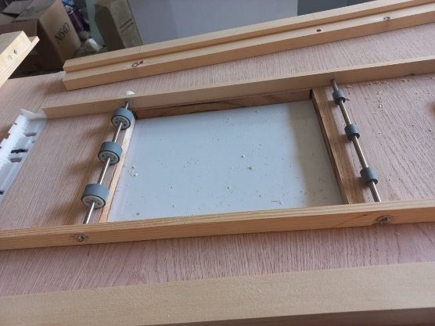 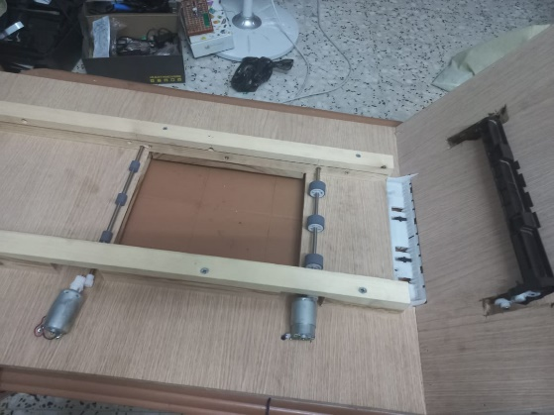

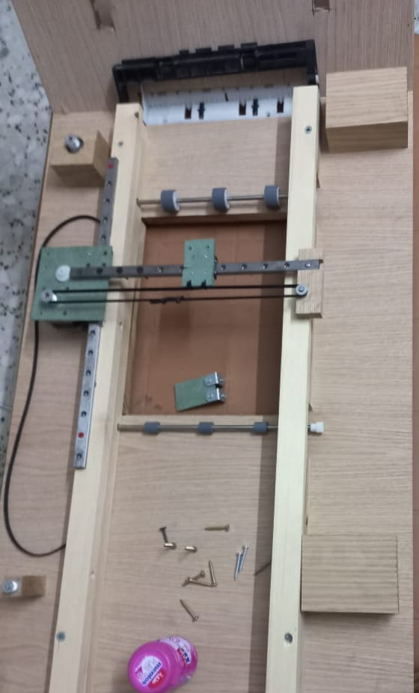

Figure 7: assemble of the final design

* **HC_06 model connection**

In addition, we incorporated an HC-06 Bluetooth module into the system. The HC-06 module was connected to pins 10 and 11 of the Arduino Mega for transmitting (TX) and receiving (RX) data. We powered the module by connecting its VCC and ground pins to the logic converter, which, in turn, received 5 volts from the LM2596 DC-DC converter. This setup allowed us to establish a wireless communication link between the Arduino and a mobile device using the Bluetooth module. We utilized the Mobile Arduino Serial Bluetooth Terminal app to send and receive commands, enabling convenient control and monitoring of the system remotely, this pseudocode explain how its implemented in c :

if (Serial.available()) {

outgoing = Serial.readString();

bluetooth.write(outgoing);

}

if (bluetooth.available()) {

incoming = bluetooth.readString();

Serial.print(incoming);

}

delay(100);

* **React native app**  
   Furthermore, we developed a mobile application using React Native CLI with a user-friendly interface. This mobile app served as a control interface for the system, allowing users to conveniently interact with the various functionalities and settings. The React Native framework enabled us to create a cross-platform app compatible with Android .

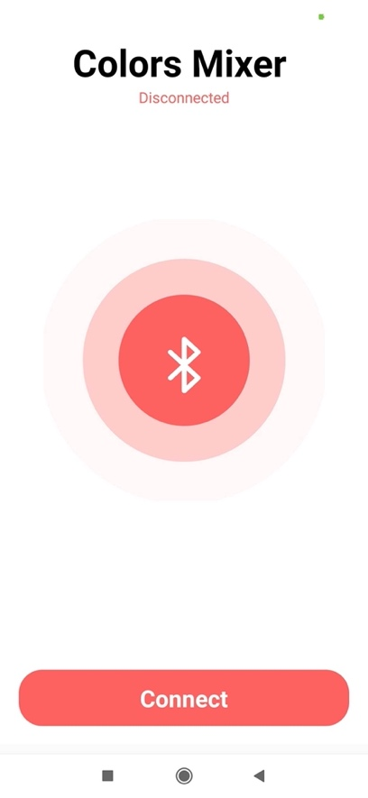 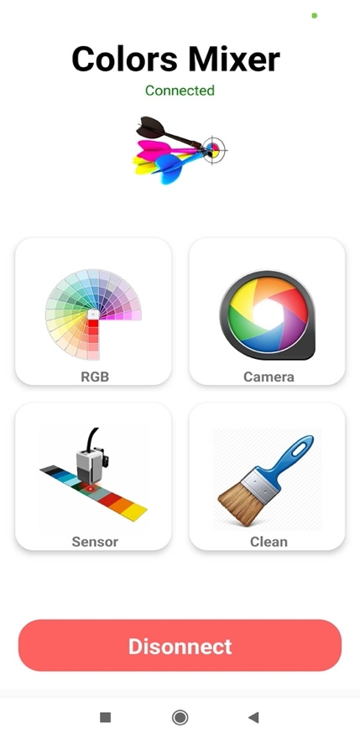

In our project, we utilized the **react-native-bluetooth-serial-next** library to establish Bluetooth communication in our React Native mobile application. This library provides a convenient interface for interacting with Bluetooth devices.

* **Container design**To ensure leak-proof and containment of the paints, we sought the assistance of a skilled 3D printing specialist to design a suitable container. The container was specifically designed with a 1/2 inch opening to seamlessly accommodate the solenoid valve and ensure compatibility with the system. This precise design enables efficient controlled to the paints without any leakage . The resulting design is as follows:

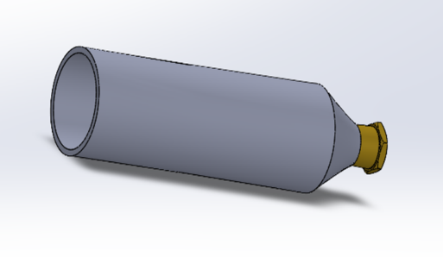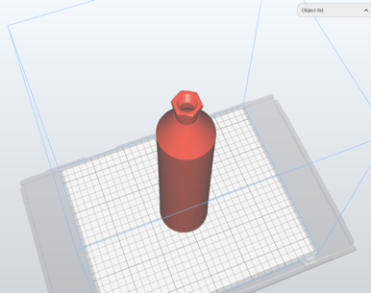

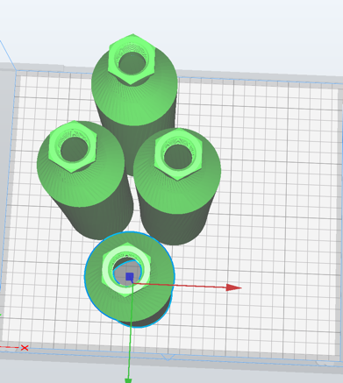 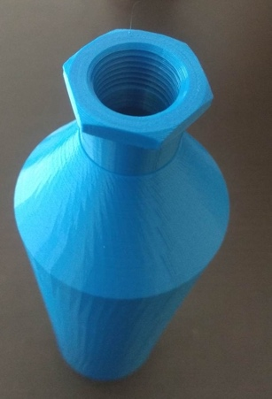

* **Control Peristaltic pump**

In our system, we employed four A4988 drivers to individually control four peristaltic pumps, each responsible for one color in the CMYK color model. These drivers were soldered onto a custom board, similar to a shield, along with a DC-to-DC buck converter. The buck converter efficiently converted the 12-volt input voltage to a stable 5-volt output, which powered both the drivers and other components in the system requiring 5 volts.

The circuit required six pins: four pins for enable signals linked to pins 22 to 25 in controller , one for the pulse signal, and one for the direction signal . These two pins were consistent across all four drivers connected to pins 26 and 27. The drivers were directly connected to the coil of each peristaltic pump, enabling precise control over the pumping action.

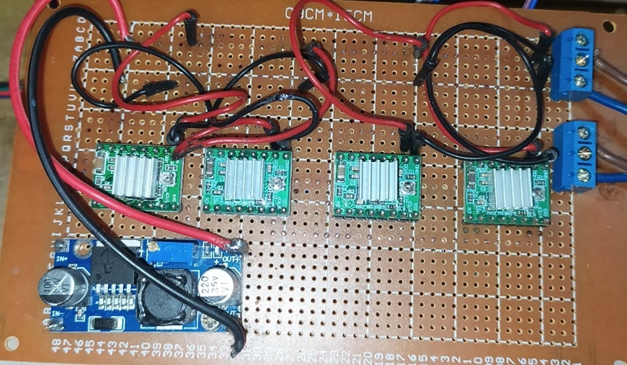

* **Peristaltic pump**

Each pump was programmed to operate for a specific duration, tailored to the requirements of each color. By assigning different time intervals to each pump, we could ensure that the colors were dispensed in the desired proportions and with precise timing, resulting in accurate color mixing and distribution within the system. This synchronized and coordinated operation of the pumps ensured consistent and reliable performance, enabling us to achieve the desired output quality and efficiency in our system.

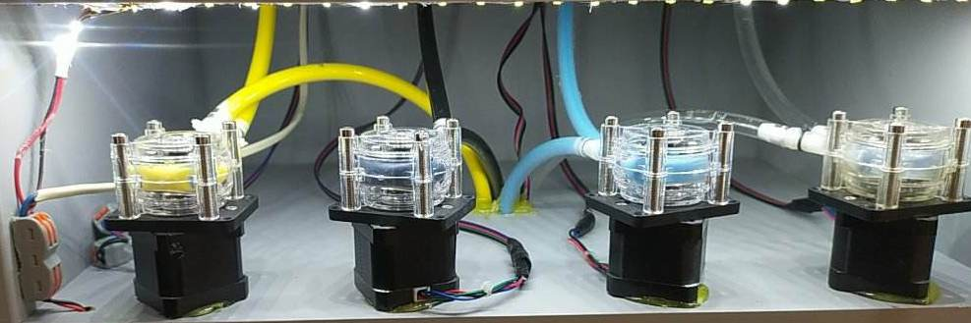

**• Adding ultra-sonic**

We integrated an ultrasonic sensor into the system to check for the presence of a final tube. The ultrasonic sensor was connected to the controller, with the echo and trigger pins connected to pins 28 and 29 respectively. It was powered by a 5V supply from the LM2596 DC-DC converter.

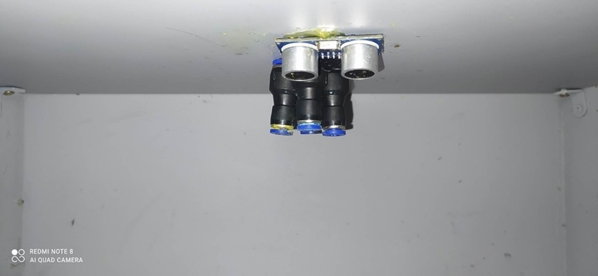

* **Final design of machine**The final design of the machine incorporates all the necessary hardware components and auxiliary elements to ensure its proper functionality.

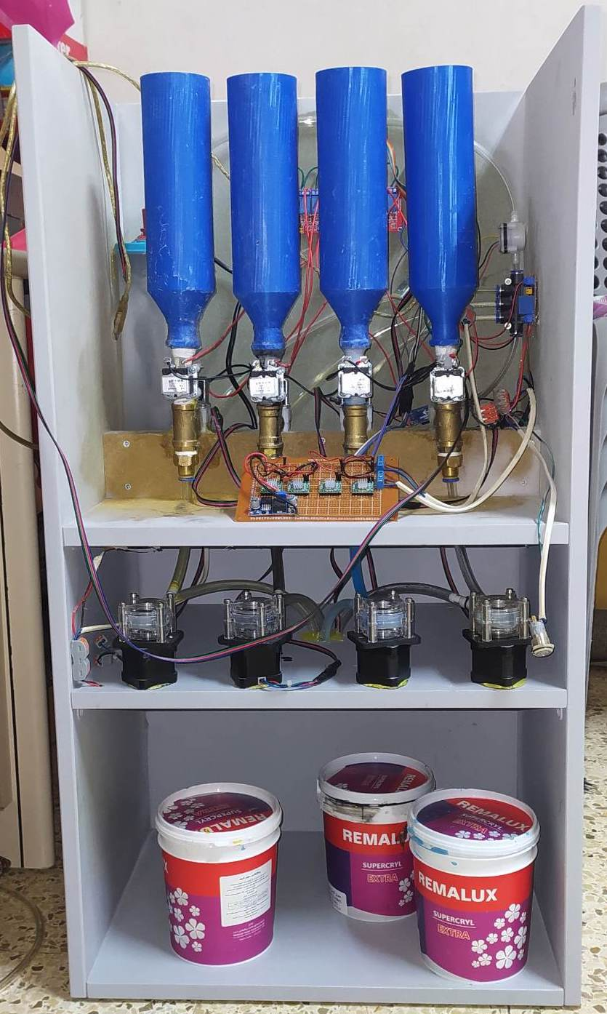

## Standards and specifications

* **The Brille language:**  is a tactile writing system that enables individuals with visual impairments to read and write through touch. It consists of raised dots arranged in a grid, with different combinations of dots representing letters, numbers, punctuation, and even whole words. The Braille language has its own standard that governs its usage and ensures consistency in communication for people who are blind or visually impaired.
* **WiFi technology for communication**: employed as the standard protocol for communication between the Web application using Server and the printer.

## Constraints and design limitations

* **Build the suitable design:** The process involves working with woods that are inherently tough to manipulate, especially in achieving the precise and intricate shape demanded by the desired design.
* **Handling paper:** handle paperwith very small thickness presents a set of intricate challenges that revolve around the paper's delicate nature and its interactions with various mechanical systems. The difficulties mainly stem from the fact that the paper's thinness makes it less substantial and more susceptible to a range of mechanical and environmental factors.
* **Rare mechanical components:** Some mechanical components suitable for the project were difficult to find in markets such as GT2 and MGN.
* **Printing accuracy:** the solenoid it has a shiver while XY coordinate move and while solenoid knocking.
* **Head of solenoid:** find the suitable head that knock the paper in correct dimension.
* **Surface of printing area:** to be able to knocking the paper and the knock appear on the paper clearly should have mushy surface while the current surface is solid wood.

# Chapter 5: Result and Analysis

Furthermore, the Color Mixer machine demonstrated a reasonable level of accuracy in color mixing. Through testing and experiments, we observed that the machine produced color outputs that were generally close to the selected colors. While there were occasional variations and slight deviations, the overall accuracy of the Color Mixer met the requirements for most craftsmen's projects. It is important to note that achieving absolute color accuracy can be challenging due to various factors, including variations in paint batches and the subjective nature of color perception. However, the Color Mixer still provided craftsmen with a reliable tool to achieve satisfactory color mixtures, even if it may not reach the level of precision required for highly specialized.

**Chapter 6: Conclusions and Recommandation**



# Chapter 7: Conclusions and Recommendation

In summary, the Color Mixer demonstrated a satisfactory level of accuracy in color mixing, meeting the needs of most users. Overall, it provides craftsmen with a reliable solution for achieving desired color outcomes.

**References**

* **RapidTables.**RGB to CMYK colorconversion**.**available:[**https://www.rapidtables.com/convert/color/rgb-to-cmyk.html**](https://www.rapidtables.com/convert/color/rgb-to-cmyk.html).
* **How To Mechatronics**. Ultrasonic Sensor HC-SR04 and Arduino Complete Guide .available:<https://howtomechatronics.com/tutorials/arduino/ultrasonic-sensor-hc-sr04/>.
* **AUTODESK** **Instructible**. How to Use Water Flow Sensor. available: <https://www.instructables.com/How-to-Use-Water-Flow-Sensor-Arduino-Tutorial/> .
* **How To Mechatronics .Stepper Motors and Arduino.** <https://howtomechatronics.com/tutorials/arduino/stepper-motors-and-arduino-the-ultimate-guide/> .
* **AUTODESK** **Instructible**. MESOMIX - Automated Paint Mixing Machine. <https://www.instructables.com/MESOMIX-Automated-Paint-Mixing-Machine/>.
* **HACKADAY**. M5Stack Color Maker.<https://www.hackster.io/news/reproduce-the-color-of-any-object-in-paint-with-this-novel-color-maker-58d94edf2c83>.
* **AG Grid**. Calculate difference in percentage between 2 hex colors. <https://embed.plnkr.co/plunk/ERaf37> .
* **TRYCOLORS**. Simulate colors mixer. [https://trycolors.com](https://trycolors.com/) .
* **BlueBits Academy**.React Native CLI. <https://www.youtube.com/watch?v=WAs20_f6rtc&list=LL&index=7>.
* **Laraveloper**. React Native en Español | Instalando la dependencia bluetooth. <https://www.youtube.com/watch?v=Ko_SjnpKO3g&list=LL&index=6> .
* **DroneBot Workshop**. Arduino Color Sensors - TCS230 & ISL29125. <https://www.youtube.com/watch?v=MwdANEcTiPY&list=LL&index=3> .
* **Omar Hannon**.P-Mix || Hardware Graduation Project || 2021. <https://www.youtube.com/watch?v=Dm_vItHpvvc&list=LL&index=1> .
* **Mohamed Yousef.** Logic Level Converter. <https://www.youtube.com/watch?v=M4BwK9PQQMQ>