An Exact Null for Many-to-One Strategy Comparison Under Unequal, Estimated Volatilities
and what it reveals about the procedures currently in use
Working paper. Every figure and table in this document is reproduced by the scripts listed in Appendix A.

Abstract
A desk comparing several candidate strategies against one benchmark faces a multiple-comparison problem with a specific structure: every comparison shares the benchmark, and the benchmark's volatility is itself estimated, so the shared estimate sits in every denominator. This is Dunnett's many-to-one problem, solved in 1955 for equal variances and unsolved since for unequal ones. The state of the art, published in 2023, approximates the joint law of the denominators and generates it by simulation.
This paper computes that law exactly. Both couplings run through the benchmark and nothing else, so conditioning on both of the benchmark's sufficient statistics, rather than on its mean alone as tradition does, makes the comparisons exactly independent. A (2K+2)-dimensional integral becomes a two-dimensional outer rule over K one-dimensional inner rules, and the outer dimension does not grow with the number of candidates. The joint law of the denominators is never formed, so it is never approximated. Six falsifiers pin the answer.
The law is then used as an instrument rather than as a procedure. It gives the true familywise error rate of every rule in use: the studentised maximum modulus route realises as little as 58% of the error rate it is allowed, and Dunnett's constant carried across over-rejects by up to 84%. Run head-to-head against the 2023 method on its own scenarios, the exact law with estimated volatility ratios loses, and the reason is instructive: where that method's approximation bias is largest, its own estimation error has the opposite sign and cancels most of it. Below five degrees of freedom on a group that method should be preferred; by seven the exact rule is within 2% of nominal, and a standard prepivoting calibration halves what remains. Separating approximation error from estimation error is what exposed that cancellation, and no single simulation can do it; the same law also supplies a control variation whose true value is known exactly.
The guarantee a desk needs can also be stated as a bound rather than as an estimate. Admitting a region of ratio vectors whose coverage is certified by exact quadrature, and taking the exact constant over the region's vertices, gives a rule whose familywise error rate is at most the nominal level plus the region's miss probability. That rule is never liberal on the designs of Section 7, and it raises the critical constant by 1.6 to 23%. Branch and bound with interval arithmetic and a Bernstein-ellipse remainder then certifies the supremum over the continuum of ratios on 12 of 17 designs, at a tolerance declared in advance and a median gap of 9.5e-07.
The region rule is nonetheless not the one to run. It realises 0.7% of the error rate it is allowed and gives up 72.1 of 80 percentage points of power, because it meets a conditional statement on every draw where the guarantee asks only for an average over draws. Imposing the guarantee unconditionally, on the same exact law and at the same ceiling, gives up 4.5 points instead. A global linear program over the invariant class places the deployed rule 0.21 to 0.24 percentage points above the best such rule on mean power, and 0.21 to 0.43 on the worst-case criterion the invariance argument covers. Serial correlation and factor exposure are then handled as declared nuisances, where an exact transform returns the independent problem and every certificate with it. A serial coefficient fitted on a disjoint calibration period gives 0.0414 against a ceiling of 0.025, so that result is a declared-coefficient guarantee and nothing weaker.

1. Introduction

1.1 Motivation
Suppose a desk runs one benchmark, a live book or a benchmark sleeve, and is considering K candidate strategies. For each candidate the question is whether its mean return beats the benchmark's, relative to the noise in that difference. The natural statistic is
$$t_{i}=\frac{{\overline{X}}_{i}-{\overline{X}}_{0}}{\sqrt{s_{i}^{2}/n_{i}+s_{0}^{2}/n_{0}}},$$
$$i=1,…,K,$$ (1)
with subscript 0 denoting the benchmark. Taken one at a time these are textbook. Taken together they are not, because the desk will deploy the best-looking candidate, and the chance that at least one of K independent-looking tests clears a 5% bar by luck is far above 5%. The discipline that prevents this is a familywise guarantee, written FWER throughout: at most a 5% chance that any candidate looks like a winner when none of them is. Enforcing it means comparing the largest of the statistics in (1) against a constant chosen for the whole family rather than for one test.
Everything therefore depends on that constant. Set it too high and real strategies are discarded; too low and noise is deployed with a familywise guarantee attached to it. The problem of choosing it is Dunnett's many-to-one comparison, and for the case in which every group has the same variance it was solved in 1955. The case a desk actually has is the other one. Candidate strategies do not share a volatility, and neither the candidates' volatilities nor the benchmark's are known; all of them are estimated from finite track records.
That difference is not cosmetic. Under equal variances the K comparisons are equicorrelated at one half, and a single tabulated constant serves. Under unequal variances the correlations differ across candidates, and they differ in a way that has a clear reading: how much a candidate's verdict is driven by the shared benchmark depends on how noisy that candidate is relative to it. Figure 1 shows the effect on a realistic desk sizing.
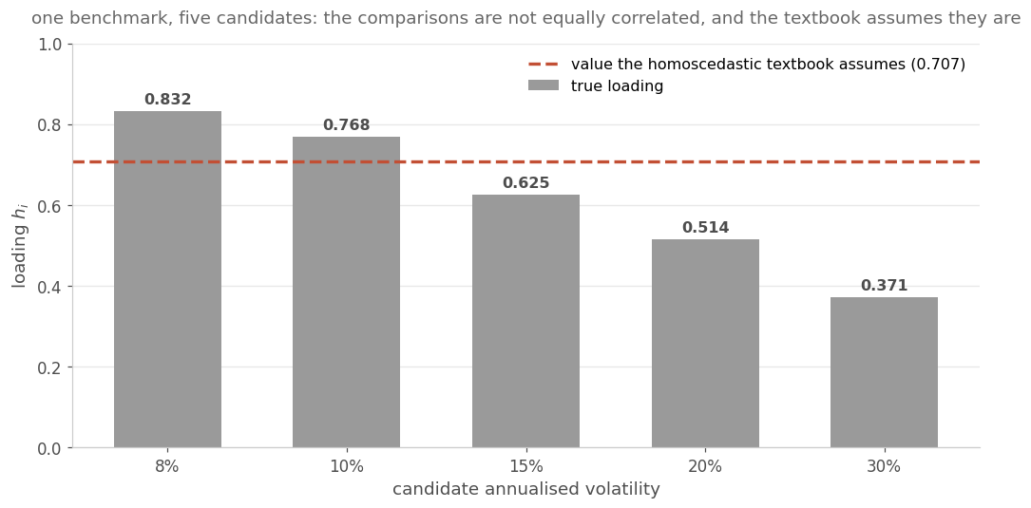
Figure 1. One benchmark at 12% annualised volatility and five candidates at 8 to 30%, 36 monthly returns each. The correlation between two comparisons' numerators is the product of their loadings, equation (11). The statistics themselves are more strongly dependent than that, because they also share a denominator, which is the subject of Section 6.1. The loading runs from 0.832 for the quietest candidate, whose verdict is dominated by the benchmark's noise, to 0.371 for the wildest, whose verdict is dominated by its own. The homoscedastic textbook assumes 0.707 for all five.

1.2 Aims and objectives
The first aim is to compute the exact null distribution of the maximum of the statistics above, for unequal variances, without approximating the joint law of the denominators and without simulation. The second is to use that law as a measuring instrument: to report what the procedures currently in use actually deliver, rather than what they are believed to deliver. The third is to establish whether the exact law yields a better procedure on data, where the volatility ratios must be estimated, and if not, where the boundary lies.

1.3 Scope and constraints
The model is the standard one for this problem: independent normal observations, K+1 groups, unknown and possibly unequal variances, and the usual chi-square sample variances. Real strategy returns are neither normal nor serially independent, and the second of those matters more than the first; the results here apply to monthly or otherwise weakly dependent return series, and applying them to daily returns of position-holding rules requires handling the autocorrelation first. Nothing in the paper depends on the application being financial, but the framing throughout is the desk problem, because that is where the design constants and sample sizes come from.

1.4 Contributions
(1) An exact null law. Conditioning on both benchmark’s sufficient statistics makes the K comparisons exactly independent and reduces a (2K+2)-dimensional problem to two dimensions outside and K one-dimensional integrals inside, with the outer dimension independent of K (Section 3).
(2) A numerical realisation that can certify itself. The textbook quadrature rules fail here in two distinct ways, one of which makes refinement counterproductive. Composite panels on a probability scale, with panel edges planted on a transition the grid would otherwise never see, fix both (Section 4).
(3) The true error rates of the procedures in use, computed rather than simulated, including the finding that equalising volatilities does not rescue either of the two shipped rules (Section 6).
(4) A head-to-head with the state of the art on its own scenarios, which the exact law loses, together with the diagnosis. Method 3's accuracy comes from an internal cancellation of a large positive approximation bias against a negative estimation bias, which its own all-in-one simulation cannot reveal (Section 7).
(5) A map rather than a verdict. The disadvantage is confined to designs with fewer than about five degrees of freedom on a group; by seven it is gone (Section 7.4).
(6) A calibrated rule that halves the remaining error and overtakes Method 3 on mean error, affordable only because the exact law turns each bootstrap replicate into one evaluation instead of a nested root-find (Section 8).
(7) A rule with a bounded error rate, and what it gives up. An admission region for the ratio estimates, certified by exact quadrature, with the envelope constant over its vertices, bounds the familywise error rate by $α$ plus the region's miss probability. It is never liberal on the designs tested, raises the critical constant by 1.6 to 23% and gives up as much as 18.5 percentage points of power (Section 9).
(8) What a proven constant requires, and where dependence stops the guarantee. A certified constant holding at every ratio vector in the region sits at 1.14 to 4.24 times the envelope's own. The guarantee stops in two places, serial correlation at $ϕ≈0.1$ and a common factor with opposite-sign loadings, both of which are boundaries of rules built for independent samples and are removed by item (13) for a declared nuisance (Section 9).
(9) A certified supremum over the continuum. Branch and bound with interval arithmetic and a certified quadrature remainder bounds the supremum of the critical constant over an entire region of ratio vectors, on 12 of 17 designs at a tolerance declared in advance (Section 9.11).
(10) What the region rule gives up, and a rule that does not. The region rule realises 0.7% of the error rate it is allowed and gives up 72.1 percentage points of power against the known-ratio oracle. Imposing the guarantee unconditionally instead gives up 4.5 points, at the same ceiling and with the same exact law (Section 10).
(11) Certificates at any candidate count and on either side without a high-dimensional enclosure, by a union step for the per-candidate rule and a projection of the deployed table for the joint one. Certifying the coupled rule is harder than the coupling is worth: the per-candidate certificate asks for the lower threshold at every design tested (Sections 10.5 and 10.6).
(12) Evidence that the residual loss is a limit of the available information. Optimising over every threshold function of the estimated ratios recovers no more than 0.06 percentage points at 11, 19 and 35 degrees of freedom, and the binding quantity is the smaller group rather than the benchmark (Sections 10.7 and 10.8).
(13) Serial correlation and factor exposure moved from boundaries to declared nuisances. An exact whitening transform and an exact residualisation return the independent problem, so every certificate transfers, on one condition a falsifier located: the first observation must be dropped rather than rescaled, which makes the whitened mean vector constant. What remains estimated is labelled and its effect measured (Section 11).
(14) The efficiency result placed in its class, and a floor. The maximal invariant of the one-candidate problem under the affine group is the pair consisting of the statistic and the estimated ratio, so the search of Section 10.7 covers every non-randomised invariant test. A linear program over that plane, monotone or not and randomised or not, is solved globally and returns the monotone optimum, placing the deployed rule 0.21 to 0.24 percentage points above the best achievable above eleven degrees of freedom (Section 10.8).
(15) The declared nuisance shown to be load-bearing. Estimating the serial coefficient rather than declaring it breaks the guarantee at every tier tested. Equation (49) names the reason, a pooled estimator halves it without removing it, and the exact rule is then worse than the bootstraps it replaces. The factor nuisance survives a calibration period (Sections 11.4 and 11.5).
(16) The general factor reduction implemented, and the sign that decides the direction. The construction of Section 9.10 is carried out for any number of candidates and validated against 4,000,000 draws. The numerator carries the squared contrast of the loadings and the denominator their sum of squares, so opposite-sign loadings make the independent-groups rule liberal and same-sign loadings make it conservative (Section 11.6).

2. Background and Related Work

2.1 The many-to-one problem and Dunnett's solution
Dunnett (1955) considered K candidates against one benchmark with a common unknown variance. Pooling all groups gives a single variance estimate on N minus K minus one degrees of freedom, and the statistics
$$S^{2}=\frac{\sum_{i=0}^{K}{\sum_{j=1}^{n_{i}}{{\left(X_{ij} − {\overline{X}}_{i}\right)}^{2}}}}{N-(K+1)},$$
$$T_{i}=\frac{{\overline{X}}_{i}-{\overline{X}}_{0}}{\sqrt{S^{2}\left(1/n_{0}+1/n_{i}\right)}}$$ (2)
have a K-variate t distribution on those degrees of freedom, with pairwise correlations
$$ρ_{ij}=\sqrt{\frac{n_{i}n_{j}}{\left(n_{0}+n_{i})(n_{0}+n_{j}\right)}},$$
$$1≤i<j≤K,$$ (3)
which for equal group sizes is one half for every pair. Dunnett reduced the resulting probability to a one-dimensional integral and evaluated it numerically to produce the tables the field has used since, extended in Dunnett (1964), and the modern route to such probabilities is the mvtnorm package of Genz et al. (2021). The familywise framing used throughout follows Hochberg and Tamhane (1987). Those constants are numerical integrals, and no closed form for them exists either. Exactness in this literature has always meant deterministic numerical evaluation of a reduced integral, which is precisely what this paper delivers for the unequal-variance case.

2.2 The heteroscedastic case and the procedures in use
With unequal variances the pooled estimate is inappropriate and the statistic becomes the Welch-type $t_{i}$ of equation (1). Its marginal null distribution is approximated by Student's t with Welch-Satterthwaite degrees of freedom (Welch 1938, Satterthwaite 1946),
$${\hat{ν}}_{i}=\frac{{\left(s_{0}^{2}/n_{0}+s_{i}^{2}/n_{i}\right)}^{2}}{\frac{s_{0}^{4}}{n_{0}^{2}(n_{0}-1)}+\frac{s_{i}^{4}}{n_{i}^{2}(n_{i}-1)}},$$ (4)
and the joint distribution is not multivariate t at all. The literature answers this in three ways, and all three are in use.
The first is a product bound. Tamhane (1977, 1979) bounds the probability of the intersection below by the product of the marginal probabilities, which gives a single constant solving
$\prod_{j}{F_{{\hat{ν}}_{j}}}(c)=1-α.$ (5)
It is conservative by construction, since the inequality bounds the adjusted p-value from above.
The second is Dunnett's T3 (Dunnett 1980), which uses the studentised maximum modulus. Its companion in that paper, Games-Howell, uses the studentised range instead and is an all-pairs procedure rather than a many-to-one one, so it is not the rule at issue here. That distribution is the multivariate t at correlation zero, so this route keeps the estimated degrees of freedom and discards the dependence between comparisons.
The third keeps the correlation and forces a single degrees-of-freedom value. Hasler and Hothorn (2008) use a K-variate t with estimated product correlations and a different critical value per comparison. Their own limitation, stated by Tamhane and Xi, is that it does not account for the correlations among the denominators.

2.3 The state of the art, and where its approximations are
Tamhane and Xi (2023) give the current best method and state the obstruction precisely. Their notation is used for the rest of this section only, and does not carry into Section 3, where U and Z name different objects. Writing $t_{i}=Z_{i}/\sqrt{{U_{i}}/{{\hat{ν}}_{i}}}$, the denominators are, in their words, mixtures of chi-squares that are correlated because of the common control sample variance present in all of them. Their solution approximates that joint law by correlated chi-squares and generates it by simulation.
Their construction carries four layers of approximation, all stated in their own text, and it is worth enumerating them because the contribution of this paper is precisely their removal.
First, each denominator is replaced by a single chi-square with Welch-Satterthwaite degrees of freedom, matched on two moments.
Second, their Appendix derives the correlation between denominators after replacing the estimated degrees of freedom by the true ones, a step they justify as tending to one as the sample sizes grow.
Third, the nested construction $U_{i}=V_{i}+W_{i}$ that they use to generate correlated chi-squares cannot reproduce the required correlation matrix, and they say so explicitly. The formula it produces does not factor into a product, so the component degrees of freedom cannot be derived and are instead proposed. In their worked example they note that the correlation matrix cannot be exactly reproduced by chi-square distributed denominators and is approximated.
Fourth, Monte Carlo error sits on top of the other three.
A third line in the literature predates both and treats the case in which the ratios are known. Li (2009, published 2012) conditions on the benchmark's mean and pools the group variance estimates into a single control variance on $\sum_{i}{(}n_{i}-1)$ degrees of freedom, weighting each estimate by its known ratio. That pooling is what the known ratios license, and it is the step that becomes unavailable once the ratios are estimated. For estimated ratios his treatment falls back on two conservative inequalities, Bonferroni and Slepian, because the correlation between the standardised statistics then depends on the unknown variances. In his own simulation the resulting method sits at 0.0370 to 0.0452 against a nominal 0.05 and is described as slightly conservative, while Tamhane's Welch-based method exceeds nominal over the same configurations. The reduction of Section 3 applies to the estimated case directly, and Section 9 adds a rule whose error rate is bounded there without an inequality and without simulation. The two lines are disjoint in the literature: the reference list of the 2023 paper contains no entry for the known-ratio exact method.

2.4 Why no closed form exists, and why that is not the relevant bar
Each inner expectation in this problem contains the square root of a sum of two independent chi-squares. That object has no elementary closed form; it is the reason the two-sample Behrens-Fisher problem is a named problem, and it is present with a single candidate and with every variance known. The two-sample case was still receiving new closed forms as recently as 2025 (Nagananda and Kim 2025, via a Mellin-Barnes factorisation), and an exact Student t solution has been available since Scheffe (1943), though it depends on the order of the observations. Beyond it lies a second obstruction: the product over K inside an expectation is essentially a multivariate normal orthant probability, and closed forms for those are known only for two and three dimensions. A closed form for general K is therefore not available regardless of progress on the first obstruction. Since Dunnett's own constants are numerical integrals, the relevant contrast is not closed form against numerics but deterministic exact integration against approximation plus simulation.

2.5 Multiple testing in strategy selection
The desk problem differs from the clinical one in a way that turns out to matter for every result in Section 7. Clinical designs in this literature use four to thirteen observations per group. A strategy evaluated on 36 monthly returns has 35 degrees of freedom, an order of magnitude more, and as Section 7.4 shows the entire practical disagreement between methods lives below about five.

3. The Reduction

3.1 Model and statistic
There are K+1 independent samples. Group 0 is the benchmark and groups 1 to K are the candidates, the variances are unknown and possibly unequal, and the degrees of freedom on each sample variance are one fewer than its sample size.
$X_{ij}=μ_{i}+ε_{ij},$ $ε_{ij}\sim N(0,σ_{i}^{2}),$ $j=1,…,n_{i}$ (6)
Two statistics are computed from each sample and classical sampling theory says exactly what they are. The sample mean satisfies
$${\overline{X}}_{i}\sim N\left(μ_{i} , w_{i}\right),$$
$$w_{i}=σ_{i}^{2}/n_{i},$$ (7)
where $w_{i}$ is the variance of the mean and shrinks as the track record lengthens. The sample variance satisfies
$$\frac{(n_{i}-1)s_{i}^{2}}{σ_{i}^{2}}\sim χ_{n_{i}-1}^{2}.$$ (8)
One further fact carries the argument below: the sample mean and the sample variance of a normal sample are independent of each other. That is a property of the Gaussian specifically and not a general one, and Section 3.3 uses it K+1 times, once for each candidate and once for the benchmark. The benchmark's use is the one that is easy to miss. It makes the outer law a product of a normal and an independent scaled chi-square, and so makes the outer rule a two-dimensional product rule rather than an integral against a joint density with no structure.
The statistic for testing whether candidate i beats the benchmark is
$$t_{i}=\frac{{\overline{X}}_{i}-{\overline{X}}_{0}}{\sqrt{s_{i}^{2}/n_{i}+s_{0}^{2}/n_{0}}}.$$ (9)
Read it as an estimated edge divided by the estimated standard error of that edge. The denominator has two terms because the difference wobbles for two independent reasons, the candidate's mean being noisy and the benchmark's mean being noisy, and variances of independent quantities add.
Under the global null $μ_{0}=μ_{1}=…=μ_{K}$ the object required is the joint law of the statistics, and specifically the constant $c$ with $P\left({\text{max}}_{i}t_{i} ≤ c\right)=1-α$.

3.2 The two couplings
The quantity required is a single joint probability,
$P\left(t_{1}≤c,t_{2}≤c,…,t_{K}≤c\right),$ (10)
as a function of $c$; the critical constant is the value at which it equals $1-α$. If the statistics were independent this would factor into $K$ one-dimensional integrals and the problem would be elementary. They are not, and the direct alternative is a high-dimensional integral: each $t_{i}$ is a function of four random variables, so the joint event involves $2K+2$ of them, and written as a single integral that is a $\left(2K + 2\right)$-dimensional object whose cost grows exponentially in the dimension. With twelve candidates it is a 26-dimensional integral. That is why the field simulates.
The K statistics are not independent, for two separate reasons, and separating them is the whole of the argument.
The first is the shared mean. Every numerator contains the benchmark's mean, so if the benchmark had a lucky sample every candidate looks bad together. Since the groups are independent, the covariance between two numerators is the variance of the benchmark's mean, which gives
$$ρ_{ij}=\frac{w_{0}}{\sqrt{\left(w_{i}+w_{0})(w_{j}+w_{0}\right)}}=h_{i}h_{j},$$
$$h_{i}=\sqrt{\frac{w_{0}}{w_{i}+w_{0}}}.$$ (11)
The numerators therefore carry a one-factor structure: each loads on one common driver, and the correlation between two of them is the product of their loadings. That statement is about the numerators and not yet about the statistics, which divide by denominators that are themselves random and themselves coupled. The second coupling is the subject of the next paragraph, and its consequences are taken up in Section 6.1. The reading of the loadings is direct. A quiet candidate has a small $w_{i}$, so its loading approaches one and its verdict is dominated by the benchmark's noise. A volatile candidate has a large $w_{i}$, so its loading approaches zero and its verdict is dominated by its own noise. Figure 1 is this formula evaluated on a realistic sizing. This first coupling is classical, and Dunnett's 1955 treatment removes it by conditioning on the benchmark's mean.
The second is the shared variance estimate. Every denominator contains $s_{0}^{2}$. This is the coupling that has no classical treatment, and it is the one Tamhane and Xi identify and then approximate. Conditioning on the benchmark's mean does nothing about it, because $s_{0}^{2}$ is a different statistic.

3.3 Conditioning on both sufficient statistics
The observation is that both couplings run through the benchmark and nothing else. So condition on both of the benchmark's sufficient statistics, its sample mean and its sample variance, rather than on its mean alone. It is convenient to centre the mean first. Centring loses nothing here, because the null law does not depend on the common mean, so conditioning on the centred mean and conditioning on the uncentred one leave the same quantities random. Write
$U={\overline{X}}_{0}-μ_{0}\sim N(0,w_{0}),$ $V=s_{0}^{2}/n_{0}.$ (12)
For every candidate the pair of sample mean and sample variance is mutually independent across candidates and independent of the benchmark's pair, because they are computed from disjoint samples. Expanding the numerator under the null gives
$${\overline{X}}_{i}-{\overline{X}}_{0}=\left({\overline{X}}_{i} − μ_{i}\right)-U=Z_{i}-U,$$
$$Z_{i}\sim N(0,w_{i}),$$ (13)
so that the event for candidate i rearranges to
$$Z_{i}-U≤c_{i}\sqrt{s_{i}^{2}/n_{i}+V}⟺Z_{i}≤U+c_{i}\sqrt{s_{i}^{2}/n_{i}+V}.$$ (14)
The benchmark now appears only through the pair $\left(U , V\right)$. It has been confined to two scalar random variables, and the left side of the rearranged event involves nothing but candidate $i$.
Fix $U=u$ and $V=v$. Three independence facts then hold at once. The pair for candidate i is independent of the benchmark's pair, because they come from different samples. The pair for candidate i is independent of the pair for candidate j, for the same reason. And within candidate i the mean is independent of the variance estimate, by the Gaussian property noted in Section 3.1. The first two give the conditional independence of the K events, exactly and not approximately. The third is what lets each conditional probability be written as the one-dimensional integral below.
The same Gaussian property is used a fourth time, now for the benchmark rather than for a candidate, and this is the use that keeps the outer rule inexpensive. Because ${\overline{X}}_{0}$ and $s_{0}^{2}$ are independent, so are $U$ and $V$, and the outer expectation factors into a normal in one variable against a scaled chi-square in the other. Without that independence the outer step would still be two-dimensional, but it would require a joint density with no product form.
For fixed (u, v), and for a fixed value of the candidate's variance estimate, the event is a statement about a normal variable, so its probability is a normal distribution function. Averaging over the one remaining random quantity gives a one-dimensional integral,
$$g_{i}(u,v;c)=E_{s_{i}^{2}}\left[Φ\left(\frac{\sqrt{n_{i}}}{σ_{i}}\left(u + c\sqrt{s_{i}^{2}/n_{i}+v}\right)\right)\right],$$ (15)
with $Φ$ the standard normal distribution function. The conditional joint probability is the product of these over i, and the unconditional answer averages that product over the two-dimensional law of (U, V):
$$P\left(t_{i} ≤ c_{i}\text{ for every }i\right)=E_{U,V}\left[\prod_{i=1}^{K}{g_{i}}(U,V;c_{i})\right].$$ (16)
The outer expectation is over a normal and a scaled chi-square, and each inner expectation is over a single scaled chi-square. Every integrand is smooth and bounded by one. Allowing a vector of constants rather than a single one requires no change to the construction, and it is what step-down procedures and per-comparison degrees-of-freedom rules need.

3.4 The dimension result
The content of the reduction is dimensional rather than algebraic. Evaluating the null law directly means integrating over the benchmark's mean and variance and over the K candidate pairs, which is a $\left(2K + 2\right)$-dimensional problem and hopeless for even moderate $K$. After conditioning it is a two-dimensional outer rule over K separate one-dimensional inner rules. The outer dimension does not grow with K at all, and the total cost is linear in K. Taking the candidates one at a time is what makes this possible, and the shared benchmark, which was the obstacle, is what licenses it.
The joint distribution of the denominators, the object that has to be approximated in the simulation route, is never formed. There is therefore nothing to approximate about it.

3.5 What exactness means here, and what it does not
Two limits are load-bearing and neither is hidden.
The result is exact to quadrature precision rather than in closed form, and that precision is not uniform across the problem. Where the answer is known independently, the agreement runs to thirteen significant figures in the easiest corner and to about ten in the hardest of the falsifiers. In the perfect-dependence limit, which is the most demanding case the paper constructs, Section 5.2 bounds the integration error at 1.2e‑7, or about seven figures. All of it is deterministic and reproducible, with no seed and no replicate count. It is not an analytic formula, and for the reasons in Section 2.4 no analytic formula is in prospect.
The law is scale invariant but not pivotal. It depends on the variance ratios $λ_{i}=σ_{i}^{2}/σ_{0}^{2}$, which are unknown. What the reduction removes is the approximation of the denominators' joint law and the simulation used to generate it. It does not remove the nuisance parameter, and the residual that leaves is measured in Sections 7 and 8 rather than absorbed into the word exact. One consequence is worth stating immediately: the critical constant depends on K unknown ratios as well as on K and the sample sizes, so there is no table analogous to Dunnett's. That is precisely why the field ships approximations. What the reduction offers instead is a computation cheap enough to run per comparison set, about two seconds.

4. Numerical Realisation

4.1 Why the textbook rules fail
The natural rules are Gauss-Hermite for the normal and generalised Gauss-Laguerre for the chi-square. Both fail, in two different ways, and both failures are properties of the problem rather than of any implementation.
The Laguerre weights sum to
$Γ(ν/2),$ (17)
and the gamma function passes the double-precision ceiling of about 1.8e308 at an argument of 171.62, so the weights overflow once the degrees of freedom pass 343. Measured directly they are finite at 343 and infinite at 344, so any design with a long benchmark track record returns infinity. More seriously, the rule cannot be refined far enough to show that it has converged. On a benchmark with five degrees of freedom the critical value moved 2.603127, 2.603205, 2.603209 and 2.603209 as the chi-square rule went from 24 to 48 to 96 to 192 nodes, a spread of 8.3e‑5, and at 384 nodes it returned a non-number. The composite rule of Section 4.2 refines on the same designs to 2.2e‑15. The Laguerre answer may well be right to five figures. The point is that its own refinement cannot say so, because the node count at which it would demonstrate convergence is the node count at which it fails. A rule that cannot be refined cannot certify its own answer, which disqualifies it here whatever its accuracy at any single setting.

4.2 Composite panels on a probability scale
Both were replaced by the same construction, in three steps. First, map the variable to a probability with its own quantile function. Second, map that probability to a z-score. Third, integrate against the standard normal density in z, with composite Gauss-Legendre over a truncated range. Every panel is a low-order rule, so conditioning never degrades, and accuracy improves by adding panels rather than by raising order, so refinement is monotone and the answer can certify itself. The integrands here are bounded by one, so truncating at eight standard deviations introduces an error of at most about 1.2e‑15.

4.3 A step the grid cannot see
A second and less obvious failure appears in one corner. The inner function carries a factor ${\sqrt{n_{i}}}/{σ_{i}}$ inside the normal distribution function. When a candidate is far more precise than the benchmark that factor is large and the function becomes a near-step in $u$, centred on the curve
$$u^{*}=-c\sqrt{σ_{i}^{2}/n_{i}+v},$$
$$δ_{i}=σ_{i}/\sqrt{n_{i}}.$$ (18)
On a benchmark with nine degrees of freedom against candidates a thousand times more precise, that width is about 1.6e‑5 while a quadrature panel is about 0.36 wide, so the transition is 22,900 times narrower than a panel. Uniform refinement does not help, because the probability that a panel edge lands on the transition stays negligible however many panels are added; the answer stalls at four or five correct digits.
Figure 2 shows the problem at two magnifications. The location of the step is known in closed form, so the fix is to stop refining blindly and plant panel edges on it. The u-grid is rebuilt for each candidate critical value, with edges at each step centre and six step-widths either side, per value of v. Because the location depends on the critical value the grid must be rebuilt at each evaluation, which is why the construction is not the obvious one. Edges are planted only where the step is too narrow for the base panels to resolve, so on an ordinary design nothing is planted and the grid is left as it was.
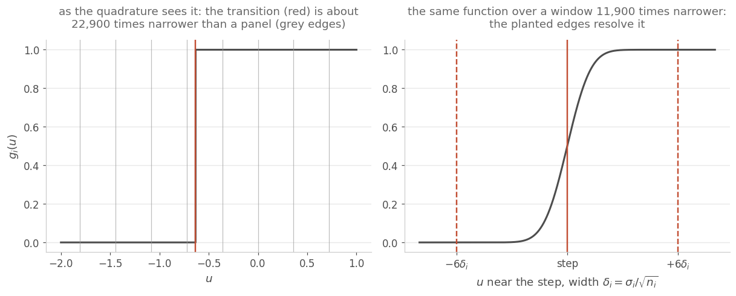
Figure 2. The inner function on a design with a nine-degree-of-freedom benchmark and candidates a thousand times more precise. Left: at the scale of the integration the transition is a vertical jump, and the uniform panel edges are nowhere near it. Right: the same function over a window narrower by four orders of magnitude, with the planted edges at the centre and six step-widths either side.

4.4 Cost
A critical value takes about two seconds on one core at the working grid, measured at 1.64 to 2.24 seconds across four designs. There is no speed claim in this paper: a million-draw simulation takes comparable time and gives about four significant figures. What the exact route provides is exactness and reproducibility at comparable computational cost, and that should not be presented as speed.

5. Verification

5.1 Six falsifiers
The exact law was required to reproduce six independently known answers. These are not sanity checks; each is a case whose value is known by a separate argument, and a failure of any one would have ended the route.
Table 1. The six falsifiers. F2 and F5 are two corners of the correlation structure, zero correlation and perfect dependence, and F1 is the one-candidate case where there is no correlation structure to get wrong. F4 is brute force and F3 is the self-certification the classical rules could not pass. F4 is the only one of the six that bears directly on the factorisation itself, which Section 13 returns to.
 | Test | Known answer | Worst error
F1 | One candidate, equal sizes, equal variances | The statistic is algebraically the pooled two-sample t, so the answer is the Student t quantile on twice the group size minus two degrees of freedom | 1.1e‑13
F2 | Benchmark volatility driven to zero | The benchmark becomes known, the comparisons become independent Student t variables, so the distribution function is the product of the marginals over the candidates' own degrees of freedom | 4.3e‑11
F3 | Grid refinement | The answer must converge as panels are added | 2.2e‑15 from fine to finest
F4 | Brute force, 8 million draws, four heteroscedastic unbalanced designs including one that overflows the Laguerre rule | The simulated size must match the nominal | |z| = 0.64
F5 | Candidates made very precise | Every comparison collapses onto the same benchmark-driven quantity, so the maximum becomes a single Student t on the benchmark's degrees of freedom, independent of K | 1.2e‑7; see Section 5.2
F6 | The same corner, with K swept | In that limit the maximum of K identical quantities is that quantity, so the answer must not depend on K at all | 1.6e‑7 across K = 1 to 12; see Section 5.3

Table 1 states each falsifier, the answer it must reproduce, and the worst error observed. Two of them deserve their algebra shown, because the reason each limit is known is not obvious.
F1. With one candidate, equal sample sizes and equal variances, the pooled two-sample variance estimate is
$$s_{p}^{2}=\frac{(n-1)s_{i}^{2}+(n-1)s_{0}^{2}}{2n-2}=\frac{s_{i}^{2}+s_{0}^{2}}{2},$$
$$\frac{2s_{p}^{2}}{n}=\frac{s_{i}^{2}+s_{0}^{2}}{n},$$ (19)
which is exactly the quantity under the square root in the Welch statistic. The two denominators are algebraically identical, so the critical value must be the Student t quantile on $2n-2$ degrees of freedom. Checked numerically, the two denominators agree to 1.1e‑16.
F5. Driving the candidates' volatilities to zero sends their means to the common null value and their variance estimates to zero, so every statistic collapses onto the same quantity,
$$t_{i}⟶-\frac{{\overline{X}}_{0}-μ_{0}}{{s_{0}}/{\sqrt{n_{0}}}}=-t_{ν_{0}},$$ (20)
which is minus a one-sample Student t on the benchmark's degrees of freedom. The maximum of K identical quantities is that quantity, so by the symmetry of the t distribution the answer must be the single Student t distribution function at c, whatever K is. Two distinct things are being asserted there, and they need separate tests: that the limit is the Student t, which Section 5.2 handles as a scaling law, and that the answer does not move with K at all, which Section 5.3 measures directly.

5.2 A scaling test in place of a tolerance
F5 deserves separate treatment because a tolerance cannot express it, and Figure 3 is the test. There are exactly two reasons the computed answer can differ from a single Student t in that limit. The first is that the candidates are not infinitely precise, so their own sampling noise moves the true answer by an amount proportional to their volatility. The second is that the integration may be wrong, which does not depend on their volatility at all. Because only one of the two scales with volatility, the test is a scaling law rather than a bound: sweep the candidate volatility down by decades and ask whether the residual follows.
With planted edges the residual falls by a factor of 10.0 per decade in every one of twelve cells. That identifies the whole residual as model difference, and it puts the integration error below the residual still standing at the tightest volatility. That bound is 1.2e‑7, the largest such residual over the twelve cells; the smallest is 1.0e‑8. Without the planted edges the residual saturates, moving by a factor of 1.0 per decade and sitting between 3.8e‑5 and 6.0e‑4 depending on the cell. A fixed tolerance would not have distinguished these two situations. The scaling law does, and the unadapted grid fails it outright.
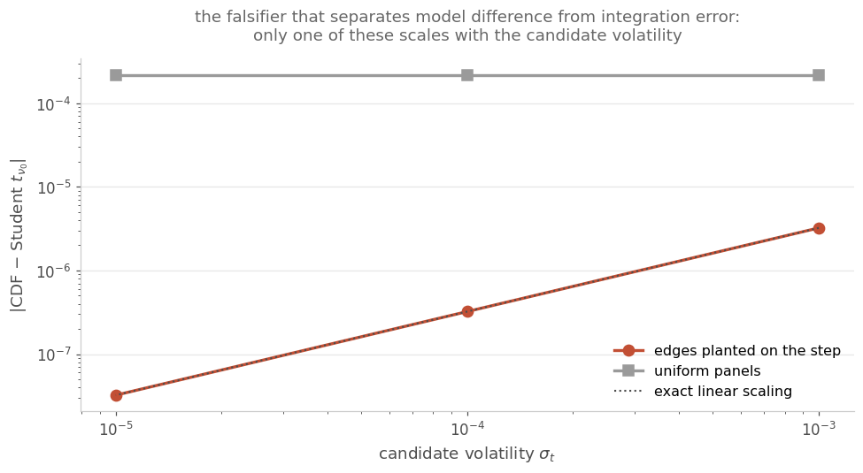
Figure 3. The residual against a single Student t as the candidate volatility falls. The adapted grid tracks the volatility exactly, so what remains is model difference, and the integration error lies below the residual still standing at the tightest volatility. The uniform grid is flat, so what remains there is integration error and nothing else.

5.3 K-invariance measured
The scaling law of Section 5.2 pins each cell against the Student t it must collapse onto, but it compares no cell against another, so on its own it does not test the second half of the F5 claim. Holding the benchmark's degrees of freedom and the critical value fixed, and sweeping K from 1 to 12 with the candidates at their tightest, gives that test directly. A factorisation that had lost a dependence on K would show up in this sweep and nowhere else in the set.
Over nine combinations of benchmark degrees of freedom and critical value the answer moves by at most 1.6e‑7 across the whole sweep. That is the same size as the quadrature bound established in Section 5.2, 1.2e‑7, which is the right reading: the spread is the integration error the previous section already bounded, and there is no residual dependence on K above it. The claim is therefore K-invariance to about a part in ten million, not to the part in a billion an earlier draft of this paper asserted on no evidence.

5.4 External agreement
Three checks tie the implementation to things computed by other people. The one-factor multivariate t used as a comparison arm reproduces the published Dunnett two-sided constant for six groups including the control at twelve degrees of freedom and 5%: computed 2.901255 against a published 2.901. It agrees with the dunnett routine of SciPy (Virtanen et al. 2020), an independent implementation, to 4.4e‑5, which is that routine's own quasi-Monte-Carlo error. And at K = 1 it returns the Student t quantile to 9.1e‑14.

6. What the Procedures in Use Actually Deliver

6.1 The rules compared
With the exact law available, a question becomes answerable that previously could only be simulated: feed each approximate critical value back through the exact distribution and read off the familywise error rate it really delivers. Four rules are evaluated this way, all on the same Welch statistic.
The first is the studentised maximum modulus at each comparison's own Welch degrees of freedom, which is Dunnett's T3 route. The second is the independent-scales reading, the product of marginal Student distribution functions. The third and fourth both keep the one-factor correlation of the numerators derived in Section 3.2, and differ only in the degrees of freedom they attach to it. The third carries the pooled value across, which is Dunnett's own computation transplanted; the fourth uses the mean of the Welch values instead. The pair is evaluated together for two reasons. A practitioner can get the numerator correlation wrong, or get it right and the degrees of freedom wrong, and these two arms both take the same numerator correlation, so comparing them isolates the second error from the first. That correlation is the right one for the numerators and not for the statistics, as the next paragraph explains, so both arms remain approximations however their degrees of freedom are chosen. The comparison also shows how much of the third arm's failure is attributable to the degrees of freedom alone.
One correction emerged from building these arms, and it bears on how the literature is read. At correlation zero the one-factor t is not the product of independent Student distribution functions. A shared denominator leaves the comparisons dependent even when their numerators are uncorrelated, so the studentised maximum modulus and the independent-scales rule are different objects and neither is the other. The same observation is the reason the one-factor loadings of Section 3.2 describe the numerators rather than the statistics. The third and fourth arms above are therefore approximations too, and they are evaluated here as such rather than treated as the truth.

6.2 Exact familywise error rates
Table 2 gives the result and Figure 4 plots it.
Table 2. True familywise error rate of each rule at a one-sided nominal 0.05, computed exactly rather than estimated. The two rules in widest use fail in opposite directions.
Design | T3 / SMM | Independent scales | Dunnett carried across | One-factor, mean Welch df
balanced n=10, homoscedastic | 0.04432 | 0.04369 | 0.05926 | 0.05159
balanced n=10, sd 1:1:2:4 | 0.04898 | 0.04793 | 0.06707 | 0.05267
balanced n=20, sd 1:3:3:3 | 0.04975 | 0.04919 | 0.06061 | 0.05058
balanced n=20, sd 3:1:1:1 noisy control | 0.02880 | 0.02848 | 0.05611 | 0.05002
small control n0=6, sd 1:.25:4:1 | 0.04589 | 0.04368 | 0.09177 | 0.05726
unbalanced K=4, sd spread 6x | 0.04723 | 0.04618 | 0.07000 | 0.06074
K=8 balanced n=15, graded sd | 0.04378 | 0.04242 | 0.07229 | 0.05417
large df n0=400, sd 1:2:.5:3 | 0.04950 | 0.04936 | 0.05353 | 0.05260

The studentised maximum modulus route is conservative in all eight designs, running from 0.02880 to 0.04975, which at its worst realises only 58% of the error rate the desk allowed. Real candidates are discarded for no reason other than the approximation. Dunnett's constant carried across is liberal in all eight, from 0.05353 to 0.09177, which at its worst deploys noise at nearly twice the advertised rate. Dunnett's own 1980 comparison concluded that T3 has the desirable property of being conservative, and Tamhane and Xi's stated motivation is that existing methods are either too conservative or liberal; the exact computation confirms both directions and puts numbers on them.
One row deserves emphasis because it is counterintuitive. On the homoscedastic design, where the textbook conditions hold, Dunnett's constant still over-rejects by 18.5% and the studentised maximum modulus still under-rejects by 11.4%. Equalising volatilities does not rescue either rule, because the statistic in use employs separate variance estimates rather than a pooled one. A desk that equalises risk across candidates has not fixed this.
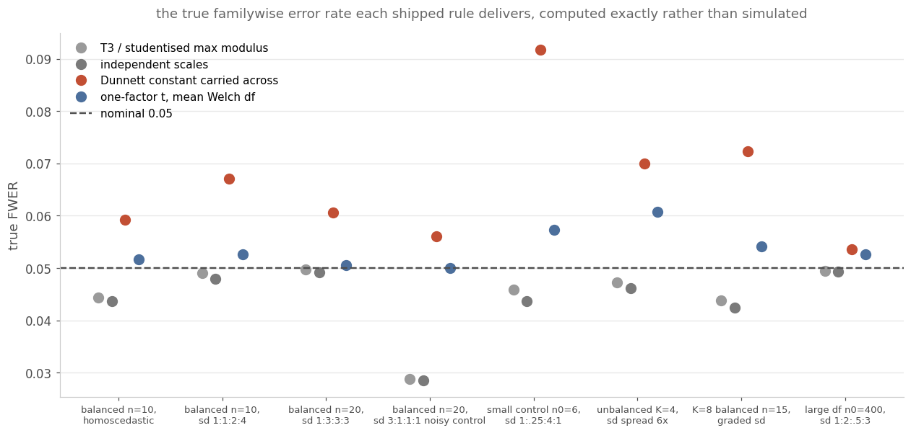
Figure 4. The same eight designs. The studentised maximum modulus route sits below the nominal line everywhere and Dunnett's constant above it everywhere, including on the homoscedastic design at the left.

6.3 A desk example
Consider one benchmark and five candidate strategies with 36 monthly returns each, at annualised volatilities of 12% for the benchmark and 8, 10, 15, 20 and 30% for the candidates. The exact critical value is 2.3219 and delivers 5.000% by construction. The studentised maximum modulus route delivers 4.368%, which is 13% below the rate the desk allowed. Dunnett's constant delivers 5.549%, 11% over. The factor loadings are 0.832, 0.768, 0.625, 0.514 and 0.371 against the 0.707 the homoscedastic case would assume for all five, which is Figure 1 and is the whole problem in one row.

7. Head to Head With the State of the Art

7.1 Reimplementation and its check
Tamhane and Xi report the familywise error rate of four methods over seven designs with two treatments and seven with three, each estimated from 100,000 simulated data sets, giving a standard error of 0.00049. Every number in those tables is a Monte Carlo estimate of a quantity the reduction can compute, so the whole study was recomputed with the exact procedure added as a further arm.
Their Methods 1, 2 and 3 were reimplemented from the paper, which is possible because it specifies them completely. Their Method 0 assumes homoscedasticity and uses a pooled variance, so it is a different statistic; it is excluded here rather than misrepresented, and both they and Hasler and Hothorn already report it as non-robust.
The reimplementation must be checked before the comparison means anything. Across the 42 published cells the largest difference between recomputed and published is 0.00134, with no systematic sign: 19 of the 42 go up and 23 go down. Their standard error is 0.00049 and the recomputation's is 0.00023, the root mean square of the per-cell standard errors the run itself reports, which combine in quadrature to 0.00054. The worst of the 42 cells therefore sits at 2.5 combined standard errors and the rest below it. One cell in forty-two at that distance is what a faithful rebuild looks like.

7.2 Measurement design
Two devices make the measurement sharper than simulating data sets and counting rejections, and both are consequences of the reduction.
The first is Rao-Blackwellisation. Only the variance estimates are drawn. Every method's critical value is computed from those estimates exactly as it would be on real data, and the rejection probability conditional on the drawn variances is then evaluated in closed form by the same conditioning argument that gives the exact law. The normal draws are integrated out rather than sampled.
The second is a control variate whose true value is known exactly. The oracle arm uses the exact critical value at the true variances, so its familywise error rate is exactly the nominal level by construction, verified per scenario as one minus the distribution function at the constant to 5.3e‑16 on the two-candidate block and 5.2e‑15 on the three-candidate one. Every arm runs on identical draws, so the estimate of any method's rate is the nominal level plus the mean paired difference, with the standard error of that difference. This gives 0.00046 with two candidates and 0.00063 with three, at 800 draws, against 0.00049 for their 100,000 data sets. With two candidates that is better on a hundred and twenty-fifth of the replicate count; with three it is slightly worse on the same count. The claim is comparable precision at roughly 1% of the replication, with the three-candidate case slightly worse than the two-candidate one.

7.3 Results
Table 3. The head-to-head at a one-sided 2.5% level, on Tamhane and Xi's own fourteen scenarios. Method 3 controls the error rate more accurately than the exact law with estimated ratios.
Design set | Rule | True FWER range | Worst relative error
K = 2 | Exact law, plug-in ratios | 0.02407 to 0.02884 | +15.4%
K = 2 | Method 1, product bound | 0.01599 to 0.02649 | −36.0%
K = 2 | Method 2, Hasler and Hothorn | 0.02439 to 0.02885 | +15.4%
K = 2 | Method 3, Tamhane and Xi | 0.02381 to 0.02659 | +6.4%
K = 3 | Exact law, plug-in ratios | 0.02377 to 0.02837 | +13.5%
K = 3 | Method 1, product bound | 0.01237 to 0.02556 | −50.5%
K = 3 | Method 2, Hasler and Hothorn | 0.02376 to 0.02934 | +17.4%
K = 3 | Method 3, Tamhane and Xi | 0.02322 to 0.02583 | −7.1%

Method 3 wins on this grid, at this level, and the qualifications are in Sections 7.6 and 7.7. Plugging estimated variance ratios into the exact law is liberal by up to 15.4% with two candidates and 13.5% with three, while their approximate method stays within 6.4% and 7.1%. Method 1 is confirmed as badly conservative, realising half the error rate it is allowed with three candidates, exactly as its multiplicative inequality implies it must.
The exact law removes one error source and leaves the other untouched, and on designs this small the one left untouched is the larger of the two. The next three subsections establish how far that conclusion generalises, and the answer is: not very far.

7.4 Where the crossover is
Their designs put four observations on a group, three degrees of freedom, where a variance estimate is the mean of roughly three squared deviations and is mostly noise. Varying only the benchmark's sample size, with the treatment groups and all volatilities held fixed, locates the transition.
Table 4. A degrees-of-freedom sweep at a one-sided 2.5% level, with n = (n0, 13, 13) and volatilities (10, 10, 50). The exact rule's error collapses by seven degrees of freedom and the gap falls by an order of magnitude.
Benchmark degrees of freedom | Exact law, plug-in ratios | Method 3 | Absolute gap
3 | +13.8% | +4.7% | 0.00226
4 | +5.5% | +1.0% | 0.00111
5 | +2.1% | −1.2% | 0.00081
7 | −0.1% | −1.2% | 0.00026
11 | −0.7% | −1.6% | 0.00022
19 | +0.4% | −0.1% | 0.00011
35 | +1.9% | +0.7% | 0.00031
59 | +1.6% | +0.2% | 0.00037

The disadvantage is confined to a corner. At three degrees of freedom the exact plug-in rule is 13.8% liberal; by seven it is 0.1%, and it never exceeds about 2% thereafter. The ordering also stops being one-sided: at seven and at eleven degrees of freedom the exact rule is the closer of the two to nominal, and Method 3 is closer at the other six counts. What matters is not the ordering but the size, which drops from 0.0023 at three degrees of freedom to between 0.0001 and 0.0004 from seven upward, without falling monotonically inside that band. A desk with 36 monthly returns has 35 degrees of freedom and sits in the flat part of this curve.
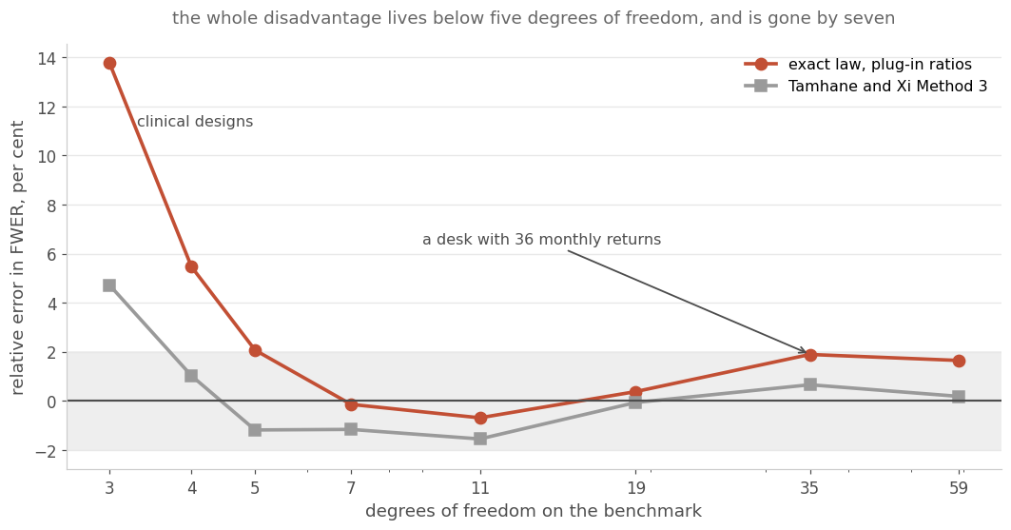
Figure 5. The same sweep, on a logarithmic horizontal axis tick-marked at the eight degrees-of-freedom values computed. The shaded band is plus or minus 2% of nominal. Four observations on a group is a clinical design size; a strategy with three years of monthly returns sits at the right-hand end.

7.5 Decomposing Method 3's error
A natural first reading of Table 3 is that Method 3's approximations happen to offset the plug-in error. That reading is loose, because the critical value it was based on was computed at estimated variances and therefore contained Method 3's approximation error and its estimation error together. Evaluating Method 3's constant at the true variances isolates the first, and the difference isolates the second.
Table 5. Bias in the critical value against the oracle value. Method 3's approximation pushes the constant up on all four designs. On the two where it pushes hardest the estimation step pulls back and the two partly cancel; on the other two there is little approximation bias to cancel.
Design | Oracle constant | Exact law, estimation bias | Method 3 total | Method 3 approximation | Method 3 estimation
S4 control smallest n and sd | 2.7003 | −0.0121 | +0.0734 | +0.1077 | −0.0343
S5 trt smallest n, largest sd | 3.1856 | −0.0519 | +0.0082 | +0.0516 | −0.0434
S6 control smallest n, largest sd | 3.2202 | −0.0471 | +0.0456 | +0.0449 | +0.0007
S1 balanced, equal sd | 2.4089 | +0.0129 | +0.0161 | +0.0025 | +0.0135

Table 5 and Figure 6 give the split. The corrected statement is sharper than the loose one. Method 3's Welch-Satterthwaite approximation to the degrees of freedom produces a constant that is systematically too high on all four designs, by as much as +0.1077 where the oracle value is 2.7003. Its plug-in step pulls the constant back down on two of the four, by −0.0343 and −0.0434, which offsets about a third and about four fifths of the approximation bias on those designs.
The decomposition does not show that cancellation on the other two designs, and the exceptions are the informative part. On the design with the smallest and noisiest benchmark the estimation step is essentially inert at +0.0007, while the exact law's estimation bias on the same design is −0.0471. The two have opposite signs, which is why Method 3 keeps most of its approximation bias there. On the balanced equal-variance design the estimation step pushes further up, at +0.0135, but the approximation bias there is only +0.0025, so there was almost nothing to cancel. That last row is also a check the decomposition passes, since balanced equal variances is exactly where Welch-Satterthwaite should be near exact.
So the cancellation is a tendency and not a law. It is confined to the designs where the approximation bias is large, and where it does hold it is internal to Method 3, between its own approximation error and its own estimation error, rather than its approximation offsetting somebody else's estimation error.
The split between the two biases is a fact about Method 3 that Method 3 cannot establish about itself. Because it is evaluated by simulating data and counting rejections, its approximation error and its estimation error arrive already summed. Separating them requires a reference that is exact at known variances, which is what the reduction supplies.
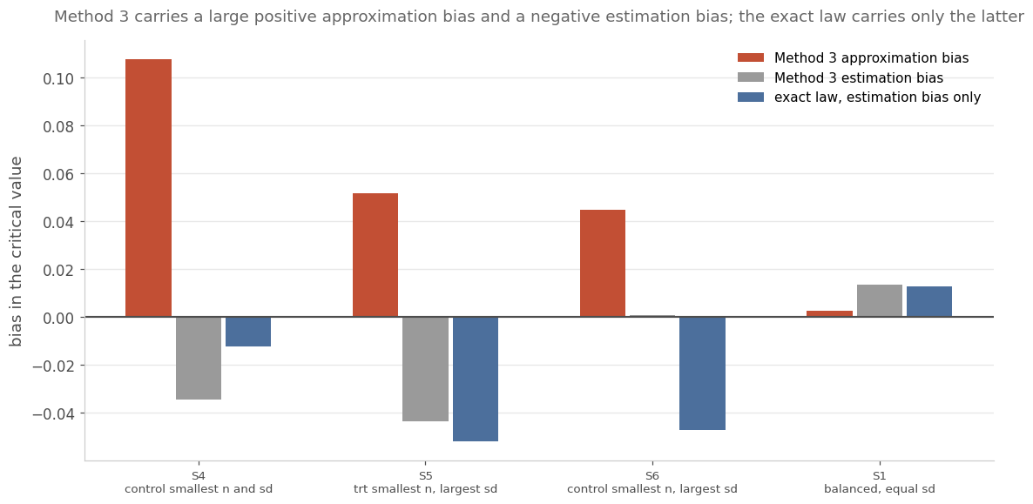
Figure 6. The decomposition. The first bar in each group is Method 3's approximation error alone, evaluated at the true variances. The second is its estimation error. The third is the exact law's estimation error, which is all the error it has.

7.6 Method 3's own Monte Carlo noise
Method 3's critical value is a simulated quantile, so it is a random variable even given the data, and the size of that randomness bounds how finely any comparison against it can be resolved. Raising its replicate count from 20,000 to 100,000 moves its measured error rate by 0.00122 on one design, which is 3.8 standard errors. That is larger than every exact-versus-Method-3 gap at seven degrees of freedom or more in Table 4. At moderate degrees of freedom, therefore, the comparison is between two procedures whose difference is smaller than Method 3's own simulation noise. It also means the head to head, run at 40,000 replicates, slightly understated Method 3.

7.7 Level sensitivity
Table 6 repeats four of the designs at a 5% level. Much of the separation does not survive, since each rule is nearer nominal on two of the four. Part of what Table 3 shows is therefore the amplification of relative error at a smaller level, rather than a difference between the procedures.
Table 6. The same four designs at a 5% level. Each rule is closer to nominal on two of them, so the separation seen at 0.025 is partly the amplification of relative error at a smaller level.
Design | Exact law, plug-in ratios | Method 3
S4 | +5.8% | +0.3%
S5 | +5.5% | +2.1%
S6 | +1.2% | −3.9%
S1 | −1.8% | −1.9%

8. Calibrating the Plug-In Rule

8.1 Prepivoting the exact adjusted p-value
The plug-in error is now exactly measurable, which makes correcting it a well-posed problem rather than an aspiration. Write the exact adjusted p-value at the plug-in ratios,
$$P=1-F_{\hat{λ}}\left({\text{max}}_{i}t_{i}\right),$$ (21)
where the distribution function is the exact one for the maximum, computed at the estimated ratios. The uncalibrated rule rejects when $P≤α$. Were the estimated ratios the truth, $P$ would be exactly uniform; it is not, and that non-uniformity is the plug-in error. Beran's prepivoting (Beran 1987) says not to use $α$ but the $α$-quantile of the null distribution of $P$:
$α^{*}=\text{the }α\text{-quantile of the null law of }P,$ $\text{reject if }{\text{max}}_{i}t_{i}>F_{\hat{λ}}^{-1}\left(1 − α^{*}\right).$ (22)
Every ingredient is available from the data. The sample sizes are known exactly and the ratios come from the sample variances, so the rule is deployable. It has the shape of a double bootstrap, but only the outer level is resampled: the exact law computes the inner one in closed form. That is what makes the procedure affordable, because each replicate then costs one evaluation of a distribution function instead of a nested root-find.

8.2 Why it must be Rao-Blackwellised
The naive estimator of $α^{*}$ is the empirical $α$-quantile of simulated values of $P$. At $α=0.025$ that is a deep tail order statistic and it is expensive at practical replicate counts. On the balanced equal-variance design, where the level being estimated is 0.0258, the measured standard deviation of that estimator is 0.0122 at 200 replicates and still 0.0025 at 4,000. Instead, for each bootstrap draw of the variance estimates the rejection probability is evaluated in closed form, and the map from level to critical value is taken on a small grid so the whole function
$$F(a)=E_{s^{2}}\left[P\left(\text{reject}∣s^{2}, \text{level }a\right)\right]$$ (23)
is available from one pass and inverted by bisection. Both estimators were measured on the same pool of bootstrap draws, so the only difference between them is the estimator. The conditional one reaches a standard deviation of 0.0022 at 100 replicates and 0.0014 at 200, against the naive estimator's 0.0025 at 4,000: a fortyfold reduction in the replicate count for the same precision. The variance reduction is itself a consequence of the conditioning, since the conditional rejection probability is exactly what the reduction computes. The runs reported below use 80 replicates, which leaves about 0.003 of sampling error in the calibrated level and is averaged away across data sets.

8.3 Results
Table 7. The calibrated rule against the uncalibrated one and against Method 3, on the same fourteen scenarios at a one-sided 2.5% level.
Design set | Rule | True FWER range | Worst | Mean absolute
K = 2 | Plug-in, uncalibrated | 0.02428 to 0.02879 | +15.2% | 6.5%
K = 2 | Plug-in, calibrated | 0.02341 to 0.02720 | +8.8% | 3.5%
K = 2 | Method 3 | 0.02406 to 0.02667 | +6.7% | 3.8%
K = 3 | Plug-in, uncalibrated | 0.02358 to 0.02868 | +14.7% | 6.9%
K = 3 | Plug-in, calibrated | 0.02383 to 0.02772 | +10.9% | 3.2%
K = 3 | Method 3 | 0.02311 to 0.02626 | −7.5% | 5.3%

Table 7 gives the result and Figure 7 plots the mean error. Calibration roughly halves the error and turns the verdict into a split one. On mean absolute error across the seven designs the calibrated exact rule beats Method 3 in both blocks, 3.5 against 3.8 and 3.2 against 5.3. On worst case it still loses, 8.8 against 6.7 and 10.9 against 7.5. So the exact law with a standard calibration is competitive with the state of the art and better on average, while remaining worse in the three-degrees-of-freedom corner. That is neither the clean win nor the clean loss that the two previous sections might have suggested in isolation.
Table 7 comes from an independent run at 200 data sets per scenario, where Table 3 used 800. The two tables therefore report the uncalibrated exact rule and Method 3 twice from different samples, and the figures do not coincide. That is sampling error rather than disagreement, and it is worth measuring rather than asserting. Across the 28 shared comparisons the largest discrepancy is 1.7 standard errors of the two runs combined, the mean is 0.7, and every one of the 28 falls inside three. Where the two tables differ, Table 3 is the better estimate.
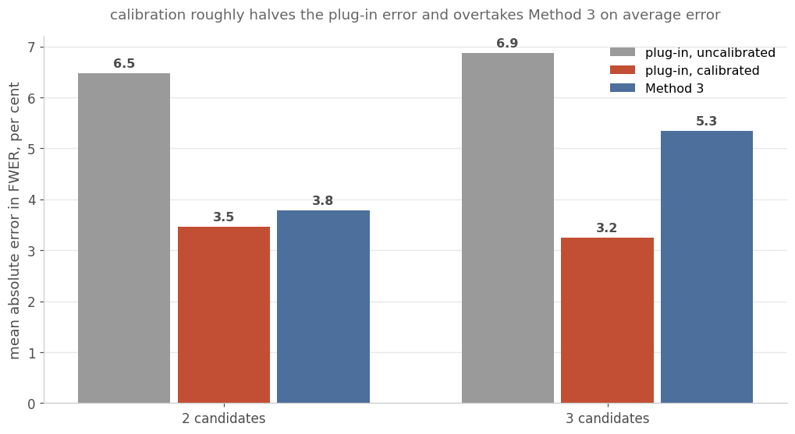
Figure 7. Mean absolute error in the familywise error rate across the seven designs in each block. Calibration moves the exact rule from worst to best on this measure.

8.4 Falsifiers, including one that failed first
The calibration's own checks are reported in full, including the one that failed, because its failure was instructive.
The first check is that $α^{*}$ must tend to $α$ as the degrees of freedom grow, since there is then nothing to correct. The ratio ${α^{*}}/α$ runs 1.078, 1.139, 0.979, 0.997 and 1.019 as the per-group count goes 5, 10, 30, 100 and 400. It is not monotone, since the estimate at each count carries its own error, but the departure from one shrinks from 0.139 to 0.019 as it should.
The second check is that calibrating at the true ratios and applying that level to the plug-in rule must return $α$, by the definition of $α^{*}$. In the main run this arm returned 0.01863 and 0.03507 on two scenarios, which against the one-sided 0.025 ceiling is 25% low and 40% high. That was a flaw in the check rather than in the method, and the cause is identifiable: this arm's level is estimated once per scenario and the same estimate is reused for every data set, so its error passes straight through instead of averaging out.
Rebuilt, the definition is exact. The calibrator satisfies $F(α^{*})=α$ to 1.7e‑16, and its $F(α)$ reproduces the uncalibrated size measured by the entirely separate head-to-head code to within 0.00077. The end-to-end arm, which runs the oracle-calibrated level through the whole procedure, does not pass on the criterion it was given: its worst case sits at 3.8 standard errors. The paper applies to itself the same yardstick it applies to Method 3 in Section 7.6, rather than a softer one.
The residual behind that is about 0.0006, and three pieces of evidence point to estimation noise in the calibrated level rather than to a defect in the definition. It is unchanged by refining the level-to-constant grid from 11 points to 31, and by switching the inner quadrature grid. Its root mean square matches the predicted standard deviation, 0.00060 observed against 0.00069 predicted at 1,200 replicates. Its sign flips between seed families. On the deposited criterion the check is still recorded as failing, and it is listed again in Section 13. The local slope of the error rate in the calibrated level is 0.92 to 1.00, so the replicate count needed for any target precision can be read off rather than guessed.
The calibration's residual is characterised by a gate whose acceptance criterion was fixed in writing before the run. The design is eight independent seeds, 3000 inner replicates and 1200 outer draws. Acceptance requires an absolute residual no larger than 0.0002 or twice its own between-seed standard error, with the upper two-standard-error bound inside the 0.0005 margin the region allows. That is a different criterion from the end-to-end falsifier above, which was judged against a three-standard-error yardstick. Nine of the ten pre-registered cells pass. The single failure is at the smallest inner count on the widest-spread design, it is in the conservative direction rather than the liberal one, and it resolves once that count reaches 1500. The plain arm, measured on the same seeds for contrast, fails five of the same cells, which is the contribution of the control variate.

9. A rule with a controlled error rate
Sections 7 and 8 established two things about the exact law used as a procedure. Plugging in estimated ratios leaves the rule liberal where those estimates are noisy, by as much as 13.8% at three degrees of freedom. Calibrating the level roughly halves that error without bounding it: the calibrated rule still sits 8.8% above nominal in its worst two-candidate scenario and 10.9% above in its worst three-candidate one. A desk that has to attach a guarantee to a decision needs a rule whose error rate holds whatever the estimates happen to be. This section builds one from the same exact law, states what it adds to the constant and gives up in power, and locates the two conditions under which the guarantee stops holding.

9.1 The gap an estimated constant leaves
Write $c(\hat{λ})$ for any constant computed from the estimated ratios. Its true error rate is the rejection probability averaged over the sampling law of the estimates, at the true ratios:
$$FWER(λ)=E_{s^{2}}\left[P\left({\text{max}}_{i}t_{i}>c(\hat{λ})∣s^{2},λ\right)\right]$$ (24)
The plug-in rule evaluates the population constant at $\hat{λ}$ and so inherits the difference between that and the constant at $λ$. The target for a controlled rule is the strongest statement available without knowing $λ$: a constant whose conditional rejection is bounded at every ratio vector the data can plausibly imply,
$${\text{sup}}_{λ∈Λ}P\left({\text{max}}_{i}t_{i}>c∣s^{2},λ\right)≤α for every draw s^{2}$$ (25)
where $Λ$ is a set of ratio vectors the data do not exclude. The rest of this section constructs that set, measures what it adds to the critical constant, and measures how often the truth falls outside it.

9.2 An admission region for the ratios
The region comes from the sampling law of the estimates rather than from any assumption about the ratios themselves. Each sample variance is a scaled chi-square, independent across groups, so writing $W=s_{0}^{2}/σ_{0}^{2}$ and $Y_{i}=s_{i}^{2}/(λ_{i}σ_{0}^{2})$ gives
$$W\sim χ_{ν_{0}}^{2}/ν_{0},Y_{i}\sim χ_{ν_{i}}^{2}/ν_{i},λ_{i}={\hat{λ}}_{i}\frac{W}{Y_{i}},ν_{i}=n_{i}-1$$ (26)
with all $K+1$ variables independent, $W$ of the benchmark and $Y_{i}$ of candidate $i$. A box is then the natural shape, since the ratios enter the denominators separately:
$$Λ(\hat{λ})=\prod_{i=1}^{K}{\left[{\hat{λ}}_{i}\frac{w_{lo}}{y_{hi,i}} , {\hat{λ}}_{i}\frac{w_{hi}}{y_{lo,i}}\right]}$$ (27)
The eight endpoints are equal-tail chi-square quantiles at a common level scale $s$, with half of the level assigned to the shared benchmark factor and half spread across the candidates:
$$w_{lo}=\frac{χ_{sγ/4,ν_{0}}^{2}}{ν_{0}},w_{hi}=\frac{χ_{1-sγ/4,ν_{0}}^{2}}{ν_{0}},y_{lo,i}=\frac{χ_{sγ/(4K),ν_{i}}^{2}}{ν_{i}},y_{hi,i}=\frac{χ_{1-sγ/(4K),ν_{i}}^{2}}{ν_{i}}$$ (28)
Because the ratios are ratios of independent scaled chi-squares, the coverage of that box is an exact one-dimensional integral, available in closed form up to a quadrature over the benchmark factor:
$$cov(s)=\int_{0}^{∞}{\prod_{i=1}^{K}{\left[F_{χ_{ν_{i}}^{2}}\left(ν_{i}wa_{hi,i}\right) − F_{χ_{ν_{i}}^{2}}\left(ν_{i}wa_{lo,i}\right)\right]}}f_{χ_{ν_{0}}^{2}}(ν_{0}w)ν_{0}dw$$ (29)
with $a_{lo,i}=y_{lo,i}/w_{hi}$ and $a_{hi,i}=y_{hi,i}/w_{lo}$. Coverage decreases as the level scale grows, since the box widens with the levels; the tightest admitted region is therefore the one at the largest feasible scale,
$s^{⋆}=sup\left\{s:cov(s)≥1-γ\right\}$ (30)
A union-bound allocation assigns $γ/2$ to the benchmark and $γ/(2K)$ to each candidate without asking what the integral gives. It corresponds to $s=1$ and it over-covers: on the desk designs it covers 0.999971 where the target is 0.9995, and that surplus appears as a wider region and a larger constant. Using the level exactly is what the scale search does, and Section 9.5 measures the difference between the two allocations.

9.3 The envelope rule and its guarantee
With the region in hand, the rule evaluates the known-ratio constant of Section 3 at each vertex of the region and uses the largest:
$$c_{env}(\hat{λ})={\text{max}}_{λ∈V(\hat{λ})}c_{pop}^{⋆}(λ),V(\hat{λ})=vertices of Λ(\hat{λ})$$ (31)
where $c_{pop}^{⋆}(λ)$ solves $F(c,λ)=1-α$ with $F$ the exact law of Section 3 at known ratios. The guarantee follows from one observation, which has two cases. If the true ratios lie in the box, the constant at the true ratios is at most the maximum over the box, so the conditional rejection at $c_{env}$ is at most $α$. If they do not, the draw is one the region was entitled to exclude. Hence
$$FWER≤α+P\left(λ∉Λ(\hat{λ})\right)≤α+γ$$ (32)
The second term is certified by the quadrature of equation (29) rather than estimated, and that is what separates this rule from a calibrated one. A calibrated rule improves an error rate; this one bounds it, by adding a second term whose value is known exactly.

9.4 What the guarantee delivers on the designs of Section 7
Table 8. The envelope, the plug-in and the oracle on the four designs of Section 7, at a one-sided 0.025 with $γ=5×{10}^{-4}$, over 200 draws per design. The envelope is never liberal; the plug-in is liberal on all four; the oracle sits at nominal by construction. The last two columns give the percentage by which each rule raises the critical constant.
Design | Envelope | Plug-in | Oracle | Envelope cost | Plug-in cost
S1 balanced, equal sd | 0.0160 | 0.0241 | 0.0250 | +9.1% | +0.6%
S4 control smallest n and sd | 0.0099 | 0.0283 | 0.0250 | +23.0% | -0.3%
S5 trt smallest n, largest sd | 0.0218 | 0.0288 | 0.0250 | +4.3% | -1.6%
S6 control smallest n, largest sd | 0.0238 | 0.0275 | 0.0250 | +1.6% | -1.1%
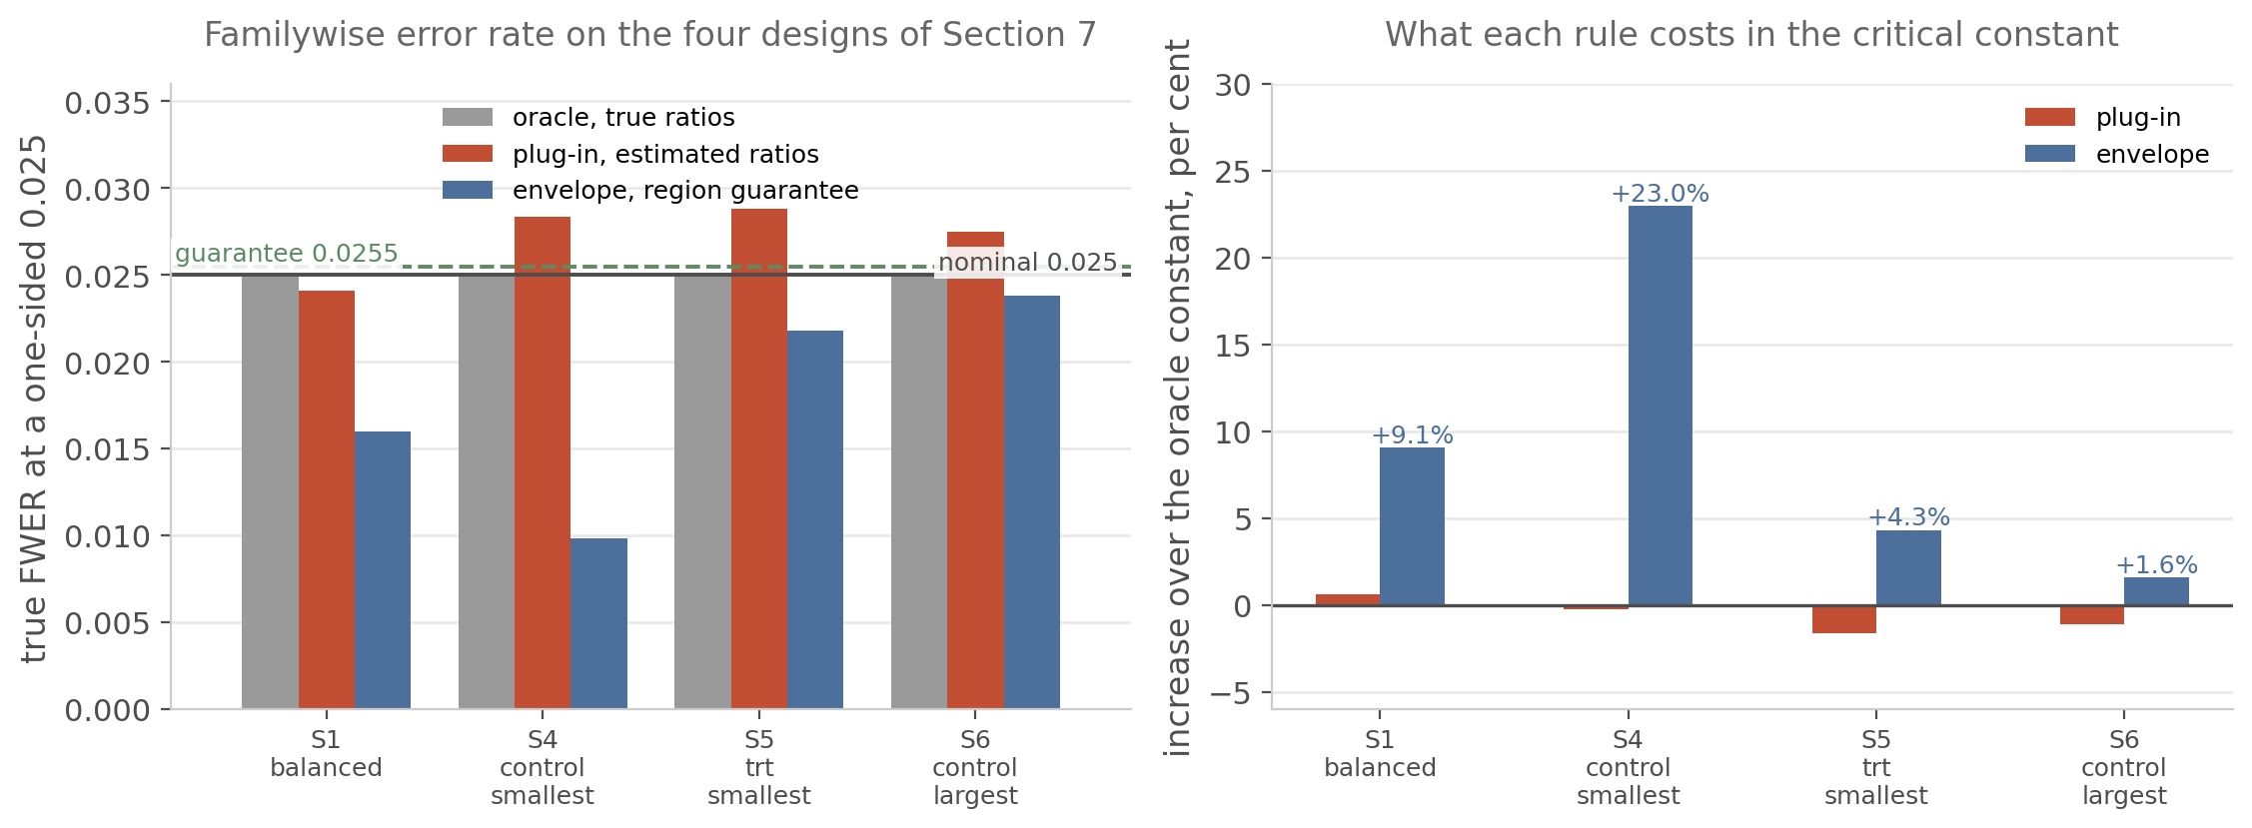
Figure 8. The same four designs. The plug-in rule rises above the nominal line on three of them and would do so on the fourth with a different draw; the envelope stays below the guarantee line everywhere. The right panel shows the increase in the critical constant: the envelope's is between 1.6 and 23%, and the plug-in's is zero because it does not carry the guarantee.
The largest increase falls on S4, where the benchmark has three degrees of freedom and the ratios span a factor of twenty-five, and the smallest on S6, where the benchmark is the noisiest group and the region is correspondingly confined. The oracle column reproduces the nominal level to the last digit in all four designs, which is the property Section 7.2 uses as a control variate.

9.5 The desk map, and what the region adds to the constant
Table 9. Twelve desk designs: two volatility families and six benchmark degrees of freedom, 200 draws per cell. Family A has all ratios equal to 0.04; family B has ratios of 1 and 25. The envelope's error rate is below the guarantee in every cell, no draw places the true ratios outside the region, and the tight allocation of the level gives a smaller constant than the union-bound allocation in every cell.
Family | df | Envelope | Plug-in | Escape | Tight cost | Union cost | Scale
A | 3 | 0.0239 | 0.0282 | 0.000 | +1.58% | +1.78% | 12.716
A | 5 | 0.0221 | 0.0251 | 0.000 | +2.78% | +3.77% | 20.332
A | 7 | 0.0213 | 0.0246 | 0.000 | +3.37% | +4.93% | 26.928
A | 11 | 0.0209 | 0.0245 | 0.000 | +3.82% | +6.02% | 34.828
A | 19 | 0.0197 | 0.0245 | 0.000 | +4.50% | +7.07% | 37.763
A | 35 | 0.0185 | 0.0246 | 0.000 | +5.85% | +8.92% | 32.528
B | 3 | 0.0091 | 0.0288 | 0.000 | +22.99% | +23.64% | 12.716
B | 5 | 0.0158 | 0.0254 | 0.000 | +11.09% | +11.96% | 20.332
B | 7 | 0.0186 | 0.0249 | 0.000 | +6.91% | +7.86% | 26.928
B | 11 | 0.0212 | 0.0248 | 0.000 | +3.49% | +4.14% | 34.828
B | 19 | 0.0214 | 0.0252 | 0.000 | +3.05% | +3.72% | 37.763
B | 35 | 0.0220 | 0.0254 | 0.000 | +2.66% | +3.11% | 32.528
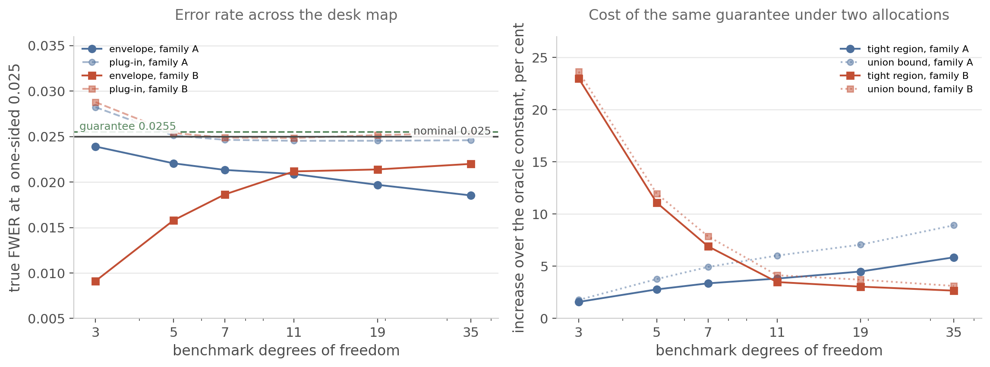
Figure 9. The same twelve designs. Left: the envelope's error rate rises towards nominal as the benchmark gains degrees of freedom, while the plug-in stays above it across the whole map. Right: the tight allocation of the level gives a smaller constant than the union-bound allocation in every cell, by between 0.2 and 3.1 percentage points of the constant.
Across the twelve cells the envelope's error rate runs 0.0091 to 0.0239 against a guarantee of 0.0255, the plug-in's runs 0.0245 to 0.0288, and the fraction of draws on which the true ratios fell outside the region is zero in 1200 draws. The envelope raises the constant by 6.0% on average and by between 1.6 and 23.0%; the union-bound allocation raises it by 7.2% on average and by up to 23.6%. The region's scale runs 12.7 to 37.8% and its certified coverage is 0.999501 in every cell, which is the target plus the margin the search keeps.

9.6 The supremum on the vertices, and the miss rate
The guarantee rests on the vertices carrying the region's supremum. If an interior point of the box beat every vertex, the envelope would fail to dominate the constant at the true ratios and the argument would collapse. That is a property of the region's shape rather than of the law, so it is measured rather than assumed. On a grid of eleven points per axis in $\text{log}λ$, 121 points per cell and twenty draws per cell, the supremum falls on a vertex in all twelve cells, with a worst corner deficit of 0.0000. The certified constant exceeds the grid supremum by 0.41 to 0.78 in family A and 3.48 to 10.33 in family B, so the margin is not marginal.
The sweep contains one dominance violation, an excess of $+0.0118$ at family B with three degrees of freedom, and dissecting that draw separates the two ways the guarantee can fail. On that draw the vertices attained the fine-grid supremum exactly, 2.5763 against 2.5763 with a deficit of 0.0000, and the constant at the true ratios was 2.7003, so the failure is not a missed supremum. The true ratios lay outside the admitted box, which is the event the additive term of equation (32) accounts for. One event in the sweep's 1200 draws is 8.3e-4 against a designed 5e-4, and a single event at that rate has roughly a one in ten chance of appearing in a window of that size.
The designed rate itself is available exactly, since it is one minus the coverage of equation (29), and it can be measured independently. Over 240,000 draws, 20,000 per cell, the observed miss rate is 4.96e-4 pooled against a designed 4.99e-4, with a worst per-cell deviation of 2.0e-4 and a largest absolute $z$ of 1.13.
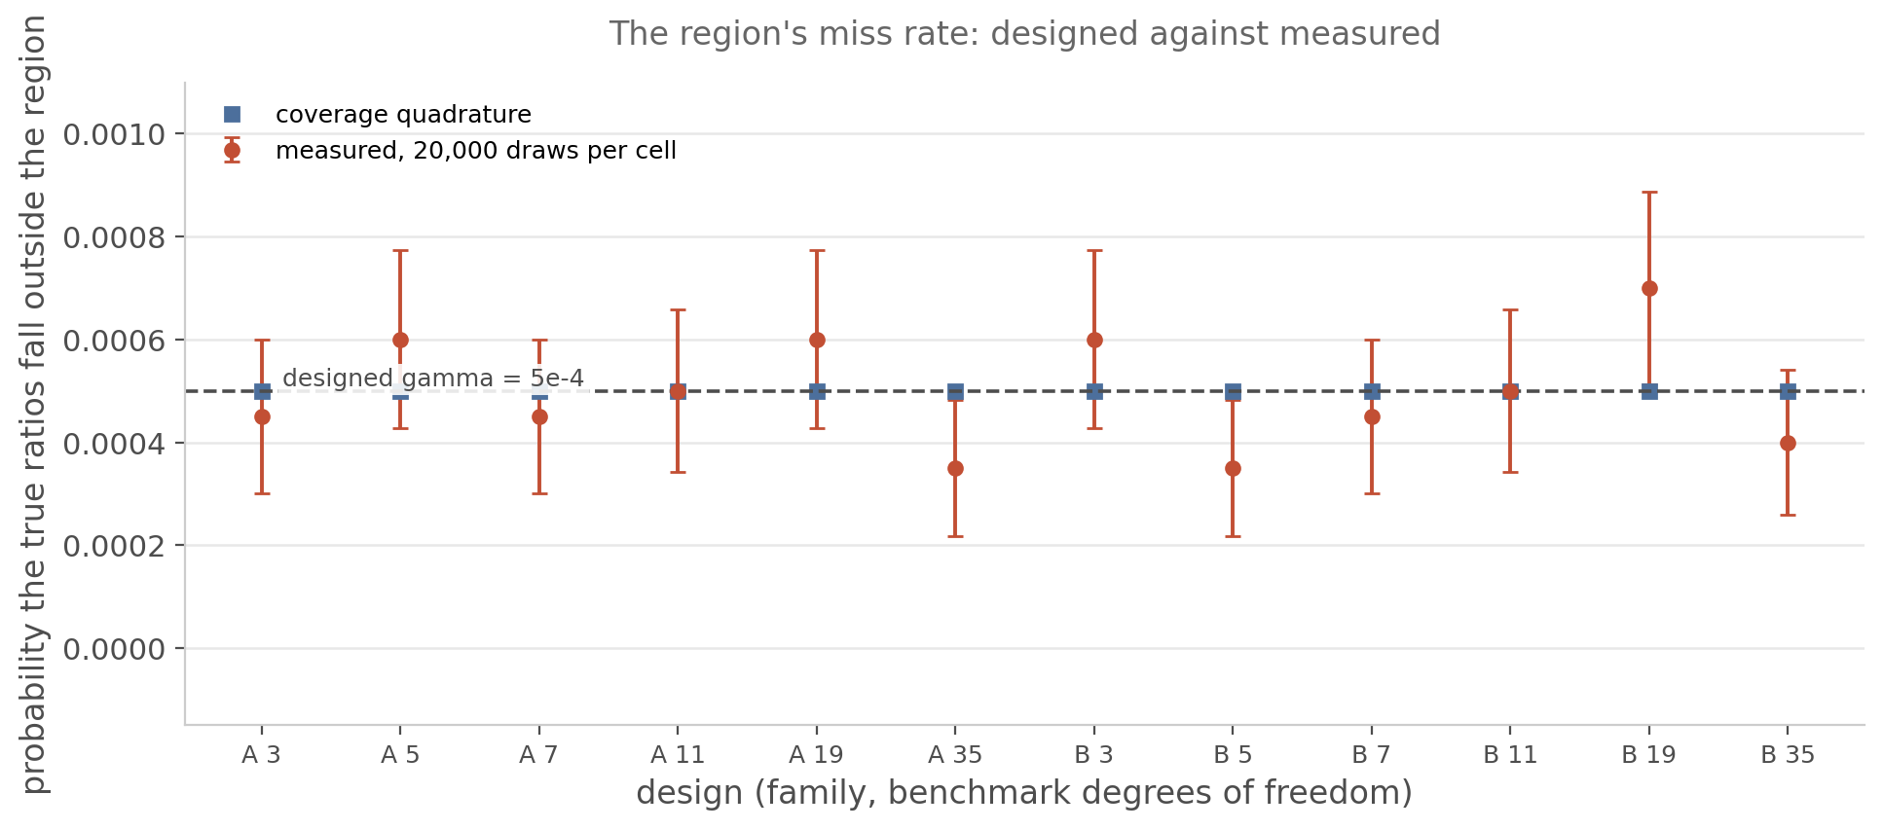
Figure 10. The same twelve designs, each with 20,000 draws. The measured miss rate and the quadrature value it certifies agree within Monte-Carlo error in every cell, and the pooled rates are 4.96e-4 against 4.99e-4. The measured points carry their own standard error; the quadrature value carries none.
Table 10. The region's coverage and its associated constant at the wider candidate counts. Nine designs at $K=5$ with three sizes each and nine at $K=8$ with two, four seeds per row, 200 and 100 draws per row respectively. No row exceeds the guarantee, and no draw places the true ratios outside the region.
Candidate count | Rows | Envelope bound, range | Escape fraction | Bound violations
$$K=5$$ | 27 | -0.0012 to 0.0226 | 0.000 in every row | 0
$$K=8$$ | 18 | -0.0038 to 0.0228 | 0.000 in every row | 0
The bound runs slightly negative in some rows because the estimated rejection is paired against the oracle and inherits its sampling error. The quantity to read is the upper end of the range, which stays below 0.025 in both blocks. At these draw counts the standard error on a rate near 0.02 is about 0.01, so the table rules out violations larger than a percentage point and does not resolve the 5e-4 margin. The coverage column is the exact quantity and carries no such restriction.

9.7 The power the guarantee gives up
A constant larger than the oracle's gives up power, and that loss is measured at the effect size where the oracle would have had 80%. The alternative law is the same reduction with the numerator shifted: for a signal-to-noise $ν_{i}$ per comparison,
$$P\left(reject∣s^{2},ν\right)=E_{U}\left[\prod_{i=1}^{K}{Φ}\left(s_{i}\left(U + cd_{i}\right) − s_{i}ν_{i}{SE}_{i}^{pop}\right)\right]$$ (33)
which is evaluated with the same composite rule as the null law. The two agree against a brute-force simulation on identical draws to 0.0028.
Table 11. Power at the effect size where the oracle would clear 80%, by design. The signal-to-noise column is that effect. The last column is the power the envelope gives up there.
Family | df | Oracle constant | Envelope constant | ν₈₀ | Envelope power | Loss (points)
A | 3 | 3.2201 | 3.2702 | 4.000 | 0.745 | 5.5
B | 3 | 2.7003 | 3.3224 | 2.917 | 0.615 | 18.5
A | 5 | 2.6420 | 2.7114 | 3.587 | 0.783 | 1.7
B | 5 | 2.5400 | 2.8253 | 2.777 | 0.712 | 8.8
A | 7 | 2.4468 | 2.5264 | 3.257 | 0.780 | 2.0
B | 7 | 2.4876 | 2.6577 | 2.679 | 0.746 | 5.4
A | 11 | 2.2972 | 2.3811 | 3.253 | 0.777 | 2.3
B | 11 | 2.4558 | 2.5417 | 2.720 | 0.774 | 2.6
A | 19 | 2.2100 | 2.3087 | 2.962 | 0.772 | 2.8
B | 19 | 2.4521 | 2.5293 | 2.658 | 0.775 | 2.5
A | 35 | 2.1767 | 2.2892 | 2.929 | 0.767 | 3.3
B | 35 | 2.4702 | 2.5341 | 2.525 | 0.780 | 2.0
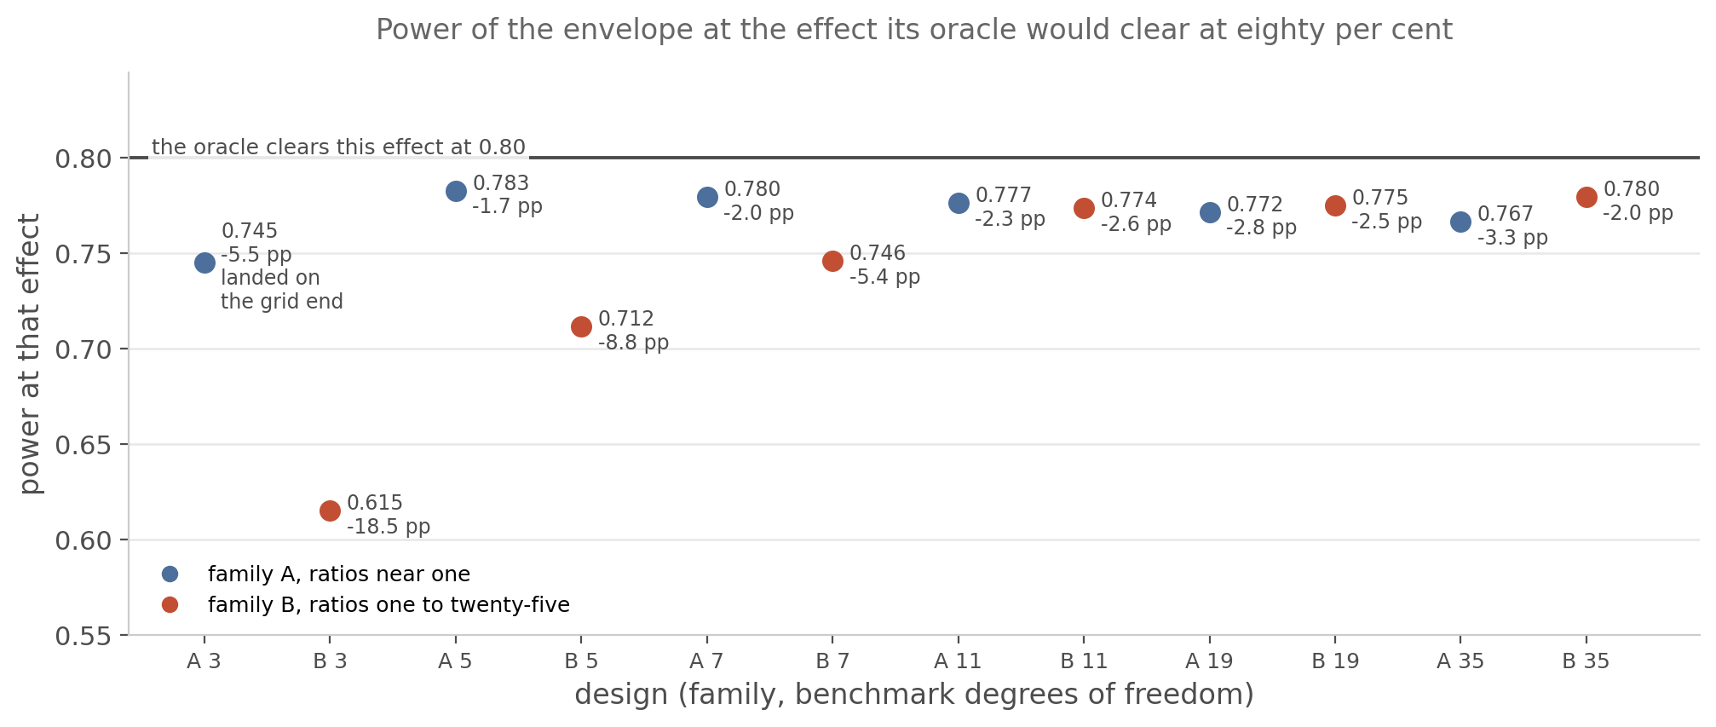
Figure 11. The same twelve designs. The loss is concentrated where the region is widest: family B at three benchmark degrees of freedom gives up 18.5 points, while every other design gives up at most 8.8 and family A designs at most 5.5. The A df 3 point is marked because its effect landed on the end of the signal-to-noise grid, where the oracle itself reaches only 0.756, so part of that cell's apparent loss is grid shortfall rather than a loss due to the envelope.
Reading the table by family: family A loses 1.7 to 5.5 percentage points once the grid-end cell is set aside, and family B 2.0 to 18.5, with the largest loss on the same design that carries the largest increase in the constant.

9.8 A proven tier, and the constant it requires
The envelope carries an additive term. For a reader who needs the conditional statement without one, the same law yields a constant that is valid at every ratio vector in the region, with no candidate set and no covering radius. The construction below is the simple one; Section 9.11 replaces it with a branch-and-bound certificate that reaches the same statement with a far smaller constant. For each $u$ the integrand of equation (16) is monotone in $u$, because the factors $Φ(s_{i}(U+cd_{i}))$ are evaluated at $s_{lo,i}$ when the argument is negative and at $s_{hi,i}$ when it is positive. The minimum over the region is therefore enclosed by evaluating the integrand at the region's endpoints, and the integral of that enclosure is a lower bound on the integral:
$$F_{lo}(c)≤{\text{min}}_{λ∈Λ}F(c,λ),F_{lo}(c)=\sum_{j}{h_{j}}{\text{min}}_{λ∈Λ}G(u_{j};c,λ)$$ (34)
with the sum over the quadrature panels on $u$. The certified constant is the smallest $c$ whose lower bound reaches $1-α$, so it dominates the population constant at every ratio vector in the region:
$$c_{rig}=min\left\{c:F_{lo}(c)≥1-α\right\},c_{rig}≥c_{pop}^{⋆}(λ) ∀λ∈Λ$$ (35)
The falsifier for that construction sweeps a dense grid of ratio vectors over the region and reads the conditional rejection at the certified constant in each cell: the worst value anywhere on the grid is 0.024964, below the nominal 0.025, in all twelve cells. The constant sits just under the level rather than far below it, which is what a boundary on a supremum should do.
Table 12. The two tiers on the desk map. The candidate column is the envelope's mean constant, computed at the region's vertices. The certified column is the constant that holds at every ratio vector in the region, with no additive term. The last column is the ratio between them.
Family | df | Oracle | Envelope | Certified | Certified / envelope
A | 3 | 3.2201 | 3.2703 | 4.3648 | 1.33
B | 3 | 2.7003 | 3.3201 | 14.0915 | 4.24
A | 5 | 2.6420 | 2.7145 | 3.4809 | 1.28
B | 5 | 2.5400 | 2.8169 | 10.3212 | 3.66
A | 7 | 2.4468 | 2.5253 | 2.9361 | 1.16
B | 7 | 2.4876 | 2.6602 | 8.2846 | 3.11
A | 11 | 2.2972 | 2.3827 | 2.7195 | 1.14
B | 11 | 2.4558 | 2.5427 | 6.8519 | 2.69
A | 19 | 2.2100 | 2.3031 | 2.7559 | 1.20
B | 19 | 2.4521 | 2.5269 | 6.3221 | 2.50
A | 35 | 2.1767 | 2.2891 | 2.8361 | 1.24
B | 35 | 2.4702 | 2.5325 | 5.9007 | 2.33
The proven tier raises the constant by between 14 and 33% in family A and by between 133 and 324% in family B, where a region spanning a factor of twenty-five admits ratio vectors far from the estimated ones. The envelope is the rule to run; the certified constant is what to quote when a conditional statement is required and the region's coverage is not an acceptable substitute.

9.9 How the level should be allocated across the region
The allocation of $γ$ between the shared benchmark factor and the candidates is a free choice, and so is the shape of the interval within each factor. Three constructions were compared, each at its own maximal feasible scale so that all three attain the same certified coverage of 0.9995: the uniform split used above, the split that minimises the region's mean log-width per candidate, and shortest-interval levels in place of equal-tail ones.
Table 13. The better of the two alternative shapes against the shipped one, per cell, at matched certified coverage. The best alternative improves the constant by at most 0.21% and never raises it by more than 0.13, so the shipped split is at the floor of this family. The shortest-interval levels narrow the region's width while raising the constant in one cell by 0.39%, which is why the comparison is made in the constant rather than in the width.
Family | df | Envelope | Best alternative | Difference
A | 3 | 3.2707 | 3.2687 | -0.06%
A | 5 | 2.7071 | 2.7015 | -0.21%
A | 7 | 2.5268 | 2.5215 | -0.21%
A | 11 | 2.3910 | 2.3890 | -0.08%
A | 19 | 2.3081 | 2.3094 | +0.06%
A | 35 | 2.3000 | 2.3030 | +0.13%
B | 3 | 3.3158 | 3.3182 | +0.07%
B | 5 | 2.8236 | 2.8248 | +0.04%
B | 7 | 2.6605 | 2.6621 | +0.06%
B | 11 | 2.5412 | 2.5413 | +0.00%
B | 19 | 2.5262 | 2.5268 | +0.02%
B | 35 | 2.5363 | 2.5370 | +0.03%
The shipped split is therefore at the floor of this family. The best alternative among the shapes tried improves the constant by at most 0.21% and never makes it worse by more than 0.13%, so no allocation or shape in this family moves the constant appreciably. The one construction that raises it, by 0.39% at family B with three degrees of freedom, is the shortest-interval shape, and it does so while narrowing the region, which is a reminder that the region's width and the constant are different objectives.

9.10 Where the control stops
Two departures from independent normal samples bound the region's reach, and both are measured rather than asserted.
Table 14. The guarantee under serial correlation. AR(1) innovations with lag-one correlation $ϕ$, three groups, equal sample sizes, 2000 draws per cell, moving-block bootstrap with block length $⌈n^{1/3}⌉$. Nominal is 0.025; the last three columns are relative errors.
n | φ | Plug-in | Envelope | Bootstrap
36 | 0.0 | 0.0250 (+0%) | 0.0245 (-2%) | 0.0380 (+52%)
36 | 0.1 | 0.0500 (+100%) | 0.0480 (+92%) | 0.0520 (+108%)
36 | 0.2 | 0.0570 (+128%) | 0.0545 (+118%) | 0.0510 (+104%)
36 | 0.3 | 0.1010 (+304%) | 0.0980 (+292%) | 0.0650 (+160%)
36 | 0.4 | 0.1245 (+398%) | 0.1200 (+380%) | 0.0765 (+206%)
60 | 0.0 | 0.0245 (-2%) | 0.0225 (-10%) | 0.0335 (+34%)
60 | 0.1 | 0.0330 (+32%) | 0.0320 (+28%) | 0.0360 (+44%)
60 | 0.2 | 0.0690 (+176%) | 0.0670 (+168%) | 0.0495 (+98%)
60 | 0.3 | 0.0910 (+264%) | 0.0885 (+254%) | 0.0545 (+118%)
60 | 0.4 | 0.1360 (+444%) | 0.1320 (+428%) | 0.0665 (+166%)
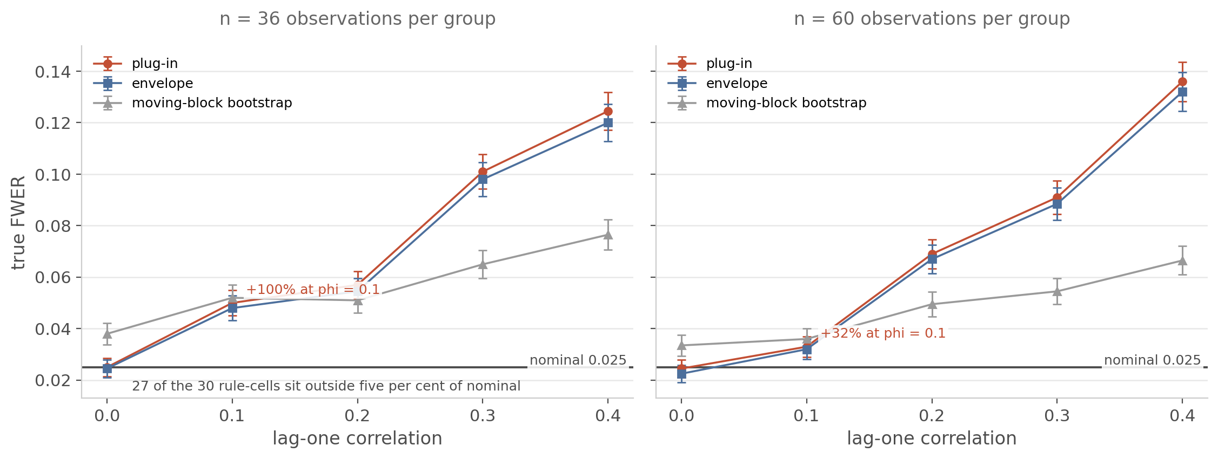
Figure 12. Error rates against the correlation, at both sample sizes. At $ϕ=0.1$ the plug-in rule is already twice nominal at $n=36$ and a third above it at $n=60$. The envelope does not help, because its region absorbs uncertainty in the ratios and not dependence. The bootstrap is never within 5% of nominal at any correlation in the grid.
At $n=36$ and $ϕ=0.1$ the plug-in's error rate is 0.0500, twice nominal and five standard errors away from it, and by $ϕ=0.4$ it is 0.1245. The envelope tracks the plug-in rather than the nominal level, which is the expected consequence of its region describing the ratios and not the dependence. The bootstrap is more conservative than both at large correlation and worse than both at small correlation, and it never reaches 5% of nominal. Twenty-seven of the thirty rule-cells fall outside that band.
Replacing the chi-square degrees of freedom by an effective value computed from the lag-one autocorrelations does not repair this. Two variants were implemented, a sample-size route and a Satterthwaite route, both applied to the critical value only while the observed statistics keep their real sample sizes. The Satterthwaite route lands within 5% of nominal in two of ten cells, and both are at $ϕ=0$ where no correction is needed. The corrections move the excess by between 0 and 3% of its size, because the inflation is driven by the dependence between each comparison's numerator and its denominator rather than by the spread of the denominator alone.
The second departure is a common factor. If the groups load on one factor, each comparison's numerator carries a shift proportional to the difference in loadings and each denominator acquires a non-central chi-square structure. With known loadings the numerator variance becomes $\left(b_{i}-b_{0})^{2}+2(1-ρ\right)$ while the denominator estimates $b_{i}^{2}+b_{0}^{2}+2(1-ρ)$, so the leading correction is the scale factor
$$w=\sqrt{\frac{\left(b_{i}-b_{0})^{2}+2(1-ρ\right)}{b_{i}^{2}+b_{0}^{2}+2(1-ρ)}}$$ (36)
That factor is exact when the benchmark carries no loading. There the numerator and the denominator expectations fall together and $w=1.000$ at every $ρ$, a prediction the measurements reproduce to the last digit. It removes severe over-conservatism when the loadings agree, where the uncorrected rule cannot reject at all at $ρ≥0.5$. It overshoots when the loadings have opposite signs, where the uncorrected rule is liberal by 64% at $ρ=0.75$ and the corrected one is conservative by 54%.
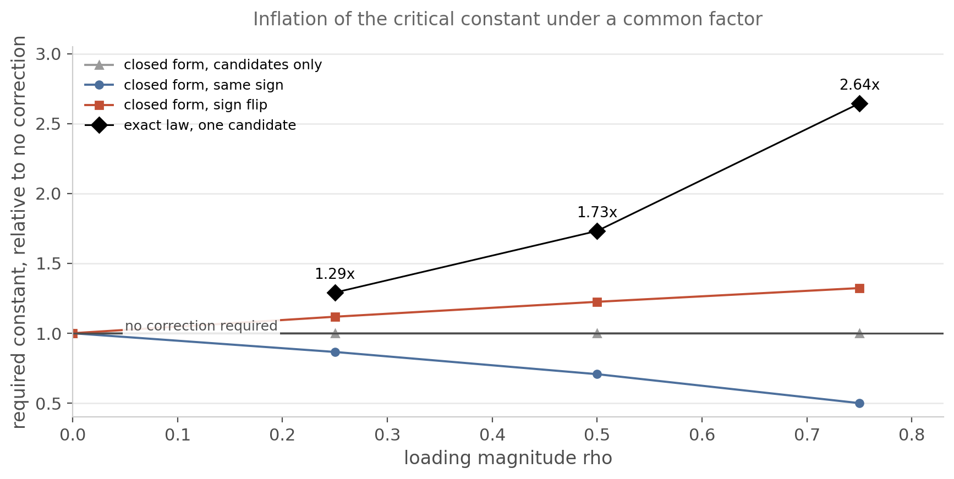
Figure 13. The inflation the exact law requires against the one the closed-form correction supplies, as a function of the loading magnitude. The exact law for one candidate, computed by quadrature over the factor's sufficient statistics, requires 2.64 times the uncorrected constant at $ρ=0.75$; the closed form supplies 1.32. The gap is the correlation the factor induces in the denominators, which no multiplicative correction on the numerator can supply.
That residual is what the general case has to account for. Condition in addition on the factor's mean and on its sum of squares, together with the benchmark's variance estimate. The candidates are then independent again, and each candidate's variance has a non-central chi-square law whose non-centrality is driven by the factor. What remains is a three-dimensional outer quadrature over those three statistics, with a product over candidates in place of the two-dimensional rule. The reduction for one candidate is implemented and validated against the closed form, and Section 11.6 carries the construction out for any number of candidates and validates it against brute-force simulation. Section 11 also takes a different route to both departures: where the dependence is declared rather than estimated, an exact transform returns the independent problem, and every certificate in Sections 9 and 10 transfers to it under the conditions Section 11 states and tests.

9.11 A certified supremum over the continuum
Section 9.6 measured the step that Section 9.3 needs, and Section 9.8 gave a version of that step which is proven rather than measured. The measured step is that the supremum of the population constant over the admission region is attained on the region's vertices. The proven version raises the constant by between 14 and 33% in family A and between 133 and 324% in family B. This subsection replaces both with an upper bound on the supremum over the whole continuum of ratio vectors in the region, computed to a tolerance declared in advance, with no candidate set, no covering radius and no Lipschitz constant.
The object is built from a two-sided enclosure of the inner function on a box of ratio vectors. For $Λ=\prod_{i}{[}λ_{i}^{-},λ_{i}^{+}]$ write $s_{i}^{-}=\sqrt{{n_{i}}/{λ_{i}^{+}}}$ and $s_{i}^{+}=\sqrt{{n_{i}}/{λ_{i}^{-}}}$, and let $x_{i}(z)=z/\sqrt{n_{0}}+cd_{i}$ be the argument the inner normal distribution function receives. Each factor of the product is increasing in $s_{i}$ where $x_{i}$ is positive and decreasing where it is negative, so substituting the corner that matches the sign gives
$G^{-}(z,c)=\prod_{i=1}^{K}{Φ}\left(σ_{i}^{-}(z)x_{i}(z)\right)≤\prod_{i=1}^{K}{Φ}\left(s_{i}x_{i}(z)\right)≤G^{+}(z,c),σ_{i}^{-}(z)=\left\{\begin{matrix}s_{i}^{-} & x_{i}(z)≥0 \\ s_{i}^{+} & x_{i}(z)<0\end{matrix}\right.$ (37)
at every ratio vector in the box and every $z$. Integrating the lower envelope against the standard normal bounds the minimum over the box of the conditional distribution function from below, and the smallest $c$ at which that lower bound reaches $1-α_{0}$ is an upper bound on the constant at every ratio vector in the box.
The direction is worth stating, because the opposite one is the natural mistake. An upper bound on the supremum of the constant comes from a lower bound on the minimum of the distribution function, since the constant is the point at which that function reaches its target. An upper bound on the maximum of the distribution function bounds the smallest constant in the region instead, which is not the quantity a guarantee needs. The matching lower bound comes separately, from a witness ratio vector evaluated exactly.
Two properties of the quadrature belong to the certificate rather than to the implementation. The remainder of a Gauss-Legendre panel is bounded through the Bernstein ellipse, which requires the integrand to be analytic on that ellipse. On a box the integrand is only piecewise analytic, because the branch in equation (37) switches where $x_{i}(z)=0$, that is at $z_{i}^{*}=-cd_{i}\sqrt{n_{0}}$. A panel edge is planted at each switch, so on each panel the branch is fixed. The remainder bound is then licensed by the branch-fixed integrand being entire, since it is a product of normal distribution functions and a normal density, and so analytic on and inside the ellipse drawn about that panel. Planting the edges is what makes that entire function coincide with the true integrand on the panel; it is not by itself the analyticity the theorem needs, because the ellipse about a panel reaches beyond the panel's own endpoints. The magnitude on the ellipse is obtained without sampling, by a single interval evaluation on the rectangle that circumscribes it. The perturbation of the float nodes and weights is carried inside the interval arithmetic rather than bounded by a separate term. Every operation runs in directed rounding, so what is reported is an enclosure of the exact value and not an estimate of it. The Bernstein-ellipse remainder, interval arithmetic in directed rounding and branch and bound are standard constructions and none of them is claimed here as new; what is new is their application to the constant of Section 3.
With an enclosure available on any box, the supremum over the region follows by branch and bound. A box is pruned when its upper bound falls within the tolerance of the best witness found so far, and split along the coordinate with the largest variation otherwise. The certificate is the maximum over every terminal box, pruned boxes included, because the terminal boxes tile the region: every ratio vector lies in one of them, and the constant there is dominated by that box's own bound. Pruned boxes are not a convenience in that maximum but a necessity, and on the twelve cells that certify without a split every terminal box is a pruned one:
$$c_{U} = {\text{max}}_{Λ}c_{ub}(Λ) ≥ {\text{sup}}_{λ∈Λ_{0}}c_{pop}^{*}(λ) ≥ c_{L}$$ (38)
with the maximum over every leaf box and $c_{L}$ the best witness. The run certifies when $c_{U}-c_{L}$ falls under the declared tolerance. A budget that runs out is reported as a failure to certify at that tolerance, together with the gap reached, and never as a pass. Such a cell loses tightness and not validity: $c_{U}$ is an upper bound on the supremum whether the leaf boxes were pruned or merely left unsplit. The guarantee of Section 9.3 therefore holds on every cell in the table below, and the cells that miss the tolerance hold it less tightly.
Table 15. The certified supremum on the two families of the desk map and on five further geometries, at a tolerance of 1e-4 declared before the run. The gap is the difference between the certified upper bound and the witness lower bound, both conditional on the same draw. Family B and all five extra geometries certify without a single split; the five widest family A cells exhaust a 64-split budget and report the gap they reached.
Design | Candidates | Gap in the constant | Certified at 1e-4 | Splits used | Seconds
family A, 3 df | 2 | 3.81e-05 | yes | 1 | 24
family A, 5 df | 2 | 1.48e-03 | no | 64 | 132
family A, 7 df | 2 | 2.76e-03 | no | 64 | 122
family A, 11 df | 2 | 3.17e-03 | no | 64 | 124
family A, 19 df | 2 | 2.12e-03 | no | 64 | 127
family A, 35 df | 2 | 7.10e-04 | no | 64 | 130
family B, 3 df | 2 | 9.54e-07 | yes | 0 | 10
family B, 5 df | 2 | 9.54e-07 | yes | 0 | 9
family B, 7 df | 2 | 9.54e-07 | yes | 0 | 9
family B, 11 df | 2 | 9.54e-07 | yes | 0 | 9
family B, 19 df | 2 | 9.54e-07 | yes | 0 | 7
family B, 35 df | 2 | 9.54e-07 | yes | 0 | 8
1 candidate, 3 df | 1 | 9.54e-07 | yes | 0 | 6
3 candidates, 6 df | 3 | 9.54e-07 | yes | 0 | 19
5 candidates, 11 df | 5 | 9.54e-07 | yes | 0 | 31
extreme spread | 2 | 9.54e-07 | yes | 0 | 32
quiet benchmark | 2 | 9.54e-07 | yes | 0 | 8
12 of the 17 cells certify at the declared tolerance. The median gap is 9.537e-07 and the largest anywhere is 3.166e-03, on a constant of 4.583, so even the worst cell is inside 0.069% of the quantity it bounds. The whole programme takes 836 seconds. Table 12 records 14 to 324% for the corner-substitution tier on its own twelve cells, and against that this certificate removes effectively all of the increase a proven statement required. The two tables are not row-for-row comparable: these cells are run at a drawn ratio vector and Table 12's at each family's designed ratio, so the constants themselves differ.
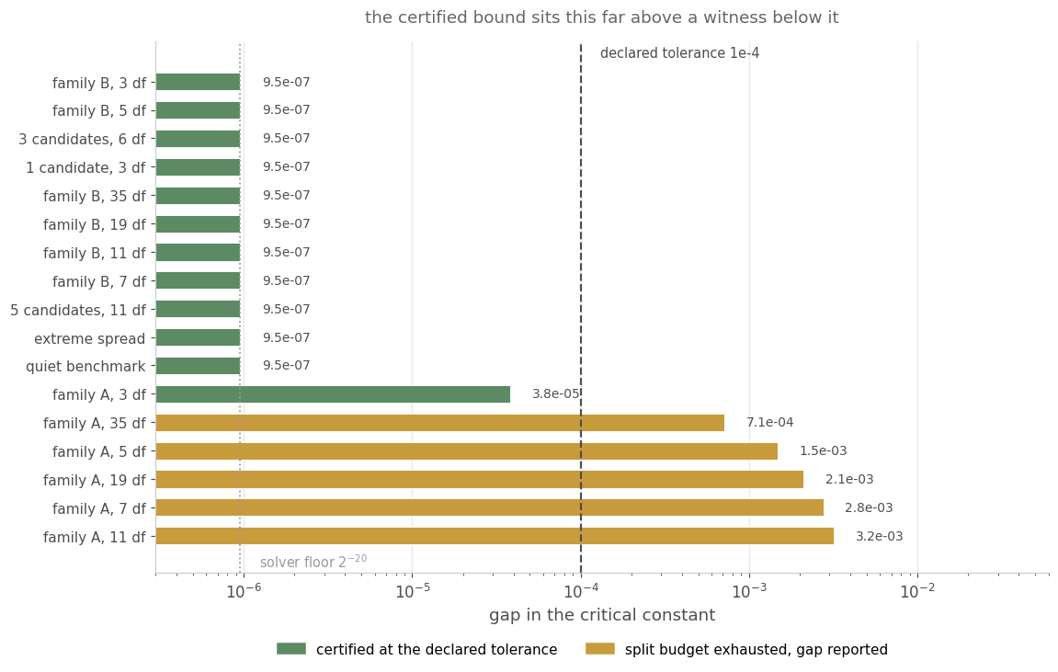
Figure 14. The gap in the critical constant, cell by cell, on a logarithmic scale. Eleven cells sit exactly on the bisection's terminal width, which is the resolution below which the measurement cannot separate the certificate from the truth. The five that exceed the tolerance are the widest regions in the programme and are reported as gaps rather than as passes.
The median gap is the same number in eleven cells because it is $2^{-20}$, the terminal width of the bisection that locates the constant. On those cells the certificate is tight to the resolution of the search, and the true gap is smaller than the measurement can resolve. The five cells that miss the tolerance miss it for a reason that is geometric rather than numerical. The box enclosure integrates the pointwise minimum over the box, whereas the box infimum is the minimum of the integral, and the two differ because the minimising ratio moves with $z$. That slack falls with the box width, from 2.88e-02 on a box spanning a factor of three to 5.34e-05 on a box 0.1% wide, so reaching the tolerance on a wide region is a question of split budget alone.
Four checks sit under the construction, each able to fail. 91 point brackets across 17 cells were re-derived by an independently refined solver and all 91 agree, the widest bracket being 1.60e-06. A suite of 20 adversarial geometries, declared before the run and chosen to break the enclosure, certifies 16 of them; coverage and witness checks pass in all 20, and the four that do not certify report gaps up to 9.01e-02. At the hardest configuration an independent 40-digit interval evaluation lies inside the enclosure, and 5 of 5 such points are contained. The assembled error budget puts the worst width on the probability scale at 8.38e-14 against a declared target of 1e-06.
The certificate also settles the measured claim it replaces. Comparing the continuum bound against the vertex maximum on the same draw gives a median difference of 5.63e-07 and a maximum of 3.17e-03. A dense grid with multi-start refinement finds the population supremum at a vertex in 16 of 16 cells, with nothing above it in any of them. The vertex step of Section 9.3 was therefore right, and Section 9.6's miss rate is no longer the evidence for it.
The engine underneath is the one-sided maximum, so what is certified here is the one-sided constant. A two-sided analogue would need the joint law of the absolute statistics, which this construction does not build. Section 10.5 reaches two-sided levels by a different route, from an exact identity at one candidate.
What this subsection does not supply is a rule worth running. The certificate makes the region rule's guarantee proven rather than measured; it does not make the region rule's threshold smaller. Section 10 measures that threshold and builds a rule with the same ceiling that gives up far less power.

10. An Efficient Rule With the Same Guarantee
Section 9 produced a rule whose familywise error rate is bounded rather than estimated, and Section 9.11 replaced the one measured step in its argument with a certificate over the continuum. Neither establishes that the rule is worth running. This section measures it, finds that it is not, identifies which step of the construction is responsible, and builds a rule with the same ceiling that gives up far less power.

10.1 What the region rule gives up
Three quantities have to be kept apart. The branch-and-bound gap of Section 9.11 is the numerical tightness of a certificate: on the cells that certify it says the certified constant is within about 1e-6 of the supremum it bounds. The second is the ratio between the certified constant and the envelope's own, which is what a proven statement requires. Neither is the quantity that matters to a desk, which is the power given up against a rule that knows what the region rule is protecting against.
Table 16 compares four objects on one design, all conditional on the same data and all aimed at the same rejection event. With a single candidate each of them is available in closed form, so the comparison carries no simulation error. The region rule is included exactly rather than approximately: with one candidate the conditional constant is increasing in the ratio, so the supremum over an admitted interval sits at that interval's upper endpoint and no search is needed to find it.
Table 16. Four objects on a benchmark of 36 monthly returns with one candidate of 13, so 35 and 12 degrees of freedom, at equal variances, averaged over the sampling law of the variance estimates. The ceiling is a one-sided 0.025 throughout. Power given up is measured at the effect size where the oracle reaches 80%, which is the only like-for-like way to compare thresholds in power.
Object | Mean constant | Multiple of the oracle's | Error rate | Power given up
The oracle, which knows the ratios | 2.030 | 1.00 | 0.02500 | 0.0 pp
The plug-in at the full level | 2.071 | 1.05 | 0.02551 | 3.7 pp
The region rule of Section 9 | 4.903 | 2.48 | 0.00018 | 72.1 pp
The calibrated rule of this section | 2.095 | 1.06 | 0.02428 | 4.5 pp
The region rule's entry has to be read against Section 9.7, which measures the same construction at 1.7 to 18.5 percentage points on the desk map. Both are right, and they are not the same measurement. The width of the admitted interval is set by the candidate's degrees of freedom, and this design has twelve of them, so a 0.9995 interval for the ratio reaches 7.9 times the estimate and the constant with it. The desk map covers designs where the region is narrower, each at its own alternative. The same reading applies to the constant. On the desk map, Section 9 measures the region rule as raising it by 1.6 to 23%; here it asks for 2.48 times the oracle's, which is the same quantity on a design where the region is wider, written as a multiple rather than as an increase. The number to carry forward is not 72.1 but the shape: the region rule's loss rises with the width of the region, and the width is not something a desk chooses.
Three readings follow.
The region rule realises almost none of the error rate it is allowed. Its realised rate is 0.00018 against a ceiling of 0.025, which is 0.7% of what the guarantee permits, and it gives up 72.1 of the 80 percentage points of power the oracle has. Its threshold is 2.48 times the oracle's here and between 2.38 and 2.72 times across the benchmark lengths in Figure 15. A rule at that threshold promotes almost nothing under any alternative a desk would recognise.
The plug-in at the full level is not a valid rule, and the table shows where. Its error rate is 0.02551 at 35 degrees of freedom and 0.03108 at three, both above the ceiling, and the worst value over the declared ratio domain is worse still: 0.03434 with two candidates on a three-degree-of-freedom benchmark, 37.4% above nominal. Its power looks good in the table for exactly that reason, which is why the comparison that matters is the one between the last two rows.
The rule built in this section attains the same ceiling while giving up 4.5 percentage points of power, where the region rule gives up 72.1, and it uses the same exact law in the decision path.
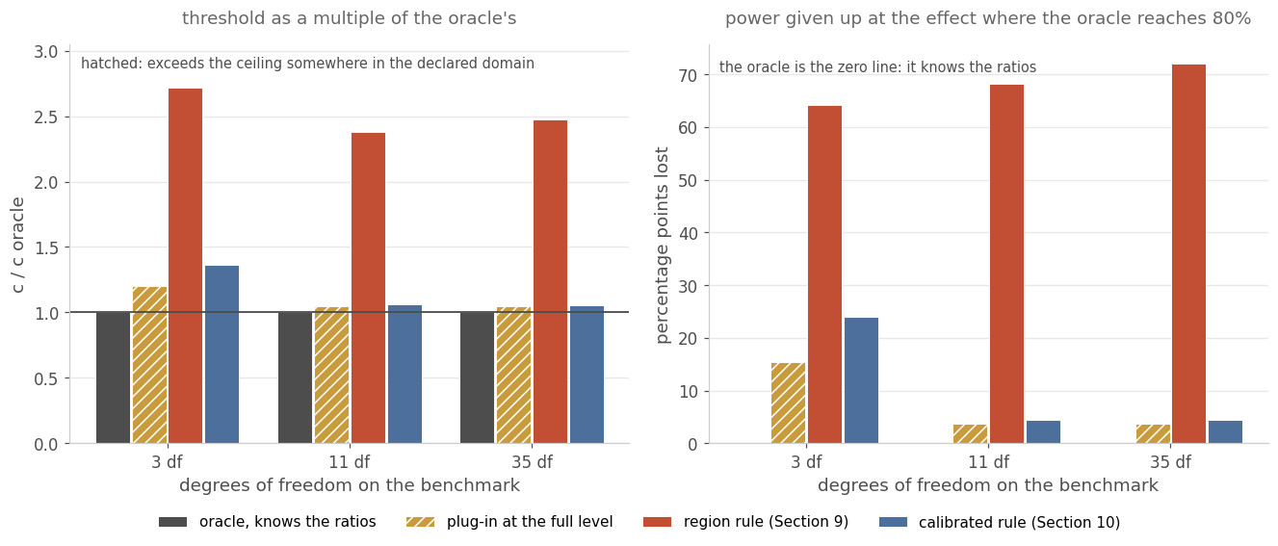
Figure 15. The same four objects at three benchmark lengths. Left: the threshold each rule asks for, as a multiple of the oracle's. Right: the power each gives up at the effect where the oracle reaches 80%, so the oracle is the zero line and carries no bar there. The plug-in's bars are hatched because its error rate exceeds the ceiling somewhere in the declared ratio domain, so its power is not a merit; at three degrees of freedom it gives up 15.3 points in any case.

10.2 Where the region rule's conservatism comes from
The region rule protects, on every draw, against every ratio vector in the admitted region. The guarantee it has to meet does not ask for that. Familywise control is a statement about the average over draws, not about each draw separately:
$${\text{sup}}_{λ∈Λ_{0}} E_{s^{2}}\left[P_{λ}\left({\text{max}}_{1≤i≤K}T_{i}>c(s^{2}) | s^{2}\right)\right] ≤ \overline{α}$$ (39)
A rule that meets the conditional statement on every draw meets equation (39) as well, but it holds the error rate below the ceiling at every ratio vector separately, which equation (39) never required. On a benign draw its error rate falls far below the ceiling, and that slack is discarded rather than made available to a hostile draw. The size of that discard is the gap between the last two rows of Table 16.
The two guarantees differ in more than tightness, and the difference is a quantifier. Section 9's region is built from the data and covers the true ratios with a known probability, so its statement holds at every ratio vector whatever it is, at the ceiling plus the region's miss probability. The rule below holds at the ceiling exactly, but only for ratios inside a domain declared in advance; outside that domain it says nothing. The stronger ceiling therefore holds over a narrower domain of validity, and Section 10.10 measures what the width of that domain is worth.
Imposing equation (39) directly gives a different rule. Take the constant this paper has used throughout, the exact fixed-ratio value of Section 3 evaluated at the estimated ratios, and run it at an internal level $α_{0}$ rather than at the ceiling:
$$\text{reject candidate }i⟺T_{i}>c^{*}\left(\hat{λ};α_{0}\right),α_{0}=\text{max}\left\{a∈(0,\overline{α}]:{\text{sup}}_{λ∈Λ_{0}}{FWER}_{λ}(a)≤\overline{α}\right\}$$ (40)
This rule is called the calibrated rule below. It is not the prepivoted rule of Section 8, which calibrates an adjusted p-value and carries the falsifier Section 13 records against it; the two share only the word.
One scalar per design. Validity needs only that the constraint in equation (40) holds at the level used, not that the level is the largest such. The search returns a level it has verified feasible and approaches the supremum from below, and nothing that follows depends on that supremum being attained. There is no region, no per-draw supremum and no simulation in the decision path, and the law the desk evaluates is the same exact law as in Sections 3 and 4. What remains is to establish three things: that $α_{0}$ can be found without seeing the data, that the resulting rule is worth running, and that nothing in its class does better.

10.3 The level the constraint allows
With one candidate every quantity in equation (39) is a two-dimensional integral over the two scaled chi-squares, so the supremum over the ratio domain is evaluated by quadrature with no draws anywhere. Table 17 reports the largest internal level the constraint permits on ten designs, with the power that level gives up against the oracle that knows the ratios.
Table 17. One candidate, one-sided, at a ceiling of 0.025 over a declared ratio domain spanning three decades. Decades are counted in the volatility ratio throughout this paper, so that domain is [0.001, 1000] in the variance ratio and a factor of about 32 either way in volatility. The internal level is the largest for which the unconditional error rate stays at or below the ceiling at every ratio in that domain; the certified bound is the rigorous supremum of Section 10.4 over the continuum of ratios. Power is given up against the known-ratio oracle, which is the strongest available reference: it is the test a desk would run if it knew the variances, and nothing that estimates them can beat it.
Benchmark | Candidate | Internal level | Certified bound on the error rate | Power given up, median | Power given up, worst
3 df | 12 df | 0.01585 | 0.024999 | 23.9 pp | 40.3 pp
5 df | 12 df | 0.02160 | 0.025000 | 11.2 pp | 20.7 pp
7 df | 12 df | 0.02328 | 0.025000 | 7.3 pp | 13.3 pp
11 df | 12 df | 0.02393 | 0.024998 | 5.9 pp | 7.8 pp
19 df | 12 df | 0.02389 | 0.024998 | 4.4 pp | 7.3 pp
35 df | 12 df | 0.02377 | 0.025000 | 4.5 pp | 7.6 pp
59 df | 12 df | 0.02365 | 0.024996 | 5.4 pp | 7.8 pp
35 df | 4 df | 0.01856 | 0.025000 | 21.5 pp | 30.5 pp
11 df | 11 df | 0.02389 | 0.024999 | 5.8 pp | 7.8 pp
35 df | 35 df | 0.02397 | 0.024998 | 2.1 pp | 2.6 pp
Holding the candidate at twelve degrees of freedom, from eleven on the benchmark upward the constraint removes between 4.3% and 5.4% of the ceiling, and the rule gives up between 4.4 and 5.9 percentage points of power. Below that the loss rises sharply, and at three degrees of freedom the rule gives up 23.9 points in the median and 40.3 at the worst ratio tested. The last three rows carry a finding the degrees-of-freedom sweep of Section 7.4 could not reach. A benchmark with 35 degrees of freedom against a candidate with four gives up 21.5 points, which is the three-degree-of-freedom corner again with the roles exchanged, while a balanced design at 35 and 35 gives up 2.1. Section 10.9 makes that symmetry explicit.
Above one candidate the outer expectation runs over $K+1$ chi-squares and is sampled rather than quadratured, with the inner rejection probability still exact. Two devices keep that measurement from flattering itself. One state sample is shared by every ratio vector and every candidate level, so the search moves over a smooth deterministic surface rather than over noise, and the constraint is applied to the estimate plus twice its standard error rather than to the estimate.
Table 18. Two, three and five candidates, one-sided, at the same ceiling, over 500 draws of the variance estimates with the inner rejection probability exact. The second column is the worst error rate of the uncalibrated plug-in over the declared ratio domain and the third is its excess over the ceiling; that excess is why an internal level is needed at all. Power is given up against the population oracle at the true ratios, a weaker reference than the one in Table 17, so the two sets of losses are not comparable with one another. The internal level is the column that is.
Design | Plug-in at the ceiling | Excess | Internal level | Power given up, median | Power given up, worst
2 candidates, 3 df | 0.03434 | +37.4% | 0.01573 | 10.6 pp | 12.6 pp
2 candidates, 5 df | 0.02832 | +13.3% | 0.02130 | 3.8 pp | 4.6 pp
2 candidates, 7 df | 0.02594 | +3.8% | 0.02381 | 2.2 pp | 2.4 pp
2 candidates, 11 df | 0.02642 | +5.7% | 0.02352 | 2.2 pp | 2.5 pp
2 candidates, 19 df | 0.02567 | +2.7% | 0.02427 | 1.5 pp | 1.9 pp
2 candidates, 35 df | 0.02571 | +2.9% | 0.02445 | 1.5 pp | 1.8 pp
3 candidates, 11 df | 0.02658 | +6.3% | 0.02369 | 1.7 pp | 2.2 pp
3 candidates, 35 df | 0.02697 | +7.9% | 0.02329 | 1.8 pp | 2.6 pp
5 candidates, 11 df | 0.02628 | +5.1% | 0.02338 | 1.6 pp | 2.5 pp
5 candidates, 35 df | 0.02611 | +4.5% | 0.02403 | 1.7 pp | 2.2 pp
The plug-in exceeds the ceiling on every design in the table, by 37.4% at three degrees of freedom and by between 2.7% and 7.9% from seven upward. The calibrated rule gives up 2.2 percentage points at two candidates and seven degrees of freedom, and between 1.5 and 2.2 at every design from there upward, all measured against the population oracle rather than the conditional one of Table 17. The quantity that does carry across the two tables is the internal level: from seven degrees of freedom upward the constraint leaves between 93.2% and 97.8% of the ceiling at every candidate count tested, against 95.7% at one candidate and eleven degrees of freedom. Multiplicity shows up as a reduction in the internal level, not in the calibration.

10.4 A certificate for the internal level
The level in Table 17 is the output of a search over a ratio domain, and a search over a grid is not a bound over a continuum. The certificate that closes that distance reuses the interval enclosure of Section 9.11, applied to the unconditional error rate rather than to the conditional constant.
Partition the two nuisance coordinates on the probability scale rather than on the ratio scale, so that each cell carries a known mass rather than a known width. Write $Q$ for the partition of the unit square into $m^{2}$ cells, $p(q)$ for the mass of cell $q$, and $\overline{R}(q,λ)$ for the maximum over that cell of the conditional rejection probability, obtained by corner substitution as in equation (37). Then
$${FWER}_{λ}(α_{0}) ≤ \sum_{q∈Q}{p(q)}\overline{R}(q,λ) + ε_{tail}$$ (41)
with $ε_{tail}=4p_{\text{min}}$. The final term is not decoration. The partition spans $\left[p_{\text{min}},1-p_{\text{min}}\right]$ in each coordinate with $p_{\text{min}}={10}^{-9}$, which leaves 4e-09 of probability mass outside it; the integrand there is a probability and can be one, so that mass is added to every upper bound. The term is four times the partition's outer limit, so tightening that limit shrinks it in proportion. It is not negligible against what it corrects: the tightest margin in Table 17 is 1.20e-08, on the design with a 35-degree-of-freedom benchmark and a four-degree-of-freedom candidate, and the omitted mass is a third of it. With the term included all ten designs still certify and none needed its level lowered, which is a re-run reported in the deposit rather than an assumption that nothing moved.
Three substitutions turn that into a bound over a box of ratios rather than a statement at one ratio. On a box $\left[λ^{-} , λ^{+}\right]$, the estimated standard error $d$ is evaluated at $λ^{-}$; the true standard error $σ$ is evaluated at $λ^{+}$; and the threshold is taken as the smallest value the deployed step function returns anywhere in the range of estimated ratios the box can reach. All three move the rejection probability upward. Decoupling $λ$ between the places it appears only enlarges the bound further, so the result holds at every ratio in the box at once. Branch and bound over boxes then gives the supremum over the domain.
The corner substitution is the step that could be wrong, so it is the step that is falsified directly. Sampling ratio vectors inside each cell and comparing the sampled rejection probability against the substituted corner found no violations in 2,400 trials in the certificate's own run and none in 1,800 trials in the deposited gate. The certified bounds in Table 17 sit between 0.024996 and 0.025000 against a ceiling of 0.025, which is where a bound on a supremum should sit: just under the level rather than far below it.

10.5 Any number of candidates, and both sides
A certificate at one candidate would be of limited use if the general case needed a $K$-dimensional enclosure. It does not, for a rule that applies the same threshold function to each candidate separately. Write $g_{i}(λ)$ for the probability that candidate $i$ is not rejected. Conditional on the benchmark pair the candidates are independent, by the reduction of Section 3, so the conditional probability that no candidate is rejected is the product of those probabilities. Take the expectation of that product over the benchmark pair, then bound it from below by Boole's inequality, which gives
$${FWER}_{λ}=E_{S}\left[1-\prod_{i=1}^{K}{g_{i}}(λ∣S)\right] ≤ \sum_{i=1}^{K}{\left(1-g_{i}(λ)\right)} ≤ K{\text{sup}}_{λ_{1}}{FWER}_{λ_{1}}^{\left(1\right)}(α_{0})$$ (42)
with $S$ the benchmark's pair of sufficient statistics. The middle term needs no independence of its own: the product is taken inside the expectation, where Section 3 makes it exact, and Boole's inequality then holds term by term whatever the unconditional dependence is.
The last step holds because each candidate's marginal non-rejection probability is the one-candidate quantity at that candidate's own ratio, so the supremum over the $K$-dimensional cube is bounded by $K$ times the one-dimensional supremum already certified. Setting the internal level so that $K$ times the one-candidate bound reaches the ceiling certifies the rule at any number of candidates, with no enclosure beyond the one of Section 10.4.
The same device covers two-sided testing. At one candidate the two-sided error rate is exactly twice the one-sided rate at the same constant, because the null law is symmetric and the two tails are disjoint:
$${FWER}_{2s}^{\left(1\right)}(λ,c) = 2{FWER}_{1s}^{\left(1\right)}(λ,c)⟹{FWER}_{2s} ≤ 2K{\text{sup}}_{λ_{1}}{FWER}_{1s}^{\left(1\right)}(α_{0})$$ (43)
The identity on the left of equation (43) holds at one candidate and fails above it, which is what makes it a check rather than an assumption. The deposited falsifier reproduces it to the last bit over 300 trials, conditionally and unconditionally, and confirms the failure at two candidates, where the ratio of the two rates is 1.9989 rather than 2. The two-sided certificates therefore come from the identity applied one candidate at a time, and not from any K-candidate analogue of it. At one candidate the two-sided rule runs at internal levels from 0.00484 to 0.01244 on the 7 designs of Table 17 for which it was computed, and gives up 3.1 to 35.6 percentage points of power. The second tail halves the level, by a factor of 0.31 to 0.52, and the power it gives up is about half as much again as the one-sided rule, between 1.45 and 1.72 times.
Table 19. Certificates for the per-candidate rule at two, three and five candidates, one-sided and two-sided, on benchmarks of 11 and 35 degrees of freedom. The total bound is $K$ times the one-candidate bound, or $2K$ times it two-sided, and it is the quantity that must not exceed 0.025. The last column is the rule's own exact unconditional error rate at its worst ratio pattern. The gap between that rate and the total bound is what the union step leaves unused, at worst 2.25e-03 on the widest row of the table.
Design | Candidates | Side | Per-candidate level | One-candidate bound | Total bound | The deployed rule's own error rate
35 df | 2 | one-sided | 0.01155 | 0.012500 | 0.025000 | 0.023652
35 df | 2 | two-sided | 0.00556 | 0.006250 | 0.024999 | 0.023606
35 df | 3 | one-sided | 0.00753 | 0.008333 | 0.025000 | 0.023373
35 df | 3 | two-sided | 0.00359 | 0.004167 | 0.025000 | 0.023275
35 df | 5 | one-sided | 0.00438 | 0.005000 | 0.025000 | 0.023123
35 df | 5 | two-sided | 0.00204 | 0.002500 | 0.024999 | 0.022746
11 df | 2 | one-sided | 0.01177 | 0.012500 | 0.025000 | 0.024101
11 df | 2 | two-sided | 0.00571 | 0.006250 | 0.025000 | 0.024085
11 df | 3 | one-sided | 0.00772 | 0.008333 | 0.024998 | 0.023965
11 df | 3 | two-sided | 0.00371 | 0.004167 | 0.025000 | 0.023897
All ten certificates pass. The effect of the union step is visible in the level column: five candidates on a 35-degree-of-freedom benchmark run at an internal level of 0.00438 one-sided and 0.00204 two-sided, against 0.02377 for one candidate on the same benchmark. That is what a bound holding without any assumption about how the candidates' ratios move together requires.
The union step is loose as an inequality and tight as a rule. The last column of Table 19 runs from 0.0227 to 0.0241 against a ceiling of 0.025, so the certified per-candidate rule realises between 91% and 96% of the error rate it is allowed. Against the same design's measured per-candidate level of 0.01224, the certificate gives up 5.6% of the level. That is what makes it a rule to deploy and not only a bound to quote, and Section 10.6 shows the coupled alternative does not beat it once both are certified.
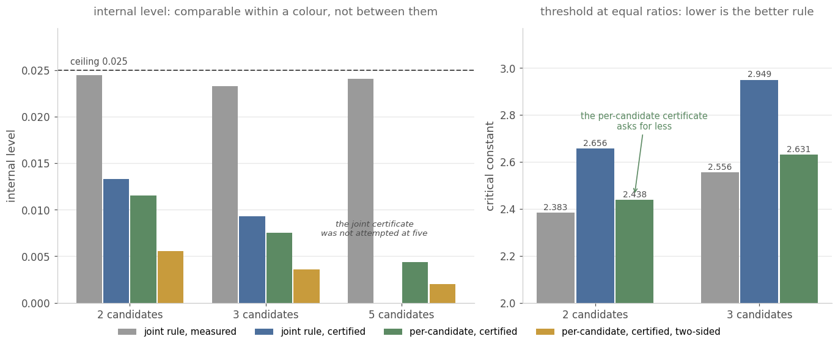
Figure 16. Left: the internal level each construction supports on a 35-degree-of-freedom benchmark. Levels on different statistics do not compare, so that panel is to be read within one colour across candidate counts and not between colours. The joint certificate was not attempted at five candidates, which is why that group has three bars. Right: the quantity that does compare, the threshold each certified rule applies when the estimated ratios are all one, on the two designs where both certificates exist. The per-candidate certificate asks for the lower threshold at both, which is the result of Section 10.6. Its axis starts at 2.0 and every bar carries its value.

10.6 The joint rule, and what certifying it requires
The union step of equation (42) is loose by construction, because it replaces the probability that at least one candidate rejects with the sum of the individual probabilities. A rule whose threshold depends on all $K$ estimated ratios at once can do better, and certifying it needs a way to bound a $K+1$ dimensional object without enclosing one.
A direct enclosure was tried first and abandoned. At four nuisance dimensions the corner-substitution bound stays loose by roughly a factor of two against a true value near 0.025, and refining the grid recovers too little of that to be worth the hours it costs. The run behind that judgement predates the deposit discipline of this programme and is not reproducible from the artefacts here, so it is reported as the reason a route was dropped and not as a measurement to rely on.
The route that works projects the deployed rule instead of bounding it. The rule in deployment is a tabulated step function of the full ratio vector, so for each candidate the quantity
$$ψ_{i}(t) = {\text{min}}_{{\hat{λ}}_{-i}}c_{joint}\left(t , {\hat{λ}}_{-i};α_{0}\right) ≤ c_{joint}\left(\hat{λ};α_{0}\right),{\hat{λ}}_{i}=t$$ (44)
is exact rather than an approximation of some other object, because the minimum is taken over the deployed table itself. Rejection of candidate $i$ therefore implies $T_{i}>ψ_{i}({\hat{λ}}_{i})$, the union of those $K$ events contains the familywise event, and each term is a one-candidate supremum of exactly the kind Section 10.4 certifies over the continuum.
Table 20. The joint certificate at two and three candidates. The certificate's effect is measured against how much of the level the same rule supports when its level is merely measured. The last column is the threshold the certified rule asks for when the estimated ratios are all one, which is the quantity that compares across rule types; the internal levels do not, because they are levels on different statistics. The error-rate column is the deployed joint rule's own unconditional error rate at its worst ratio pattern, Rao-Blackwellised over 4,000 draws, which every bound dominates. The deployed table is tabulated on 30 bins per ratio axis at two candidates and 16 at three, so the two candidate counts are not measured on the same grid.
Benchmark | Candidates | Joint level | Total bound | Cost of the certificate | The deployed rule's own error rate | Its threshold at equal ratios
35 df | 2 | 0.01332 | 0.024958 | 45.5% | 0.013688 (se 0.000177) | 2.6560
11 df | 2 | 0.01296 | 0.024990 | 44.9% | 0.013409 (se 0.000230) | 2.6647
35 df | 3 | 0.00928 | 0.024964 | 60.2% | 0.009586 (se 0.000131) | 2.9494
11 df | 3 | 0.00883 | 0.024983 | 62.7% | 0.008948 (se 0.000161) | 2.9914
The projection certifies the joint rule, and the joint rule is then not worth deploying. Its internal level is higher than the per-candidate rule's, which looks like a gain and is not one. The two are levels on different statistics, the joint level on the maximum over candidates and the per-candidate level on one comparison, and at any common level the constant on the maximum is the larger of the two. The quantity that does compare is the threshold a desk applies. On a 35-degree-of-freedom benchmark with two candidates at equal estimated ratios, the certified joint rule asks for 2.6560 and the certified per-candidate rule for 2.4384, and the per-candidate threshold is the lower of the two at every design and every ratio pair tested.
The realised error rates say the same thing on the error-rate scale. The certified joint rule realises 36% to 55% of the ceiling; the certified per-candidate rule realises 91% to 96%. What separates them is how much level certification removes from each: 44.9% to 62.7% of the joint rule's own measured level, against 3.7% to 6.8% of the per-candidate rule's. The projection handles the coupling, and the coupling turns out to be hard to prove and easy to give up.
The joint rule is still the better rule when its level is merely measured: at the same design its measured threshold is 2.3828, below the per-candidate certificate's 2.4384. The result of this subsection is therefore about proof and not about the rules. Certifying the coupled rule removes more level than the coupling gains, so the rule to deploy under a certificate is the per-candidate one of Section 10.5, and the joint certificate is what bounds the coupled rule for a reader who wants it bounded. The projection gap, the distance between the joint bound and the per-candidate bound from the same enclosure, is 3.7% to 11.2%.
The comparison column in Table 20 was wrong in the first version of this certificate and a gate caught it. The field had been filled by evaluating a per-candidate table at the joint rule's level, which is a different rule with a lower threshold and therefore a higher error rate, and the recorded value sat above the bound. The certificates never used that field, so they were unaffected; it now carries the deployed joint rule's own error rate with its Monte-Carlo standard error, and all four bounds dominate. A gate that compares a bound against the wrong object is worse than no gate, which is why the field was recomputed rather than the gate relaxed.

10.7 Whether anything in the same class does better
A rule that sees only the estimated ratios can be any function of them. The rule of equation (40) is one such function, chosen for being the exact fixed-ratio constant at a shrunken level. Its residual loss against the oracle might be due to that choice, or it might be due to not knowing the ratios. Those two have different remedies, so the question is worth settling.
The size of that class is probed by optimising over it, to the resolution the search can reach. Represent a threshold function as piecewise constant on 36 bins, whose 35 interior edges run from 0.003 to 333 in the variance ratio with an unbounded bin beyond each end, so the declared domain is covered from one edge to the other. Maximise mean power over the alternatives subject to the same unconditional ceiling, and compare the optimum against the calibrated rule. Every rule that sees only the estimated ratio is of this form up to bin resolution, so the optimum's loss bounds what any such rule achieves, to the extent that the search finds the optimum.
Table 21. The calibrated rule against the best rule of its class, averaged over the five ratio settings 0.04, 0.25, 1, 4, 25, which span a factor of 625. A positive gain means the optimiser found a better threshold function; a negative one means the optimiser, searching numerically under the same constraint, did not reach the calibrated rule. The last column is the optimum's own worst error rate on a refined grid.
Benchmark | The calibrated rule | The best rule of its class | Gain available | The optimum's own worst error rate
3 df | 25.2 pp | 20.9 pp | +4.24 pp | 0.0248
5 df | 12.8 pp | 11.5 pp | +1.30 pp | 0.0247
7 df | 8.6 pp | 8.1 pp | +0.49 pp | 0.0247
11 df | 5.7 pp | 5.8 pp | -0.02 pp | 0.0247
19 df | 4.6 pp | 4.6 pp | +0.01 pp | 0.0247
35 df | 4.4 pp | 4.4 pp | +0.06 pp | 0.0248
Below seven degrees of freedom there is something to gain: +4.24 percentage points at three and +1.30 at five. From eleven upward the gains are -0.02, +0.01 and +0.06 percentage points, which is zero to the resolution of the search. The negative entry at eleven measures that resolution: a local solver on a bin parameterisation failed to recover a rule its own class contains. The residual loss the calibrated rule carries at those sample sizes is therefore the loss due to not knowing the variance ratio, to within what this search resolves. Section 10.8 removes that qualification: it identifies the class this search ranges over, drops the two restrictions the search imposes, and solves the resulting program globally rather than locally.
The two tables measure the same rule on different bases and are not to be read across. Table 17 takes the median over a ratio grid with a 60-bin threshold table at the certified level; Table 21 takes the mean over five ratio settings with the 36-bin table the optimiser searches, at that table's own calibrated level. At three degrees of freedom the two give 23.9 and 25.2 percentage points for the same rule. The 36-bin basis is the one that makes the comparison internal, because the calibrated rule and the optimum are then members of the same class.
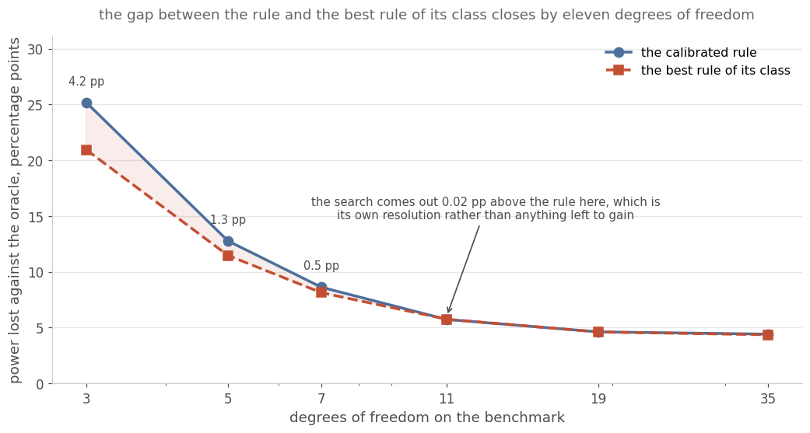
Figure 17. The calibrated rule against the best rule of its class by benchmark length. The shaded gap is what a better threshold function recovers, and it closes by eleven degrees of freedom, where the search stops finding anything and the remaining loss is due to not knowing the ratio. The y-axis runs to zero so that the residual is read as the level it is rather than as convergence.

10.8 The floor the class reaches
Section 10.7 optimised over threshold functions of the estimated ratio and found nothing above eleven degrees of freedom. Two questions decide what that sentence means. The first is how large the class is. The second is whether the search's answer is the class's answer: the search ranged over monotone threshold functions and was solved by a local method on a bin parameterisation, and the negative entry at eleven degrees of freedom shows that method did not always recover a rule its own class contains.
Both are settled here, and the second is settled globally rather than by a better local solver.
Take the first. Under the null the parameter is the common mean and the two variances, and the sufficient statistic has four coordinates. The only transformations that leave the testing problem alone are
$x↦a+bx,b>0,\text{applied to both groups}$ (47)
which is the affine group of the line, with two parameters. Scaling the groups separately is not admissible, because it changes the variance ratio and so changes the problem. A maximal invariant is therefore two-dimensional, and $\left(t_{i} , {\hat{λ}}_{i}\right)$ is one: both coordinates are unchanged by every group element, and any two sufficient statistics that share them are related by the explicit element $b=(w_{0}^{2}/s_{0}^{2})^{1/2}$, $a={\overline{Y}}_{0}-b{\overline{X}}_{0}$.
Neither half is asserted. Applying random affine maps to raw data moves the invariant by at most 4.25e-12 across three designs. For the converse, a second sufficient statistic is constructed directly on the same level set rather than by applying a group element, and the element that maps one onto the other is recovered in closed form; the worst reconstruction error over 200,000 pairs per design is 1.46e-11. The class Section 10.7 searched is therefore the class of non-randomised invariant tests, up to monotonicity and bin resolution, and not a convenient parametric family.
Take the second, and drop both of the search's restrictions at once. Discretise the $\left(t , \hat{λ}\right)$ plane and let $q_{bk}∈[0,1]$ be the probability of rejecting when the estimated ratio falls in bin $b$ and the statistic falls in cell $k$. Conditionally on a state the statistic is normal, so the mass each cell receives is a closed form in the same tensor quadrature Section 10.7 uses, and both the objective and every constraint are linear in $q$:
$${\text{max}}_{0≤q≤1} \sum_{b,k}{q_{bk}}m_{bk}^{alt}\text{subject to}\sum_{b,k}{q_{bk}}m_{bk}^{λ}≤\overline{α} for every declared λ$$ (48)
This is a linear program, so its optimum is global, and it ranges over every region in the plane rather than over threshold functions: regions that are not upper sets in the statistic are admitted, and so are randomised decisions, neither of which validity requires. Monotonicity is imposed by adding $q_{bk}≤q_{b,k+1}$, so the restricted and unrestricted optima are two solutions of the same program on the same grid under the same constraint, and their difference measures the effect of monotonicity and nothing else.
Table 28. The calibrated rule against the best rule of its class and against the best rule of any shape, on the basis of Table 21: mean power given up at 80% over the five ratio settings 0.04, 0.25, 1, 4, 25. The two region columns are optima of one linear program with and without the monotonicity constraint, and they agree at every design, which is the result rather than a repeated column. The last column is the difference between the deployed rule and the global optimum, and is a lower bound on what any rule measurable in the estimated ratio must give up.
Benchmark | The calibrated rule | Section 10.7's optimum | Best monotone region | Best region of any shape | What the calibrated rule gives up
3 df | 25.19 pp | 20.95 pp | 20.69 pp | 20.69 pp | 4.50 pp
5 df | 12.77 pp | 11.47 pp | 11.23 pp | 11.23 pp | 1.54 pp
7 df | 8.62 pp | 8.13 pp | 7.89 pp | 7.89 pp | 0.73 pp
11 df | 5.73 pp | 5.75 pp | 5.52 pp | 5.52 pp | 0.21 pp
19 df | 4.62 pp | 4.61 pp | 4.40 pp | 4.40 pp | 0.22 pp
35 df | 4.42 pp | 4.36 pp | 4.17 pp | 4.17 pp | 0.24 pp
Two readings. The first is that the monotonicity constraint is not binding. The unrestricted optimum satisfies it at every design, and the two objective values agree to six decimal places in percentage points, which is why the last two columns of Table 28 are identical. Allowing a non-monotone region gains nothing and allowing randomisation gains nothing, so the optimal rule in this class is monotone and deterministic, which Section 10.7 assumed without argument. Rounding the program's fractional cells down, which is what an exactly deterministic boundary requires rather than determinism itself, gives up 0.46 to 0.85 percentage points.
The second is the last column. Above eleven degrees of freedom the deployed rule sits 0.21 to 0.24 percentage points above the best any rule that sees only the estimated ratio can reach. That is a stronger statement than Section 10.7 could make, because the program is global and the class is the invariant class, and it is the sense in which the residual loss is a limit of the available information rather than of the procedure.
The bound is conservative in the right direction. The uniform constraint is imposed at 97 ratio values and verified at 193, where the solution overshoots the ceiling by at most 3.69e-04, which is 1.48% of it. An overshooting solution achieves more power than a feasible one, so the gap reported above is if anything too large. Sensitivity to the statistic's grid is at most 0.034 percentage points.
Thirty-six bins is itself an approximation, so the frontier was re-solved at 72 and 144 with the same shrink step applied to each, so that valid rules are compared with valid rules. At 35 degrees of freedom the optimal loss moves from 4.36 to 4.35 to 4.36 percentage points and at 3 from 20.95 to 20.93 to 20.93, so the bin count can hide at most 0.017 percentage points anywhere. The result of Section 10.7 is not an artefact of the grid.
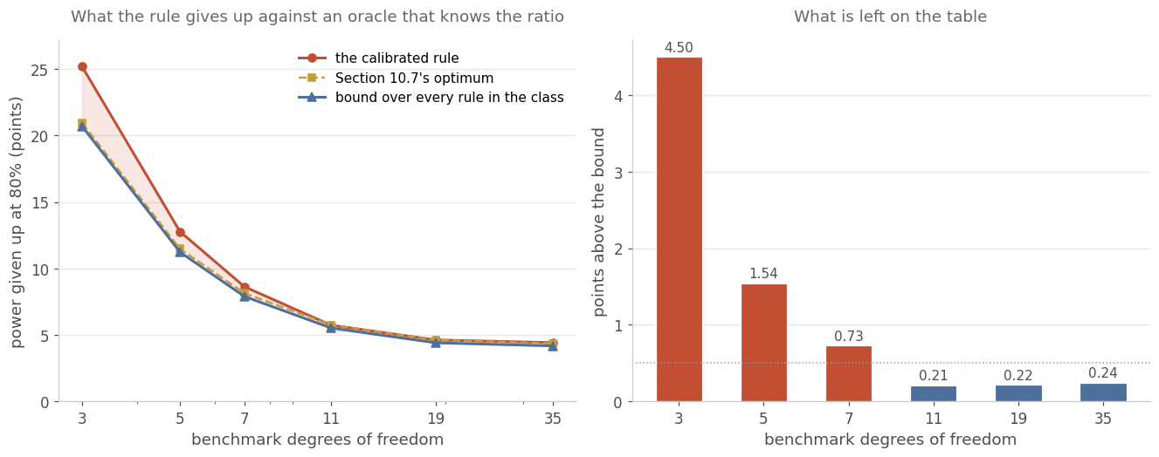
Figure 18. Left: three losses by benchmark length, with the shaded band between the deployed rule and the global bound. Right: the band as a number. Above eleven degrees of freedom it is a fifth of a percentage point, and below seven it is what Section 10.7 already reported as available.
How far that bound extends is a separate question. The affine group is solvable, because the translations form a normal abelian subgroup with abelian quotient, and solvable groups are amenable. For an amenable group the Hunt-Stein theorem gives that a minimax test may be taken invariant, which would make the bound above a bound over all tests rather than over invariant ones, for a worst-case criterion.
That step is taken here, and taking it changes the criterion the claim is made on. Hunt-Stein applies to a problem whose loss is unchanged by the group, because the proof averages a test over the group and needs the risk to survive that averaging. Worst-case regret against the known-ratio oracle is such a loss: it is the oracle's power minus the rule's, at the alternative where that gap is widest, and the oracle's power depends on the parameter only through the maximal invariant above. Weighted average power at chosen ratio settings is not. Averaging over the group returns a test's mean power over an orbit, the set of parameters the group maps to one another, and a mean bounds a supremum but not a weighted sum at selected points. The last column of Table 28 is a mean over five ratio settings, so it is not the quantity the theorem covers.
The floor on that criterion is not Table 28's. It is the same linear program with worst-case regret as its objective. Against it, evaluated by the same exact quadrature, at the same ceiling and over the same declared alternatives, the deployed rule sits 0.21 percentage points above the floor at eleven degrees of freedom, 0.28 at nineteen and 0.43 at thirty-five. Below eleven the gap is larger, 1.04 at seven, 2.76 at five and 9.30 at three, which is the boundary Section 10.7 locates on the average criterion. Monotonicity again makes no difference: the restricted and unrestricted programs agree to 7.5e-06 percentage points.
Three conditions carry that statement, and two are checked here. The first is that the loss is invariant, which is what lets the averaging step leave the risk unchanged. The oracle's power, computed from the raw parameter rather than from the invariant, is unmoved by the group to 5.4e-15 over 48 draws placed between 0.058 and 0.927, the range in which it is not saturated at zero or one and can therefore move. The second is that the null and the alternative are invariant under the same group, and that the maximal invariant above closes in exact algebra at one and at two candidates rather than to a numerical tolerance. The third is the passage from almost invariance to invariance, which is taken from the literature rather than proved here (Bondar and Milnes 1981; Lehmann and Romano 2005). Separately, the extension above one candidate is still unwritten, where the group is the same but the invariant is a pair of vectors.
The conclusion is tested as well as argued. 36 rules that read the benchmark's variance estimate alongside the maximal invariant were each calibrated against the constraint uniformly over that variance, by the same quadrature, and scored on the worst-case regret above. None beats the floor, and the best falls 1.33 percentage points short. The rule that uses that variance to de-bias the estimated ratio gives up between 2.05 and 5.14 points, and it is the case an invariance argument should be most vulnerable to, because it puts the discarded coordinate to work on the retained one. One further check separates the invariant rules from the rest. Widening the range of the benchmark's variance over 16 orders of magnitude leaves the deployed rule's worst regret at 7.227473 percentage points, unchanged in every digit, while making every one of those rules worse: the deployed rule reads the estimated ratio alone, and the law of that ratio does not involve the benchmark's variance.
The floor is reached above eleven degrees of freedom and not below it, and Section 10.7 reported that as a benchmark effect. Section 10.9 shows the binding quantity is the smaller of the two groups, so the same optimisation was run over both group sizes on the grid 3, 4, 5, 7, 9 and 11. A gain was counted as material at 0.50 percentage points, declared before the run.
Table 34. What a design-specific threshold function is worth, by the smaller of the two groups. Each entry is the mean over the cells of the 36-cell grid that share that value, against the calibrated rule on the same basis as Table 28.
Smaller group | Mean gain from a design-specific threshold
3 df | 3.34 pp
4 df | 1.81 pp
5 df | 1.09 pp
7 df | 0.38 pp
9 df | 0.09 pp
11 df | -0.05 pp
The gain is material in 26 of the 36 cells, worth at most 4.09 percentage points, and every material cell has a smaller group of five degrees of freedom or fewer. The operational reading is that the shipped table is deployable unaltered when the smaller group has more than five degrees of freedom, and that at or below that a threshold function solved for the design is worth 0.50 percentage points or more. This does not displace the boundary of Section 10.9: at three degrees of freedom the 2023 method is still the better instrument, and what this adds is that a desk which must use this one should not use the shipped table there.
Tables 28 and 34 are not to be read across, for the same reason Tables 17 and 21 are not. Table 28's last column takes one design and measures the deployed rule against the global bound over the whole class. Table 34 averages the cells of the 36-cell grid that share a value of the smaller group, and measures them against a threshold function solved for each design. At seven degrees of freedom the two give 0.73 and 0.38 percentage points. The difference between them is the difference between what no rule of this class can recover and what this search does recover.

10.9 Which group binds, and a map for planning
Section 10.3 showed a 35-degree-of-freedom benchmark against a four-degree-of-freedom candidate giving up as much power as a three-degree-of-freedom benchmark against a long candidate. That points at the smaller of the two groups rather than at the benchmark as the binding quantity, which is what the sweep behind Section 12.3 could not see, and it matters for planning because a desk chooses both sample sizes.
A sweep over seven benchmark lengths and five candidate lengths settles it. If the smaller group binds, designs sharing a value of $\text{min}(ν_{0},ν_{1})$ should have similar losses and designs sharing a benchmark length should not.
Table 22. The spread of the worst power loss across designs grouped two ways. Grouping by the smaller of the two degrees of freedom collapses the spread from eleven upward; grouping by the benchmark's own degrees of freedom does not, and the spread grows with the benchmark because the candidate is then free to be short. The six lengths shown are the ones the two groupings share. The sweep also covers a 59-degree-of-freedom benchmark, where the spread is 43.4, and a 23-degree-of-freedom smaller group, where it is 0.1.
Degrees of freedom | Spread across designs sharing this as the smaller group | Spread across designs sharing this as the benchmark
3 df | 13.1 pp | 11.6 pp
5 df | 4.8 pp | 17.0 pp
7 df | 1.1 pp | 23.6 pp
11 df | 0.8 pp | 32.3 pp
19 df | 0.1 pp | 38.1 pp
35 df | 0.1 pp | 42.0 pp
Above seven degrees of freedom the spread within a shared smaller group is 0.83 percentage points or less, while the spread within a shared benchmark length reaches 42.0. The binding quantity is $\text{min}(ν_{0},ν_{1})$, and the planning rule follows from it directly: 19 degrees of freedom on the smaller group for a loss under 5 percentage points, 11 for under 10, 5 for under 25 and 3 for under 50.
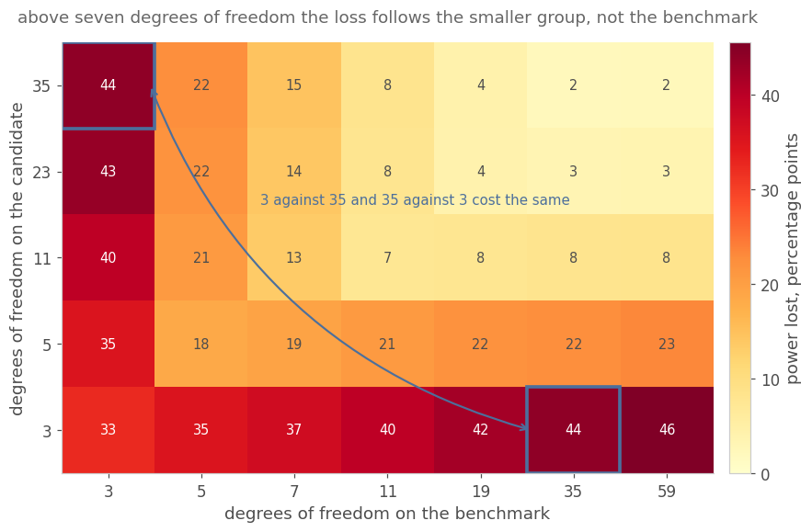
Figure 19. The worst power loss over both groups' degrees of freedom. The two axes carry different sets of lengths, so the symmetry is between cells and not about a drawn diagonal: exchanging the two groups leaves the loss unchanged, and the two boxed cells are the pair that makes it visible, a 3-degree-of-freedom benchmark against a 35-degree-of-freedom candidate giving up what the reverse pairing gives up.

10.10 What a declared ratio domain is worth
The domain in every certificate above is [0.001, 1000] in the variance ratio, three decades in volatility, which admits a candidate about 32 times as volatile as the benchmark or a benchmark that much more volatile than the candidate. A desk that runs a volatility target knows neither is the case, and a narrower domain allows a higher internal level.
Table 23. Median power given up under six declared domains, at one candidate. A domain is admissible only if the desk declares it before seeing the performance data. Four sources qualify: a published volatility target, a contractual risk limit, a construction constraint, and a volatility history from before the evaluation that was not reused for selection. A bound inferred from the same returns being tested is circular, and it voids the guarantee.
Declared domain | 3 df | 5 df | 11 df | 35 df
three decades, unrestricted | 23.7 pp | 11.1 pp | 5.8 pp | 4.1 pp
two decades | 23.7 pp | 11.1 pp | 5.8 pp | 4.1 pp
one decade | 23.7 pp | 11.1 pp | 5.2 pp | 4.1 pp
a factor of 4 either way | 23.7 pp | 11.1 pp | 4.8 pp | 4.1 pp
a factor of 2 either way | 23.0 pp | 10.6 pp | 3.8 pp | 4.1 pp
volatility targeted, a factor of 1.5 | 22.1 pp | 10.2 pp | 3.8 pp | 4.1 pp
The recovery is real and small. The tightest admissible domain takes eleven degrees of freedom from 5.8 to 3.8 percentage points, three from 23.7 to 22.1 and five from 11.1 to 10.2, and leaves 35 where it was, because there the rule is already close to the oracle and the domain is not what binds. Two decades and one decade gain nothing at all on most designs, because the worst ratio for the unconditional error rate sits well inside a single decade: on the unrestricted domain the binding ratio is 0.251 at three degrees of freedom and 1.995 at 35, neither of them near an edge, so removing the edges removes nothing.

10.11 Cost, and what checks the numbers
The certificates in this section are quadrature rather than simulation, and the programme runs on a laptop. The original sweep cost one root-find per design per candidate level; tabulating the distribution function once per design on a fixed grid of constants and inverting it by monotone interpolation serves every level from one pass, and the passes are independent across designs. On 10 workers that is 9.9 seconds against an estimated 255 for the root-find route, a factor of 26, and the inversion agrees with a direct root-find to 6.3e-05 in the constant.
The interpolation runs in the logarithm of the rejection probability rather than in the probability itself. The reason is that the rejection tail is close to exponential in the constant. Both scales were measured on the same grid: the logarithmic one is out by 6.3e-05 in the constant and the probability scale by 9.1e-04, a factor of 15. The gate that guards the speed layer allows 0.001. So the obvious choice of scale would have passed it with almost nothing to spare, and the choice is reported as a measurement rather than as a preference.
Table 24. The checks that stand behind this section. Each compares two objects computed by different routes, so agreement is evidence and disagreement would be a defect rather than a tuning parameter. The last row is the one that could have invalidated the certificates.
Check | What it compares | Result
Tabulation against root-finding | the tabulated inverse of the distribution function against a direct root-find, at every level in the sweep | worst difference 6.3e-05 in the constant
Parallel against serial | the same sweep on 10 workers and on one | identical to the last bit
An independent quadrature | the conditional rejection probability by a second rule, at 6 points | worst absolute difference 1.1e-03
Simulation against the exact level | realised error rates against the quadrature over 18 comparisons, in standard errors | worst |z| = 1.36
Simulation against the exact power | realised power against the quadrature over 12 comparisons, in standard errors | worst |z| = 2.50
Certificates against samples | every deposited certified bound against a direct simulation at 42 ratio points | never breached
11 of 11 deposited gates pass. They include the one that re-reads every deposited rule on a finer grid than the one it was built on, and the one that refuses a certificate whose tier label overstates what it proved. The cross-check is not a blind replication: the same author wrote it in the same session as the code it checks, and it reuses the deposited thresholds rather than re-deriving them from a specification. What it rules out is that the quadrature, the tabulation and the enclosure are all wrong in the same direction, because each computes the same quantity by a different route. That is the failure mode a single implementation cannot detect.

11. Dependence as a Declared Nuisance
Section 9.10 measured two boundaries and repaired neither. Serial correlation exhausts the guarantee at a lag-one coefficient near 0.1, and a common factor with opposite-sign loadings requires a constant the leading correction does not supply. Both statements are true of rules built for independent samples applied to data that are not independent. Neither is a statement about what the reduction of Section 3 can reach.
This section moves both departures out of the decision rule and into a declared pre-processing step. Where the nuisance is declared rather than estimated, the transform returns the independent problem this paper already solves, and every certificate in Sections 9 and 10 applies to it, subject in the serial case to a choice of transform that Section 11.1 states and a falsifier settles. Where the nuisance is estimated from the same data, what results is a labelled plug-in, and its effect on the error rate is measured.

11.1 Serial correlation
If the returns follow a stationary Gaussian AR(1) with a declared coefficient $ϕ$, the Prais-Winsten transform
$$y_{1}=\sqrt{1-ϕ^{2}}x_{1},y_{t}=x_{t}-ϕx_{t-1} (t≥2),y\sim N\left(μk(ϕ),σ^{2}I_{n}\right)$$ (45)
maps the series to exactly independent Gaussians. Exactly, not approximately: the transformed covariance is a multiple of the identity, with no asymptotics. What the transform does not give is a constant mean. The transformed mean is $μk(ϕ)$ with $k=(\sqrt{1-ϕ^{2}},1-ϕ,…,1-ϕ)$, whose first coordinate differs from the rest, so the whitened sample is a one-regressor Gaussian model rather than the location model of Sections 3 and 4.
That distinction is immaterial when the two groups are the same length and fatal when they are not. The statistic takes the difference of the two sample means, and the plain sample mean of a whitened series estimates $μ\overline{k}$, where $\overline{k}$ depends on the group's length. With equal lengths the two groups share $\overline{k}$, the difference is unbiased for zero under the null whatever the common mean is, and the exact law, the calibrated rule of Section 10 and every certificate behind them transfer unchanged. With unequal lengths the numerator carries a bias proportional to the common mean, and the rule drifts off its ceiling as that mean grows.
The repair is to drop the first observation rather than rescale it. Taking $y_{t}=x_{t}-ϕx_{t-1}$ for $t≥2$ and discarding $y_{1}$ leaves a mean vector that is constant at $μ(1-ϕ)$ at every $t$, identical whatever the group's length. The transformed sample is therefore a location model on $n-1$ observations, and it lands in the family of Sections 3 and 4 with $n$ replaced by $n-1$. There is no regression to run and no effective sample size to compute, and the transform discards one observation per group.
Serial dependence then stops being a boundary on the guarantee and becomes a step taken before the statistic is formed, on two conditions: the coefficient has to be declared rather than read off the same returns, and the first observation has to be dropped rather than rescaled unless the groups are of equal length.
Table 25. Realised familywise error rates under AR(1) returns at a ceiling of 0.025, with 36 observations in each group and 40,000 draws per cell. The left column applies the rule of Section 10 to the raw series; the right column applies the same rule to the whitened series with the true coefficient declared.
Lag-one correlation | No transform | Whitened at the declared coefficient
0.00 | 0.0254 (se 0.0008) | 0.0254 (se 0.0008)
0.05 | 0.0308 (se 0.0009) | 0.0249 (se 0.0008)
0.10 | 0.0394 (se 0.0010) | 0.0252 (se 0.0008)
0.20 | 0.0546 (se 0.0011) | 0.0248 (se 0.0008)
0.30 | 0.0748 (se 0.0013) | 0.0243 (se 0.0008)
0.40 | 0.1000 (se 0.0015) | 0.0249 (se 0.0008)
Untransformed, the rule reaches 157% of the ceiling at $ϕ=0.1$ and 400% of it at $ϕ=0.4$. Whitened at the declared coefficient it sits between 0.0243 and 0.0254 across the whole range, every value within 0.9 standard errors of the ceiling. The boundary Section 9.10 reported at 0.1 is a boundary of the untransformed rule.
None of that is asserted. The deposited falsifier runs both transforms at both designs, over three coefficients and three common means. Rescaling the first observation holds the ceiling at equal lengths, within 2.1 standard errors and flat in the common mean, and fails at 36 against 13. With the coefficient at 0.4 and a common mean of 2 it reaches 0.0303, which is 6.2 standard errors above the ceiling and 121% of it, while the same cell at a zero mean sits on the ceiling. Dropping the first observation instead holds the ceiling at both designs, with a worst deviation of 0.00062 at 0.8 standard errors. Its realised rate is identical to five decimals across every common mean tested, which is the signature the constant mean vector predicts: the repaired statistic does not see the common mean at all. Table 25 was run at equal lengths and a zero mean, so it could not have seen any of this.
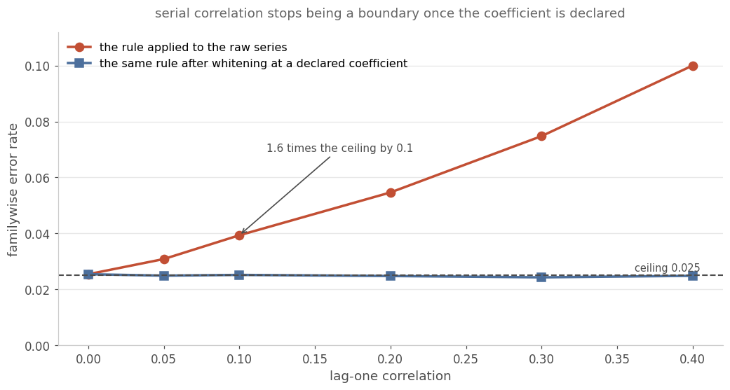
Figure 20. The error rate against the lag-one correlation, with and without the transform. The untransformed rule is at the ceiling only at zero correlation, and is four times it by 0.4. The whitened rule sits on the ceiling across the range, which is what an exact transform of an exact law should do.
A declared coefficient that is wrong is a different matter and is measured rather than argued. Declaring a coefficient above the truth is conservative and declaring one below it is liberal, monotonically in both directions.
Table 26. The misspecification surface: the realised error rate when the transform uses the declared coefficient in the row and the data follow the one in the column, at 12,000 draws per cell. The diagonal is the correctly declared case, on a smaller sample than Table 25 and so at a wider standard error. Nothing off the diagonal is certified, and that is why a declared bound rather than a declared point is the deployable version.
Declared | True 0.0 | True 0.1 | True 0.2 | True 0.3
0.0 | 0.0229 | 0.0353 | 0.0533 | 0.0697
0.1 | 0.0145 | 0.0236 | 0.0402 | 0.0573
0.2 | 0.0062 | 0.0136 | 0.0255 | 0.0405
0.3 | 0.0019 | 0.0067 | 0.0140 | 0.0253
The deployable version takes the worst case over a declared bound. Whitening at $ϕ_{\text{max}}$ and requiring the error rate to stay under the ceiling at every coefficient in $\left[0 , ϕ_{\text{max}}\right]$ leaves the worst measured rate at 0.0247, 0.0244 and 0.0235 for the three bounds tested. All three are under the ceiling, and none reduces the internal level relative to the independent case, because whitening at the top of the bound is conservative everywhere inside it. Those three numbers are simulation estimates on 12,000 draws per cell, so they carry a standard error of about 0.0014, and the construction is measured rather than certified.

11.2 A common factor
The same conditioning argument handles a common factor. If each group's returns load on one factor with a declared loading, residualising on the factor path leaves independent Gaussian residuals and moves the estimand from the raw mean to the factor alpha:
$$r_{g,t}=α_{g}+β_{g}f_{t}+ϵ_{g,t},{\overset{\sim }{r}}_{g,t}=r_{g,t}-β_{g}f_{t},ϵ_{g}\sim N\left(0 , σ_{g}^{2}I_{n}\right)$$ (46)
The residual series is what the rule is applied to, and the hypothesis it tests is about the factor alpha rather than about the raw mean. That is a change in the estimand and has to be declared as one. A desk that wants the raw mean tested is asking a different question, and the raw-return column below is what that question returns.
Table 27. Realised familywise error rates under a one-factor model, 36 observations per group, 40,000 draws per cell, at a ceiling of 0.025. The loading pairs are the benchmark's and the candidate's. The last two columns estimate the loadings in sample; what separates them is whether the degree of freedom lost to the regression is returned to the rule.
Exposure pattern | Raw returns | Declared loadings | Estimated, the degree of freedom returned | Estimated, the degree of freedom not returned
no exposure (beta = 0, 0) | 0.02388 | 0.02388 | 0.02513 | 0.02697
same sign (1.0, 0.8) | 0.00477 | 0.02492 | 0.02645 | 0.02825
opposite signs (1.0, -0.8) | 0.05065 | 0.02390 | 0.02595 | 0.02810
benchmark unexposed (0, 1.0) | 0.02545 | 0.02455 | 0.02612 | 0.02788
With raw returns the factor moves the error rate in both directions and by a lot. Same-sign loadings make the rule so conservative that it reaches 0.00477, a fifth of the ceiling, and opposite-sign loadings make it liberal at 0.05065, 103% above it. Residualising on declared loadings removes the effect in all four patterns, with every rate between 0.02388 and 0.02492.
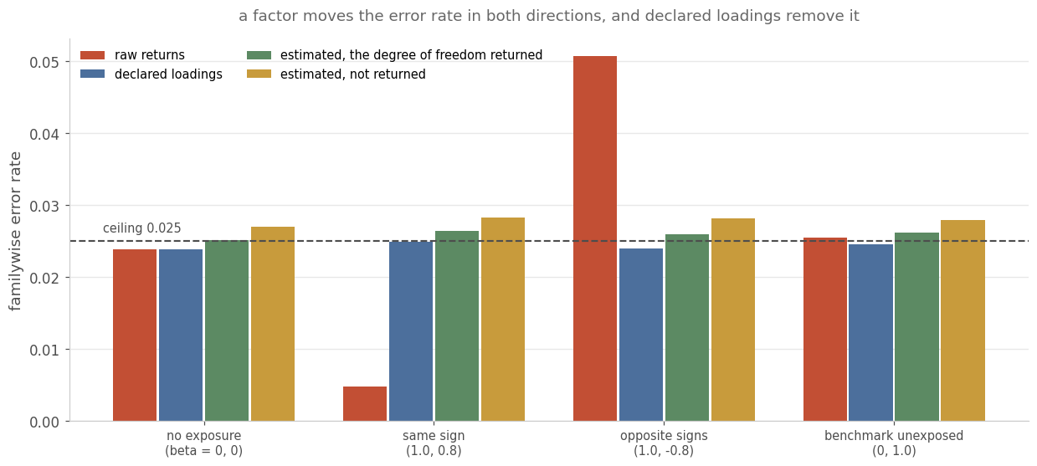
Figure 21. Error rates by exposure pattern and by what the rule is applied to. Raw returns move in both directions; declared loadings return every pattern to the ceiling; estimating the loadings moves the rate up, by a margin the data resolve only when the regression's degree of freedom is not returned.
Estimated loadings are a plug-in, and the degree of freedom the regression consumes has to be given back to the rule. The arm that gives it back sits between 0.02513 and 0.02645, which is 0.2 to 1.8 standard errors from the ceiling on 40,000 draws, so none of its four patterns is distinguishable from nominal. The arm that does not sits between 0.02697 and 0.02825, 2.4 to 3.9 standard errors above, and all four are. The correction is therefore doing the work, and what the corrected arm has is a measurement consistent with the ceiling rather than a certificate of it: the estimation error is real and this design does not resolve it. Loadings fitted on a disjoint pre-period are a different matter, because the residuals are then independent of the loadings: over 60 pre-periods the realised rate is 0.0242, 1.04 standard errors from the ceiling and under it.
The general factor case that Section 9.10 left unimplemented is also reachable without residualising, by conditioning once more. Conditional on the realised factor path the groups are independent, so the null law factorises again. The outer expectation is not one-dimensional: each group's sample variance about its own mean picks up the factor's dispersion, so its law is non-central chi-square with a non-centrality in $\sum_{t}{(}f_{t}-\overline{f})^{2}$, and the path enters through that sum as well as through its mean. Section 9.10 gives the same statement and is the version to follow. The implemented law conditions on the mean alone and takes the inner variances as central, so it holds $\sum_{t}{(}f_{t}-\overline{f})^{2}$ at its expectation rather than integrating it out. At one candidate that law agrees with 40,000 draws to |z| = 0.03, and its zero-loading limit reproduces the independent constant to 1.3%, the residual being the coarseness of the factor quadrature's product grid rather than a difference in the model. At three and five candidates the agreement is 2.9 and 4.4 standard errors, in both cases with the quadrature above the simulated rate, so the law is validated at one candidate and conservative above it. Conservative is the safe direction and it is not agreement. Those comparisons also draw the sample variances as central chi-squares, which is the quadrature's own assumption rather than the factor model's, so they check the quadrature and not the conditioning. Both are reasons the route taken above one candidate here is residualising on declared loadings.
That last limit is a falsifier that fired. The first version of the factor law paired the two chi-square quantile grids index by index, which is a comonotonic coupling and not a product measure, and the zero-loading check caught it: the critical value came out 2.5 times too large.

11.3 What is declared and what is estimated
The distinction running through this section is not stylistic. A declared nuisance is a modelling choice made before the performance data are seen, and the certificate applies to the transformed problem exactly. An estimated nuisance is a second source of sampling error inside the decision path, and the certificate does not cover it.
The experiments in 11.1 give the benchmark and the candidates one shared coefficient, and those in 11.2 give them declared loadings on one shared factor. Groups with different autocorrelations, or with more than one factor, are neither tested nor excluded here; the transform argument does not depend on the coefficients being equal, and the measurements do not cover the unequal case.
Two objects are therefore labelled plug-ins rather than certified rules: an autocorrelation coefficient estimated from the same returns, and factor loadings estimated in sample. For each the measured effect on the error rate is above, and for each the repair is procedural rather than mathematical. Declare a bound on the coefficient and whiten at its top, dropping the first observation; fit loadings on a disjoint pre-period. The second repair works, since fitted loadings hold the ceiling at every calibration length tested. The first does not, and Section 11.4 measures how far it falls short, which is why the coefficient repair is a declared bound rather than an estimate from another period. Both are available only to a desk that plans the evaluation before it runs.

11.4 Three validity tiers, and the effect of estimating the coefficient
Section 11.3 divides nuisances into declared and estimated. That is the right division for the certificate, and it is too coarse for a desk, because between declaring a coefficient and reading it off the returns under test there is a third option: estimate it on a period that is not reused. Three tiers, and the middle one is the one a desk would actually reach for.
Tier A declares the parameter. The transform is exact, the transformed groups are independent, and every certificate transfers at the shortened count. This is the tier Sections 11.1 and 11.2 establish. Tier B estimates it on a disjoint calibration period and then freezes it, so the transform is random but independent of the evaluation data. Tier C estimates it on the evaluation period, so the transform is a function of the data being tested.
Table 29. Worst realised familywise error rate at each tier, against a ceiling of 0.025, over three coefficients, three common means and two designs for the serial case and three loading patterns for the factor case, 300,000 draws per cell. Tier B is shown at three calibration lengths so the trade is visible rather than asserted.
Nuisance | A, declared | B, 36 | B, 120 | B, 360 | C, same period
AR(1) coefficient | 0.0253 | 0.1583 | 0.0736 | 0.0414 | 0.2830
factor loadings | 0.0253 | 0.0252 | 0.0254 | 0.0252 | 0.0343
The two rows do not behave alike. Factor loadings fitted on a disjoint pre-period hold the ceiling at every length tested, worst 0.0252 at 360 observations, and fail only when fitted in sample, where the worst rate is 0.0343. The serial coefficient fails at every tier below A. At 360 calibration observations the worst rate is 0.0414, and read off the evaluation period it is 0.2830, which is 11.3 times the ceiling.
Section 11.1 already met this effect, arriving by another route. The transform of equation (45), with the first observation dropped as Section 11.1 requires, maps a series with mean $μ$ to one with mean $μ(1-ϕ)$. With $ϕ$ declared, both groups are multiplied by the same constant, so the difference of transformed means is still zero under the null whatever $μ$ is. That is why tier A is exact. With $ϕ$ estimated separately in each group the two multipliers differ, and the numerator acquires a term in the difference between the benchmark's estimate and the candidate's,
$μ({\hat{ϕ}}_{0}-{\hat{ϕ}}_{i})$ (49)
which is zero in expectation and not zero in any sample, and whose spread grows linearly in the common mean. The denominator does not know about it, so the statistic inflates. Section 11.1 found the same shape: there the multiplier varied with the group's length, and here it varies with the group's estimate.
The repair that follows is to pool. Estimate one coefficient from both groups and apply it to both, and the multiplier is identical by construction, so the common mean cancels whatever the estimate happens to be.
Table 30. The worst cell of the grid, held fixed while the common mean moves. The left column is one coefficient per group and the right is one pooled across both, 400,000 draws per cell.
Common mean | One coefficient per group | One coefficient, pooled
0 | 0.0896 | 0.0782
2 | 0.2816 | 0.0792
5 | 0.4841 | 0.0787
The left column grows with the common mean exactly as equation (49) predicts. The right column does not move, because the pooled statistic cannot see the common mean at all, and that invariance is the signature rather than the size: across both tiers the pooled rate varies by at most 0.0010 as the mean runs from 0 to 5.
Pooling is an improvement and not a repair. It takes the worst rate from 0.4841 to 0.0792, from 19.4 times the ceiling to 3.2, and every one of the 36 cells in both arms is still above it. What remains is imperfect whitening at an estimated coefficient, which biases the variance estimate and is what the zero-mean rows isolate; it does not depend on the mean and pooling cannot touch it.
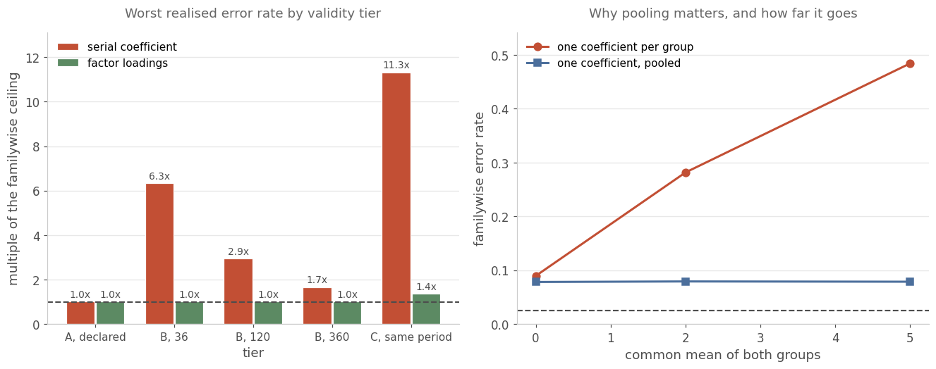
Figure 22. Left: the worst realised rate at each tier as a multiple of the ceiling, for both nuisances; the dashed line is the ceiling itself. Right: why pooling matters and how far it goes, at the worst cell of the grid, with the ceiling dashed.
This narrows Section 11.1. The serial result there is a tier-A result: it holds when the coefficient is declared and it does not hold when the coefficient is estimated, at either tier, at the sample sizes a monthly panel has. Section 11.3's statement that both repairs are available to a desk that plans the evaluation in advance holds for the loadings and does not hold for the coefficient, where planning provides a calibration period and a calibration period is not enough. The declared bound of Section 11.3, whitening at the top of a range fixed in advance, remains the only route that keeps the guarantee.

11.5 What the alternatives deliver at these sample sizes
A desk that will not declare a coefficient has procedures to reach for, and they are not this paper's. Newey-West standard errors and block bootstraps are justified by limit theorems and make no declaration at all. Section 9.10 already measures a moving-block bootstrap against the plug-in and the envelope; this subsection measures the same family against the exact rule on the same draws, with the coefficient estimated rather than known, which is the comparison a desk actually faces.
Table 31. Realised size of each procedure under AR(1) data with the coefficient unknown, one candidate, target 0.025 one-sided, 400,000 draws per cell for the closed-form rows and 12,000 with 299 resamples for the bootstraps, over four coefficients and three designs. The common mean is 2.0, because the separate and pooled variants coincide when it is zero.
Procedure | Worst size | Times the target | Cells above the target
the exact rule, coefficient declared | 0.0254 | 1.02 | 0 of 12
the exact rule, coefficient per group | 0.2824 | 11.30 | 12 of 12
the exact rule, coefficient pooled | 0.0783 | 3.13 | 12 of 12
Newey-West, normal critical value | 0.1268 | 5.07 | 12 of 12
Newey-West, t critical value | 0.1046 | 4.18 | 12 of 12
moving-block bootstrap | 0.1108 | 4.43 | 12 of 12
stationary bootstrap | 0.1246 | 4.98 | 12 of 12
The first row is a reference and not a competitor. It is given the coefficient and the others are not, and its only job is to confirm that the instrument reads correctly before the rest of the column is believed: it holds at 1.02 times the target and is the only row that does.
Among the rows that must estimate the coefficient, nothing holds. Two things follow, and the first is uncomfortable for this paper. The exact law derives its guarantee from the coefficient being declared and not from being exact: the same rule with the coefficient estimated separately in each group is the worst row in the table at 11.30 times the target, worse than either bootstrap. The second is that once the estimate is pooled the exact rule is the best of them at 3.13 times, against 4.18 for the closest alternative. Being least bad is not a guarantee and is not offered as one.

11.6 The factor case without residualising
Section 11.2 removes a factor by residualising on declared loadings, which changes the estimand from a raw mean difference to a factor alpha and has to be declared as a change of question. A desk that wants the raw comparison on returns that share a factor needs the law of the statistic it already computes, under dependence it does not remove.
Section 9.10 names the reduction that supplies it and reports it as implemented at one candidate only: conditioning on the factor's mean and on its sum of squares, together with the benchmark's sufficient statistics, makes the candidates independent again, with a non-central chi-square law for each candidate's variance. What follows is that construction carried out for any number of candidates. The outer rule is 4-dimensional over one one-dimensional inner rule per candidate, so the cost is linear in the number of candidates exactly as in Section 3.
Table 32. The general reduction against brute-force simulation of the full panel, 4,000,000 draws per cell. The last column is what the independent-groups law of Section 3 would give on the same design, and is the check that the comparison is not vacuous.
Cell | Brute force | The exact law | z | What the independent law gives
no loadings, independent | 0.02884 | 0.02872 | -1.42 | 0.02872
equal loadings | 0.00282 | 0.00281 | -0.16 | 0.02872
unequal loadings | 0.00895 | 0.00897 | +0.38 | 0.02872
unequal loadings and ratios | 0.01118 | 0.01123 | +0.82 | 0.03055
thirteen observations | 0.01025 | 0.01028 | +0.53 | 0.02602
strong loadings | 0.00935 | 0.00933 | -0.38 | 0.02872
one negative loading | 0.03153 | 0.03156 | +0.42 | 0.02928
five candidates | 0.00707 | 0.00713 | +1.58 | 0.02819
The worst discrepancy over the eight cells is 1.58 standard errors. The last column carries the weight: the independent-groups law is wrong here by up to 90.2% in relative terms, and the reduction tracks the truth across that range, so a reduction that quietly ignored the factor would pass every other column and fail this one. A coarser quadrature moves the answer by 3.5e-04.
Which side of the ceiling a desk lands on is decided by the loadings, and Section 9.10 reports the two cases: the uncorrected rule is conservative when the loadings agree and liberal when they have opposite signs. The exact law says why, and the reason is a comparison between two quantities that are equal only in one case. The numerator carries the squared contrast of the loadings and the denominator carries their sum of squares:
$$Var({\overline{X}}_{i}-{\overline{X}}_{0})=\frac{\left(β_{i}-β_{0})^{2}σ_{f}^{2}+σ_{i}^{2}+σ_{0}^{2}\right.}{n},E[\frac{s_{i}^{2}}{n}+\frac{s_{0}^{2}}{n}]=\frac{(β_{i}^{2}+β_{0}^{2})σ_{f}^{2}+σ_{i}^{2}+σ_{0}^{2}}{n}$$ (50)
The two differ by $2β_{i}β_{0}σ_{f}^{2}/n$, so they agree only when one loading is zero. With loadings of the same sign the contrast is the smaller of the two and the rule is conservative; with loadings of opposite sign the contrast is the larger and the rule is liberal. The case a desk is most likely to be in, a long-short candidate against a directional benchmark, is the second.
Table 33. The rule of Section 10, certified for independent groups, run on aligned returns that share one factor. Equal group lengths of 36, 300,000 draws per cell. The ceiling is 0.025.
Variance ratio | Benchmark loading | Candidate loading | Realised error rate | Standard errors above the ceiling
0.25 | 0.0 | 1.0 | 0.02496 | -0.1
0.25 | 1.0 | 1.0 | 0.00117 | -382.4
0.25 | 1.0 | 0.2 | 0.01601 | -39.2
0.25 | 1.0 | -0.5 | 0.04841 | +59.7
0.25 | 1.0 | -1.0 | 0.06103 | +82.4
0.25 | 1.5 | -1.5 | 0.07155 | +98.9
1.00 | 0.0 | 1.0 | 0.02475 | -0.9
1.00 | 1.0 | 1.0 | 0.00312 | -215.0
1.00 | 1.0 | 0.2 | 0.01790 | -29.3
1.00 | 1.0 | -0.5 | 0.04281 | +48.2
1.00 | 1.0 | -1.0 | 0.05420 | +70.6
1.00 | 1.5 | -1.5 | 0.06543 | +89.6
4.00 | 0.0 | 1.0 | 0.02540 | +1.4
4.00 | 1.0 | 1.0 | 0.01066 | -76.5
4.00 | 1.0 | 0.2 | 0.02092 | -15.6
4.00 | 1.0 | -0.5 | 0.03441 | +28.3
4.00 | 1.0 | -1.0 | 0.04161 | +45.6
4.00 | 1.5 | -1.5 | 0.05288 | +68.2
9 of the 18 cells are liberal and the split is exactly along the sign: 9 of 9 opposite-sign cells and 0 of 9 same-sign cells. The worst rate is 0.07155, which is 2.86 times the ceiling, while the worst same-sign cell reaches only 0.02540. So the aligned factor is not a conservative nuisance that a desk can ignore, and which side of the ceiling it lands on is decided by a sign the rule never sees.
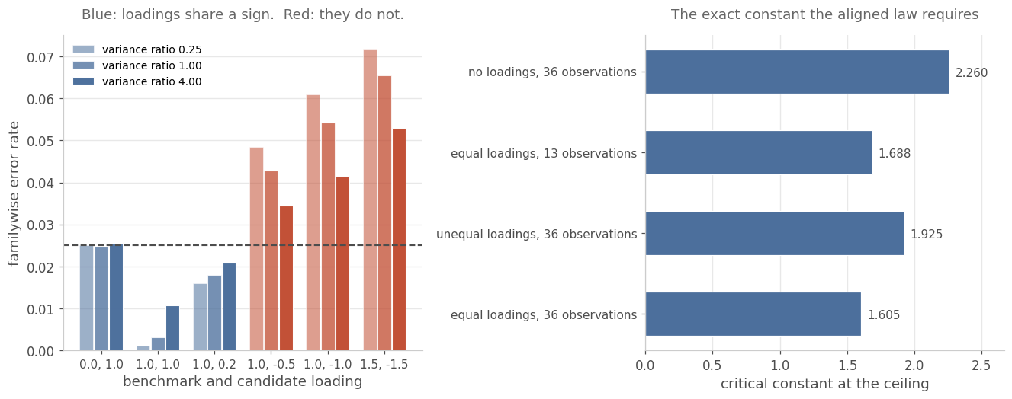
Figure 23. Left: the realised rate by loading pair and variance ratio, with same-sign pairs in blue and opposite-sign pairs in red, and the ceiling dashed. Right: the constant the exact aligned law requires, against the independent-groups constant on the same design.
What can be certified here is less than Section 9 certifies. The nuisance is now three-dimensional per candidate, the variance ratio and both loadings, and only the ratio is a function of what the rule sees. That is the asymmetry which separates this case from Section 9's, and it is a statement about the rule rather than about the data: with three or more series the one-factor model is identified and the loadings are recoverable from the covariance, exactly at the population level and to a median absolute error of 0.384 at 36 observations. At one candidate the model is under-identified, 4 parameters against 3 distinct covariance entries, and a declared domain is the only route. So a region of the kind Section 9.2 builds for the ratio is available above one candidate and is not built here. Over a declared box of 175 points the constant that holds everywhere is 2.7366, against known-parameter constants running 0.9003 to 2.7367. It is therefore 1.00 times the worst of them and 3.04 times the best, which is what a single constant over a box must do: it is exact at the corner that binds and carries the full spread of the box everywhere else.
That supremum is a grid maximum and not a continuum certificate, and the distinction is the one Section 9.11 exists to enforce. The branch-and-bound construction applies in principle, because the branch-fixed integrand is entire in the loadings for the same reason it is entire in the ratios, but the enclosure would be three-dimensional per candidate rather than one-dimensional and it has not been built. Until it is, this subsection supplies an exact law and a measured constant, and Section 13 records that it supplies no certificate.
One further departure separates this model from a promotion gate. The reduction above assumes the groups are observed on the same dates, which a promotion gate rarely gives: the incumbent has the longer record. Using the benchmark's prehistory for its variance alone, which needs a constant variance and not a constant mean, recovers 0.07 percentage points on a 24-observation overlap, which is nothing. The reason is structural, since the prehistory enters only through $s_{0}^{2}$ and its sampling error is second order once the overlap is long enough to matter. Using it for the mean as well recovers 25.24 percentage points, and it does not saturate by 360.
That gain rests entirely on a stationarity assumption about the mean. Breaking it in the direction that matters, a prehistory running below the later mean, takes the worst error rate to 0.57120, which is 23 times the ceiling. The other direction is harmless to the error rate and destroys the power instead. A desk therefore chooses between strict pairing and its 25.24 percentage points, or an assumption about the mean whose failure is not survivable.

12. Discussion

12.1 What is settled
The distribution theory is settled. The joint null law of the maximum Welch statistic against a shared benchmark is computable exactly, deterministically, and at a cost linear in the number of candidates, by conditioning on one statistic more than tradition conditions on. Six falsifiers pin it: the one-candidate case, two corners of the correlation structure, invariance in the number of candidates, refinement, and brute force. Only the last bears directly on the factorisation, which Section 13 states as a limitation.
The error rates of the procedures in use are settled, as numbers rather than as directions. So is the fact that equalising volatilities does not rescue either of them.
The diagnosis of Method 3 is settled. Its accuracy is real, and on the designs where its approximation bias is largest it comes from an internal cancellation between that bias and a negative estimation bias, rather than from the correlation modelling to which its authors attribute it. Where the approximation bias is already small there is nothing to cancel and the two biases add instead. The cancellation therefore operates where it is most needed rather than everywhere, which is a property of the designs and not of the method. Neither statement could have been made without a reference that is exact at known variances.

12.2 What is not
Whether the exact law yields a better procedure is not settled in the affirmative. Uncalibrated, it loses on the hardest designs. Calibrated, it wins on average and loses on the worst case. The crossover near seven degrees of freedom is located on one sweep with a single treatment-volatility pattern and should be read as approximate.
One route remains untried: integrate the critical value over the sampling law of the estimates rather than calibrating the level. A second route is to plug in an upper confidence bound on the ratios, so that the procedure is conservative by construction rather than by the benchmark's accident. That route is the admission region of Section 9, which bounds the error rate at the nominal level plus the region's miss probability. Both are inexpensive to compute because the exact law is. Section 10 takes a third: hold the critical value at its plug-in value, and shrink the level until the error rate, integrated over the sampling law of the estimates, meets the ceiling.

12.3 Guidance for a desk
The operating rule is a map. Where the benchmark has fewer than about five degrees of freedom, which on monthly data means fewer than six observations, the estimation error dominates and Method 3 should be preferred. The sweep behind that boundary varied the benchmark's sample size alone, holding the candidates at twelve degrees of freedom, so it locates the boundary in the benchmark. Section 10.9 shows the binding quantity is instead the smaller of the two groups. From about seven upward the exact rule is within 2% of nominal and the residual gap is roughly 0.0003, which is smaller than the noise in Method 3's own simulated constant. A desk comparing candidates on three years of monthly returns is in that second regime. There the exact rule is deterministic and needs no seed, no replicate count and no table, while its loss in accuracy is not measurable in any way that matters.
Independently of which constant is used, two findings in Section 6 change what a desk should expect. If the software in use takes the studentised maximum modulus route, the test is more conservative than advertised and real candidates are being discarded. If it applies Dunnett's constant to a separate-variance statistic, the test is liberal by up to 84%. Which of the two is in force is usually a function of which package was installed rather than of any decision.

13. Limitations
Normality and independence across candidates are assumed throughout, with variance estimates of the usual chi-square form. Serial dependence in the return series is not handled by the guarantee: Section 9.10 measures the boundary at a lag-one correlation near 0.1 for the sample sizes studied, and none of the rules tested there survives it. Section 11 removes that boundary for a declared AR(1) coefficient, by whitening before the statistic is formed; a coefficient estimated from the same returns remains a plug-in.
The procedure comparison rests on Tamhane and Xi's scenario grid plus one degrees-of-freedom sweep, all with a single treatment-volatility pattern. Other patterns are untested. The sweep also varied only the benchmark's sample size, so the five-degrees-of-freedom boundary in Section 12.3 is a statement about the benchmark. Section 10.9 varies both groups and locates the binding quantity in the smaller of the two.
Of the six falsifiers, only the brute-force one bears directly on the factorisation that is this paper's contribution. F1 has a single candidate and therefore no product over candidates; F2 sends the benchmark's variance to zero, which makes the conditioning vacuous; F5 and its K-invariance companion make every inner function identical, so a factorisation error would cancel; and F3 is self-consistency. Eight million draws across four designs, worst |z| = 0.64, is a serious check and it is the only external one of its kind here. A reader who wants the factorisation itself stressed further should ask for more designs in that arm rather than more falsifiers of the other kinds.
Method 3's own Monte Carlo noise moves its measured rate by up to 3.8 standard errors between 20,000 and 100,000 replicates, which bounds the resolution of any comparison against it, including the ones here.
The exact law is exact given the variance ratios. Every rate reported for it on data, and every rate in Section 7, includes the plug-in step.
The calibration is one specific device, and its end-to-end falsifier does not pass. The residual is about 0.0006, which is 3.8 standard errors in the worst scenario, and the evidence in Section 8.4 attributes it to the precision of the calibrated level estimate rather than to the definition. A reader who wants that residual smaller should raise the replicate count using the slope reported there. Until that is done the calibrated rule carries a check it has not passed, and it is offered on that basis.
The rule of Section 9 carries an additive term whose size is certified rather than assumed. The region covers the true ratios with probability 0.9995 by exact quadrature, so one draw in two thousand can fall outside it, and the guarantee accounts for that draw. The supremum the envelope takes over the region's vertices is still the vertex maximum, and Section 9.11 does not replace it in the deployed rule. What Section 9.11 certifies is a bound on the continuum supremum, which comes within 1e-4 of a witness below it on twelve of seventeen designs and within 3.17e-03 on the other five. The vertex maximum is therefore known to understate the continuum supremum by at most that much, in place of the grid of 121 points per cell.
The measurements at five and eight candidates are screening-grade. Their draw counts put a standard error of about 0.01 on a rate near 0.02, so at one standard error they exclude violations larger than a percentage point and they do not resolve the 5e-4 margin. The coverage of the region is exact at every candidate count, and it is the quantity that carries the guarantee.
Two departures from the model are measured, and each has a repair that requires a declaration rather than an estimate. Serial correlation exhausts the guarantee by $ϕ≈0.1$ at $n=36$, and no member of the tested set, including an effective-degrees-of-freedom plug-in and a moving-block bootstrap, survives it. A common factor with opposite-sign loadings requires a constant 2.64 times the uncorrected one at $ρ=0.75$ for a single candidate, which the closed-form correction does not supply; the general case is implemented and validated at one candidate in Section 11.2 and conservative at three and five, which is why residualising on declared loadings is the route taken above one candidate.
Five of the seventeen branch-and-bound cells do not reach the declared tolerance and report gaps up to 3.17e-03 instead. Their upper bounds remain valid, because the certificate is the maximum over terminal boxes whether those were pruned or left unsplit, so what those five lack is tightness at 1e-4 and not the guarantee. They are the widest regions in the programme, the slack falls with the box width, and the remedy is split budget.
The optimum of Section 10.7 is the output of a local solver on a 36-bin parameterisation, not a proven global optimum of its own programme. The negative gain at eleven degrees of freedom is the direct evidence: the search failed to recover a rule its own class contains. The conclusion that the residual loss is an information constraint rests on the search finding nothing, which is weaker than a proof that there is nothing to find.
The certificate of Section 9.11 is one-sided. The two-sided levels in this paper come from the identity at one candidate together with the enclosure of Section 10.4, and not from the branch-and-bound construction, whose engine is the one-sided maximum.
The certificates above one candidate cover the rule's level and not its power. Power at two, three and five candidates is sampled with a shared state sample of 500 draws, and no standard error on those losses is deposited, so differences of a few tenths of a percentage point between designs in Table 18 should not be read as real. The deposited Monte-Carlo error is on the error rate, where the worst value is 0.00179.
The internal level above one candidate in Table 18 is a measured quantity with a two-standard-error margin built into the search, not a certified one. The certified levels for those designs are in Tables 19 and 20 and are lower, because they carry the union step or the projection.
The whitening result is measured at two designs, three coefficients and three common means, with the repaired transform exactly invariant to the common mean by construction. It is not measured at more than one candidate, and the AR(1) coefficient is shared by both groups throughout.
Two nuisances remain estimated rather than declared. An autocorrelation coefficient read from the same returns and factor loadings fitted in sample are both plug-ins. With the regression's degree of freedom returned the measured rates are within 1.8 standard errors of the ceiling, which is consistency with it and not a certificate of it; without that correction they are 2.4 to 3.9 standard errors above. The repairs certified here are procedural, a declared bound and a disjoint pre-period.
The replication kit for Sections 10 and 11 is sealed and has not been executed by a second party. It fixes the rules, the domains, the designs and the seeds and withholds the expected outputs, so a replication produces its numbers before it can see them. That is the design of the kit and not evidence from it.
Section 10.8 extends its bound from invariant tests to all tests through the Hunt-Stein theorem, on worst-case regret against the known-ratio oracle and not on the mean criterion Table 28 reports, which no theorem here covers. One condition of that theorem, the passage from almost invariance to invariance, is taken from the literature rather than proved, and the extension above one candidate is not written. The linear program is also a discretisation: its solution overshoots the ceiling by at most 3.69e-04 on the verification grid, in the direction that makes the reported gap too large rather than too small.
Section 11.6 supplies an exact law for aligned returns and no certificate. The supremum over the declared box of loadings and ratios is a grid maximum over 175 points, not a continuum bound, and the enclosure that would make it one is three-dimensional per candidate where Section 9.11's is one-dimensional. The loadings are also not a function of what the rule sees; above one candidate they are identified from the covariance and a region for them is constructible, which this paper does not build, and at one candidate the model is under-identified and a declared domain is the only route.
One further departure is measured and is not in the list of Section 9.10. Estimating the variance on a trailing subwindow while the mean uses the whole sample, which is what a rolling risk model does, breaches on its own: at a 12-observation window against a 36-observation mean the realised rate reaches 0.0310. Of the 54 cells in the stress battery 12 breach, and they come from two families only, untreated positive serial correlation and this one. The rest are conservative rather than liberal: Student t on three and five degrees of freedom, a skewed innovation, GARCH volatility, a variance regime shift, negative serial correlation and an undeclared second factor.

14. Conclusion
The joint null distribution that the many-to-one comparison needs under unequal, estimated variances has been treated as intractable for seventy years, and the current state of the art approximates it in four places and then simulates the result. It is not intractable. Both of the couplings that make it hard run through the benchmark, so conditioning on both of the benchmark's sufficient statistics makes the comparisons exactly independent and reduces the problem to two outer dimensions and K inner ones, with the outer dimension independent of K.
For a desk that needs the error rate bounded rather than estimated, the same law supplies a second rule. Admit a region of ratio vectors whose coverage is certified by quadrature, evaluate the known-ratio constant at each of the region's vertices, and use the largest. The error rate is then at most the nominal level plus the region's miss probability, which is known exactly, and the rule is never liberal on the designs of Section 7.
What the efficiency claim rests on is now stated in its own terms. The class is the invariant class, the optimum over it is found by a global program rather than a local search, and the deployed rule is 0.21 to 0.24 percentage points above that floor when the benchmark has more than eleven degrees of freedom. Below seven the floor is not reached, and a threshold function solved for the design is worth up to 4.09 percentage points.
What the dependence result rests on is also now stated. It is a declaration, and the measurements show the declaration is doing the work rather than the exactness: with the coefficient estimated the same rule is worse than the procedures it was built to replace. That is the boundary a desk should plan around, and it is the reason the procedure asks for a bound fixed in advance rather than a number read from the returns.
It is nonetheless not the rule to run, because it meets a conditional statement on every draw where the guarantee asks only for an average over draws. It therefore realises a small fraction of the error rate it is allowed and gives up most of the power the oracle has. Imposing the guarantee unconditionally, at the same ceiling and on the same law, recovers nearly all of that, and the per-candidate variant is certified over the continuum of ratios at any candidate count and on either side.
The two boundaries reported in Section 9.10 are boundaries of rules built for independent samples and not of the reduction. Whitening a declared AR(1) and residualising on declared loadings are exact transforms that return the independent problem, and every certificate in Sections 9 and 10 transfers to it, the whitening dropping its first observation so that the transformed mean does not depend on the group's length. What is left estimated is labelled: a coefficient read from the same returns and loadings fitted in sample are plug-ins, and the repairs are procedural, a declared bound and a disjoint pre-period.
At the sample sizes where the question has been studied, what the reduction provides is an instrument rather than a better test. The exact law measures every procedure in use, separates approximation error from estimation error for the first time, shows that where the best existing method is most accurate it is so by cancellation rather than by construction, and supplies a control variate that makes any remaining simulation in this literature roughly a hundred times more efficient.
The practical conclusion is narrower than the theoretical one. Below five degrees of freedom on the benchmark, use Method 3. Above seven, the difference is smaller than Method 3's own simulation noise, and the exact constant is the one with no seed attached.

References
Beran, R. (1987). Prepivoting to reduce level error of confidence sets. Biometrika, 74(3), 457-468.
Bondar, J. V., and Milnes, P. (1981). Amenability: a survey for statistical applications of Hunt-Stein and related conditions on groups. Zeitschrift fur Wahrscheinlichkeitstheorie und verwandte Gebiete, 57(1), 103-128.
Dunnett, C. W. (1955). A multiple comparison procedure for comparing several treatments with a control. Journal of the American Statistical Association, 50(272), 1096-1121.
Dunnett, C. W. (1964). New tables for multiple comparisons with a control. Biometrics, 20(3), 482-491.
Dunnett, C. W. (1980). Pairwise multiple comparisons in the unequal variance case. Journal of the American Statistical Association, 75(372), 796-800.
Genz, A., Bretz, F., Miwa, T., Mi, X., Leisch, F., Scheipl, F., and Hothorn, T. (2021). mvtnorm: Multivariate normal and t distributions. R package version 1.1-3.
Hasler, M., and Hothorn, L. A. (2008). Multiple contrast tests in the presence of heteroscedasticity. Biometrical Journal, 50(5), 793-800.
Hochberg, Y., and Tamhane, A. C. (1987). Multiple Comparison Procedures. Wiley.
Lehmann, E. L., and Romano, J. P. (2005). Testing Statistical Hypotheses, third edition. Springer.
Li, H. (2012). A multiple comparison procedure for populations with unequal variances. Journal of Statistical Theory and Practice, 11(2), 165-181. (The method is developed in the author's doctoral dissertation, Bowling Green State University, 2009.)
Nagananda, K. G., and Kim, J. S. (2025). A unified approach to the Behrens-Fisher problem. arXiv:2511.03951.
Satterthwaite, F. E. (1946). An approximate distribution of estimates of variance components. Biometrics Bulletin, 2(6), 110-114.
Scheffe, H. (1943). On solutions of the Behrens-Fisher problem, based on the t-distribution. Annals of Mathematical Statistics, 14, 35-44.
Tamhane, A. C. (1977). Multiple comparisons in model I one-way ANOVA with unequal variances. Communications in Statistics: Theory and Methods, 6(1), 15-32.
Tamhane, A. C. (1979). A comparison of procedures for multiple comparisons of means with unequal variances. Journal of the American Statistical Association, 74(366a), 471-480.
Tamhane, A. C., and Xi, D. (2023). Multiplicity adjustments for the Dunnett procedure under heteroskedasticity. Biometrical Journal, 65, e2200300.
Virtanen, P., et al. (2020). SciPy 1.0: fundamental algorithms for scientific computing in Python. Nature Methods, 17, 261-272.
Welch, B. L. (1938). The significance of the difference between two means when the population variances are unequal. Biometrika, 29(3/4), 350-362.

Appendix A. Reproduction
Every number in this paper is produced by the following scripts and deposited as JSON alongside them, as set out in Table A1. No result is quoted that is not in a deposit, and h12_paper_verify.py checks each quoted figure against its deposit by formatting the expected string from the deposit rather than from a literal of its own, so a check cannot be satisfied by the paper agreeing with itself.
Table A1. Scripts and what each produces. Every figure is drawn by h12_paper_figs.py from the deposits of the script named beside it, so no result is attributed twice. Running them in the order listed reproduces every deposit, then every figure, then the document, then the audit.
Script | What it produces
h12_quad.py | Quadrature primitives: composite panels on a probability scale. Used by everything below; quotes no results of its own.
h12_numerics.py | The failure of the textbook rules, the step geometry, the cost, the worked desk example, the faithfulness of the reimplementation and the agreement between the two runs. Source for Sections 4.1, 4.3, 4.4, 6.3, 7.1 and 8.3.
h12_hetero_exact.py | The exact law and the six falsifiers. Source for Table 1 and for the tests behind Figure 3 and Section 5.3.
h12_hetero_compare.py | Exact error rates of the rules in use and the checks on the comparison arms. Source for Table 2, and for the loadings in Figure 1.
h12_hetero_plugin.py | The plug-in residual, Rao-Blackwellised. Superseded for the paper's purposes by h12_crossover.py and h12_calibrated.py; retained because it is the first measurement of the residual and no figure in this document depends on it.
h12_tamhane_headtohead.py | The head to head on the published scenarios. Source for Table 3.
h12_crossover.py | Degrees-of-freedom sweep, decomposition, replicate-count sensitivity and level sensitivity. Source for Tables 4, 5 and 6.
h12_calibrated.py | The calibrated rule, and the measurement of what the Rao-Blackwellisation buys. Source for Table 7 and for Section 8.2.
h12_f1_recheck.py | The calibration's falsifiers, rebuilt. Quoted in Section 8.4.
h12_omml.py | Typesets the mathematics from LaTeX into Word equations.
h12_paper_figs.py | Draws Figures 1 to 7 from the deposits above. No results of its own.
h12_paper_verify.py | Checks every figure quoted in this document against its deposit.

The verification of Section 5 is internal to this implementation. A party that has not seen the code can still reproduce the design-level quantities from a deposited specification. replicate/METHOD.md fixes the exact law, the admission region and its coverage integral, the two rules and four falsifiers. replicate/inputs/designs.json carries the twelve designs, the nominal levels and the seeds as recorded in the deposits. The expected outputs are withheld, so a replication produces numbers to be compared against the deposits rather than against this document.
Table A2. The scripts behind Section 9, in the form of Table A1.
Script | What it produces
02-bounded-rule/env_rule.py | The admission region, its exact coverage by quadrature, and the envelope constant over its vertices. Source for Sections 9.2 and 9.3.
02-bounded-rule/env_on_paper_cases.py | The envelope and the plug-in on the four designs of Section 7. Source for Table 8 and the left panel of Figure 8.
02-bounded-rule/env_sweep.py | The twelve-cell desk map, both allocations of the level budget. Source for Table 9 and Figure 9.
02-bounded-rule/cert_falsify.py | The dense-grid test of the supremum on the region's vertices. Source for Section 9.6.
02-bounded-rule/cert_leak.py | The draw-level dissection of the single dominance violation. Source for Section 9.6.
02-bounded-rule/cert_sup.py | The certified constant and its falsifier. Source for Table 12.
02-bounded-rule/miss_probe.py | The region's miss rate, designed against measured, over 240,000 draws. Source for Figure 10.
02-bounded-rule/w5_env.py | The five- and eight-candidate blocks. Source for Table 10.
02-bounded-rule/power.py | The alternative law and the power price. Source for Table 11 and Figure 11.
02-bounded-rule/frontier.py | The region's split and shape at matched coverage. Source for Table 13.
02-bounded-rule/w6_ar2.py | Serial correlation, three rules, two sample sizes. Source for Table 14 and Figure 12.
02-bounded-rule/ar1_effdf.py | The effective-degrees-of-freedom plug-in. Quoted in Section 9.10.
02-bounded-rule/factor_d2.py | The common-factor boundary and the exact one-candidate law. Source for Figure 13.
02-bounded-rule/calib_gate.py | The pre-registered calibration gate. Quoted in Section 8.4.
02-bounded-rule/w5_boundary.py | The design shapes and candidate-ratio grids behind the five- and eight-candidate blocks.
02-bounded-rule/w5_analyse.py | Reduces those blocks to the deposited rows.
02-bounded-rule/w5_best.py | Selects the candidate set at each candidate count.
02-bounded-rule/w6_model.py | AR(1) generation and the factor design.
02-bounded-rule/cert_rule.py, env_falsifiers.py, env_dominance.py, env_tight.py | Supporting harnesses for the certified rule, the envelope falsifiers, the dominance sweeps and the region construction.
02-bounded-rule/paper_figs_w26.py | Draws Figures 8 to 13 from the deposits above.
02-bounded-rule/paper_verify_w26.py | Checks every new figure quoted in this document against its deposit.

Table A3. The scripts behind Sections 10 and 11, together with the branch-and-bound certificate of Section 9.11, in the form of Table A1.
Script | What it produces | Deposit
03-certified-supremum/enclose_iv.py, enclose_gl.py | the interval-arithmetic and Gauss-Legendre enclosures, with the Bernstein-ellipse remainder and the kink-aware panel layout | enclose_iv.json
03-certified-supremum/cert_bnb.py | the branch-and-bound certificate of the supremum over the region | bnb.json
03-certified-supremum/rootcert.py, box_slack.py | bracket containment against an independently refined solver, and the box enclosure's slack against the box width | rootcert.json, box_slack.json
03-certified-supremum/adversarial.py, sup_compare.py | the pre-declared adversarial suite, and the continuum bound against the vertex maximum | adversarial.json, sup_compare.json
03-certified-supremum/error_budget.py | the assembled error budget on the probability scale | error_budget.json
03-certified-supremum/factor_general.py | the conditional factor law, its Monte-Carlo agreement and its zero-loading limit | factor_general.json
wa_ledger.py | the four objects priced on one design, in the constant and in power | wa_ledger.json
wb_k1.py, wb_certify.py, wb_certified_rule.py | the internal level at one candidate and its certificate over the continuum | wb_certified_rule.json
wb_general.py | the measured internal level at two, three and five candidates | wb_general.json
wb_percand.py, certify_anyk.py | the per-candidate rule and its union-step certificates, one-sided and two-sided | wb_percand.json, certify_anyk.json
certify_joint.py, fix_joint_compare.py | the joint step rule, its projection certificate, and the deployed rule's own error rate | certify_joint.json
wc_frontier.py | the best rule of the class, by optimisation over threshold functions | wc_frontier.json
wd_designmap.py, wd_restricted.py | the planning surface over both groups, and what a declared domain buys | wd_designmap.json, wd_restricted.json
twosided.py | the two-sided identity at one candidate and its failure above | twosided.json
serial.py, factor.py | the whitening and residualisation results, declared and estimated | serial.json, factor.json
serial_falsify.py | the whitened rule at unequal group lengths and a non-zero mean, which is the condition Section 11.1 states | serial_falsify.json
coverage_frontier.py | how much of the new material any check covers, and what it does not | -
fast.py, recertify.py | the tabulated inversion, the parallel map, and the re-levelling after the tail correction | fast.json
crosscheck.py, tests_frontier.py | the independent cross-checks and the eleven gates | crosscheck.json, gates.json
rule_compare.py | the deployed thresholds of the two certified general-K rules, and which of them dominates | rule_compare.json
paper_figs_frontier.py | Figures 14 to 20, drawn from the deposits named beside each | -
paper_verify_frontier.py | checks every figure quoted in Sections 9.11, 10 and 11 against its deposit | -

