Freight Rate Prediction: Validation, Split and Results
Task: predict posted_rate (USD per load) for 12,000 Nov–Dec 2025 loads from 48,000 labelled Jan–Oct 2025 loads. The selected model scores 1.84% mean absolute percentage error (MAPE) on clean rows in out-of-time tests, against 3.40% for a lane-median baseline. For Nov–Dec, expect roughly 1.8–2.8% on clean rows, because month-level price swings are not predictable from the inputs (section 5). Including the ~1.4% of rows with corrupted prices, expect about 4.2%.
Terms used: MAPE = mean |predicted − actual| / actual. pp = percentage points. Walk-forward fold = train on earlier months, test on the next two months. Detrended market_index = the day's average market_index minus its 28-day average, i.e. the short-term ups and downs with the slow drift removed.

1. Validating the train/test data
Before modelling, I checked every column in code. The schema, the date ranges and the IDs are clean: there are no duplicate loads and no loads whose pickup city equals the delivery city. Equipment, distance and weight are distributed the same way in train and validation, so the only shift is the dates. The issues found, and how each was handled:
Issue | Rows (train / val) | Handling
quote_signal switches behaviour by month. In Jan, Feb, Mar, Jun and Sep it is within 3% of the true $/mile on 98% of loads. In Apr, May, Jul and Oct it is a mirror image. In Aug, Nov and Dec it is noise. The pooled correlation (0.05) hides this. | all | Excluded from every model (target leak)
Negative weights (sign errors; same magnitudes as positive ones) | 292 / 145 | abs()
Missing weight | 300 / 165 | Training median per equipment (31.4k–31.6k lb)
Missing market_index | 374 / 249 | Every row gets the same-day mean. Within-day variation is noise. In a masking test the same-day mean reaches the noise floor, while a ±5-day mean is 4× worse
Price outliers: $/mile about 0.2× or 3× the lane norm | 677 (1.41%) / – | Removed from training rows only; kept and reported separately in test folds
Weights clipped at 5,000 and 47,500 lb | 1,236 / 308 | Kept (prices normal)
Coordinates differ from the real cities (median 110 mi) | all cities | Kept: distance is 1.18× the straight line between the data's own coordinates (r = 0.9995), and it does not fit the real ones
Same lane has different distances (±2.2%) | most lanes | Kept: price follows per-load distance
December file lacks coordinates and market_index | 31 | Coordinates from the training city table; market_index from validation same-day means

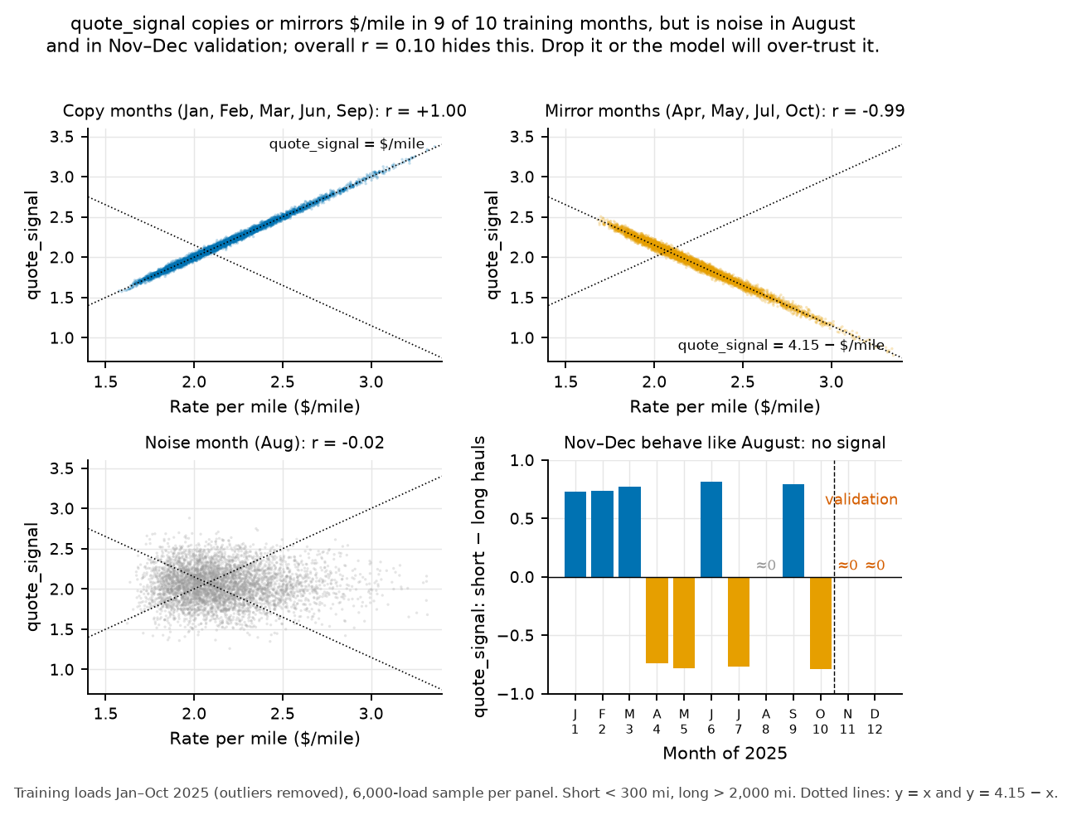
Figure 1. quote_signal copies or mirrors the target in 9 of 10 training months and is noise in Nov–Dec. A model using it would score well on September (a copy month) and fail on the real data.
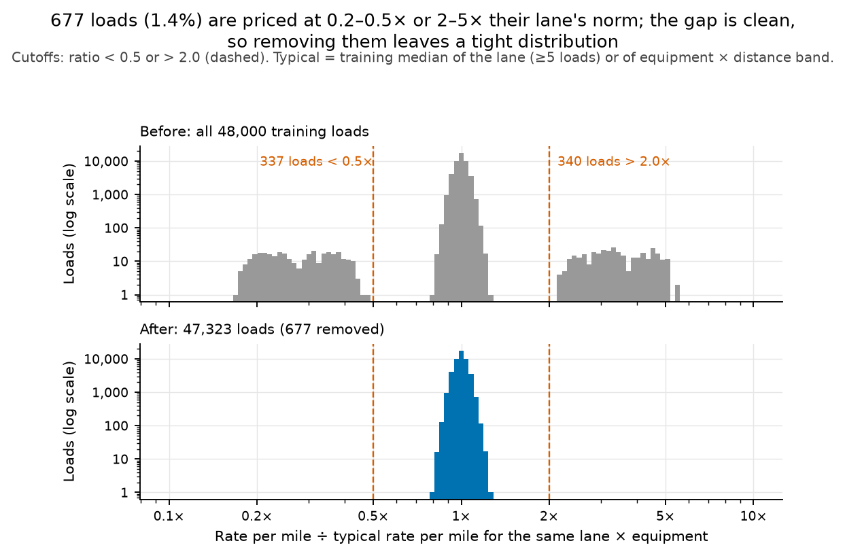
Figure 2. Outlier rule: $/mile ÷ lane reference (lanes with ≥5 loads, otherwise equipment × distance band), cut at 0.5× and 2×. The cut-offs sit in an empty gap. The rule flags the same 336 rows as an independent check in the months where quote_signal reveals the true price (0 false positives, 0 false negatives).
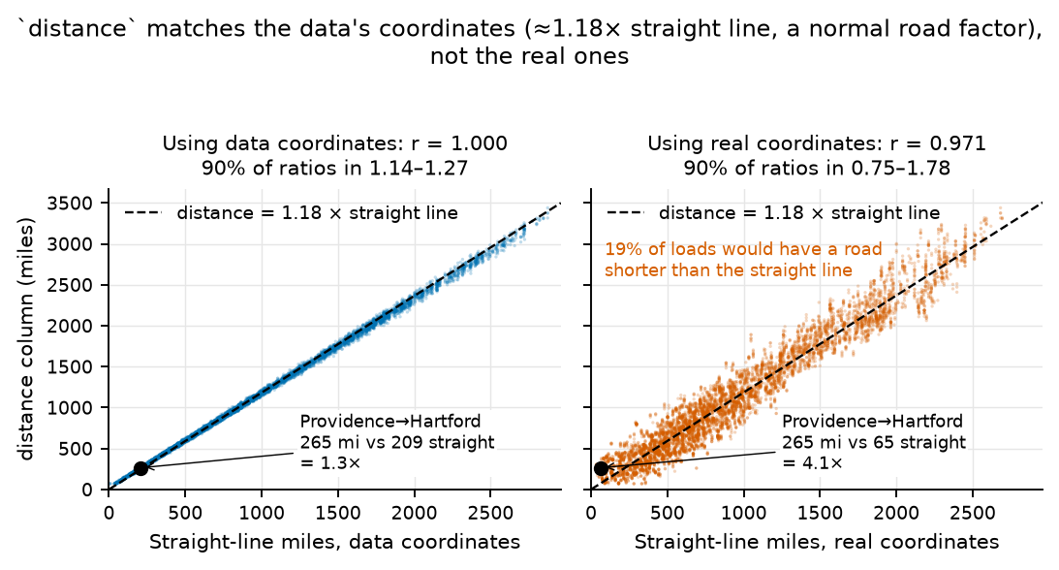
Figure 3. distance matches the dataset's own coordinates, not the real ones (Providence→Hartford would be 4.07× the straight line using real coordinates).
Leakage control: weight medians, the city table, the outlier reference, the encoders and the splines are all fitted on each fold's training rows only, then applied to that fold's test rows. One Cleaner class does this for train, validation and the December file, so all three are prepared the same way. One deliberate exception is the daily market_index series, which is built from the inputs of train and validation (never from labels), because validation.csv provides those values at prediction time. Automated tests (tests/test_pipeline.py) check these rules.

2. Split and validation approach
The task is a forecast 1–2 months past the last labelled date, so a random split would leak the future and flatter the model. I used time-ordered folds that copy that horizon, plus one fold for unseen cities:
Fold | Train on | Test on | What it rehearses
Walk-forward 1 | Jan–Jun | Jul–Aug | 1–2 month forecast
Walk-forward 2 | Jan–Jul | Aug–Sep | 1–2 month forecast
Walk-forward 3 | Jan–Aug | Sep–Oct | 1–2 month forecast; Sep–Oct market_index ≈ Nov–Dec
City holdout | Jan–Aug minus 8 cities | Sep–Oct loads touching them | 12.1% of validation loads touch 8 cities never seen in training
Final fit | Jan–Oct (outliers removed, 47,323 rows) | Validation Nov–Dec | —

- Selection rule: lowest mean MAPE over the three walk-forward folds. A model must beat the lane-median baseline on every fold and on the city holdout. When two models are within about 0.1 pp, the simpler one wins. Later changes were adopted only if they improved the mean by at least 0.05 pp and were no more than 0.02 pp worse on any fold.
- Metrics: MAPE is the headline because pricing error is relative. Median APE, MAE, RMSE and R² are in reports/experiments.csv. Every metric is reported without and with the outlier rows. Outliers are corrupted labels that no input can predict, so the headline excludes them, but the all-rows number is what a scorer will see.
- Caveat: the walk-forward test windows overlap (Aug and Sep appear twice), and 66 configurations were compared on the same folds. Treat differences under about 0.05 pp as noise.

3. Models and results
Model | WF1 | WF2 | WF3 | Mean | All rows | City
(a) Baseline: equipment × distance median | 3.97 | 3.83 | 3.82 | 3.87 | 6.19 | 3.82
(b) Baseline: lane × equipment median | 3.57 | 3.35 | 3.29 | 3.40 | 5.73 | 3.68
(c) Baseline (b) × detrended market_index | 3.41 | 3.28 | 3.25 | 3.32 | 5.65 | 3.65
Random forest | 2.24 | 2.04 | 2.03 | 2.11 | 4.45 | 2.20
HistGradientBoosting | 2.16 | 1.90 | 1.89 | 1.98 | 4.32 | 2.42
CatBoost | 2.05 | 1.82 | 1.80 | 1.89 | 4.23 | 1.97
Ridge + splines (selected) | 1.99 | 1.76 | 1.78 | 1.84 | 4.19 | 1.96

MAPE % on clean rows. "All rows" includes outliers (mean of the three walk-forward folds). Source: reports/experiments.csv (66 configurations).
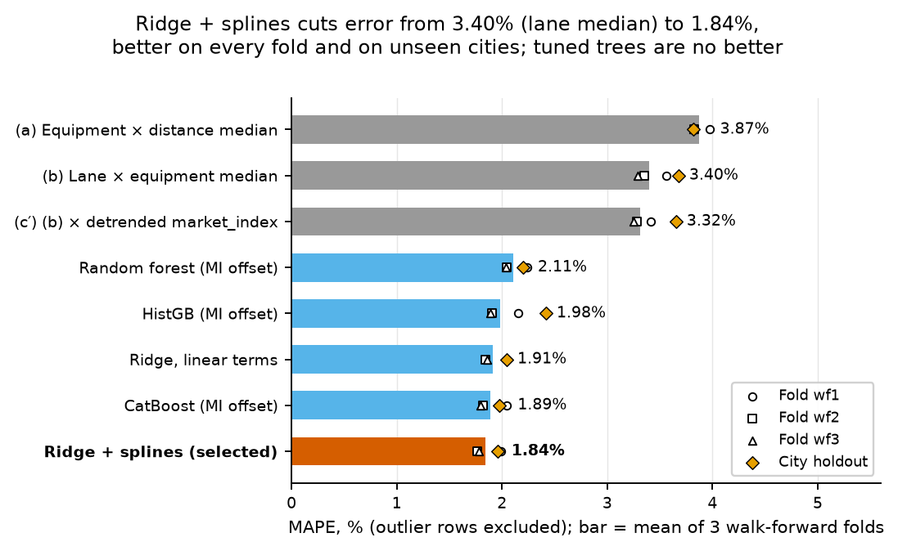
Figure 4. Walk-forward MAPE per model, with per-fold and city-holdout markers.
- The raw market_index level breaks out-of-time prediction. Apr–Jul index values of 1.2–1.3 came with prices only 1–3% above normal, so models using the level under-predicted Jul–Oct, more so the further ahead they forecast (mean bias with the level: -4.4% to -1.6% per fold; reports/fold_bias.csv). Swapping in the detrended index cut the mean MAPE from 3.48% to 1.84%. Within a month, the daily index moves with prices (r 0.75–0.95 in 8 of 10 months; reports/data_findings.md §5). It also carries the weekday cycle (Thursday high, Sunday low), so a separate day-of-week feature added nothing.
- Tree models memorised day-level noise, because market_index takes one value per day. Feeding the index as a fixed linear offset fixed that, but CatBoost (1.89%) still did not beat Ridge. Ridge plus a booster on its residuals (1.81%) was within noise, so the simpler, more transparent model was kept.
- Ridge + splines: Ridge regression on log($/mile). Inputs: one-hot pickup, delivery and equipment; splines on log-distance and weight; equipment × log-distance; coordinates, so unseen cities can be placed; detrended market_index. Tuning α and the spline knots moved MAPE by less than 0.01 pp.
- Weighting recent months more (half-life 240 days) scored 1.835%: better on walk-forward 1 and 3, worse on 2, and within noise overall. Not adopted.
- Round 2 tested 20 more variants: lane one-hots, city × equipment terms, market_index interactions, coordinate splines and re-anchoring to recent weeks. None met the adoption rule. The closest (adding a heavily shrunk lane term and coordinate splines) was better on every fold (1.96/1.72/1.73, city 1.76). Its mean gain of 0.037 pp fell short of 0.05 pp, it was the best of many tries, and its settings were tuned on the same folds, so it was not adopted. Its predictions differ from the selected model's by at most ±2.6%.
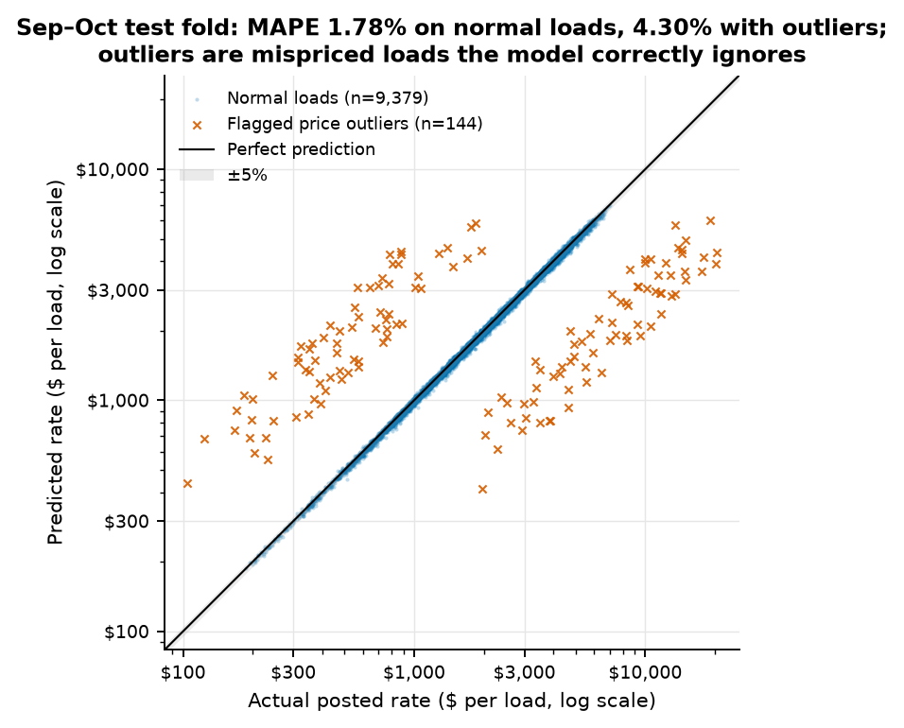
Figure 5. Walk-forward 3 (Sep–Oct): predicted vs actual. Outliers form two bands at about 0.2× and 3×.
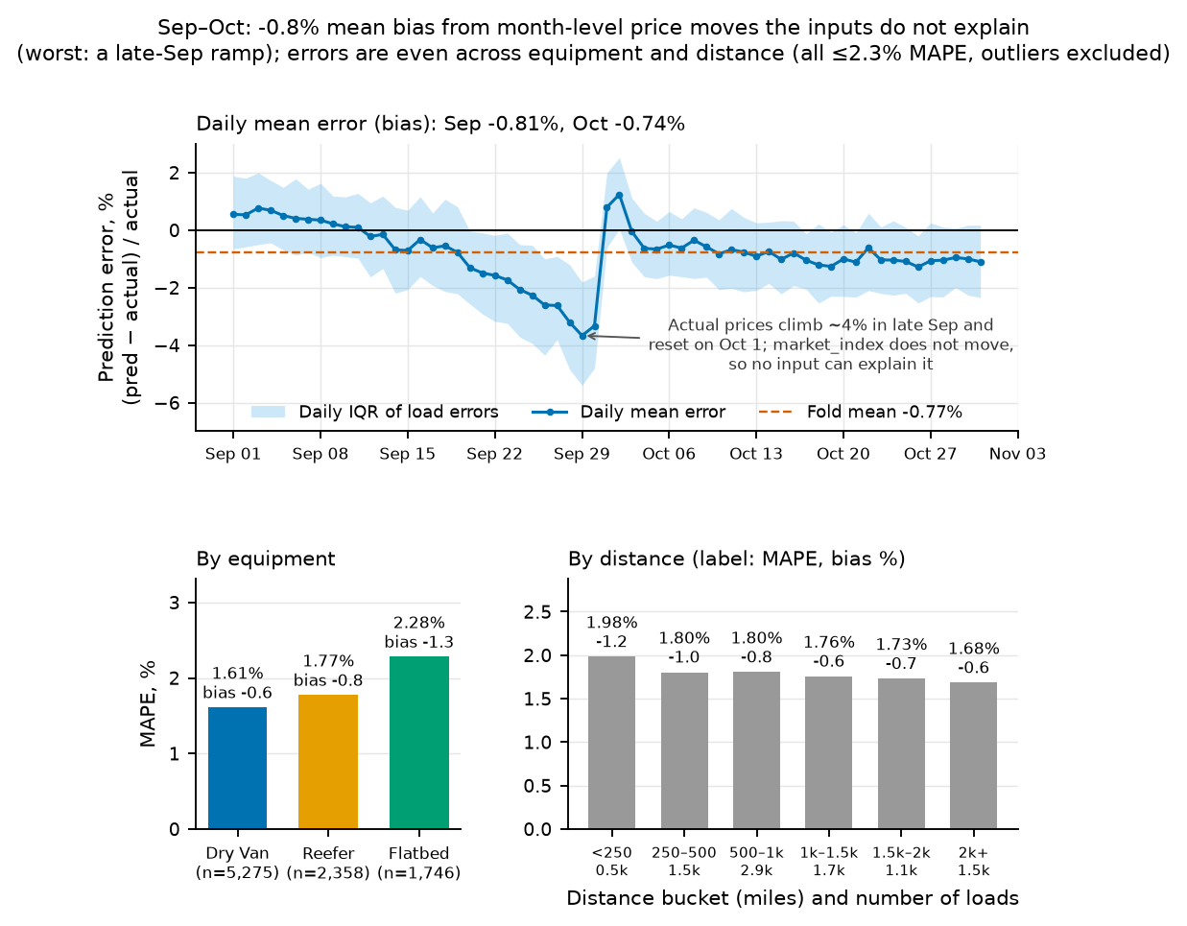
Figure 6. Sep–Oct daily bias and error by segment. Dry Van 1.61%, Reefer 1.77%, Flatbed 2.28% MAPE.

4. December prediction chart
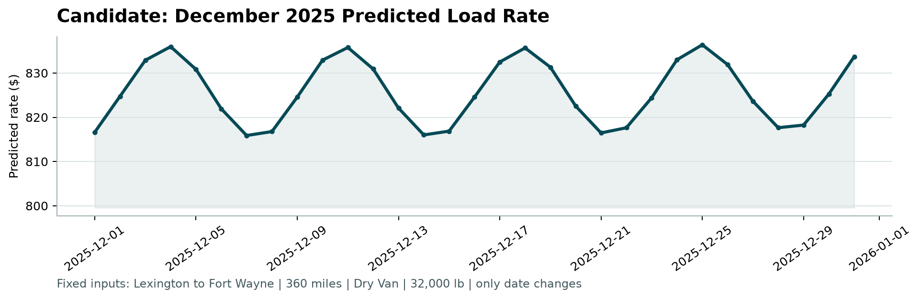
Figure 7. December chart produced by the provided score.py (Lexington → Fort Wayne, 360 mi, Dry Van, 32,000 lb). Note the zoomed y-axis: the swing is only ±$10.
With every input fixed except the date, the curve is a flat weekly cycle of $816–$836 (mean $826, ±1.2%). It follows the weekly pattern in December's market_index, peaking every Thursday (about $836) and dipping on Sunday and Monday. 25 December peaks because it is a Thursday, not because it is a holiday. Training covers Jan–Oct, so Thanksgiving and Christmas never appear in it, and there is no detectable price effect around July 4, Memorial Day or Labor Day. The model therefore has no holiday effect to learn. A real market would probably tighten before Christmas, and this data cannot teach that. The level agrees with history: Lexington↔Fort Wayne Dry Van loads at December-like market_index have an interquartile range of $792–$831 when scaled to 360 mi (n = 17; Figure 8).
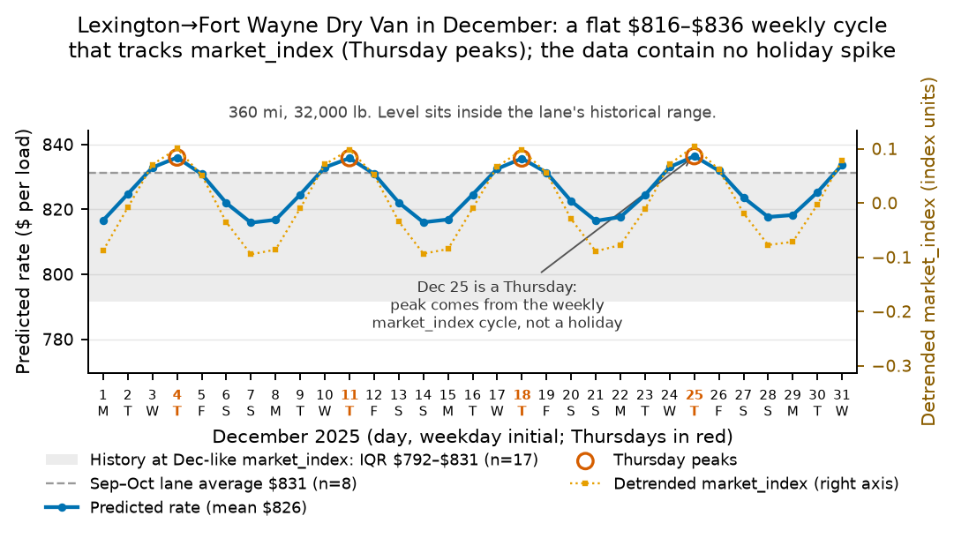
Figure 8. The December curve against detrended market_index and the lane's history.

5. Risks and limitations
- Month-level price shifts of about ±5% (Jan −5%, Jun +4%) are not explained by any input. In effect, Nov–Dec are priced at the Jan–Oct level. On Sep–Oct this produced a bias of about −0.8%, and prices also drift within some months. Real Nov–Dec error could be about 1 pp higher than the folds show.
- If the hidden labels contain the same ~1.4% corruption, the all-rows MAPE will be about 4.2%, not 1.8%.
- The 8 unseen cities are placed by their coordinates. The city holdout (1.96%) suggests this works.
- Fallback: dropping market_index and using day-of-week instead scores 1.86%. It would be the safer choice if the real December market_index differed from validation.csv.

Reproduce
pip install -r requirements.txt; python -m src.train; python -m src.predict; python score.py --predictions validation_predictions.csv --december-predictions data/december_chart_inputs.csv. python -m src.evaluate regenerates the experiment tables. python -m src.plots_eda and python -m src.plots_model regenerate the figures. python -m src.report rebuilds this document.

