

**Faculty Of Engineering And Technology**

|  |
| --- |
| **Computer Science Department** |

**<< Project Name:** **justPAL HR >>**

|  |  |
| --- | --- |
| **Students Name** | **Student Number** |
| Momen Salem | 1200034 |
| Mahmoud Khatib | 1200275 |
| Mohammad Dallash | 1200937 |
| Osaid Baba | 1203115 |
| Mustafa Jaber | 1200897 |

**Table of contents**

**Team formation** 6

**Introduction** 7

**System Features** 9

**Software Development Process** 14

**Use Case Diagram** 15

**Use-cases description:** 16

**User & System Requirements:** 19

**Momen Salem 🡪 1200034** 19

**Mohammad Dallash 🡪 1200937** 21

**Mahmoud Khatib 🡪 1200275** 22

**Mustafa Jaber 🡪 1200897** 24

**Osaid baba 🡪 1203115** 25

**Non-functional requirement :** 25

Phase Three 27

**Class Diagram** 27

**Use-Cases Specification:** 28

*1-* *Maintain Vacations Use Case* 28

**1.** **Brief Description** 28

**2.** **Flow of Events** 28

2.1 Basic Flow – Request Vacation 28

2.2 Alternative Flows 29

2.2.1 Modify a Vacation request 29

2.2.2 Delete a Vacation request 29

2.2.3 Vacation Already Requested 30

2.2.4 Can’t Request Vacation 30

**3.** **Special Requirements** 30

**4.** **Entry Conditions** 30

4.1 Log In 30

**5.** **Exit Conditions** 31

**1.Use Case Name :** 31

**2. Brief Description :** 31

**3. Actors :** 31

**4. Preconditions :** 32

**5. Main Flow :** 32

5.1.Basic Login : 32

5.2.Password Reset : 32

**6. Alternative Flows :** 33

6.1. Invalid Login Attempts Exceed Limit : 33

6.2 . Many-factor Authentication : 33

**7. Postconditions :** 34

**8. Requirements :** 34

**9. Notes and Issues :** 34

**10. Exit Conditions :** 34

*3-* *Maintain Leave Permission Use Case* 35

**1. Brief Description** 35

**2.    Flow of Events** 35

2.1 Basic Flow – Request Leave Permission 35

2.2     Alternative Flows 36

2.2.1 Modify Leave permission 36

2.2.2  Delete Leave permission 36

2.2.3  Leave Already Requested 37

2.2.4 Can’t Request Vacation 37

**3.    Special Requirements** 37

**4.     Entry Conditions** 37

4.1    Log In 37

**5.    Exit Conditions** 37

*4-* *Apply for Job Use Case* 38

**1.** **Brief Description** 38

**2.** **Flow of Events** 38

2.1     Basic Flow – Apply for a Job 38

2.2     Alternative Flows 39

2.2.1 Modify a Submitted Application: 39

2.2.2 Cancel Application 39

2.2.3 Applicant Already Exists 40

2.2.4 Submission Not Received by system 40

**3. Special Requirements** 40

3.1 validation & verification: 40

3.2 one application per email 40

**4. Entry Conditions** 41

4.1    Open positions 41

**5.    Exit Conditions** 41

*5-* *Maintain* ***Attendance*** *Use Case* 42

**1.** **Brief Description** 42

**2.** **Flow of events** 42

2.1 Basic Flow – Work from Office Check-in: 42

2.2 Basic Flow – Work from Home Check-in: 42

2.3 Alternative Flows: 42

2.3.1 System Unavailability: 43

2.3.2 Incorrect Fingerprint Read: 43

2.3.3 *Late Arrival/Early Departure*: 43

2.3.4 *Technical Issues with Fingerprint Scanner*: 43

2.3.5 *Absence Without Notification*: 43

**3.** **Special Requirements** 43

3.1 Performance 43

3.2 Attendance Types: 43

**4.** **Entry Conditions** 43

4.1 HR manager: 43

4.1 Employees: 43

**5.** **Exit Conditions** 43

**Activity Diagrams:** 44

1. Activity Diagram for maintain vacations in the system Done by: Momen Salem 1200034 44

2. Activity Diagram for maintain Login in the system 45

3. Activity Diagram for maintain Leave Permission the system Done by: Mohammad Dallash 12000937 46

4. Activity Diagram for Apply for Job in the system Done by: Mahmoud Khatib1200275 47

5. Activity Diagram for Maintain Attendance in the system Done by: Osaid Baba 1203115 48

# **Team formation**

* **Team Name:** justPAL HR Team
* **Team leader: Osaid Baba**
* Our team is made up of five students. Three computer engineers 🡪 **Momen Salem**, **Mahmoud Khatib** and **Mohammad Dallash**. and two computer science 🡪 **Osaid Baba** and **Mustafa Jaber**.
* **Team Management Strategy:** We have been planning to meet face to face twice a week (and that's what we prefer), but because of the difficult road conditions we decide to hold our meetings online via Zoom (if the condition return normal, we will communicate face to face). Basically, we make decisions together with discussions (everyone has to give his opinion of the topic being discussed). Then we combine our ideas and conclude needed work. Finally, we divide work in chunks and everyone has to choose the most suitable one and do it then integrate our chunks and writing needed documentation.

# **Introduction**

**justPAL HR** is considered one of the first companies in the region that specialized in managing and implementing Human Resource Management Systems.

In today's world, technology plays a pivotal role in various spheres of life. To streamline the company's operations and address the challenges it faces, it is imperative to develop a comprehensive system. This system will not only automate most of the company's business processes but also provide solutions to the problems the company has been experiencing.

First and foremost, Since what is needed is a System to Manage The Ministry and all its branches, then the software development will **primarily** aim to define a comprehensive approach ensuring the system's stability and resilience, particularly during high-stress periods.

Shifting our focus to another aspect, our software’s provides specialized services in the field of HRMS and enables clients to manage employee attendance using our software without the need for any external machine such as fingerprint readers, without forgetting the workers from home. We offer a number of solutions to the issue of vacation and leave management that saves time and effort, especially ensuring the rapid arrival of the application to the managers responsible for reviewing the application, and ensuring a prompt response of accepting/rejecting or perhaps other options. this field can be developed to include more options, and more types of vacations available to the employees, such as annual leaves and sick leaves.

One of the main problems that the Ministry faces is registering actual working hours for the employees either from the office or approved work from home (WFH) hours. This problem can be solved by building a database system to store every useful information, including reports of leaves and vacations, and everything. This information can then assist with controlling and tracking employees' attendance and leave, and then can be used to determine each employee’s rating and to link this in all respects, such as the possibility of giving higher priority to a higher-rated employee while a number of employees request a leave or a vacation in the same time. also, this base provides speed in accessing data in less effort and time on employees and facilitate the employee's process of reviewing their historical leave file.

# **System Features**

The key features of any system are contingent on its intended purpose and the services it aims to offer. As previously mentioned, our objective is to create an effective software/system that efficiently manages The Ministry of Higher Education and Scientific Research of the Palestinian state, along with all its branches. This system is tailored to suit the Ministry's scale, taking into account the number of branches, employees, managers, and customers. Our aim is to provide top-notch services through this project, benefiting customers and facilitating the seamless completion of tasks for employees.

We will start by mentioning the **basic requirement :**

1. **Vacations:**

* There are many types of vacations we provide to our customers with three different types: normal, sick and death vacation.
* After we read the Palestinian Civil Service Law and Palestinian Labour Law we conclude that for normal vacation each customer has two weeks per year and if he not uses them then they will remain until next year only. For sick purposes, he can absent from work for 14 days with full paid salary and if he needed more then, more 14 days but with half paid salary.
* The manager of branch has the ability to approve or deny the vacation based on rules of ministry.
* The employee can cancel vacation before its deadline and can’t do it after its time.
* As we see this feature has many problems and time consuming so our view in reducing these problems is 🡪 in our web page the employee can request any vacation just by apply the needed form. To add, if he wants to know its remaining days for vacation (vacation schedule) he can do it using any device connected with internet, also he can send direct message to his manager if he had any issue. For sick vacation, the only needed thing is to open your camera and send your medical report in few seconds (can be scanner or even as photo). To know if manager accept or reject the request a message can be sent as a notification for the employee. If you request a vacation and you don’t need it don’t worry you can delete it easily by requesting a delete form and wait for code from manager to confirm the deletion operation.

1. **Recruitment and interviews:**

* The system schedule interviews automatically when the employee wants to work in ministry which save time and effort on manager (he can change it if needed).
* Also, before the interview is accepted the system give the person who want to work some small quizzes (from ministry databases which may be old tasks) and send his result to manager to give a first emission.

1. **Leavings**

Employees are allowed to request a leave permission, so that they able to interact with a user friendly application involved within the HR system , and fill the requirements such as the leave type , leaving period and reason , he supposed to be updated with his leave balance , and have the right to receive a report of his leavings , the permission approval depends on many factors , on the other hand it may be not accepted for some justifications or as a result of negative leave balance .

The leavings separate to personal and official (related to workshops managed by the company itself)

* Managers rely on a leave system to quickly see and decide on time-off requests, keep work running smoothly, and have a record of when employees are away.
* HR is responsible for checking if leave requests are valid and follow company rules and laws, helping with approvals, and keeping accurate records.
* Address lateness or early departure through clear policies, documenting instances, and applying appropriate consequences or corrective actions as per company guidelines. Consistency and communication are key.

1. **Attendance**

* IN our system justPAL HR system the employees identified depends on Biometric Data like fingerprints and facial recognition to identify employees, we choose this way to identify employees because its safety is high and Characteristics cannot be similar from one employee to another.
* IN our system justPAL the type of machine we choose of biometric attendance is Fingerprint Scanners with Facial Recognition Systems, and the Attendance records collected from biometric machines are typically stored electronically in a database and the process for stored data involves data collection and data processing, transfer, storage and security measure and the stored attendance data is structured in a format that includes employee ID, date, time in and time out, this structured allowing for reporting and analysis and monitoring of employee attendance and the Security measures such as access control, and regular data backups, are crucial to protect the integrity and confidentiality of attendance records.
* As we mentioned earlier the Attendance records collected from biometric machines and the data stored and in a database in a tables that includes a Specific structured and the data that stored its done by Employees ,simply need to provide their biometric data (fingerprint, facial scan) to check in and out and The system verifies their identity and records the time of the entry or out and the data that stored for attendance for any employee we allow to the this employee to see their attendance only.
* The attendance times required from employees can vary widely depending on the specific organization but the Common in Palestine Attendance times are usually from eight in the morning until four in the evening and in many cases, working hours and attendance requirements are negotiated between employers and employees.
* Access to attendance records is typically restricted to individuals and roles with a legitimate need for such information like HR Personnel are responsible for managing attendance records, processing attendance data, and ensuring compliance with labor laws and company policies. And Many organizations provide employees with limited access to their own attendance records to review their attendance history, leaves taken, and accrued balances and There is more who can access attendance information like Supervisors and department managers or Payroll Administrators, IT Administrators Auditors, and Each of them has their permissions to carry out the task assigned to him.

**Now we will mention the non-functional requirements:**

* **Performance**: The Ministry's system will efficiently handle the needed amount of data and transactions, ensuring high-performance levels.
* **Reliability**: The system will be consistently available and responsive, without unexpected failures or crashes, especially during working hours.
* **Security**: Robust security features will be implemented to safeguard sensitive data within The Ministry's system.
* **Scalability**: The Ministry’s system will have the ability to accommodate the Ministry’s growth and expansion seamlessly, without necessitating extensive modifications or upgrades.
* **Usability**: The system will be designed to be user-friendly, with intuitive interfaces and clear navigation.
* **Maintainability**: The system's design should allow for easy maintenance and updates, featuring well-documented code and a modular architecture.
* **Compatibility**: The system will be accessible from various devices, operating systems, and browsers to ensure users can access it from anywhere.
* **Resilience**: the system will be able to recover quickly from any failures or outages and continue operating without data loss.
* **Supportability**: A support infrastructure will be in place, including clear documentation, training, and helpdesk support to assist users in case of issues or questions.

# **Software Development Process**

For this system we choose to create a web application for its high portability and maintainability (installation is needed on one device only), the web application will be interactive with mobile, so it will ease the interaction between the application and the employees.

The development process for this system was chosen to be a hybrid Methodology, a waterfall methodology will be used to develop critical and sensitive parts of the system. such as payroll management, and for the other non-critical parts of the system the agile process will be used, since the plan commitment for this methodology is not strict and can be changed during the process, depending on the feedback and customer needs.

The first release (version) should include the core functionalities of the system such as payroll management, overtime management, employee information management, attendance management, and user authentication and security, other functionalities and features that are not primary and only help employees to fasten some processes related with HR will be incrementally released and included in next releases.

The number of releases is hard to be determined since there is always room for improvement, by adding new or changing current features.

Phase Two

# **Use Case Diagram**

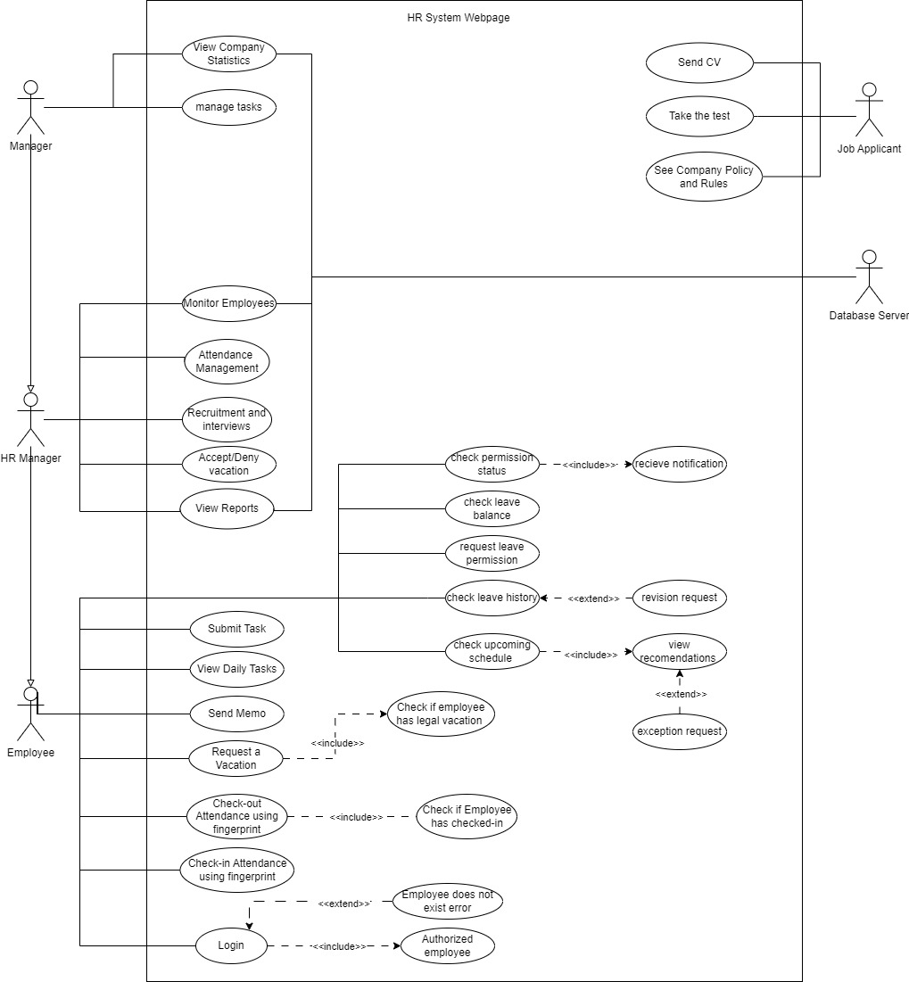

# **Use-cases description:**

-**Submit Task**: the employee shall submit work tasks that provided by manager of company (task depend on company for example: if the company is IT, then the tasks will be programs or functions).

-**View Daily Tasks**: the employee shall see the needed tasks for day to do it and see what he can do (by doing this the employee can work from home without any pressure).

-**Send memo**: the employee can send memo (email) to his manager about any problem or something else.

-**Request a Vacation**: the employee can request vacation from our website by filling needed information in the request vacation section and then wait for accept or deny his request from HR manager or even manager.

-**Login:** the employee can login to our website by giving his employee ID and password after this the system must check the Authentication for the user by comparing the information to saved information in system database, if the information exist the system open for employee else the system prints error message.

Check-in Attendance using fingerprint: the employee check attendance in by using his mobile using either face ID or fingerprint.

-**Recruitment and interviews**: The HR manager shall manage the interviews and set the rules for interview or update it based on company rules.

-**Check-out Attendance using fingerprint**: the employee check attendance out by same way in checking attendance in and the system save entered and leaved time and date for each employee to calculate his working hours and give him his salary according.

**-Check status (pending, approved, denied):** the employee has the right to check the status of the leave permission he has requested through a notification he receive each time he wants to check.

**-Check balance:** He also can see how much allowed time he can use, example: you have 8 hours monthly, total leave time shouldn’t be over them or a discount going to happen or warning.

**-check history:** the dates and times of leaving can be shown to every employee if they asked for.

**-Check upcoming schedule**: Employee can previously order a leave time if he knows he has to leave, and can cancel it if things changed. also the system recommends optimal times to leave, the employee may request an exception to leave whether he want to leave in un recommended time, and he can cancel it if things changed.

**-Attendance Management**: The HR personnel shall be able to view who has logged in from employees, who is working from home (online) or working from inside the company, and see the check-in time for each employee, as well as the ability to notify late employees.

**-Accept/Deny Vacation:** The HR personnel shall be able to accept or deny the vacation requests sent by employees.

**-View Reports:** HR manager shall be able to view reports about employees, how many hours have they worked in the last: week, month, or year, his vacations and leaves, tasks finished by this employee, and any details that will help the HR manager.

**-Send CV:** any applicant should be able to send in his/her CV through the website, without the need to log in, this option will be available if the company is hiring.

**-Take the Test:** After the applicant has requested his/her CV, he/she will be able to take a small task to solve as a quiz (random from our database), this will help him/her when choosing who from the applicants will take the job.

**-See Company Policy and Rules:** The job applicant will be able to view the company policies and rules.

**-View Company Statistics**: The manager can see the company statistics which mean number of employees and how much money in company.

**-Manage Tasks**: The manager can add, delete or update work tasks which done by employees and see the overall performance of employees

# **User & System Requirements:**

|  |  |  |  |
| --- | --- | --- | --- |
| **Task 1** | **Completed by** | **Reviewed by** | **Approved by** |
| UR: 1 | Momen | Mohammad | All |
| UR: 2 | Momen | Mohammad | All |
| UR: 3 | Mohammad | Momen | All |
| UR: 4 | Mohammad | Momen | All |
| UR: 5 | Mahmoud | Osaid | All |
| UR: 6 | Mahmoud | Osaid | All |
| UR: 7 | Mustafa | Momen | All |
| UR: 8 | Mustafa | Momen | All |
| UR: 9 | Mustafa | Momen | All |
| UR: 10 | Osaid | Mahmoud | All |
| UR: 11 | Osaid | Mahmoud | All |

## **Momen Salem 🡪 1200034**

**UR1: The users of HR system shall request vacations from the system website and fill the vacation information.**

**SR1.1**: The users can be one of the following only : 1- manager. 2- HR manager. 3- employee.

**SR1.2**: The form for requesting vacation shall be viewed after the user go to request vacation section using button labeled as request vacation.

**SR1.3**: The vacation information is : employee ID, type of vacations, and Starting date of requested vacation and ending date. Type of vacation can be one of the following types only : a- sick vacation. b- normal vacation. c- death vacation.

Date format =(YYYY-MM-DD) Y indicate year, M indicate month and D indicate day and they must be positive integers. If there is an error in requesting vacation the system must view an error message and refresh the page without saving or updating any information.

**SR1.4**: If user choose the sick vacation the system ask user to scan the medical report using camera or type the link for report (URL for medical report) (URL = Uniform Resource Locator).

**SR 1.5**: If the user fills all the information needed for requesting vacation a done message shall viewed with same information of requested vacation explained in (SR1.3) with green color as background to the typed information.

**SR 1.6**: After request vacation done message, the system shall send email to HR manager about vacation and put accept or deny button bellow the email to accept or deny the requested vacation.

**UR2: The system shall view report to HR manager about company employee.**

**SR2.1**: The report must contain all information for all employee in company database.

**SR 2.2**: The information is : employee ID, employee name (personal and family name), employee date of starting work in company, rating, number of vacations accepted and requested and employee educational degree.

**SR 2.3**: The entries must order by employee ID in ascending manner.

**SR 2.4**: The page must contain 10 employee at max and if manager needs more entries the webpage must have next and previous button bellow the table of resulting report.

**SR2.5**: The report should be implemented using Structured Query Language (SQL) on MYSQL database management system.

**SR2.6**: The report shall be viewed in time no more than 10 seconds.

**SR 2.7**: If the report does not appear in 10 seconds the webpage must refresh the page automatically.

## **Mohammad Dallash 🡪 1200937**

**UR3: the employee has the right to request a leave permission while they in the work in some situations via the system website**

**SR3.1**: the employee can apply for a leave permission which may be for (illness, emergency ,training) reasons through sending email to the HR with the reason and the time .

**SR3.2**: the user should inform the manager at least before an hour of his leaving if it’s a training leave or sick symptoms, it may be immediately if it’s an emergency type , and can ask for an exception if the leaving time slots recommendations that system suggests weren’t suitable

**SR3.3** : the leave history and the leave balance should be accessible by the employee by clicking on “check balance” and “leave history” , the leave history interface supports a “revision request” button if needed .

**SR3.4** : the employee receives a notification about the status of the permission he applied whether (denied ,acceptable ,pending) when he check the permission status

**UR4: the manager are responsible of employees data , and has access control of personal information in the database which is a data storage**

**SR4.1**: The data is a fields for personal information , department ,job rules ,contact details .

**SR4.2**: There must be an interface to add new employee profiles and edit them as needed like changing address ,contact number and position , or deleting records , the deleting process must take second approval from the head manager

Also the deleting process is not final according to the company policy so it goes to archive to enable an easy retrieval

**SR4.3**:also manager can search using various criteria such as name , department, ID ,job title , and the search history stay saved for reusing past searches .

## **Mahmoud Khatib 🡪 1200275**

**UR5: Job applicants should have the ability to access company's login page and apply for a job through the website when the company is hiring.**

**SR5.1:** The login page will show a button called "apply for job", and this button will be available only when the company is hiring (determined by manager). The manager shall have the ability to make this button enabled or disabled.

**SR5.2:** After the applicant clicks on the button, he/she will be taken to another page where the applicant can upload his/her CV of specific file types (documents, images, and url links for websites).

**SR5.3:** Before submitting the CV, the applicant shall fill in two text fields, which are email addres, and phone number, both phone number and email address shall be verified before the submission is available.

**SR5.4:** Phone number should be verified using thrid party API's, such as Google's libphonenumber, while the email verfication will be done by senting an verification email to the provided address that contains a link, and after the applicant opens the email and clicks the link, the page will refreshed and the submit button will be enabled.

**SR5.5:** The system should include an option (button) that user can click if an error happened while sending the verification email, so the system will send another verification email.

**SR5.6:** Only one submission for each phone number is allowed, but edditing the submission is available (replacing document), and the editing is done through a button that shows next to the submitted file, and after clicking the button the system should ask the user to upload another file that will replace the first one.

**UR6: HR personnel shall be able to access a dashboard displaying a list of employees' attendance statuses (logged in, working from home, working on-site).**

**SR6.1:** The system shall provide the HR personnel with a table of employees showing the employee name and id, and the attendence status (present, abscent), as well as the time for which the employees who attented have logged in at.

**SR6.2:** The table shall also have a column to specify if the employee is working from home (remote) or from inside the company.

**SR6.3:** Next to each employee, their should be a button that the HR manager can click on if the employee is late to work. If this button is clicked, the system will send an auto-generated message to the employee warning him/her to attend as soon as possible.

## **Mustafa Jaber 🡪 1200897**

**UR7: Users should have the option to log in securely by using authentication methods, such, as usernames, passwords and biometrics And the user should have the option to logout of their accounts.**

**SR7.1**: the system should support factor authentication, including the use of passwords and biometrics. Passwords must meet security standards, such as a length of 8 characters and the inclusion of special characters and symbols to enhance complexity.

**SR7.2**: to determine user permissions within the organization (e.g. employee, manager, administrator) the system should support role based access control. Access rights, for each role must be clearly documented.

**SR7.3**: Users should be able to log out of their accounts. Additionally if a user forgets to log out the system should automatically log them out after a period of inactivity to prevent access.

**UR8: In case users forget their passwords, they should be able to recover their accounts through email verification or by answering security questions.**

**SR8.1**: the system should offer password recovery options through email verification or security questions.

**UR9: Managers should be able to view a list of pending vacation requests, which includes the employees name requested dates and any notes provided by the employee. They should have the ability to either approve or deny these requests. If a vacation is approved the managers should confirm the approved dates. Inform the employee about their decision. In case of denial managers should provide reasons, for denial and notify the employee of their decision.**

## **Osaid baba 🡪 1203115**

**UR10: Managers should be able to view up-to-date company statistics without delays.**

**SR10.1:** **The system must retrieve and present real-time data from the company's databases.**

**SR10.2:** **Data caching mechanisms should be in place to ensure quick access to frequently requested information.**

**UR11: Managers should have the flexibility to customize the view of the financial breakdown based on specific criteria.**

**SR11.1:** **The system must provide options for managers to customize the financial breakdown view.**

**SR11.2:** **Customization features should include the ability to filter data by time periods, departments, or specific financial categories.**

# **Non-functional requirement :**

1. **If user train 5 hours to our website the error rate must be less than 4 error in a day.**
2. **For usability any device has network can open our website easily and do functions.**
3. **Ethical consideration**

Metric: The system should focus on fair recommendations and being unbiased , regardless gender , position in the AI-Powered Leave Recommendation System

1. **Search speed**

Metric: Ensure users get quick results by defining an acceptable response time ( for example : search results should display within a few seconds ) .

1. **Performance:** The login process should be completed within 5 seconds under operating conditions.

The system should be able to handle 100 simultaneous login requests without any decrease in performance.

1. **Security:**

Passwords must be securely stored using encryption algorithms that meet industry standards. The login module must comply with security standards.

# Phase Three

# **Class Diagram**

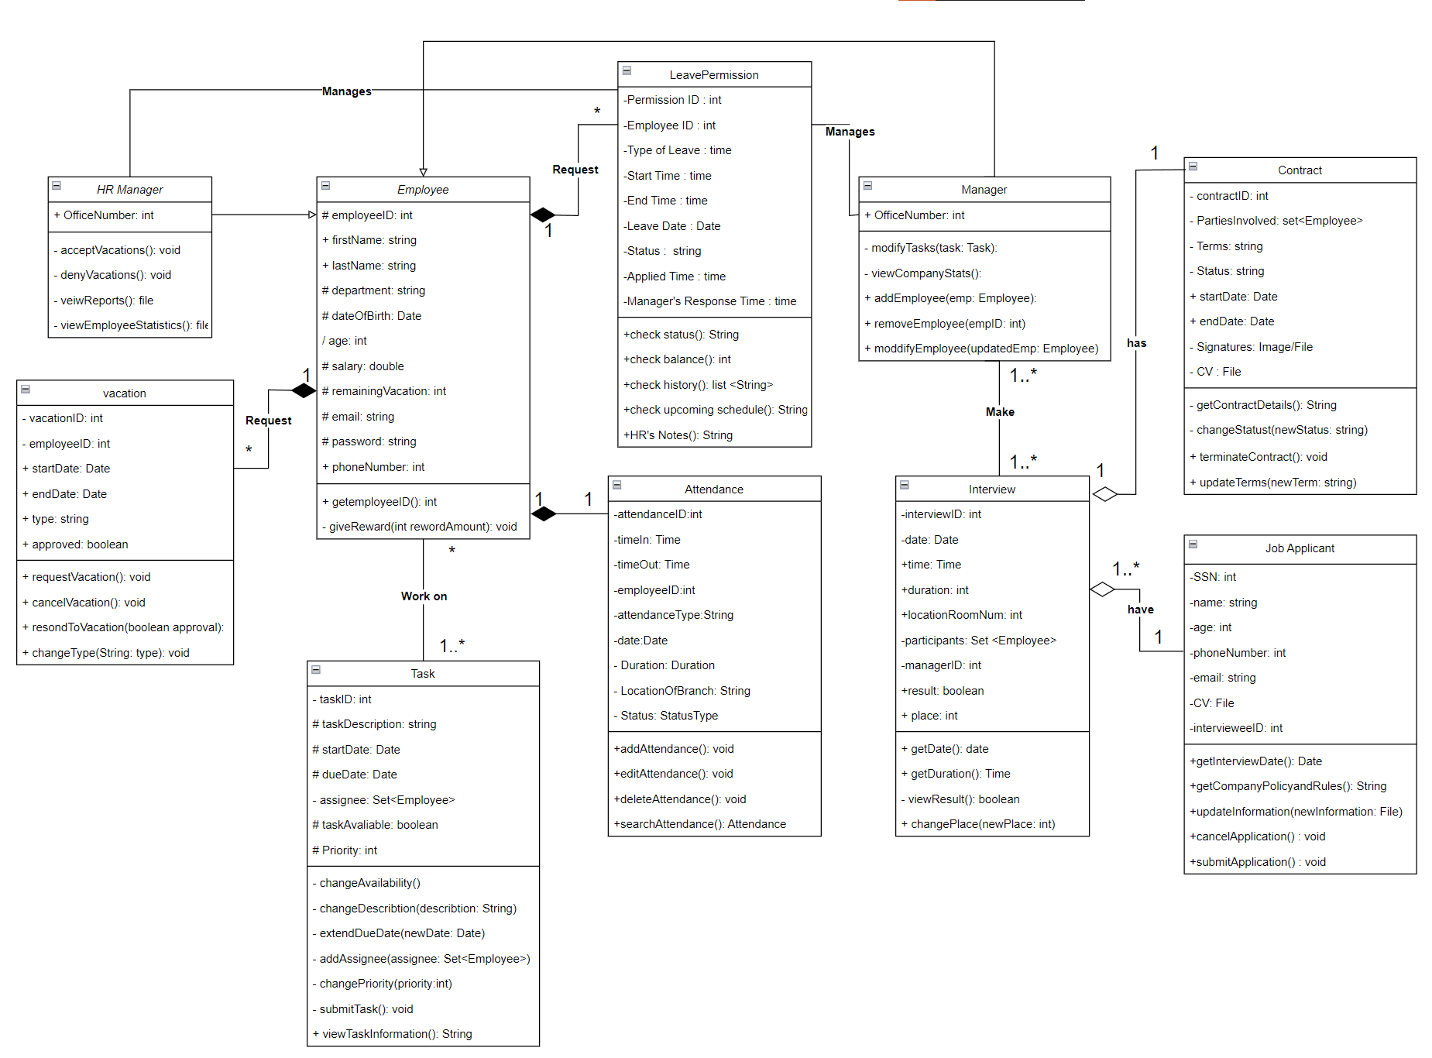

A Google Drive link for a better looking Image, if needed:

<https://drive.google.com/file/d/18WYzsiL1-4ObURKKvLCS7xvUySeeeMVo/view?usp=sharing>

# **Use-Cases Specification:**

## ***Maintain Vacations Use Case***

Done by: Momen Salem 1200034

### **Brief Description**

This use case allows the Employee to request, delete and modify requested vacations for his/her requests only. And to see his/her remaining vacations.

### **Flow of Events**

The use case begins when the Employee selects the "maintain vacation" section from the system website.

2.1 Basic Flow – Request Vacation

1. The Employee selects "request vacation" section.
2. The system displays number of remaining vacations for this Employee with blank request vacation form.
3. The Employee enters the following information to request needed vacation: Employee ID, type of vacation, Starting date of requested vacation and ending date, then selects “request” option.
4. The system validates the data to ensure the proper format and checks if the Employee has vacation balance or not.
5. The system prints confirmation message to confirm the request process.
6. The employee select “confirm” option.
7. If the data is valid the system creates a new vacation instance and assigns a unique system-generated id number.
8. Steps 2-7 are repeated for each time Employee request a vacation. When the Employee is confirming the request vacation the use case ends.

#### 2.2 Alternative Flows

##### 2.2.1 Modify a Vacation request

1. The Employee selects "modify vacation request" section.
2. The system retrieves all vacations requests for future date for the Employee (using its ID number) (future dates because the employee can modify requested vacation before its starting date only).
3. The requested vacations are presented as list of lines (request at each line) and has the following information: the type of requested vacation, date of request and the status of request (accepted/rejected/pending).
4. The Employee choose “modify” option near the request vacation needed to be modified.
5. The system displays the request form filled with request vacation need to modify.
6. The Employee modifies one or more of the vacation information fields: type of vacation, and Starting date of requested vacation and ending date.
7. When changes are complete, the Employee selects "save" option.
8. The system validates data, then updates the vacation information.
9. Steps 2-8 are repeated for each vacation the Employee wants to modify. When edits are complete, the use case ends.

##### 2.2.2 Delete a Vacation request

1. The Employee selects "delete vacation request" section.
2. The system retrieves all vacations requests for future date for the Employee (using its ID number) (future dates because the employee can modify requested vacation before its starting date only).
3. The requested vacations are presented as list of lines (request at each line) and has the following information: the type of requested vacation, date of request and the status of request (accepted/rejected/pending).
4. The Employee choose the vacation request being deleted.
5. The Employee selects "delete" option near the vacation request needed to be delete.
6. The system opens a delete request verification page to confirm deletion.
7. The Employee selects "confirm" option.
8. The vacation request is deleted from the system.
9. Steps 2-8 are repeated for each vacation request need to be delete from the system. When the Employee is finished deleting vacations to the system the use case ends.

##### 2.2.3 Vacation Already Requested

If the system finds another requested vacation for same employee in the same day an error message is printed “Sorry, you can’t request two vacations in the same day”, at which point the use case ends.

##### 2.2.4 Can’t Request Vacation

If the system finds that there are 6 (depend on company rules) vacations (from different employees) requested in that day an error message is printed “Sorry, you can’t request vacation in this day if the request is very urgent then sent an email to your manager”, at which point the use case ends.

### **Special Requirements**

when modify, delete a vacation request, the system shall retrieve all vacation requests for that employee and display it on screen in no more than 2 seconds.

### **Entry Conditions**

#### 4.1 Log In

Before this use case begins the Employee has logged into the system.

### **Exit Conditions**

A message sent to HR manager (as notification) indicating that there is a request vacation from Employee.

***2-Use Case Specification: HRMS Login***

Done by: Mustafa Jaber 1200897

### **1.Use Case Name :**

HUMAN RESOURCES MANAGEMENT SYSTEM LOGIN USE CASE .

### **2. Brief Description :**

This use case describes the steps and interactions involved in the process of a user logging into the Human Resource Management System (HRMS).

As an application user, One should be able to login to the application with the USER Information like user name and password .

Input: Enter username and password.

Output: One should be able to login to HRMS using personal information else failed.

### **3. Actors :**

• Employee

* HR Administrator

### **4. Preconditions :**

• The HRMS application is installed and accessible.

• The Employee HR Administrator Belongs to Company.

• Employee and HR Administrator accounts have been created.

• Employee and HR Administrator must have login.

### **5. Main Flow :**

#### 5.1.Basic Login :

1• Employee or HR Administrator opens the HRMS application.

2• The system displays the login screen.

3• User enters their username and password.

4• The system validates the information.

5• If the information are valid, the system logs the user in and displays the corresponding dashboard.

6• If the information are invalid, the system prompts the user to re-enter the correct information.

#### 5.2.Password Reset :

1• If a user forgets their password, they can request a password reset.

2• User clicks on the "Forgot Password" link on the login screen.

3• The system prompts the user to enter their email address.

4• An email is sent to the user's registered email address with a link to reset the password.

5• User clicks the link and sets a new password.

6• The system updates the password and notifies the user of the successful reset.

### **6. Alternative Flows :**

#### 6.1. Invalid Login Attempts Exceed Limit :

1• If a user enters incorrect information multiple times, the system locks the account temporarily.

2• The system notifies the user that their account is locked.

3• The user can choose to reset their password or contact the HR Administrator for assistance by sending email to him.

#### 6.2 . Many-factor Authentication :

1• For enhanced security, the system may implement Many-factor authentication.

2• After entering the username and password, the user is prompted to enter a verification code sent to their registered mobile device.

3• The System validates the code before allowing access.

4• The System Ask User To Enter their Fingerprint or face id.

5• The System must check the Authentication for the user by comparing the information saved in system database before allowing access.

### **7. Postconditions :**

• Upon successful login, the user has access to their respective HRMS dashboard based on their permission (Employee or HR Administrator).

### **8. Requirements :**

1• The system should encrypt and securely store user passwords.

2• Password reset links should expire after a specified time period for security reasons.

### **9. Notes and Issues :**

Any additional notes or issues related to the HRMS login process should The System prompt the user to contact the HR Administrator for assistance by sending email to him.

### **10. Exit Conditions :**

1• The user is logged out after a specified period of inactivity to ensure security.

2• The HRMS application is in a stable state, ready for the user to perform various tasks based on their role.

## ***Maintain Leave Permission Use Case***

Done by: Mohammad Dallash 1200937

### **1. Brief Description**

The employee can request leave permission for reasons like illness, training or emergency. Requests are made via email to HR, with justification specifying the reason and time.

### **2.    Flow of Events**

The use case “Leave Permission” begins when an employee accesses the designed system interface then selects “Request Leave Permission” option. This initiate the process to apply for leave.

### 2.1 Basic Flow – Request Leave Permission

1. The employee logins into the system and selects "Request Leave Permission" option.
2. The employee starts filling out a digital form, specifying the leave type( training ,emergency ,illness) , with a start and end time , also attaching a brief reason for his/her leave.
3. The system checks automatically for any conflicting dates with a previous leave requests or significant company events .
4. Upon submission , the employee receives an automated acknowledgment email with the details of the request .
5. The request is forwarded to the HR department for taking decision . it will be under validation review by HR according to the company policies.
6. The employee will receive an email notification whether his request has been approved or rejected , in case of rejection , the reason is provided .
7. A calendar update occurs automatically for the employee if the request is approved

#### 2.2     Alternative Flows

##### 2.2.1 Modify Leave permission

1. The Employee selects "modify Leave Permission" section.
2. The system shows existing leave requests .
3. The Employee chooses “modify” option near the specific submitted request which needed to be modified.
4. The system displays the information of that request
5. The modification for the requested permission leave is allowed only if the starting date is not arrived.
6. The Employee modifies fields like : leave permission type and (start/end) date and time .
7. The employee clicks “save” button after the modification completion .
8. The modified request is resubmitted .
9. The system checks validation for the updates and sends an automated confirmation .
10. When edits are finished , the use case ends. Steps 2-7 are repeated for each leave permission modification needed .

##### 2.2.2  Delete Leave permission

1. The Employee selects "delete Leave Permission" .
2. The system displays all leave permission requests has been submitted whatever their status pending/approved.
3. The Employee selects “delete” option near the leave request he want to be cancelled
4. The system opens a delete verification page to confirm deletion.
5. Once The Employee selects "agree" option ,The leave request is deleted from the system.
6. A notification of cancellation is sent to HR
7. Steps 2-6 are repeated for each vacation request deleted from the system. When the Employee is finished deleting vacations to the system the use case ends.

##### 2.2.3  Leave Already Requested

If the system finds that the employee is trying to request a leave for dates already booked , the system alerts to a conflict by an error message printed “ sorry, this request can’t be completed as a conflict with another which has been reserved previously “

So this notification implies the employee of a scheduling conflict ,, at that point , the use case ends

The employee will need to choose another date/time to be valid or choose to edit or cancel the existing request .

##### 2.2.4 Can’t Request Vacation

If the employee passes the leave balance limitation which may equal to a full time work day per month , the system display a message that he can’t take a leave .

### **3.    Special Requirements**

when modifying or deleting a leave permission request, the system should retrieve and display all leave requests for that employee .

### **4.     Entry Conditions**

#### 4.1    Log In

Before initiating the leave permission use case , the Employee must be logged into the system.

### **5.    Exit Conditions**

Upon submission of a leave request , a notification is sent to the HR manager indicating a new leave request from an employee .

## ***Apply for Job Use Case***

Done by: Mahmoud Khatib 1200275

### **Brief Description**

This use case allows any Job applicant to send in his/her CV through the website, without the need to login, and this option will be available when the company is hiring.

The actor for this use case is the Job applicant.

### **Flow of Events**

The use case begins when the Job applicant clicks on the Apply for Job button on the main page of the program.

### 2.1     Basic Flow – Apply for a Job

* + 1. The Job applicant selects "Apply for Job."
    2. The system displays a new page with the set of open positions.
    3. The Job applicant selects one or more position he/she is applying to from the check box menu.
    4. The system displays three additional empty fields for the applicant.
    5. The Job applicant fills the following information, the phone number, email address, and the CV file, then selects the "submit Application" option.
    6. The system validates the data to ensure the proper format and the validity of the phone number, and the email address. If the data is valid, the system creates a new Job applicant and assigns a unique system-generated id number.
    7. If the application is received by the system, then an email will be sent to the applicant, indicating a successful submission where he/she can view submitted application.
    8. The system starts a two-minute countdown, if the applicant does not receive email indicating a successful submission, the applicant can re-submit the application.
    9. The applicant can select "finish application", to be redirected to main page.

#### 2.2     Alternative Flows

##### 2.2.1 Modify a Submitted Application:

* + - 1. The Job applicant can edit/modify the submitted application, by referring to the email, that was sent by the system after receiving the application.
      2. The system searches for the applicant by email address, and display the same fields as in "Apply for Job" sub-flow, automatically filled with the old submitted information.
      3. The Job applicant can modify options selected in the check-box menu, and two of the fields, which are the phone number, and the CV file, the third field is not editable, which is the email address.
      4. When changes are complete, the Job applicant selects "submit changes."
      5. The system validates data, then updates the applicant information.
      6. If the information is received by the system, an email will be sent to the applicant indicating a successful submission.
      7. The Job applicant can select "finish modifying" to be redirected to main page.

##### 2.2.2 Cancel Application

* + - 1. The Registrar selects "cancel application." Option from the received email.
      2. The system displays a page saying "The application will be cancelled, are you sure?", with two options.
      3. The system displays a delete verification dialog confirming the deletion.
      4. The Job applicant selects "yes."
      5. The Job application is deleted from the system.

##### 2.2.3 Applicant Already Exists

If in the "Apply for Job" sub-flow the system finds an existing Job application with the same email address and phone number an error message is displayed "Application already sent". The Job applicant can change the email and phone number fields or cancel the operation, at which point the use case ends.

##### 2.2.4 Submission Not Received by system

If in the "apply for job" or "Modify Submitted Application" sub-flows, the submission was not received by the system due to any error, the system always starts a two-minute countdown in the "apply for job", and "Modify Submitted Application" pages, and after the countdown, the applicant can re-submit the application.

### **3. Special Requirements**

#### 3.1 validation & verification:

email validation & verification is done in two steps, first the email is validated using an external API, such as ZeroBounce API, then if the email is valid, a verification email is sent the provided email. phone number is validated using a 3rd party API such as Google's libphonenumbe.

#### 3.2 one application per email

Only one application per email is allowed, this is different than modifying already submitted applications.

### **4. Entry Conditions**

#### 4.1    Open positions

Before this use case begins the Manager has to be enable job application through the HRMS system.

### **5.    Exit Conditions**

There are no postconditions associated with this use case.

## ***Maintain Attendance Use Case***

Done by: Osaid Baba 1203115

### **Brief Description**

This use case allows an HR manager to manage attendance records in the HR system, differentiating between 'Work from Office' and 'Work from Home'. It includes detailed processes for employee check-ins at the office and for remote work.

### **Flow of events**

#### 2.1 Basic Flow – Work from Office Check-in:

1. Employee Arrival: Upon arriving at the office, the employee approaches the fingerprint scanner located at the entrance.
2. Fingerprint Scanning: The employee places their finger on the scanner. The scanner captures the fingerprint and sends the data to the attendance system.
3. Verification and Record Creation: The system verifies the fingerprint against registered employee fingerprints. Upon successful verification, it records the time of entry and marks the employee as present for the day.
4. Confirmation: The system sends a confirmation to the employee's registered device, confirming the check-in.

#### 2.2 Basic Flow – Work from Home Check-in:

1. Remote Check-in Initiation: The employee logs into the company's secure portal using their credentials.
2. Location Verification: The portal prompts the employee to enable location services on their device to verify they are at their registered remote work location.
3. Digital Check-in: Upon location verification, the employee checks in digitally by clicking the 'Check-in' button on the portal.
4. Confirmation: The system logs the check-in time and sends a confirmation message to the employee.

#### 2.3 Alternative Flows:

##### 2.3.1 System Unavailability:

If the attendance system is temporarily unavailable (e.g., due to maintenance or network issues), employees report their check-in and check-out times manually to HR. HR later updates these records in the system when it becomes available.

##### 2.3.2 Incorrect Fingerprint Read:

If an employee's fingerprint is not recognized due to a scanner error or dirty sensor, the employee is prompted to clean their finger and retry. If the issue persists, they report to HR for manual check-in and fingerprint re-registration if needed.

##### 2.3.3 *Late Arrival/Early Departure*:

If an employee checks in late or checks out early, the system flags this record for review. HR may follow up with the employee for clarification or adjustment of work hours.

##### 2.3.4 *Technical Issues with Fingerprint Scanner*:

In case of a malfunctioning fingerprint scanner, employees use an alternative check-in method, such as a PIN code system or a manual sign-in sheet, until the scanner is repaired.

##### 2.3.5 *Absence Without Notification*:

If an employee fails to check in and hasn't notified HR of their absence, the system marks them as absent. HR then follows up to determine the reason for the absence.

### **Special Requirements**

3.1 Performance: Search results should be retrieved within 3 seconds.

3.2 Attendance Types: Must clearly distinguish between 'Work from Home' and 'Work from Office'.

### **Entry Conditions**

##### 4.1 HR manager:

The HR manager must be logged into the system.

##### 4.1 Employees:

Employees have registered fingerprints (for office) or remote work locations (for home).

### **Exit Conditions**

The HR manager exits the "Manage Attendance" section.

# **Activity Diagrams:**

## Activity Diagram for maintain vacations in the system Done by: Momen Salem 1200034

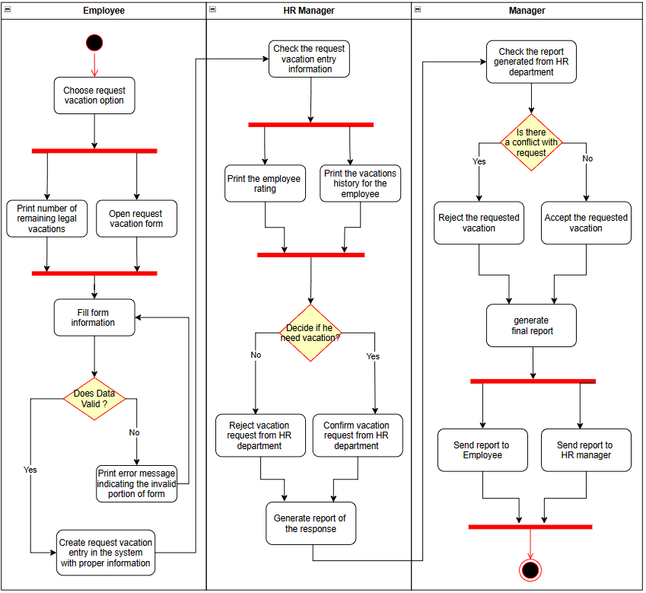

## Activity Diagram for maintain Login in the system

Done by: Mustafa Jaber 1200897

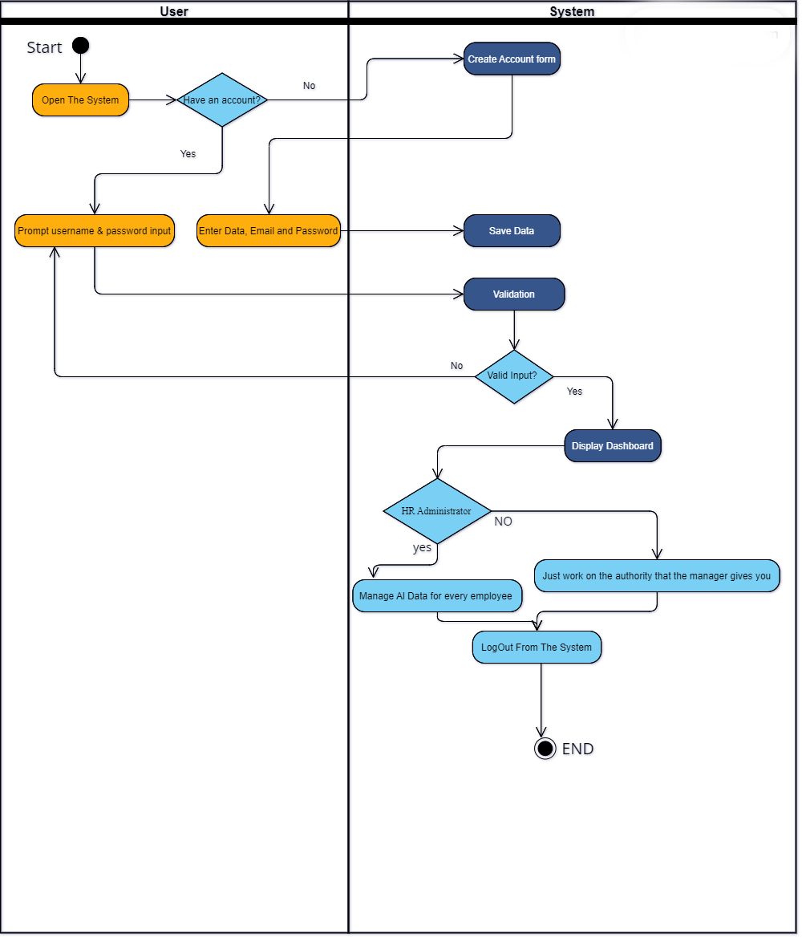

figure: Login Activity Diagram

## Activity Diagram for maintain Leave Permission the system Done by: Mohammad Dallash 12000937

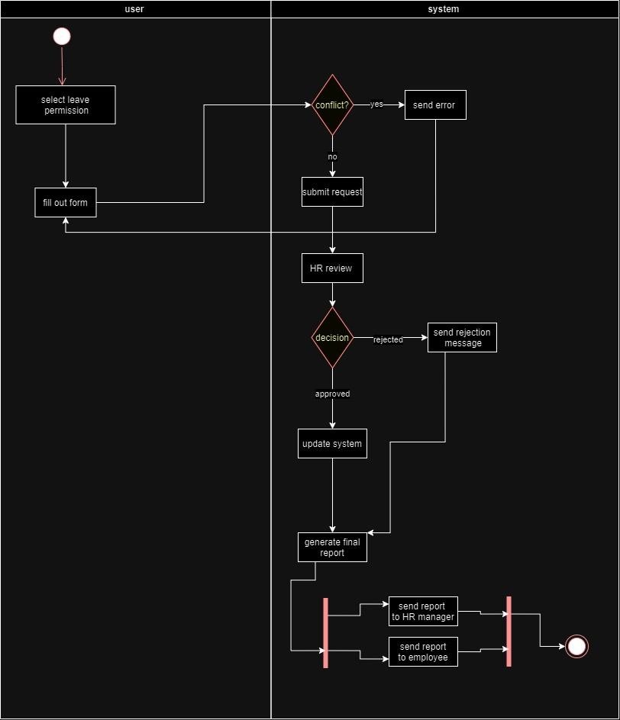

## Activity Diagram for Apply for Job in the system Done by: Mahmoud Khatib1200275

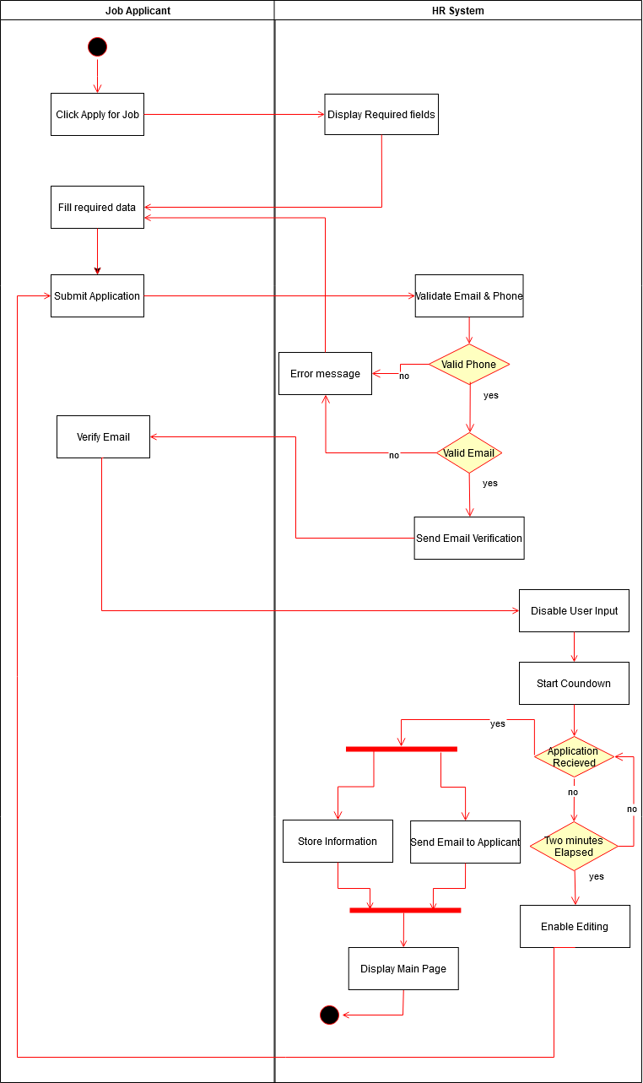

## Activity Diagram for Maintain Attendance in the system Done by: Osaid Baba 1203115

