Date: 26/07/2024

To,

Al Fardan Exchange

E-money Department (WPS)

Sharjah

Sub: Adding New Employee – Company GL# 906719 - M M R PROJECT MANAGEMENT SERVICES L.L.C

Dear Sir,

This is the confirmation letter to transfer the salary of Mrs./ Samar Mamdouh Mohsen Elghazaly to his below mentioned bank account.

Employee Name: Samar Mamdouh Mohsen Elghazaly

Personal No: 0215891746101

Bank Name: Emirates NBD

IBAN: AE32 0260 0002 1589 1746 101

Bank WPS routing code no: 302620122

Thanks

Authorized Name: Redha Darwish Al Rahma

Designation: CEO

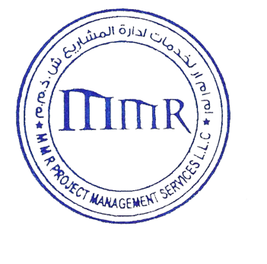Sign & company seal:

