**Bangladesh Army University of Engineering & Technology**

**(BAUET)**

**Dept. of CSE**

**7th Batch**

**Course Code: CSE-3108**

**Course title: Assembly Language programing Sessional**

|  |  |
| --- | --- |
| **Exp No** | **Experiment title** |
| 1 | Write an assembly program for summation of 2 digits |
| 2 | Write an assembly program to convert upper-case/ lower-case letter |
| 3 | An assembly program to compare ASCII value of two letters |
| 4 | How to execute FOR loop & WHILE loop in assembly language |
| 5 | Write an assembly program to find Odd or Even digit from 0 to 5 range by using CASE |
| 6 | Write an assembly program for performing Division Operation |

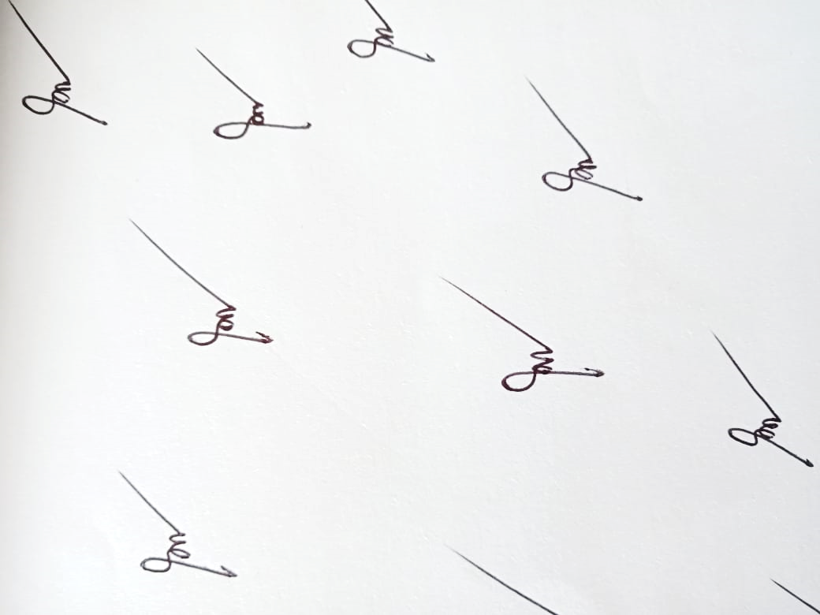

**Subrata Kumer Paul**

Lecture, Dept. of CSE