INTRODUCTION TO Python , Operator and string

**PROGRAM # 1:**

Write a script that take user input for a number then adds 3 to that number. Then multiplies the result by 2, subtract 4, then again adds 3, then print the result.

SOURCE CODE:

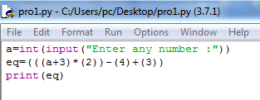

OUTPUT:

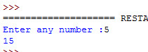

**PROGRAM # 2:**

Write a script that takes input as radius then calculate area of circle. (hint: A= πr²).

SOURCE CODE:

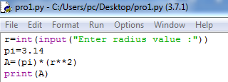

OUTPUT:

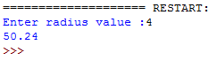

**PROGRAM # 2:**

Write program to print integer and string.

SOURCE CODE:

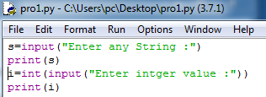

OUTPUT:

