LAB # 10

**PREDICATE LOGIC**

1. Identify which unification is succeeds and fails and also mention the comments :

• [a,d,z,c] and [H|T] = **Unification**

• [one] and [Two] = **Unified(Two = one)**

• [a,b,X] and [a,b,c,d] = **No Unification(because number of variables are not equal)**

2.Write a prolog program to write the elements of the list line by line

SOURCE CODE:

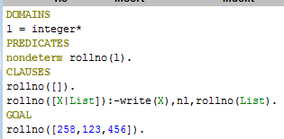

OUTPUT:

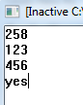

3.Write a prolog program to create list of integer and if you entered a character, program discarded and return integer list.

SOURCE CODE:

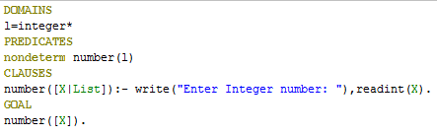

OUTPUT:



4.Write a prolog program to add an element to the beginning of a list using predicate “add(X,L,L)”.

SOURCE CODE:

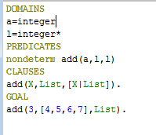

OUTPUT:



5.Write a prolog program that defines a predicate maxlist (L,Max) where Max is the greatest number of the list

SOURCE CODE:

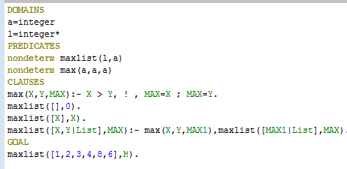

OUTPUT:

