LAB # 11

**PREDICATE LOGIC**

1.An article can be identified by its “book” and a book can be identified by its “title and author”, and author can be identified by its “first name”. The domains title, author, and names the entire standard domain symbol. Predicates name should be “owns” and owns can be identified by its name and articles, e.g. John owns the book From Here to Eternity, written by James Jones. Excute the Goal:

owns(FN,book(“abc”,X) */X=author name

SOURCE CODE:

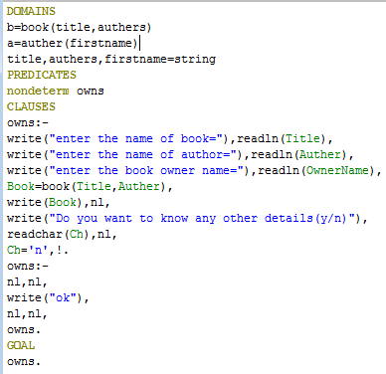

OUTPUT:

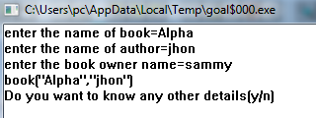

2.Write a prolog program, which take input (integar) and calculate a cube of a integar.

(hint: cube(C,N) :- C is N * N * N).

SOURCE CODE:

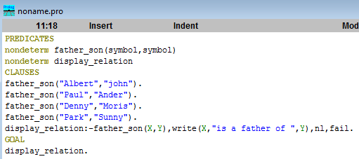

OUTPUT:

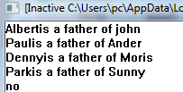

3.Write a prolog program which creates father-son relation using atoms, and display all the reasoning of father-son relation using controlling predicate.

SOURCE CODE:

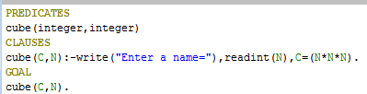

OUTPUT:

