LAB # 02

function , loop and conditional statements

* 1. Write a Python script that asks users for their favourite color. Create the following output (assuming blue is the chosen color) (hint: use ‘+’ and ‘*’)

blueblueblueblueblueblueblueblueblueblue

blue blue

blueblueblueblueblueblueblueblueblueblue

SOURCE CODE:

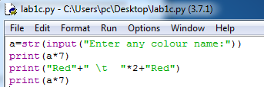

OUTPUT:

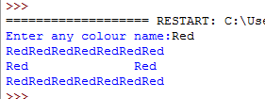

* 1. Store a person’s name, and include some whitespace characters at the beginning and end of the name. Make sure you use each character combination, "\t" and "\n", at least once. Print the name once, so the whitespace around the name is displayed. Then print the name using each of the three stripping functions, lstrip(),rstrip(), and strip().

SOURCE CODE:

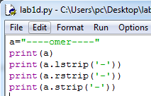

OUTPUT:

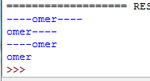

* 1. Write a python script that take a user input and to create the multiplication table (from 1 to 10) of that number.

SOURCE CODE:

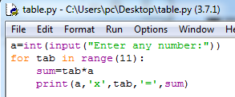

OUTPUT:

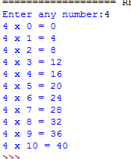

* 1. Write a function called describe_city( ) that accepts the name of a city and its country. The function should print a simple sentence, such as **Islamabad is in Pakistan**. Give the parameter for the country a default value. Call your function for three different cities, at least one of which is not in the default country.

SOURCE CODE:

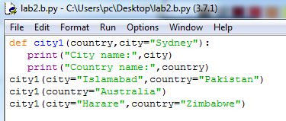

OUTPUT:

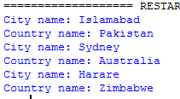

* 1. Write a function called absolute_num() that accepts one parameter, num. The function should return only positive value, and apply condition on it. This function returns the absolute value of the entered number.

SOURCE CODE:

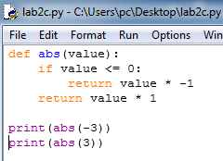

OUTPUT:



* 1. Write a Python program that prints all the numbers from 0 to 6 except 3 and 6. (Hint: Use 'continue' statement).

SOURCE CODE:

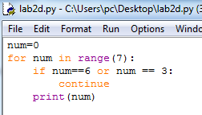

OUTPUT:

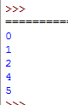

* 1. Stages of Life: Write an if-elif-else chain that determines a person’s stage of life. Set a value for the variable age, and then:
* If the person is less than 2 years old, print a message that the person is a baby.
* If the person is at least 4 years old but less than 13, print a message that the person is a kid.
* If the person is at least 13 years old but less than 20, print a message that the person is a teenager.
* If the person is at least 20 years old but less than 65, print a message that the person is an adult.
* If the person is age 65 or older, print a message that the person is an elder.

SOURCE CODE:

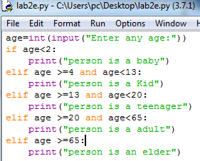

OUTPUT:

