LAB # 03

List, tuple, Dictionary, class and object

1. Store the names of a few of your friends in a list called names. Print each person’s name by accessing each element in the list, one at a time.

SOURCE CODE:

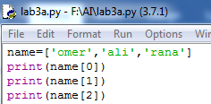

OUTPUT:

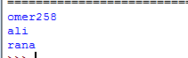

1. If you could invite anyone, living or deceased, to dinner, who would you invite? Make a list that includes at least three people you’d like to invite to dinner. Then use your list to print a message to each person, inviting them to dinner.

SOURCE CODE:

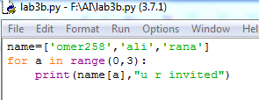

OUTPUT:



1. **Changing Guest List:** You just heard that one of your guests can’t make the dinner, so you need to send out a new set of invitations. You’ll have to think of someone else to invite.

* Modify your list, replacing the name of the guest who can’t make it with the name of the new person you are inviting.
* Print a second set of invitation messages, one for each person who is still in your list.

SOURCE CODE:

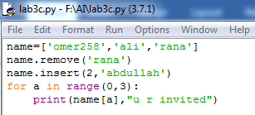

OUTPUT:

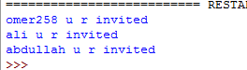

1. Create a Class “Employee”, it’s a common base class for all the employee. Then initialize employee’s parameter like empName and salary and create function like displayCount() contain total number of employee in your knowledge base and displayEmployee() contain empName and their salary.

SOURCE CODE:

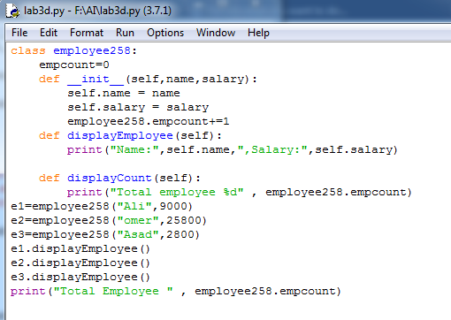

OUTPUT:

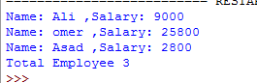

1. Write a Python script that asks users for their favourite color. Create the following output (assuming blue is the chosen color) (hint: use ‘+’ and ‘*’)

SOURCE CODE:

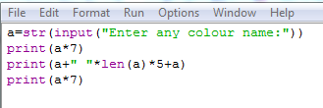

OUTPUT:

