LAB # 05

List, tuple, Dictionary, class and object

1. Represent a graph by using any data structure. Apply BFS if the starting node is “A” and goal is “G” print complete path from source to destination.

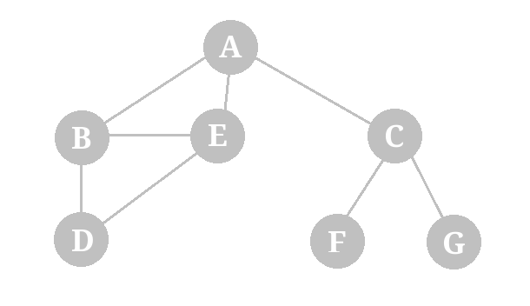

SOURCE CODE:

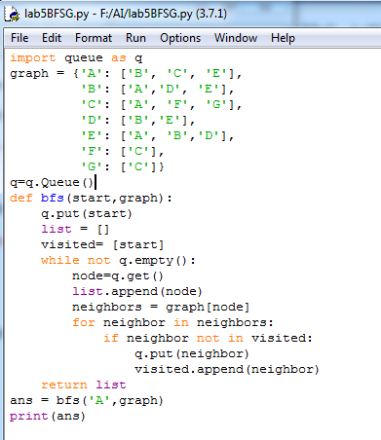

OUTPUT:



1. 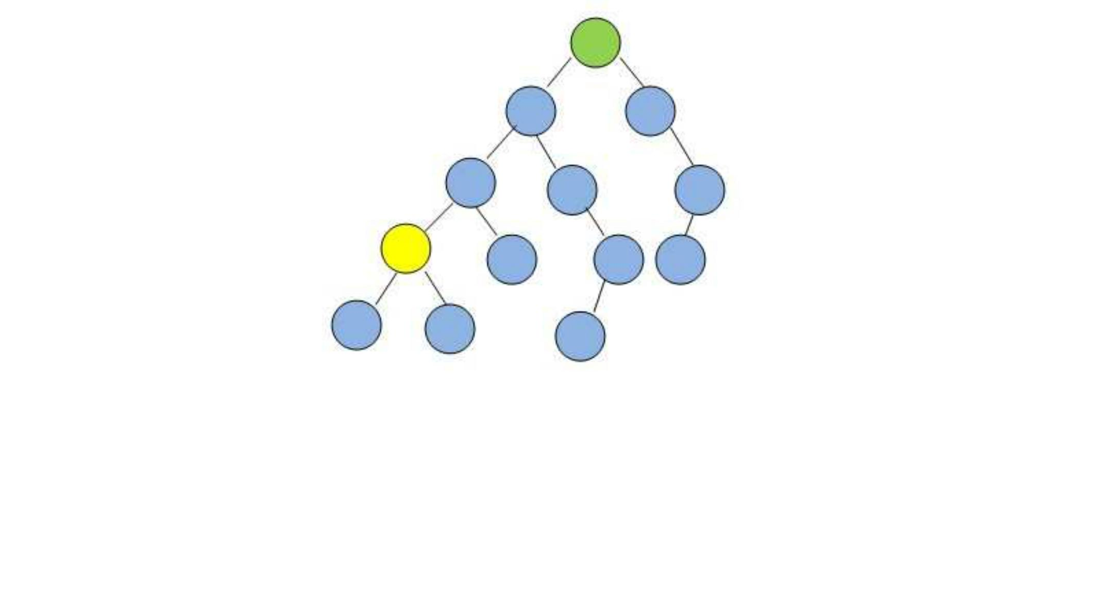DFS:

SOURCE CODE:

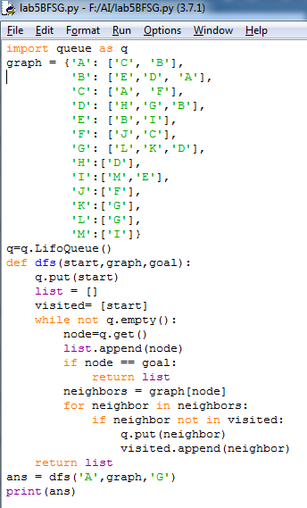

OUTPUT:



1. By using graph 1 user to state starting goal node and apply BFS and print complete path from source to destination.

SOURCE CODE:

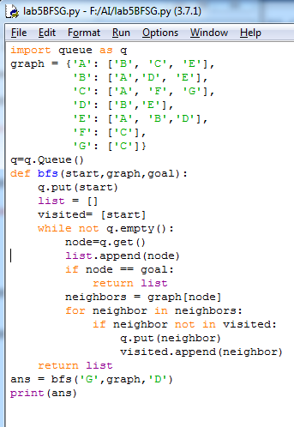

OUTPUT:

