LAB # 06

**IMPLEMENTING INFORMED SEARCH TECHNIQUIES**

Consider the following graph. If there is ever a decision between multiple neighbor nodes in the greedy best first search, find the path between S to D. Represent a graph with heuristic using list or dictionaries. The keys of the dictionary represent nodes; the values have a list of heuristic.

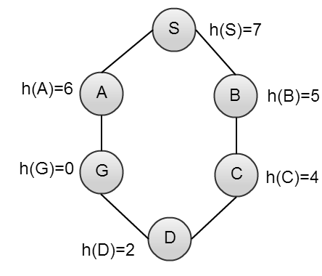

SOURCE CODE:

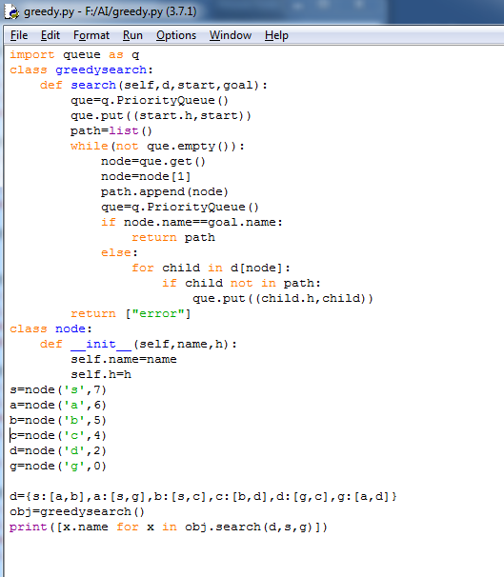

OUTPUT:

