LAB # 08

**IMPLEMENTING LOCAL SEARCH TECHNIQUIES**

**Genetic Algorithm:**

SOURCE CODE:

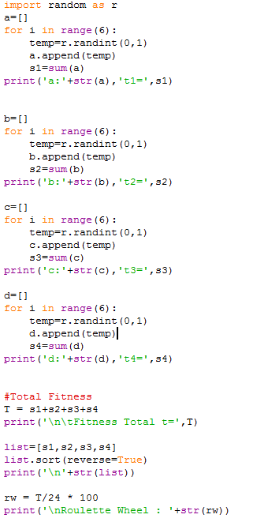

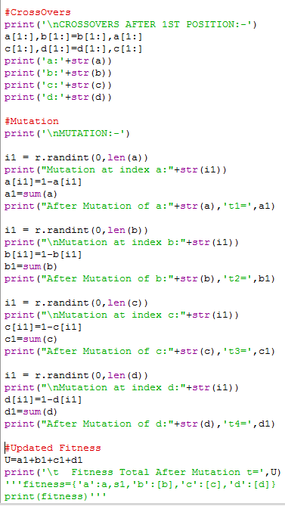

OUTPUT:

