LAB # 09

**PREDICATE LOGIC**

1.Dobby is a house elf, Harry and Dumbledore are wizards and Hermione and Rita_Skeeter are witches. Anyone who is House elf, wizard or a witch can do magic. Find out

▪ magic (dobby).

▪ magic (X).

SOURCE CODE:

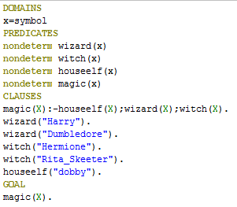



OUTPUT:

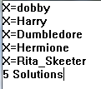



2.Write a Prolog program which defining the sister relation. Take user input X and Y, X is a sister of Y if both X and Y have the same parent and X is a female. According to the condition, create facts and rules to execute the Goal.

SOURCE CODE:

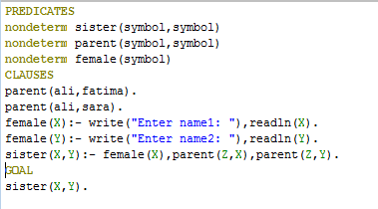

OUTPUT:

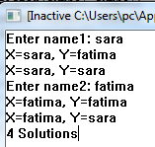

3.Write a program to find the entire students name that enrolled in AI course.

SOURCE CODE:

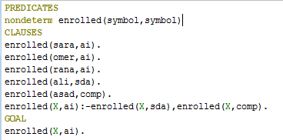

OUTPUT:

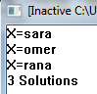

4.Write a program about family tree. Members in a family like (ali, ayesha, nawaz, mariyam, aliya, sobia) and give some predicates name like parent, men, women etc. and give some facts like parent(ali,ayesha) etc and rules like parent(X,Y) :- men(X),parent(X,mariyam). Execute some Goal:

▪ ali is a parent of mariyam?

▪ Who is Ayesha’s parent?

SOURCE CODE:

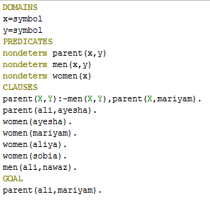



OUTPUT:



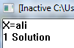

5.Write a prolog program that defines a relation max(X, Y, Max) where Max is the greater of X and Y using controlling predicate.

SOURCE CODE:

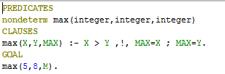

OUTPUT:

