**ACCUMULATOR REGISTER:**

This register holds the value used in arithmetic and logical computation.

**INTRODUCTION CYCLE DISPLAY:**

This show the number of instructions that has been executed since the program execution began.

**INRIDUCTION REGISTER:**

This register holds the next instruction to be executed.

The register is divided into two parts.

* One digits operating code.
* Two digits operand.

**TASK # 1:**

To take input and subtract.

SOURCE CODE:

in

sub 66

out

hlt

*66

dat 008

OUTPUT:

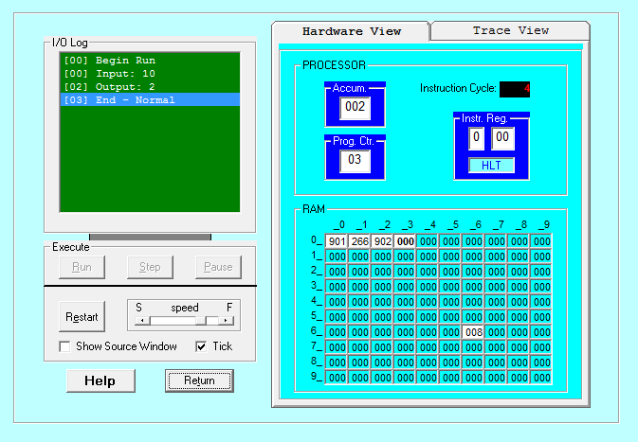

**TASK # 2:**

To take two inputs as hardware and add them.

SOURCE CODE:

in

add 66

add 78

out

hlt

*66

*78

dat 008

OUTPUT:

