**TASK # 1:**

Simple conditional structure using “brp” and “br” instruction.

SOURCE CODE:

in

sto 98

in

sto 99

lda 98

sub 99

brp 11

lda 98

sub 99

sto 97

br 14

lda 98

add 99

sto 97

out 14

hlt

OUTPUT:

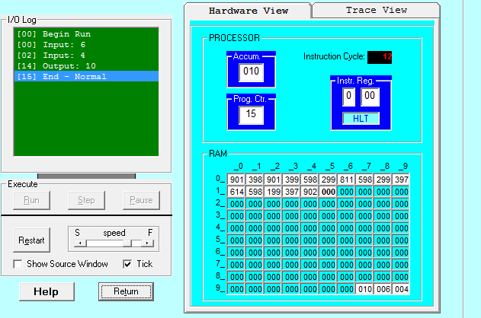

**TASK # 2:**

Take any integer as input, if the number is greater than 5 print it.

If a>5, print a

Else if a=0, then halt.

Else if a<0, then halt.

SOURCE CODE:

in

sto 98

lda 98

sub 99

brz 09

brp 06

hlt

lda 98

out

hlt

*99

dat 005

OUTPUT:

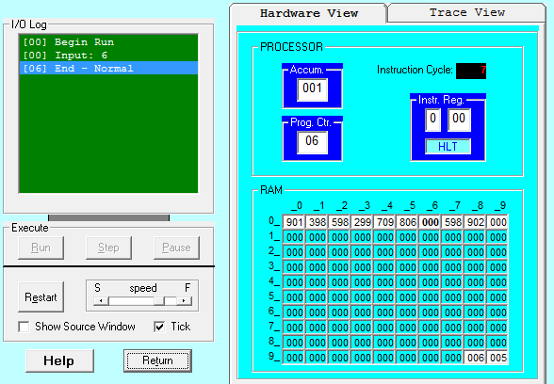

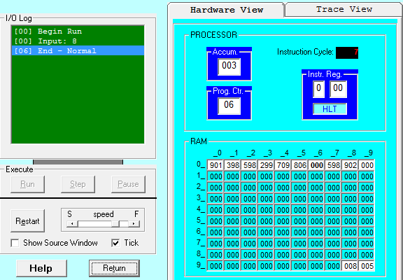

**TASK # 3:**

Take two integers as input and print the larger number.

SOURCE CODE:

in

sto 98

in

sto 99

lda 98

sub 99

brp 10

lda 99

out

hlt

lda 98

out

hlt

OUTPUT:

