An overview of VLan and how to create and why use VLan.

**TOPOLOGY:**

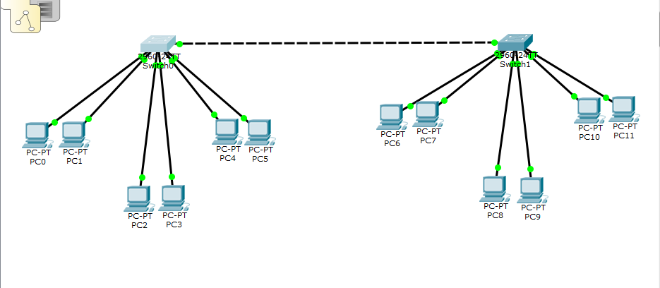

**HOSTNAME SSUET:**

**Vlan2:**

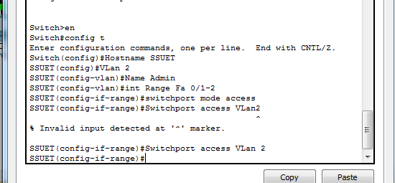

**VLan3:**

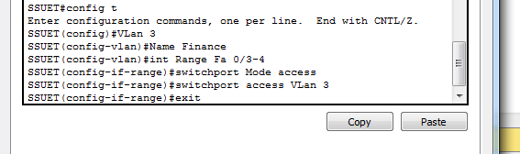

**VLan4:**

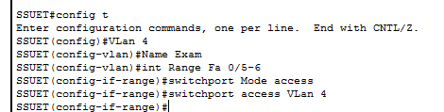

**HOSTNAME AIT:**

**VLan2:**

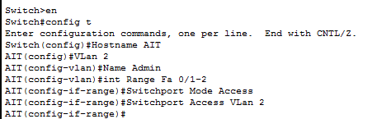

**VLan3:**

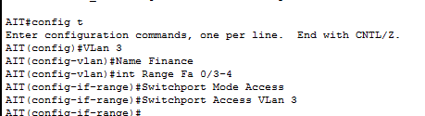

**VLan4:**

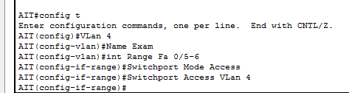

**SWITCH SSUET TRUNK:**

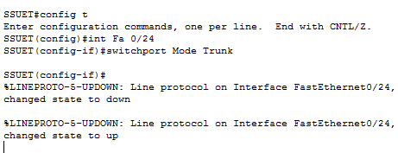

**SWITCH AIT TRUNK:**

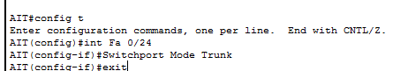

**IP CONFIGURATION:**

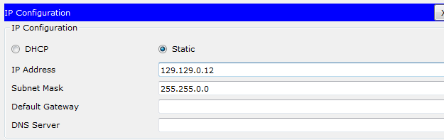

**PC IP PING 129.129.0.7:**

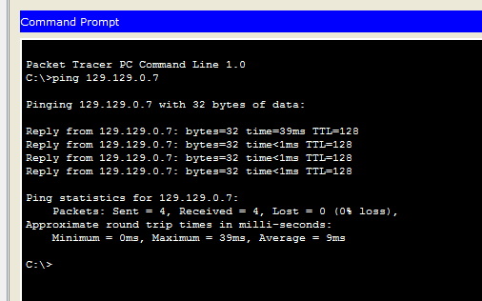

**PC IP PING 129.129.0.9:**

