How to apply port security discuss about violation

**Created Overview of switch on Topology area**

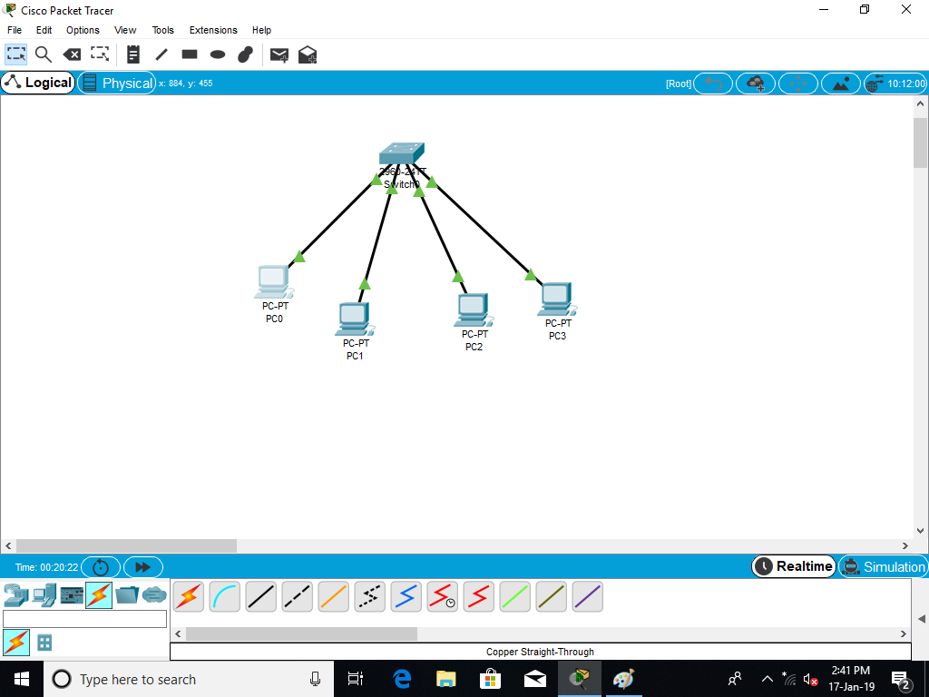

**Ping**

**CLI switch coding on switch for shutdown**

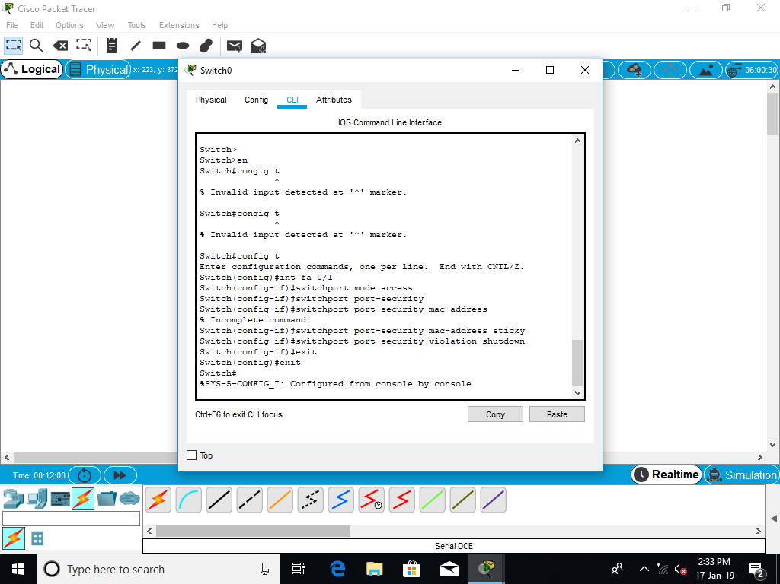

**ARP**

**IP CONFIG-renew**

**NETSTAT:**

**Change the PC MAC Address for volition.**

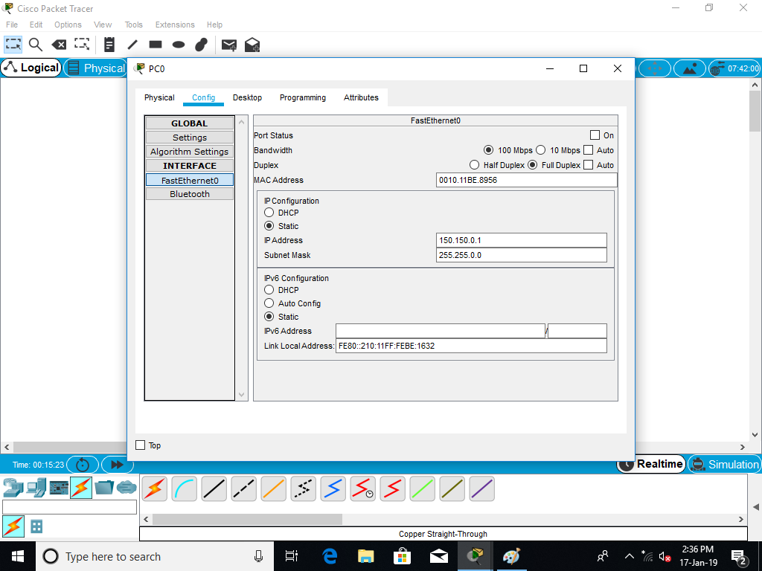

**Created Overview of switch on Topology area after volition.**

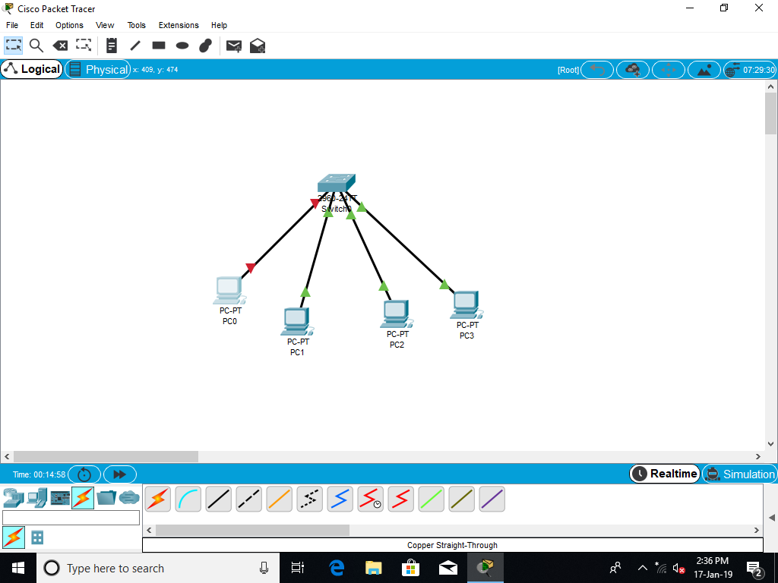

**switch codin**

**Ping Command Check the volition.**

