**TASK # 1:**

Write a program that asks the user to enter 10 integers of an array & then sort them.

SOURCE CODE:

import java.util.Arrays;

import java.util.Scanner;

public class sort {

public static void main(String args[]){

Scanner inp= new Scanner(System.in);

int a[]=new int [10];

int i,j,b;

int temp;

System.out.println("Enter 10 integers");

for(i=0;i<10;i++)

{ a[i]=inp.nextInt();

}

for(i=0;i<10;i++)

{ for(j=0;j<10;j++){

if(a[i]<a[j])

{ temp=a[i];

a[i]=a[j];

a[j]=temp;

} } }

for(i=0;i<10;i++){

System.out.println("After sorting"+a[i]);

} } }

OUTPUT:

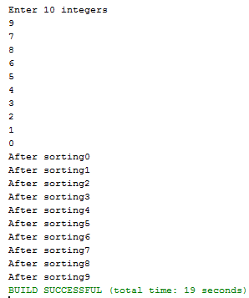

**TASK # 2:**

Write a program that initialize 3 string a) then concatenate them all b) convert s1 to upper case c) find the substring from concatenate string from 4th character to own words d) find the substring from concatenate string from 2nd to 7th character e) find the index of string 2 from concatenate string.

SOURCE CODE:

public class str {

public static void main(String args[]){

String c;

String s1="sir";

String s2="syed";

String s3="university";

System.out.println("Concatinate:"+s1.concat(s2).concat(s3));

c=s1.concat(s2).concat(s3);

System.out.println("Upper case:"+s1.toUpperCase());

System.out.println("Sub string 4 to ownwords:"+c.substring(4,17));

System.out.println("Sub string 2nd to 7"+c.substring(2, 7));

System.out.println("2nd String:"+c.substring(3,7));

} }

OUTPUT:

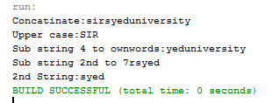

**TASK # 3:**

Write a program that take name, roll no & fees as an input & print them.

SOURCE CODE:

import java.util.Scanner;

public class data {

public static void main(String args[]){

String n;

int roll,fees;

Scanner inp=new Scanner(System.in);

System.out.println("Enter Name:");

n=inp.nextLine();

System.out.println("Enter Roll No:");

roll=inp.nextInt();

System.out.println("Enter Fees:");

fees=inp.nextInt();

System.out.println("Name:"+n+"\nRoll no:"+roll+"\nFees:"+fees);

}}

OUTPUT:

