**TASK # 1:**

Write a program to find a factorial of any given number by using algorithm.

ALGORITHM:

**Input** = K, FAC, N.

**Output** = Factorial of a number.

**Step # 1:**(Initialization)

K, FAC=1, N.

**Step # 2:**

Read K, FAC=1, N.

**Step # 3:**

Repeat for K=1 to N.

Set FAC=K*FACT

[End of for loop]

**Step # 4:**

Write “Factorial of number” FAC.

**Step # 5:**

Exit.

SOURCE CODE:

import java.util.Scanner;

public class fact {

public static void main(String args[]){

int fac=1,n,k;

Scanner inp=new Scanner(System.in);

System.out.println("Enter number:");

n=inp.nextInt();

for(k=1;k<=n;k++){

fac=fac*k; }

System.out.println("Factorial is:"+fac); }}

OUTPUT:

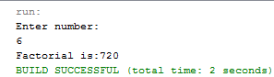

**TASK # 2:**

Write a program to find a maximum & minimum no. of an array of N element by using algorithm.

ALGORITHM:

**Input** = MAX, MIN, I,A.

**Output** = Maximum and minimum number are.

**Step # 1:**(Initialization)

MAX, MIN, I, A.

**Step # 2:**

Read MAX=0, MIN=0, I, A.

**Step # 3:**

FOR(I=0;I<5;I++)

IF(A[I]>MAX)

MAX=A[I]

IF(A[I]<MIN)

A[I]=MIN

[End of FOR loop]

**Step # 4:**

Write max & min is .

**Step # 5:**

Exit.

SOURCE CODE:

import java.util.Scanner;

public class MAXIMA {

public static void main(String args[]){

int max = 0,i,j,min=0;

Scanner inp=new Scanner(System.in);

int [] a=new int[6];

System.out.println("Enter 5 numbers");

for(i=0;i<5;i++){

a[i]=inp.nextInt();

}

for(i=0;i<5;i++){

if(a[i]>max){

max=a[i]; }

if(a[i]<min){

min=a[i]; }

}

System.out.println("max:"+max+"\nmin:"+min);

}}

OUTPUT:

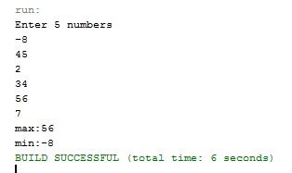

**TASK # 3:**

Write a program to solve the quadratic equation by using algorithm.

ALGORITHM:

**Input** = A, B, C, Q.

**Output** = Quadratic equation is.

**Step # 1:**(Initialization)

A, B, C, Q.

**Step # 2:**

Read A, B, C, Q.

**Step # 3:**

Q=((-B)+-(MATH.SQRT((B*B)-(4*A*C))))/(2*A)

**Step # 4:**

Write Q.

**Step # 5:**

Exit.

SOURCE CODE:

import static java.lang.Math.sqrt;

import java.util.Scanner;

public class quad {

public static void main (String[] args){

double a,b,c,q;

Scanner inp=new Scanner(System.in);

System.out.println ("enter a,b,c values");

a=inp.nextDouble();

b=inp.nextDouble();

c=inp.nextDouble();

q=((-b)+(Math.sqrt((b*b)-(4*a*c))))/(2*a);

System.out.println ("Quadratic equation"+q);

} }

OUTPUT:

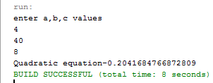

**TASK # 4:**

Write a program that take an array of integer type of size 50 fill this array by multiple of 9 & print it.

SOURCE CODE:

public class multiple {

public static void main (String[] args){

int i;

int [] a=new int[50];

int m=9;

for(i=0;i<a.length;i++){

a[i]=m;

System.out.println("Multiple of 9:"+a[i]);

m=m+9;

} }}

OUTPUT:

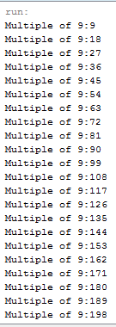

**TASK # 5:**

Write a program that take a string array of size 10 fill this array by user favourite chocolate.

SOURCE CODE:

public class favo {

public static void main (String[] args){

int i;

Scanner inp=new Scanner(System.in);

String [] a=new String[10];

System.out.println ("Enter your favourite chocolate name: ");

for(i=0;i<10;i++)

{ a[i]=inp.next(); }

for(i=0;i<10;i++){

System.out.println ("Chocolate::"+a[i]);

} } }

OUTPUT:

