**TASK # 1:**

Write an algorithm for traversing an array & implement it.

ALGORITHM:

**Input** = A, I, SUM.

**Output** = Travers.

**Step # 1:**

FOR(I=0;I<5;I++)

SUM=SUM+A[I]

**Step # 2:**

Write SUM

**Step # 3:**

Exit.

SOURCE CODE:

import java.util.Scanner;

public class traverse {

public static void main (String[] args){

int a[]=new int [5];

int i,sum=0;

Scanner inp=new Scanner(System.in);

for(i=0;i<5;i++){

a[i]=inp.nextInt();}

for(i=0;i<5;i++){

sum=sum+a[i]; }

System.out.println(""+sum);}}

OUTPUT:

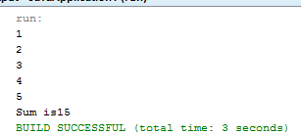

**TASK # 2:**

Write an algorithm for Inserting an element in an array & implement it in java.

ALGORITHM:

**Input** = A, J, K, E.

**Output** = After inserting Element.

**Step # 1:**

FOR(J=6;J>=K;J--)

A[J+1]=A[J] [END OF FOR LOOP]

A[K]=E

J=6+1

**Step # 2:**

Write A

**Step # 3:**

Exit.

SOURCE CODE:

import java.util.Scanner;

public class insert {

public static void main(String[] args) {

int a[]= new int [7];

int j,k,e;

Scanner inp=new Scanner(System.in);

for(j=1;j<6;j++){

a[j]=inp.nextInt(); }

System.out.println ("Enter position where u want to insert");

k=inp.nextInt();

for(j=6-1;j>=k;j--){

a[j+1]=a[j]; }

System.out.println ("Enter element u want to insert");

e=inp.nextInt();

a[k]=e;

for(j=1;j<6+1;j++){

System.out.println ("Array Element"+a[j]); } }}

OUTPUT:

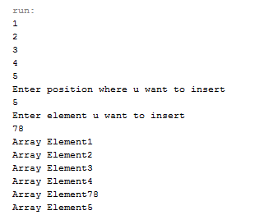

**TASK # 3:**

Write the algorithm for deleting an element in array.

ALGORITHM:

**Input** = A, J, K.

**Output** = After deleting Element.

**Step # 1:**

FOR(J=K;J<6;J++)

A[J]=A[J+1] [END OF FOR LOOP]

J=6-1

**Step # 2:**

Write A

**Step # 3:**

Exit.

SOURCE CODE:

public class delete {

public static void main(String[] args) {

int a[]= new int [7];

Scanner inp=new Scanner(System.in);

int j,k;

for(j=1;j<6;j++){

a[j]=inp.nextInt();

}

System.out.println ("Enter position u want to delete");

k=inp.nextInt();

for(j=k;j<6;j++){

a[j]=a[j+1];

}

System.out.println ("After delete");

for(j=1;j<6-1;j++){

System.out.println (a[j]);

} }}

OUTPUT:

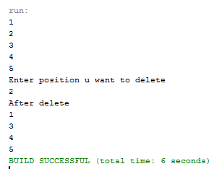

**TASK # 4:**

Write a program that use the Array list clan to add, remove, insert an element in an array(Implement all methods of array list)

SOURCE CODE:

import java.util.ArrayList;

import java.util.Scanner;

public class arraylist {

public static void main(String[] args) {

ArrayList a1=new ArrayList();

ArrayList a2=new ArrayList();

Scanner inp=new Scanner(System.in);

int a[]=new int[5];

int i,b;

a1.add("good");

a1.add("Student");

a1.add("hello");

a1.add("data structure");

System.out.println("Array "+a1);

a1.add(0,"omer");

System.out.println("Array add"+a1);

a1.remove("omer");

System.out.println("Array remove:"+a1);

System.out.println("Array size:"+a1.size());

System.out.println("Array set:"+a1.set(2,"Ali"));

System.out.println("Array index:"+a1.indexOf("Student"));

System.out.println("Array contain:"+a1.contains("good"));

System.out.println("Array set:"+a1.set(2,"Ali")); } }

OUTPUT:

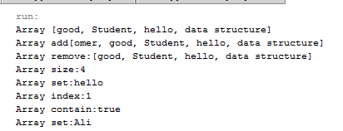

**TASK # 5:**

Write a program that initialize an array & put values in it Add a method in the class that takes another array fill and merge withthe first array print the array.

SOURCE CODE:

import java.util.Arrays;

import java.util.Scanner;

public class merge {

public static void main(String[] args) {

int i,j;

int a[]={1,2,3,4,5};

int b[]={6,7,8,9,10};

int c[]=new int [a.length+b.length];

Scanner inp=new Scanner(System.in);

System.out.println("1st Array: "+Arrays.toString(a));

System.out.println("2st Array: "+Arrays.toString(b));

System.out.println("After merge: ");

for(i=0;i<a.length;i++){

c[i]=a[i];

}

for(j=0;j<b.length;j++){

c[i++]=b[j]; }

System.out.println("Merge Array: "+Arrays.toString(c)); }}

OUTPUT:

