**TASK # 1:**

Write & implement the algorithm of Bubble Sort.

ALGORITHM:

**Input** = I, J, TEMP, A.

**Output** = After sorting elements.

**Step # 1:**(Initialization)

I, J, TEMP, A.

**Step # 2:**

Read I, J, TEMP, A.

**Step # 3:**

FOR(I=0;I<N;I++)

FOR(J=0;J<N-I-1;J++)

IF(A[I]>A[I+1])

TEMP=A[I]

A[I]=A[I+1]

A[I+1]=TEMP

[End of for loops]

**Step # 4:**

Write A[I].

**Step # 5:**

Exit.

SOURCE CODE:

import java.util.Arrays;

import java.util.Scanner;

public class bublesort {

public static void main(String[] args) {

int i,j,temp=0;

int a[]=new int [5];

Scanner inp=new Scanner(System.in);

System.out.println("enter element:");

for(i=0;i<a.length;i++){

a[i]=inp.nextInt(); }

for(i=0;i<a.length;i++){

for(j=0;j<a.length-i-1;j++){

if(a[j]>a[j+1]){

temp=a[j];

a[j]=a[j+1];

a[j+1]=temp;} } }

for(i=0;i<a.length;i++){

System.out.println("After sorting:"+a[i]); }}}

OUTPUT:

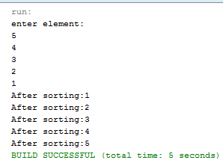

**TASK # 2:**

Write & implement the algorithm of Linear sort.

ALGORITHM:

**Input** = K, PTR, DATA, TEMP, N.

**Output** = After sorting elements.

**Step # 1:**(Initialization)

K, PTR, DATA, TEMP=0, N.

**Step # 2:**

K, PTR, DATA, TEMP=0, N.

**Step # 3:**

FOR(K=0;K<N;K++)

PTR=K+1

WHILE(PTR<=N)

IF(DATA[K]>DATA[PTR])

TEMP=DATA[K]

DATA[K]=DATA[PTR]

DATA[PTR]=TEMP

PTR++

**Step # 4:**

Write A.

**Step # 5:**

Exit.

SOURCE CODE:

import java.util.Arrays;

import java.util.Scanner;

public class linear2 {

public static void main(String args[])

{

Scanner input=new Scanner(System.in);

int[] DATA=new int[5];

int Ptr,K,N=4,Temp;

System.out.println("Enter any 5 numbers: ");

for(int i=0;i<=N;i++)

{DATA[i]=input.nextInt();}

for(K=0;K<N;K++)

{

Ptr=1+K;

while(Ptr<=N)

{

if(DATA[K]>DATA[Ptr])

{ Temp=DATA[K];

DATA[K]=DATA[Ptr];

DATA[Ptr]=Temp;}

Ptr++;}}

System.out.println("After Sorting: ");

System.out.println(Arrays.toString(DATA));}}

OUTPUT:

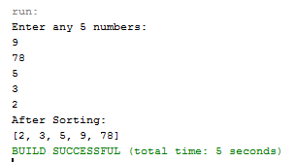

**TASK # 3:**

Use the built in sorted clan in java & sort the integer, character, double & string.

SOURCE CODE:

import java.util.Arrays;

public class BUILTINSORT {

public static void main(String args[]){

int a[]={6,5,3,21,4};

float b[]={6.3f,5.1f,33.1f,21.4f,4.9f};

char c[]={'n','g','a','b'};

String d[]={"cat","alpha","dog","baba"};

Arrays.sort(a);

System.out.println(Arrays.toString(a));

Arrays.sort(b);

System.out.println(Arrays.toString(b));

Arrays.sort(c);

System.out.println(Arrays.toString(c));

Arrays.sort(d);

System.out.println(Arrays.toString(d)); }}

OUTPUT:

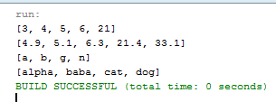

**TASK # 4:**

Using linear & bubble sort algorithm to sort string array.

SOURCE CODE:

import java.util.Arrays;

public class Bubblesortstring {

public static void main(String args[]){

String a[]={"cat","alpha","dog","baba"};

int i,j;

String temp=null;

for(i=0;i<a.length;i++){

for(j=0;j<a.length-i-1;j++){

if(a[j].compareTo(a[j+1])>0){

temp=a[j];

a[j]=a[j+1];

a[j+1]=temp;

}} }

System.out.println(Arrays.toString(a));}}

import java.util.Arrays;

public class stringlinearsort {

public static void main(String args[]){

String a[]={"cow","abcd","dog","bad"};

int i,j;

String temp=null;

for(i=0;i<a.length;i++){

for(j=i+1;j<a.length;j++){

if(a[i].compareTo(a[j])>0){

temp=a[i];

a[i]=a[j];

a[j]=temp;}}}

System.out.println(Arrays.toString(a));}}

OUTPUT:





**TASK # 5:**

Using bubble sort algorithm to sort the data in descending order.

SOURCE CODE:

import java.util.Arrays;

import java.util.Scanner;

public class bublesort {

public static void main(String[] args) {

int i,j,temp=0;

int a[]=new int [5];

Scanner inp=new Scanner(System.in);

System.out.println("enter element:");

for(i=0;i<a.length;i++){

a[i]=inp.nextInt(); }

for(i=0;i<a.length;i++){

for(j=0;j<a.length-i-1;j++){

if(a[j]<a[j+1]){

temp=a[j];

a[j]=a[j+1];

a[j+1]=temp;} } }

for(i=0;i<a.length;i++){

System.out.println("After sorting:"+a[i]); }}}

OUTPUT:

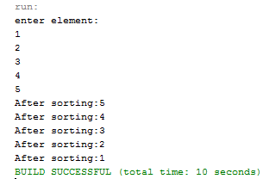

**TASK # 6:**

Using linear sort algorithm to sort the data in descending order.

SOURCE CODE:

import java.util.Arrays;

import java.util.Scanner;

public class linear2 {

public static void main(String args[])

{ Scanner input=new Scanner(System.in);

int[] DATA=new int[5];

int Ptr,K,N=4,Temp;

System.out.println("Enter any 5 numbers: ");

for(int i=0;i<=N;i++)

{DATA[i]=input.nextInt();}

for(K=0;K<N;K++)

{ Ptr=1+K;

while(Ptr<=N)

{ if(DATA[K]<DATA[Ptr])

{

Temp=DATA[K];

DATA[K]=DATA[Ptr];

DATA[Ptr]=Temp;

}

Ptr++;

}

}

System.out.println("After Sorting: ");

System.out.println(Arrays.toString(DATA));}}

OUTPUT:

