**STORED PROCEDURES**

**CREATE PROCEDURE 1:**

create procedure Emp_1 as select * from emp1 where id=10

select * from emp1

execute Emp_1

**Screen shots:**

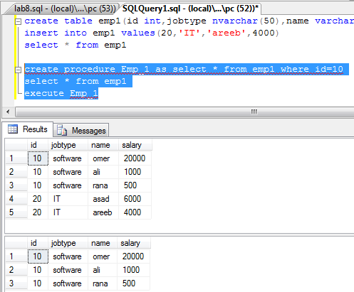

**CREATE PROCEDURE 2:**

create procedure Emp_2 @emp_id int as select * from emp1 where id=@emp_id

select * from emp1

execute Emp_2 20

**Screen shots:**

