**COMPARISON & LOGICAL OPERATORS**

1. **Using the Comparison Operators**

select * from employee where sal>18000

**Screen shots:**

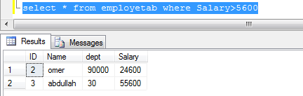

1. **The BETWEEN Operator**

select * from employee where sal between 10000 and 15000

**Screen shots:**

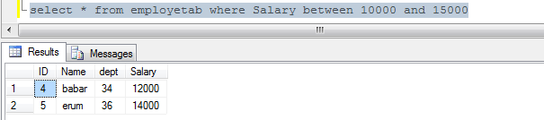

1. **The IN Operator**

select * from employee where ename in ('Mukaram')

**Screen shots:**

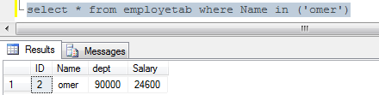

1. **Using the LIKE operator**

**Screen shots:**

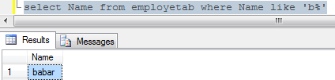

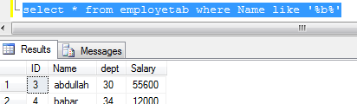

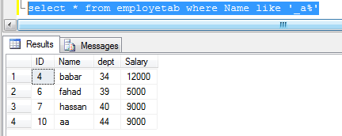

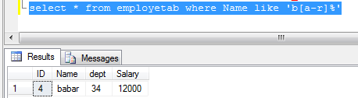

1. **Using the IS NULL operator**

select * from employee where head is null

**Screen shots:**

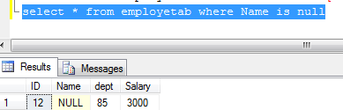

1. **Using the NOT operator**

select * from employee where not eno>=200

**Screen shots:**

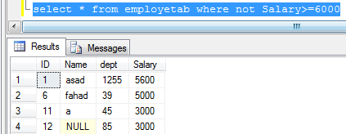

1. **Using the AND operator**

select * from department where dname='sales' and dept_location='lahore'

**Screen shots:**

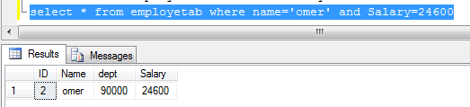

1. **Using the OR operator**

select * from department where dno=10 or dno=20

select * from employee

where (eno>=500 or eno<=150) and ename like 'j%'

**Screen shots:**



