**CREATING AND ALTERING TABLES**

1. **SQL PRIMARY KEY Constraint on CREATE TABLE**

**Screen shots:**

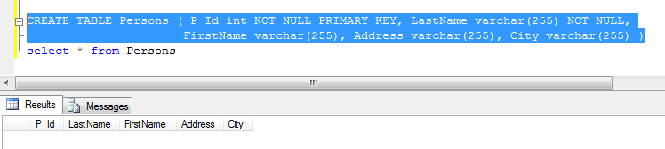

1. **INSERTING SPECIAL VALUES USING SQL FUNCTIONS**

GETGATE()

**Screen shots:**

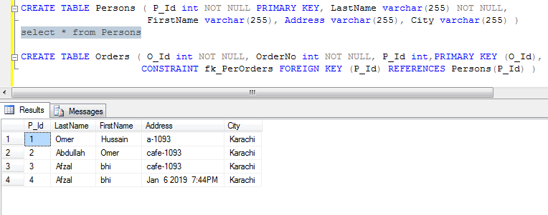

1. **COPYING ROWS FROM ANOTHER TABLE**

**Screen shots:**

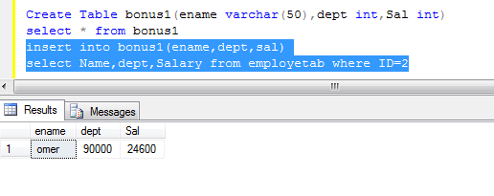

1. **Updating/Changing Data With The UPDATE Statement**

update employee set dno=10 where eno=259

**Screen shots:**

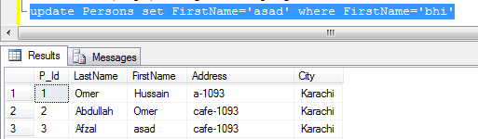

1. **Updating with Multiple Columns Subquery**

update employee

set job=(Select job from employee Where eo=231),

dno=(Select dno FROM employee Where eno=231)

where eno=760

**Screen shots:**

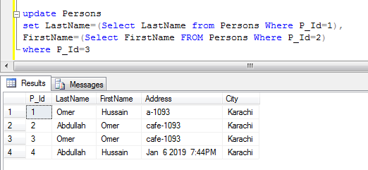

1. **Removing Data With The DELETE Statement**

**Screen shots:**

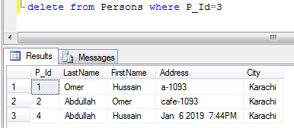

1. **To DROP a PRIMARY KEY Constraint**

**Screen shots:**

