**SORTING DATA**

1. **SORTING ROWS WITH ORDER BY CLAUSE**

**Screen shots:**

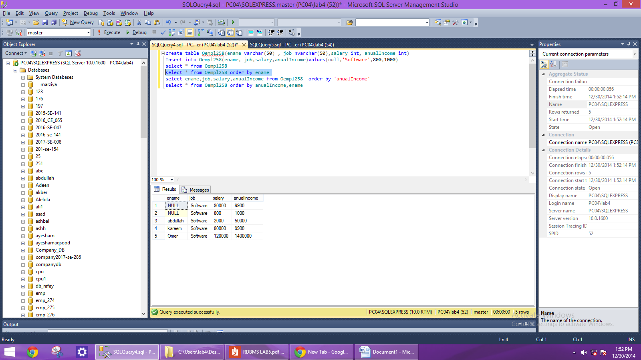

1. **Sorting by Column Alias**

**Screen shots:**

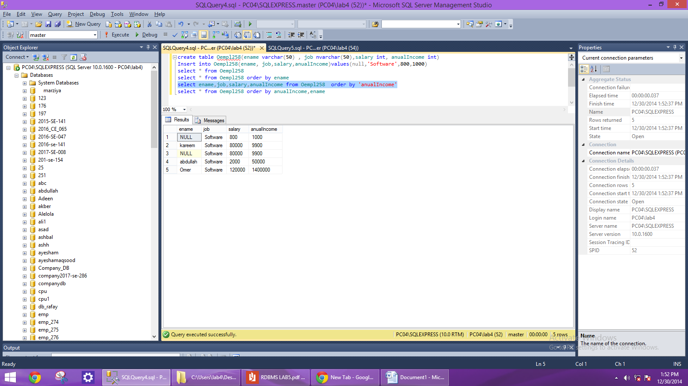

1. **Sorting by Multiple Columns**

**Screen shots:**

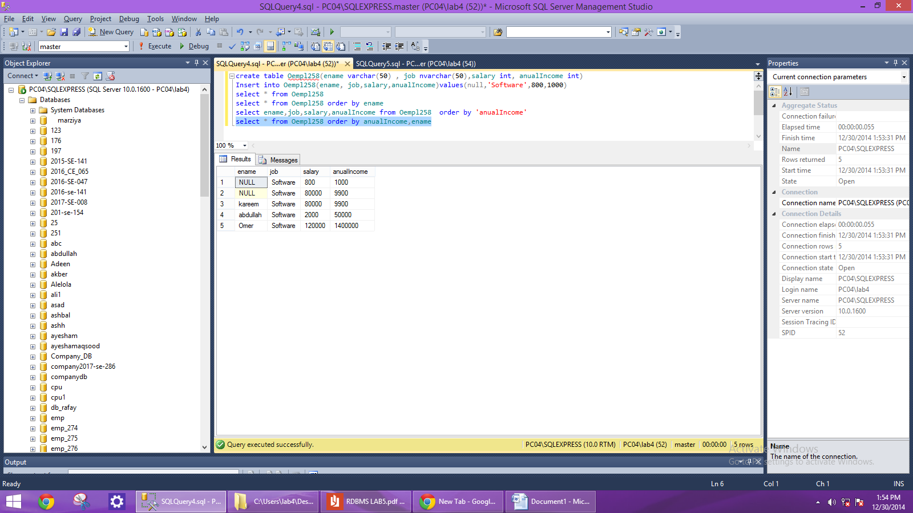

1. **Sorting in Descending Order:**

**Screen shots:**

