**SORTING DATA**

1. **UNION :**

SELECT ID, Name, dept,Salary FROM A UNION SELECT ID, Name, dept,Salary FROM B;

**Screen shots:**

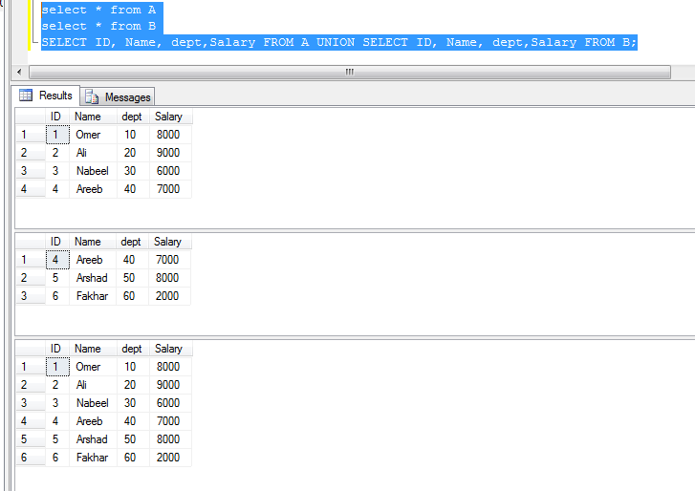

1. **UNION ALL:**

SELECT ID, Name, dept,Salary FROM A UNION ALL SELECT ID, Name, dept,Salary FROM B;

**Screen shots:**

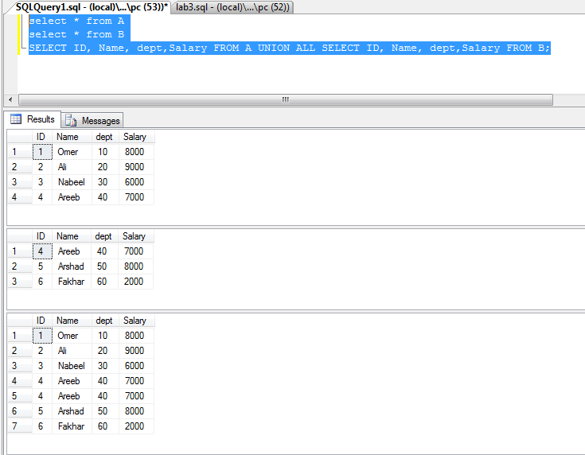

1. **INTERSECT:**

SELECT ID, Name, dept,Salary FROM A INTERSECT SELECT ID, Name, dept,Salary FROM B;

**Screen shots:**

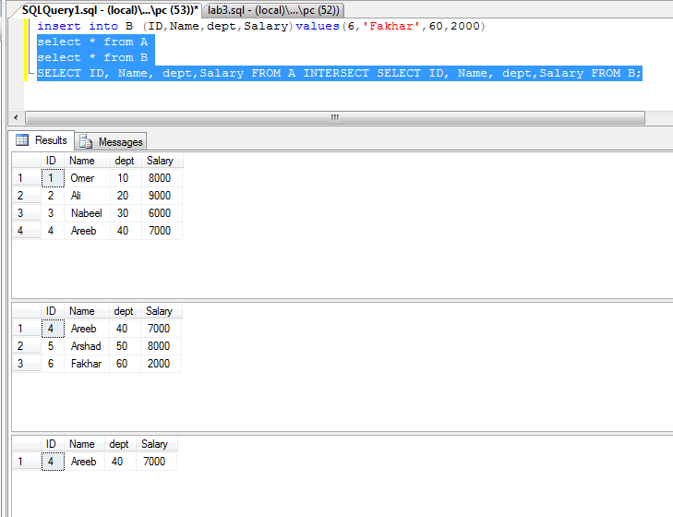

1. **EXCEPT:**

SELECT ID, Name, dept,Salary FROM A EXCEPT SELECT ID, Name, dept,Salary FROM B;

**Screen shots:**

