**DISPLAYING DATA FROM MULTIPLE TABLES**

**INNER JOIN:**

select emp.deptID,emp.lastname,dept.DeptName,dept.locationID

from emp Inner Join dept on (emp.deptID=dept.deptID)

**Screen shots:**

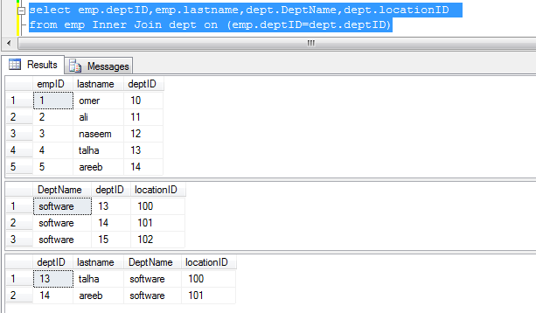

**FULL OUTER JOIN:**

select emp.deptID,emp.lastname,dept.DeptName,dept.locationID

from emp full Outer Join dept on (emp.deptID=dept.deptID)

**Screen shots:**

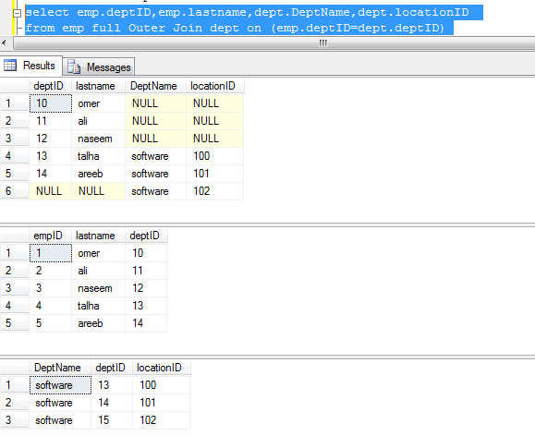

**LEFT OUTER JOIN:**

select emp.deptID,emp.lastname,dept.DeptName,dept.locationID

from emp Left Outer Join dept on (emp.deptID=dept.deptID)

**Screen shots:**

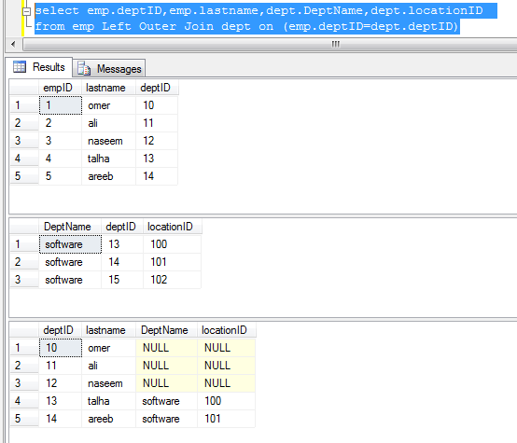

**RIGHT OUTER JOIN:**

select emp.deptID,emp.lastname,dept.DeptName,dept.locationID

from emp Right Outer Join dept on (emp.deptID=dept.deptID)

**Screen shots:**

