**GROUP FUNCTIONS**

**Using SUM Functions:**

select DeptID,jobID,SUM(salary) as 'SUM(SALARY)' from employee Group by DeptID,jobID;

**Screen shots:**

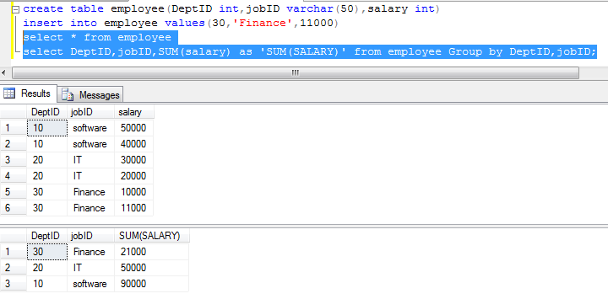

**Using AVG, MAX, MIN Functions:**

select AVG(salary) as 'AVG(SALARY)',MAX(salary) as 'MAX(SALARY)',MIN(salary) as 'MIN(SALARY)' from employee;

**Screen shots:**

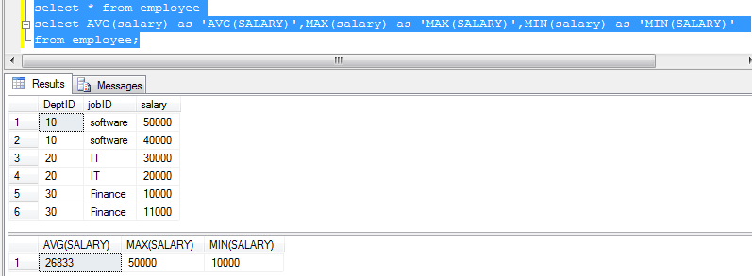

**Using COUNT, STDEV, VAR Functions:**

select COUNT(salary) as 'Count(SALARY)',STDEV(salary) as 'Standard Deviation',VAR(salary) as 'VARIANCE' from employee group by DeptID order by DeptID;

**Screen shots:**

