**VIEWS**

**SQL CREATE VIEW:**

create VIEW [SHOW_JOB_IDs]

as select DeptID,SUM(salary)as 'Sum Salary' from employe258 where jobID='Software'

group by DeptID

**Screen shots:**

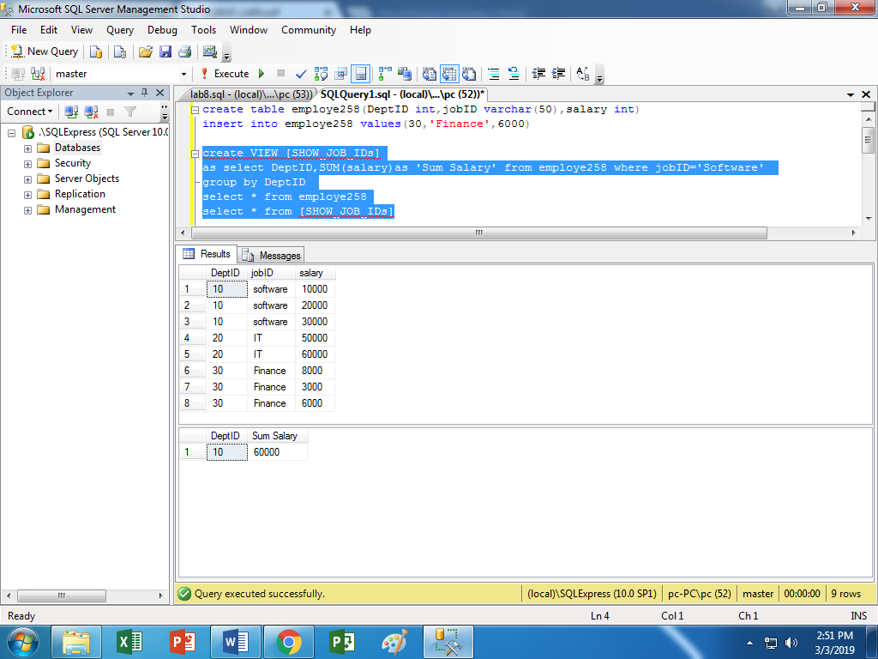

**SQL ALTER VIEW:**

Alter VIEW [SHOW_JOB_IDs]

as select jobID,SUM(salary)as 'Sum Salary' from employe258 where DeptID=20 group by jobID

**Screen shots:**

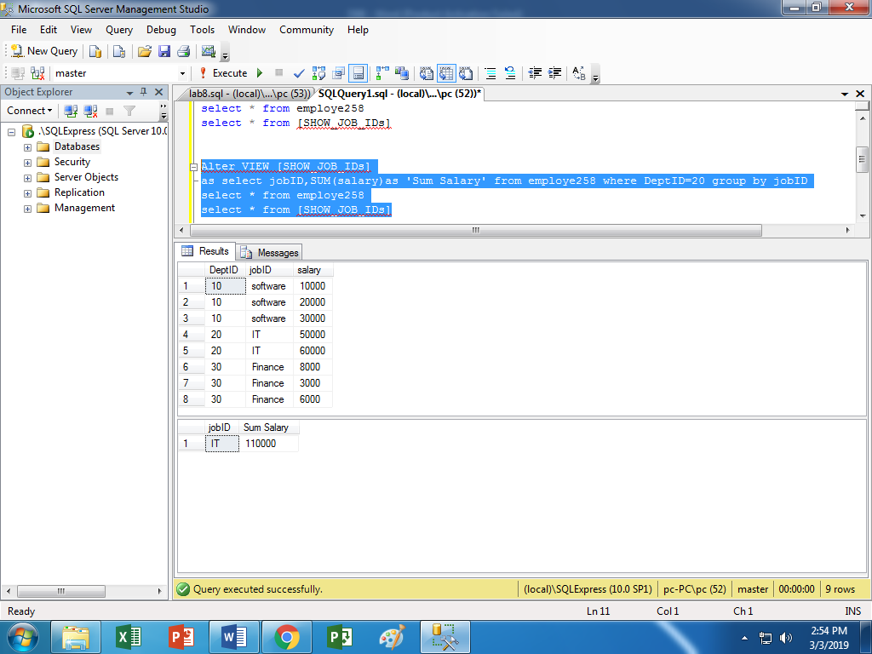

**DROP VIEW:**

drop view [SHOW_JOB_IDs]

**Screen shots:**

