**6th OBJECTIVE:**

Write a Java program to display the following character rhombus structure.

A

ABA

ABCBA

ABCDCBA

ABCDEDCBA

ABCDEFEDCBA

ABCDEFGFEDCBA

ABCDEFEDCBA

ABCDEDCBA

ABCDCBA

ABCBA

ABA

A

**PROGRAM # 6:**

SOURCE CODE:

public class alph

{

public static void main(String[] args)

{

int j;

for(int i = 1; i <= 4; i++)

{

for(j = 1; j <= 5-i; j++)

System.out.print(" ");

for(j = 1; j <= 2*i-1; j++)

if(j <= i)

System.out.print((char)(char)(j+64)+"");

else

System.out.print((char)(char)(2*i-j+64)+"");

System.out.println(); //for line break

}

for(int a = 4; a >= 1; a--)

{

for(int b = 1; b <= 5-a; b++)

System.out.print(" ");

for(int b = 1; b <= 2*a-1; b++)

if(b <= a)

System.out.print((char)(char)(b+64)+"");

else

System.out.print((char)(char)(2*a-b+64)+"");

System.out.println();

}

}}

OUTPUT:

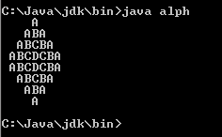

CONCLUSION:

In this program we are learning how to draw rhombus structure.

**7th OBJECTIVE:**

Write a method with a while loop that computes the sum of first n positive integers: sum = 1 + 2 + 3 + … + n

**PROGRAM # 7:**

SOURCE CODE:

import java.util.Scanner;

public class sumat

{

public static void main(String[] args)

{

int n,b=1,sum=0;

Scanner inp = new Scanner(System.in);

System.out.print("Enter number for summation:");

n=inp.nextInt();

while(b<=n)

{

sum=sum+b;

b++;

}

System.out.print("The sum of first n positive numbers="+sum);

}}

OUTPUT:

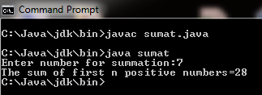

CONCLUSION:

In this program we are learning how to do summation of first n positive numbers.

**8th OBJECTIVE:**

### Write Java program to print the table of characters that are equivalent to the Ascii codes from 1 to 122.

**PROGRAM # 8:**

SOURCE CODE:

public class CHAR1

{

public static void main(String[] args)

{

char i;

for(i=0;i<=122;i++)

{

System.out.println(""+i);

}

}}

OUTPUT:



CONCLUSION:

In this program we are learning how to generate table of character.

**9th OBJECTIVE:**

Write a program that reads in grades (any # of grades) and calculates the average

Variables for input, grade, sum and number of grades entered Loop until -1 is entered.

**PROGRAM # 9:**

SOURCE CODE:

import java.util.Scanner;

public class grade1

{

public static void main(String[] args)

{

int sum=0;

int count=0;

int grade;

float average;

Scanner inp = new Scanner(System.in);

System.out.print("Enter grades:");

grade=inp.nextInt();

while(grade !=-1)

{

sum=sum+grade;

count=count+1;

System.out.print("Enter another grade:");

grade=inp.nextInt();

}

average=sum/count;

System.out.print("Average is :"+average);

}}

OUTPUT:

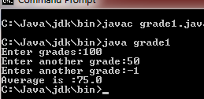

CONCLUSION:

In this program we are learning how to calculate the average of grades.

**10th OBJECTIVE:**

Generate the following output by using for loop.

+----+

\ /

/ \

\ /

/ \

\ /

/ \

+----+

**PROGRAM # 10:**

SOURCE CODE:

public class slash

{

public static void main(String[] args)

{

int i;

String a="\\";

String b="/";

String c="/";

String d="\\";

System.out.println("+----+");

for(i=0;i<=5;i++)

{

System.out.println(""+a+" "+b);

System.out.println(""+c+" "+d);

}

System.out.println("+----+");

}}

OUTPUT:

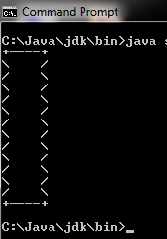

CONCLUSION:

In this program we are learning how to draw special character pattern .