DOS COMMANDS:

1#VER:

This command is used to find exact version of DOS.

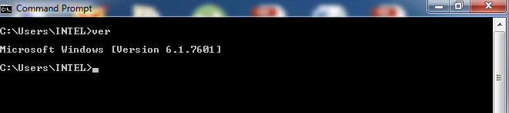

2#CLS:

This command is used to clear the screen.

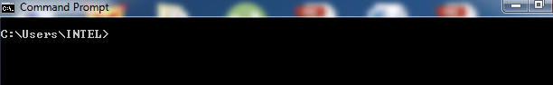

3#MD:

This command is used to create a new sub directory.

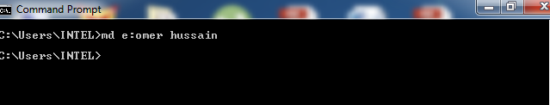

4#DIR:

This command will produce a directory listing from the default drive.

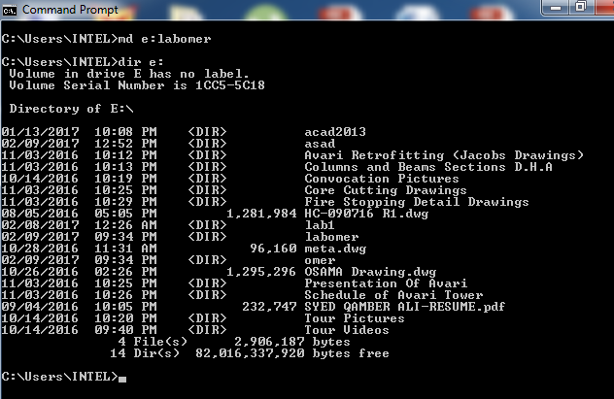

5#REN:

This command is used to rename a file or folder.

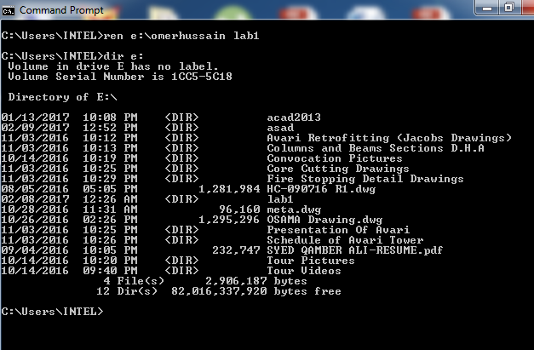

6#TREE:

This command is used to view directory listing in a hierarchical order.

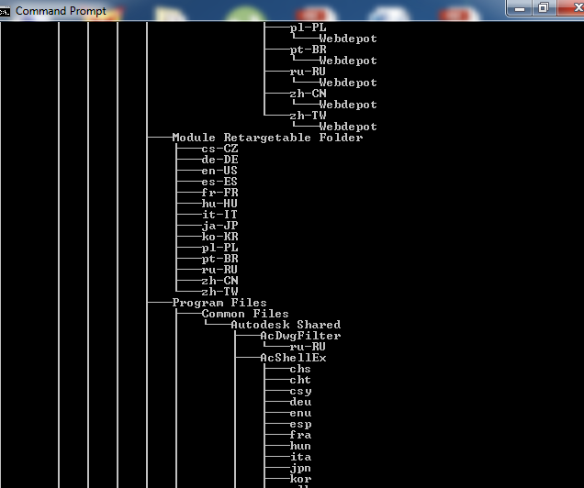

7#RD:

This command is used to remove a directory.

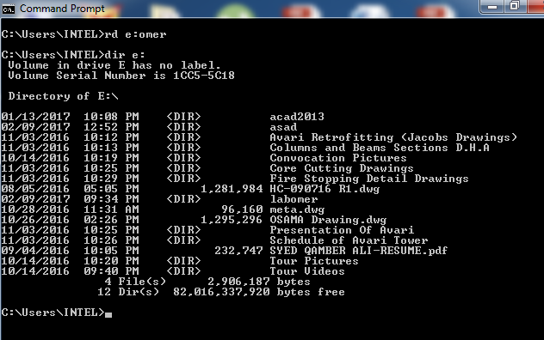

8#VOL:

This command is used to view a disk volume label.

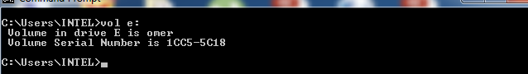

9#CD:

This command is used to change the current directory to a new directory.

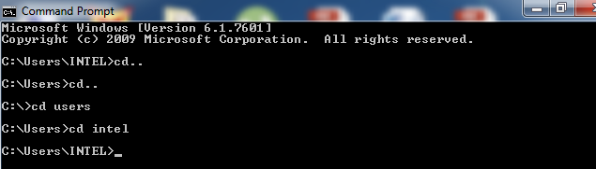

10#LABEL:

This command adds modifies or changes the volume label of a disk.

